Contents
Assumptions and Pre-Requisites: 2
R Commands and its Output 2
# All related variables with respect to damage 2
Visualization of PCA output for Damage variables: 4
Inference 6
Final Computation of PCA Score: 6

Assumptions and Pre-Requisites:
Groping is done based on Country Text present in data. PCA is done on all those grouped records, in which we have considered Total of nkill, Total of nwound, Total incidents and Total property damage.

R Commands and its Output

Following commands are used to produce the output:

# All related variables with respect to damage
countryWiseData=ddply(TerristsGDPData,.(country_txt),summarise,Total_Incidents=length(na.omit(eventid)), Total_Kill=sum(na.omit(nkill)), Total_Wound=sum(na.omit(nwound)), Total_Propvalue=sum(na.omit(propvalue)))
colnames(countryWiseData)
countryWiseDataPCA=subset(countryWiseData, select=c(Total_Incidents, Total_Kill, Total_Wound, Total_Propvalue))
pcGTD = princomp(formula=~ ., data = countryWiseDataPCA, cor=TRUE)

pcGTD

Output:
Call:
princomp(formula = ~., data = countryWiseDataPCA, cor = TRUE)

Standard deviations:
Comp.1 | Comp.2 | Comp.3 | Comp.4
1.6843120 | 0.9970655 | 0.3273429 | 0.2485962

4 variables and 206 observations.

pcGTD$loadings
Output:
#Loadings:
 | Comp.1 | Comp.2 | Comp.3 | Comp.4
Total_Incidents | 0.573 |  | 0.716 | 0.395
Total_Kill | 0.578 | -0.102 |  | -0.809
Total_Wound | 0.568 | -0.148 | -0.684 | 0.433
Total_Propvalue | 0.116 | 0.982 | -0.141

 | Comp.1 | Comp.2 | Comp.3 | Comp.4
SS loadings | 1 | 1 | 1 | 1
Proportion Var | 0.25 | 0.25 | 0.25 | 0.25
Cumulative Var | 0.25 | 0.76 | 0.90 | 0.92

summary(pcGTD)
Output:
Importance of components:
 | Comp.1 | Comp.2 | Comp.3 | Comp.4
Standard deviation | 1.6843120 | 0.9970655 | 0.32734294 | 0.24859616
Proportion of Variance | 0.7092267 | 0.2485349 | 0.02678835 | 0.01545001
Cumulative Proportion | 0.7092267 | 0.9577616 | 0.98454999 | 1.00000000

Visualization of PCA output for Damage variables:
Command:
Plot(pcGTD)

Output:

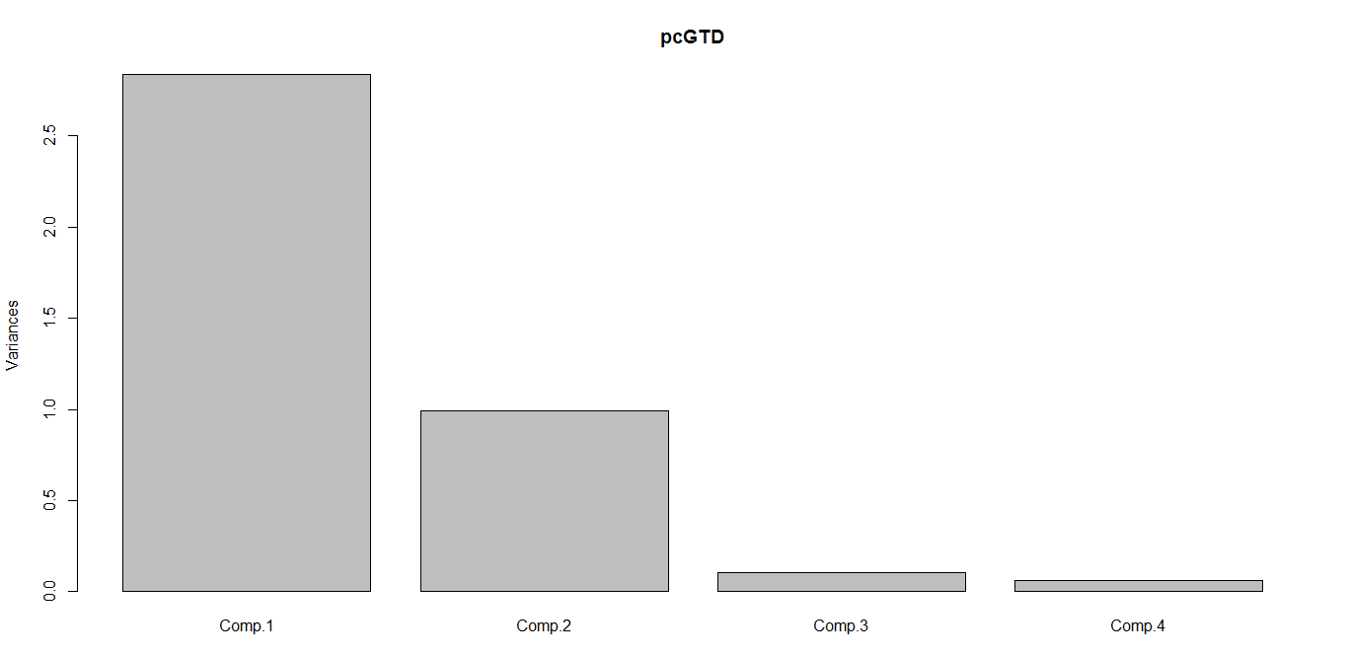
Command:
biplot(pcGTD)

Output:
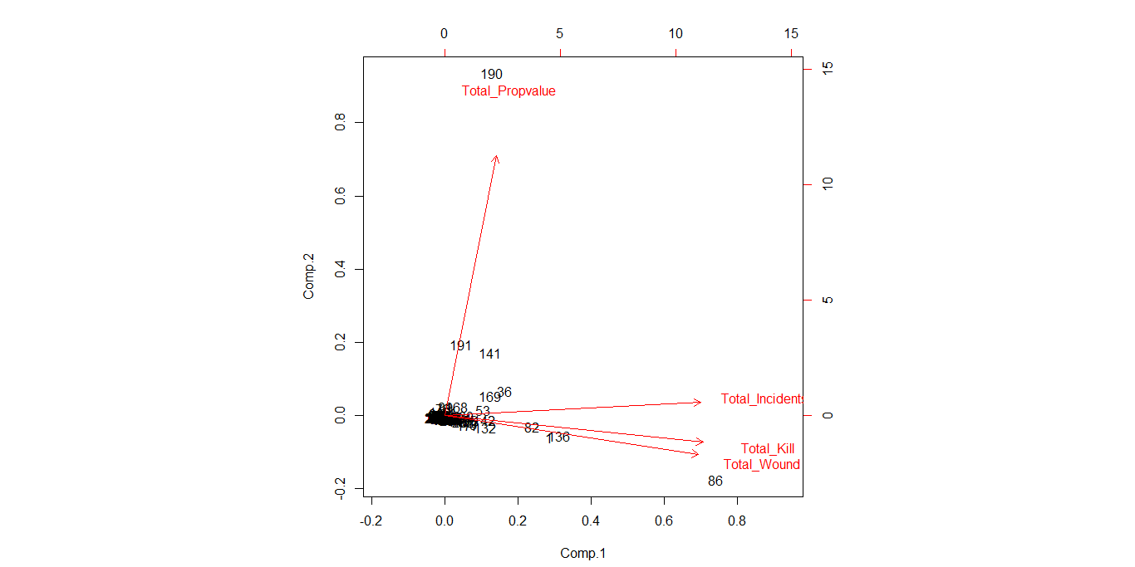

Inference
As per above analysis, inference from this is that:
Component 1 – total_incidents, total_nkill, total_nwound
Component 2 - propvalue

Final Conclusion and further analysis:
Since we found that propvalue is having lot of NA for about 80% of records, we will be excluding the same and doing PCA analysis again without it.
Summary of propvalue variable is as follows:
Min. | 1st Qu. | Median | Mean | 3rd Qu. | Max. | NA's
-99 | -99 | -99 | 249600 | 5000 | 2700000000 | 125460

So it has been decided that we will not be including propvalue for PCA analysis further as it is not a reliable variable as for most observations it is NA:
countryWiseData=ddply(TerristsGDPData,.(country_txt),summarise,Total_Incidents=length(na.omit(eventid)), Total_Kill=sum(na.omit(nkill)), Total_Wound=sum(na.omit(nwound)))
colnames(countryWiseData)
countryWiseDataPCA=subset(countryWiseData, select=c(Total_Incidents, Total_Kill, Total_Wound))
pcGTD = princomp(formula=~ ., data = countryWiseDataPCA, cor=TRUE)
pcGTD
Output:
Call:
princomp(formula = ~., data = countryWiseDataPCA, cor = TRUE)

Standard deviations:
Comp.1 | Comp.2 | Comp.3
1.6768804 | 0.3539234 | 0.2506196
3 variables and 206 observations.

pcGTD$loadings
Output:
#Loadings:
 | Comp.1 | Comp.2 | Comp.3
Total_Incidents | 0.573 | 0.747 | 0.337
Total_Kill | 0.584 |  | -0.808
Total_Wound | 0.575 | -0.659 | 0.484

 | Comp.1 | Comp.2 | Comp.3
SS loadings | 1 | 1 | 1
Proportion Var | 0.333 | 0.333 | 0.333
Cumulative Var | 0.333 | 0.667 | 1.000

summary(pcGTD)
Output:
Importance of components:
 | Comp.1 | Comp.2 | Comp.3
Standard deviation | 1.6768804 | 0.35392343 | 0.25061960
Proportion of Variance | 0.9373093 | 0.04175393 | 0.02093673
Cumulative Proportion | 0.9373093 | 0.97906327 | 1.00000000

Inference
As per above analysis, inference from this is that:
Component 1 – total_incidents, total_nkill, total_nwound
It is considering all the variance of all these variables.
So we will be using score of this component for GTI and using which we will be forming the clusters.
Following table shows top 6 countries based on this GTI scores.
Row No | Country | Total Incidents | Total Kill | Total Wound | GTI Score
1 | Iraq | 18770 | 58855 | 115042 | 18.07335
2 | Pakistan | 12768 | 21597 | 38012 | 7.628008
3 | Afghanistan | 9690 | 27018 | 31636 | 6.964922
4 | India | 9940 | 18317 | 27257 | 5.83441
5 | Colombia | 8077 | 14562 | 10138 | 3.848777
6 | Sri Lanka | 2982 | 15505 | 15537 | 2.911374

Based on this scoring, final clustering of all countries is done in excel.

Further visualization of this graph can be done using this data.

