Objective Questions

1 - What is the distribution of account balances across different regions?

Solution:
Final Answer:
Germany has the highest average account balance ($119K), while France and Spain are both notably lower and roughly similar to each other ($62K each).
Approach:
1 - Confirmed the relationship between Bank_Churn and Geography (via CustomerInfo.GeographyID) was active in the data model.
2 - Inserted a Clustered Bar Chart visual.
3- Placed Geography.Location on the Y-axis and Balance in Values, set to Average aggregation (average is more representative of "distribution" than sum, since region customer counts may differ).

Charts & Tables:
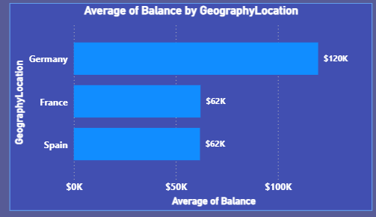

2 - Identify the top 5 customers with the highest Estimated Salary in the last quarter of the year. (SQL)
Solution:
Final Answer:
Code:
SELECT CustomerId, Surname, EstimatedSalary, Bank_DOJ FROM CustomerInfo
WHERE Bank_DOJ >= CONCAT((SELECT MAX(YEAR(Bank_DOJ)) FROM CustomerInfo), '-10-01')
AND Bank_DOJ <= CONCAT((SELECT MAX(YEAR(Bank_DOJ)) FROM CustomerInfo), '-12-31')
ORDER BY EstimatedSalary DESC LIMIT 5;
Approach:
- Since the dataset has no transaction date, used Bank_DOJ (date of joining) as the reference date field.
- Determined the most recent year dynamically using MAX(YEAR(Bank_DOJ)).
- Filtered records to Oct 1 – Dec 31 of that year (Q4 2019).
- Sorted by EstimatedSalary descending, limited to top 5.

Charts & Tables:
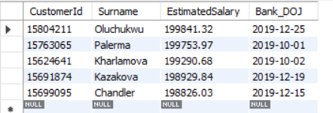

3- Calculate the average number of products used by customers who have a credit card. (SQL)
Solution:
Final Answer:
Customers who have a credit card use an average of 1.53 products.
Code:
SELECT AVG(NumOfProducts) AS AvgProductsWithCreditCard
FROM Bank_Churn
WHERE HasCrCard = 1;
Approach:
- Filtered Bank_Churn to rows where HasCrCard = 1.
- Applied AVG() on NumOfProducts for those rows.
Charts & Tables:
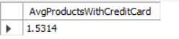

4 - Determine the churn rate by gender for the most recent year in the dataset.
Solution:
Final Answer:
Among customers who joined in 2019 (the most recent year), the churn rate is notably higher for Female customers (~25%) than Male customers (~15%).
- Approach:
  - Created a calculated column JoinYear = YEAR(CustomerInfo[Bank DOJ]).
  - Created a measure Churn Rate = DIVIDE(SUM(Bank_Churn[Exited]), COUNTROWS(Bank_Churn)).
  - Added a slicer on JoinYear, filtered to 2019.
  - Built a Clustered Column Chart with GenderCategory on axis and Churn Rate as value.
Charts & Tables:
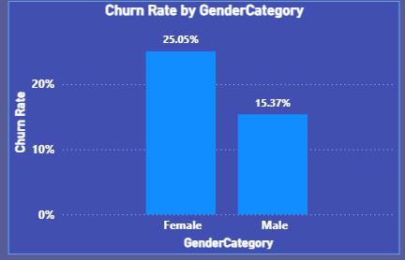

5 - Compare the average credit score of customers who have exited and those who remain. (SQL)

Solution:
Final Answer:
Retained customers have a slightly higher average credit score (651.85) than exited customers (645.35) — a ~6.5 point gap, suggesting credit score alone isn't a strong standalone churn predictor.
Code:
SELECT CASE WHEN Exited = 1 THEN 'Exited' ELSE 'Retained' END AS CustomerStatus,
AVG(CreditScore) AS AvgCreditScore, COUNT(*) AS CustomerCount
FROM Bank_Churn GROUP BY Exited;
Approach:
1- Used a CASE statement to label Exited = 1 as "Exited" and Exited = 0 as "Retained".
2- Grouped by Exited and applied AVG(CreditScore).
Charts & Tables:
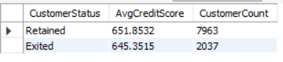
6- Which gender has a higher average estimated salary, and how does it relate to the number of active accounts? (SQL)
Solution:
Final Answer:
Females have a slightly higher average estimated salary (₹100,601.54) than males (₹99,664.58) — a small gap of ~₹937. Despite the higher salary, females have a slightly lower active account rate (50.28%) compared to males (52.54%), so higher salary doesn't translate into higher account activity for this gender.
Code:
select g.gendercategory, round(avg(ci.estimatedsalary), 2) as avgestimatedsalary,
sum(bc.isactivemember) as activeaccounts, count(*) as totalcustomers,
round(sum(bc.isactivemember) * 100.0 / count(*), 2) as activepercent
from bank_churn as bc join customerinfo as ci on bc.customerid = ci.customerid
join gender as g on ci.genderid = g.genderid group by g.gendercategory;
Approach:
- Joined Bank_Churn, CustomerInfo, and Gender tables.
- Grouped by gender, calculated average estimated salary.
- Calculated active account count and percentage per gender to relate salary to activity level.

Charts & Tables:

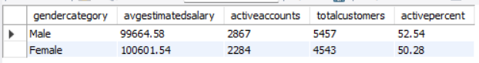

7 - Segment the customers based on their credit score and identify the segment with the highest exit rate. (SQL)
Solution:
Final Answer:
The "Poor" credit score segment (below 500) has the highest exit rate at 23.73%, followed by "Fair" (21.06%), "Excellent" (19.78%), and "Good" (19.18%). Interestingly, the exit rate doesn't fall neatly with rising credit score — "Excellent" is slightly higher than "Good" — but the lowest-scoring segment clearly churns the most.
Code:
select case when creditscore < 500 then 'Poor (<500)'
when creditscore between 500 and 649 then 'Fair (500-649)'
when creditscore between 650 and 749 then 'Good (650-749)'
when creditscore >= 750 then 'Excellent (750+)'
end as creditscoresegment, count(*) as totalcustomers,
sum(exited) as exitedcustomers,
round(sum(exited) * 100.0 / count(*), 2) as exitratepercent
from bank_churn group by creditscoresegment
order by exitratepercent desc;
Approach:
- Bucketed CreditScore into 4 standard segments: Poor (<500), Fair (500-649), Good (650-749), Excellent (750+).
- Grouped by segment, calculated total customers, exited customers, and exit rate %.
- Sorted by exit rate descending to identify the worst-performing segment.

Charts & Tables:

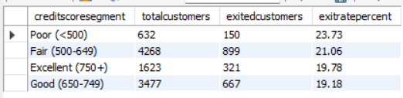

8- Find out which geographic region has the highest number of active customers with a tenure greater than 5 years. (SQL)
Solution:
Final Answer:
France has the highest number of active customers with tenure greater than 5 years (797 customers), followed by Spain (431) and Germany (399). This makes sense given France also has the largest overall customer base.
Code:
select geo.geographylocation, count(*) as activecustomerscount
from bank_churn as bc join customerinfo as ci on bc.customerid = ci.customerid
join geography as geo on ci.geographyid = geo.geographyid
where bc.isactivemember = 1 and bc.tenure > 5
group by geo.geographylocation order by activecustomerscount desc;
Approach:
- Joined Bank_Churn, CustomerInfo, and Geography tables.
- Filtered for IsActiveMember = 1 and Tenure > 5.
- Grouped by region, counted matching customers, sorted descending.
Charts & Tables:
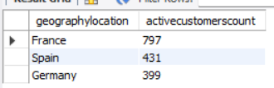

9 - What is the impact of having a credit card on customer churn, based on the available data?
Solution:
Final Answer:
Having a credit card has negligible impact on churn — both non-credit card holders (~20.3%) and credit card holders (~20.2%) churn at almost identical rates. This suggests credit card ownership is not a meaningful predictor of customer churn in this dataset.
Approach:
- Linked Bank_Churn.HasCrCard to CreditCard.CreditID via the existing relationship.
- Built a Clustered Column Chart with CreditCard.Category on axis and the Churn Rate measure as value.
Charts & Tables:
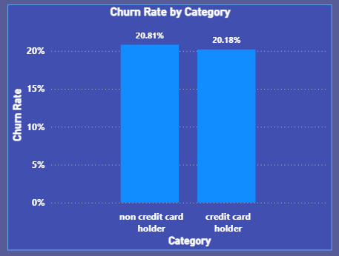

10 - For customers who have exited, what is the most common number of products they have used?
Solution:

Final Answer:
Among exited customers, 1 product is by far the most common, with 1,409 customers — nearly 3x the next-highest group (2 products: 348 customers). Followed by 3 products (220) and 4 products (60, the least common).
Approach:
- Filtered Bank_Churn to Exited = 1.
- Built a Clustered Column Chart with NumOfProducts on axis and Count of CustomerId as value.
- Enabled data labels on the chart for exact counts.
Charts & Tables:
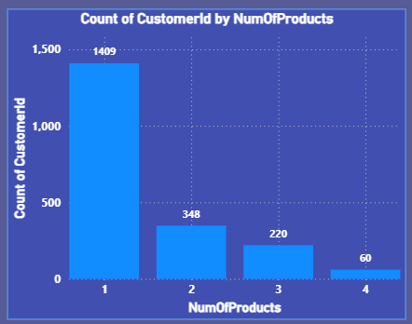

11 - Examine the trend of customers joining over time and identify any seasonal patterns (yearly or monthly). Prepare the data through SQL and then visualize it.
Solution:
Final Answer: Two clear patterns emerge:
- Yearly growth trend: Total customer joins increased consistently each year from 2016 through 2019 — each year's line sits above the previous year's across most months.
- Monthly seasonality: All four years show a dip around February (lowest joins) and a strong ramp-up from August to December, peaking around September/October–December. This suggests a recurring seasonal pattern — customer acquisition is weakest in early year (Jan-Feb) and strongest in the last quarter.
Code:
select year(bank_doj) as joinyear, month(bank_doj) as joinmonth,
count(*) as customerscount from customerinfo
group by joinyear, joinmonth order by joinyear, joinmonth;

Approach:
- Prepared the data in SQL: grouped CustomerInfo by year and month of Bank_DOJ, counting customers per month-year.
- In Power BI, created calculated columns JoinYear = YEAR(Bank_DOJ) and JoinMonth = MONTH(Bank_DOJ).
- Built a Line Chart: JoinMonth on axis, JoinYear as legend, Count of CustomerId as value.

Charts & Tables:
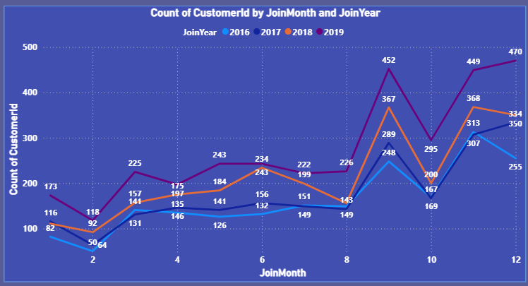

12 - Analyze the relationship between the number of products and the account balance for customers who have exited.
Solution:
Final Answer:
Among exited customers, average balance stays relatively flat across product counts — ranging narrowly from 86K to 94K. There's no strong upward or downward trend; customers with 3 products have the lowest average balance (86K), while those with 4 products have the highest (94K), but the differences are small. This suggests number of products isn't strongly correlated with balance among churned customers.

Approach:
Filtered Bank_Churn to Exited = 1.
Built a Clustered Column Chart with NumOfProducts on axis and Average of Balance as value.
Enabled data labels for exact figures.
Charts & Tables:

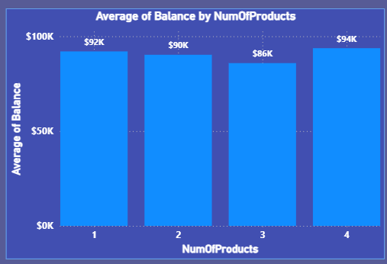

13 - Identify any potential outliers in terms of balance among customers who have remained with the bank.
Solution:
Final Answer:
Using the IQR method on retained customers' balances: Upper Bound ≈ ₹316,026 and Lower Bound ≈ -₹189,615 (below the possible minimum of 0, so no low-end outliers exist). Looking at the scatter plot, only a handful of customers exceed the ₹316K upper threshold (visible as a few isolated dots near/above 0.3M on the chart) — these represent the true high-balance outliers. The vast majority of retained customers fall well within the normal range (roughly 0–250K).
Approach:
- Created 5 measures using the IQR method: Q1 Balance (25th percentile), Q3 Balance (75th percentile), IQR Balance (Q3-Q1), Upper Bound (Q3 + 1.5×IQR), Lower Bound (Q1 - 1.5×IQR) — all filtered to Exited = 0.
- Built a Scatter Chart: CustomerId on X-axis, Balance on Y-axis, filtered to retained customers.
- Displayed Upper/Lower Bound as Card visuals for reference against the scatter.

Charts & Tables:
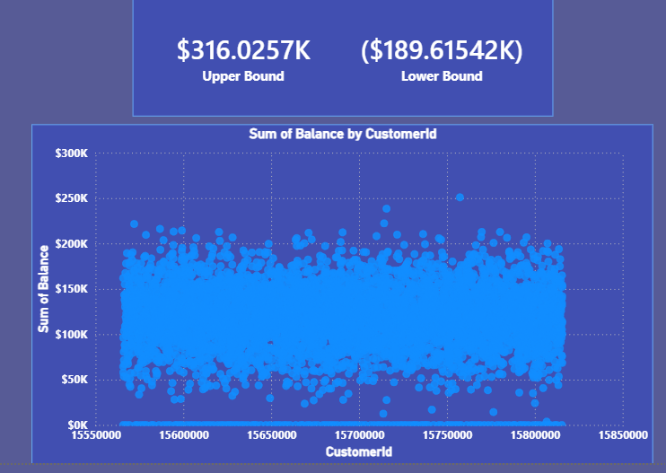

14 - How many different tables are given in the dataset, out of these tables which table only consists of categorical variables?
Solution:
Final Answer:
There are 7 tables in the dataset: Bank_Churn, CustomerInfo, Gender, Geography, CreditCard, ActiveCustomer, ExitCustomer.
Of these, 4 tables consist entirely of categorical variables: Gender, Geography, CreditCard, and ActiveCustomer/ExitCustomer — each holds only an ID and a category label (e.g., GenderID/GenderCategory, GeographyID/GeographyLocation). Since the question asks for a single table, the cleanest example is Gender (or Geography) — a pure lookup table with no numeric/measure columns at all.
Approach: NA
Charts & Tables: NA

15- Using SQL, write a query to find out the gender-wise average income of males and females in each geography id. Also, rank the gender according to the average value. (SQL)
Solution:
Final Answer:
Average income by gender varies by region, and no single gender consistently ranks #1 across all geographies:

Geography 1: Male higher (100,174.25) vs Female (99,564.25)
Geography 2: Female higher (100,734.11) vs Male (98,425.69)
Geography 3: Female higher (102,446.42) vs Male (99,905.03)

Females rank #1 in 2 of the 3 regions, though the gaps are relatively small (under ~2,500 in each case) — no dramatic gender-based income disparity by region.
Code:
select ci.geographyid, g.gendercategory,
round(avg(ci.estimatedsalary), 2) as avgincome,
rank() over (partition by ci.geographyid order by avg(ci.estimatedsalary) desc) as genderrank
from customerinfo as ci
join gender as g on ci.genderid = g.genderid
group by ci.geographyid, g.gendercategory
order by ci.geographyid, genderrank;
Approach:
- Joined CustomerInfo to Gender.
- Grouped by GeographyID and GenderCategory, calculated average EstimatedSalary.
- Used RANK() OVER (PARTITION BY GeographyID ORDER BY AVG(EstimatedSalary) DESC) to rank genders within each region.
Charts & Tables:
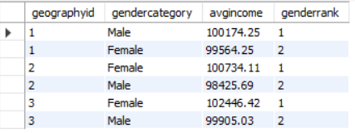

16 - Using SQL, write a query to find out the average tenure of the people who have exited in each age bracket (18-30, 30-50, 50+).
Solution:
Final Answer:
Average tenure among exited customers is remarkably consistent across all age brackets — 18-30: 4.78 years, 30-50: 4.89 years, 50+: 4.83 years. The differences are minor (under 0.11 years), suggesting tenure at time of exit doesn't vary meaningfully by age group. Notably, the 30-50 bracket has by far the most exits (1,326) compared to 18-30 (148) and 50+ (563), making it the dominant age group among churned customers.
Code:
select case
when age between 18 and 30 then '18-30'
when age between 31 and 50 then '30-50'
else '50+' end as agebracket,
round(avg(bc.tenure), 2) as avgtenure,
count(*) as exitedcustomers from bank_churn bc
join customerinfo ci on bc.customerid = ci.customerid
where bc.exited = 1 group by agebracket order by agebracket;
Approach:
- Joined Bank_Churn to CustomerInfo for Age.
- Bucketed Age into 3 brackets using CASE.
- Filtered to Exited = 1, grouped by bracket, calculated average tenure and exit count.
Charts & Tables:
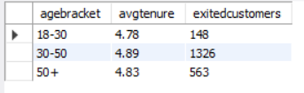

17 - Is there any direct correlation between salary and the balance of the customers? And is it different for people who have exited or not?
Solution:
Final Answer:
No, there is no direct correlation between salary and balance — the scatter plot shows a dense, uniform cloud of points across the entire salary range (0-200K) with balances scattered from 0 to ~250K, showing no diagonal trend line in either direction. This pattern holds true for both exited (dark blue) and retained (light blue) customers — both colors are mixed evenly throughout the cloud with no visible separation or distinct clustering pattern. One additional observation: there's a dense horizontal band of points at Balance = 0K across all salary levels, meaning many customers carry a zero balance regardless of income.
Approach:
- Built a Scatter Chart with EstimatedSalary (X) vs Balance (Y), colored by Exited.
- Set both EstimatedSalary and Balance to Don't summarize so each customer plots as an individual point instead of an aggregated total.
- Visually assessed the pattern for correlation (diagonal trend = correlation; random cloud = no correlation) and for any difference between exited/retained groups.

Charts & Tables:
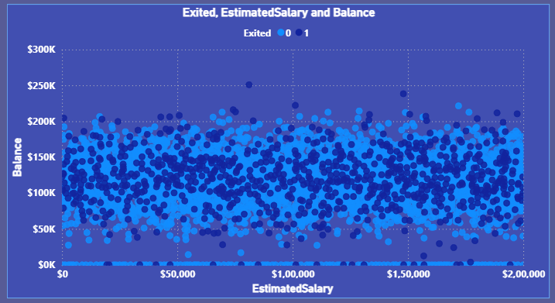

18 - Is there any correlation between the salary and the Credit score of customers?
Solution:
Final Answer:
No, there is no correlation between salary and credit score — the scatter plot shows a uniform, dense cloud of points across the entire salary range (0-200K) with credit scores spread from ~400 to ~850, with no visible diagonal trend in either direction. High earners and low earners both show the full range of credit scores equally.
Approach:
- uilt a Scatter Chart with EstimatedSalary (X) vs CreditScore (Y).
- Set both fields to Don't summarize so each customer plots as an individual point.
- Visually assessed the pattern — a random cloud with no diagonal trend indicates no correlation.
Charts & Tables:
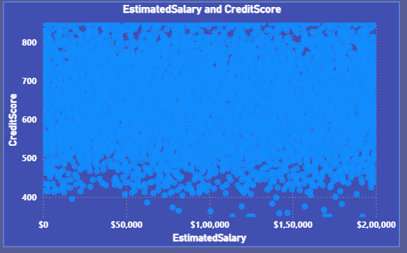

19 - Rank each bucket of credit score as per the number of customers who have churned the bank.
Solution:
Final Answer:
Ranked by number of churned customers:

Fair (500-649) — highest, ~900 churned customers
Good (650-749) — ~670 churned customers
Excellent (750+) — ~320 churned customers
Poor (<500) — lowest, ~150 churned customers

Interestingly, this ranking is largely driven by segment population size rather than a higher tendency to churn — Fair and Good are the largest customer segments overall, so they naturally produce the most churned customers in absolute terms (compare with Q7, where "Poor" actually had the highest churn rate %, despite having the fewest churned customers here).
Approach:
- Created a calculated column CreditScoreSegment bucketing CreditScore into 4 tiers (matches Q7's SQL segments).
- Filtered to Exited = 1.
- Built a Clustered Column Chart: CreditScoreSegment on axis, Count of CustomerId as value, sorted descending.
Charts & Tables:
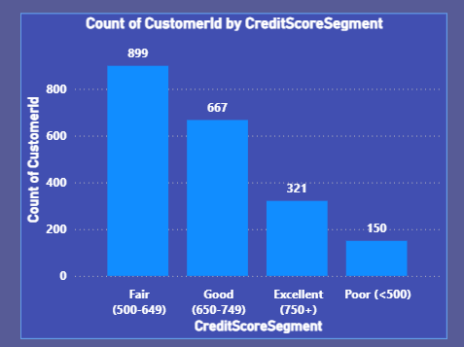

20- According to the age buckets find the number of customers who have a credit card. Also retrieve those buckets that have lesser than average number of credit cards per bucket.
Solution:
Final Answer:
Credit card holders by age bucket: 30-50: 4,781, 18-30: 1,400, 50+: 874. Total = 7,055, giving an average of ~2,352 per bucket.
Buckets below average: 18-30 (1,400) and 50+ (874). Only the 30-50 bucket exceeds the average.

Approach:
- Created AgeBucket calculated column in CustomerInfo (18-30, 30-50, 50+).
- Filtered to HasCrCard = 1, built a Clustered Column Chart with AgeBucket on axis and Count of CustomerId as value.
- Manually computed the average across the 3 buckets and identified which fall below it.
Charts & Tables:
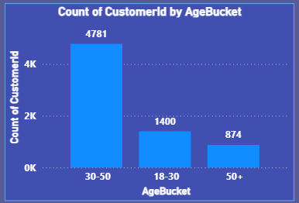

21- Rank the Locations as per the number of people who have churned the bank and average balance of the customers.
Solution:
Final Answer:
Ranked by churned customer count:

Germany — 814 churned, Average Balance ₹1,19,730.12
France — 810 churned, Average Balance ₹62,092.64
Spain — 413 churned, Average Balance ₹61,818.15

Germany and France have nearly identical churn counts (814 vs 810), while Spain churns notably fewer customers. Notably, Germany also has by far the highest average balance — nearly double France and Spain — meaning Germany is losing its highest-value customers, which is a bigger revenue risk despite similar churn volume to France.
Approach:
- Created measure Churned Count = CALCULATE(COUNTROWS(Bank_Churn), Bank_Churn[Exited]=1).
- Built a Table visual with GeographyLocation, Churned Count, and Average of Balance.
- Sorted by Churned Count descending.
Charts & Tables:
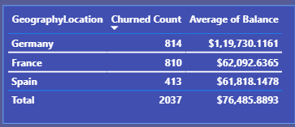

22 - As we can see that the “CustomerInfo” table has the CustomerID and Surname, now if we have to join it with a table where the primary key is also a combination of CustomerID and Surname, come up with a column where the format is “CustomerID_Surname”.
Solution:
Final Answer:
Created a new calculated column CustomerID_Surname in CustomerInfo, combining CustomerId and Surname with an underscore separator (e.g., 15754105_Olisanugo). This column can now be used as a composite join key for any external table that uses CustomerID+Surname as its primary key.
Approach:
Used DAX string concatenation in a calculated column:
CustomerID_Surname = CustomerInfo[CustomerId] & "_" & CustomerInfo[Surname]
Charts & Tables: NA

23 - Without using “Join”, can we get the “ExitCategory” from ExitCustomers table to Bank_Churn table? If yes do this using SQL.
Solution:
Final Answer:
Yes, this is possible using a correlated subquery instead of a JOIN. Each row's Exited value (0/1) is matched against ExitCustomer.ExitID inside a subquery, pulling the corresponding ExitCategory label (e.g., 0 → "Retain") without using the JOIN keyword anywhere in the query.
Code:
select customerid, exited,
(select exitcategory from exitcustomer where exitid = bank_churn.exited) as exitcategory
from bank_churn limit 10;
Approach:
Used a correlated subquery in the SELECT clause — for every row in Bank_Churn, the subquery looks up the matching ExitCategory from ExitCustomer where ExitID equals that row's Exited value. This achieves the same result as a JOIN but without using the JOIN syntax.
Charts & Tables:
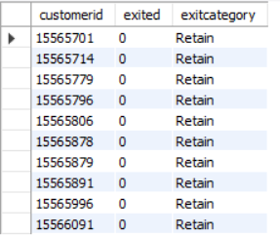

24 - Were there any missing values in the data, using which tool did you replace them and what are the ways to handle them?
Solution:
Final Answer:
No missing values were found in the dataset — all columns across Bank_Churn and CustomerInfo show 100% Valid, 0% Empty, verified using Power BI's Power Query column quality profiling (checked against the full dataset, not just a sample). Since no missing values existed, no replacement/imputation was needed.
General ways to handle missing values (for the write-up, even though not needed here):
- Deletion — remove rows/columns with missing data (only if the missing % is small)
- Mean/Median/Mode imputation — fill numeric gaps with the column average/median, categorical gaps with the most frequent value
- Forward/Backward fill — for time-series data, carry the previous/next known value forward
- Predictive imputation — use other columns to estimate the missing value (regression/KNN)
- Flagging — create an indicator column marking that a value was missing, in case "missingness" itself is meaningful.
Approach:
- Opened Power Query Editor (Transform Data).
- Enabled Column Quality view (View tab) for all tables.
- Set profiling to "entire dataset" rather than default sample.
- Confirmed 0% Empty across all columns in Bank_Churn and CustomerInfo.
Charts & Tables: NA

25 - Write the query to get the customer IDs, their last name, and whether they are active or not for the customers whose surname ends with “on”.
Solution:
Final Answer:
Retrieved 704 customers whose surname ends with "on" (e.g., Hanson, Gordon, Jamieson, Rolon, Benson, Morrison, etc.), along with their active/inactive status. A sample of the result is shown below.
Code:
select ci.customerid, ci.surname,
case when bc.isactivemember = 1 then 'Active' else 'Inactive' end as activestatus
from customerinfo ci join bank_churn bc on ci.customerid = bc.customerid
where ci.surname like '%on';
Approach:
- Joined CustomerInfo and Bank_Churn on CustomerId.
- Filtered surnames using LIKE '%on' to match any surname ending in "on".
- Used CASE to convert IsActiveMember (0/1) into readable "Active"/"Inactive" labels.
Charts & Tables:
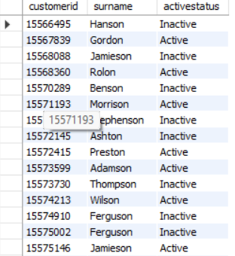

26 - Can you observe any data disrupency in the Customer’s data? As a hint it’s present in the IsActiveMember and Exited columns. One more point to consider is that the data in the Exited Column is absolutely correct and accurate.
Solution:
Final Answer:
Yes, there is a clear data discrepancy: 735 customers are marked as IsActiveMember = 1 (currently active) while also having Exited = 1 (already exited the bank) — a logical contradiction, since an exited customer cannot simultaneously be an active member. Since the question confirms Exited is accurate, this means the IsActiveMember flag is unreliable/stale for these 735 records (likely not updated after the customer churned) and should be treated with caution or corrected before using it in further analysis (e.g., churn prediction models should exclude or fix IsActiveMember for exited customers).
Approach:
- Created a measure: Discrepancy Count = CALCULATE(COUNTROWS(Bank_Churn), Bank_Churn[Exited]=1, Bank_Churn[IsActiveMember]=1).
- Added it to a Card visual to get the total contradictory row count.
Charts & Tables:
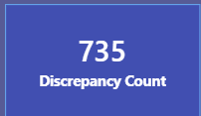

Subjective Question
1 - Customer Behavior Analysis: What patterns can be observed in the spending habits of long-term customers compared to new customers, and what might these patterns suggest about customer loyalty?
Solution:
Final Answer:
Average balance is fairly stable across tenure groups (~₹75-80K), showing tenure alone doesn't strongly drive balance. However, average number of products tells a different story: New customers (0-3 yrs) hold the most products (~1.56), which drops sharply for Long-term customers (7-10 yrs) to the lowest point (~1.50), then recovers slightly for Mid-tenure (~1.52). This is counter-intuitive — one might expect loyal, long-term customers to accumulate more products over time, but the data shows the opposite: product engagement declines with tenure. This could suggest that long-term customers become less engaged/proactive over time (a risk signal for cross-sell opportunities), while new customers may be onboarded with multiple products upfront, then don't necessarily add more later.
Approach:
- Created TenureGroup calculated column (New/Mid/Long-term based on Tenure).
- Used a Line and Clustered Column Chart: Balance as columns (primary axis), NumOfProducts as a line (secondary axis) — necessary since the two metrics have very different scales.
- Compared trends across the three tenure groups.
Charts & Tables:
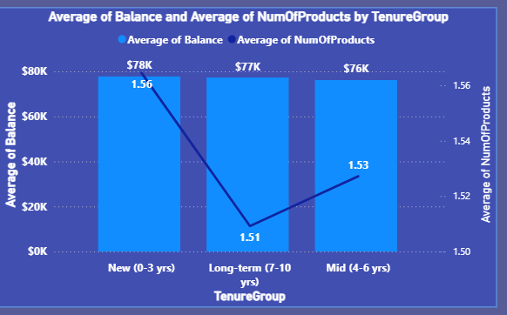

2 - Product Affinity Study: Which bank products or services are most commonly used together, and how might this influence cross-selling strategies?
Solution:
Final Answer:
Given the dataset's limitations (no individual product names — only NumOfProducts count and HasCrCard flag), true product-affinity analysis (e.g., "savings account + loan" combos) isn't possible here. Based on what's available: credit card holders consistently outnumber non-holders across every product-count tier, roughly maintaining a ~2:1 ratio at 1 and 2 products. Both groups drop off sharply at 3-4 products, with very few customers holding that many. This suggests credit card ownership is a widespread, broadly-adopted product that doesn't cluster specifically with "many products" customers — it's evenly prevalent regardless of how many total products someone holds.
Cross-selling implication: Since most customers (credit card holders or not) sit at 1-2 products, there's a large opportunity to cross-sell a 2nd or 3rd product to the majority who currently hold only one — especially non-credit-card holders, who could be offered a credit card as a natural next product given how common it already is among peers.
Approach:
- Built a Clustered Column Chart: NumOfProducts on axis, CreditCard.Category as legend, Count of CustomerId as value.
- Interpreted the pattern given the dataset only supports product-count-level analysis, not named-product combinations.
Charts & Tables:
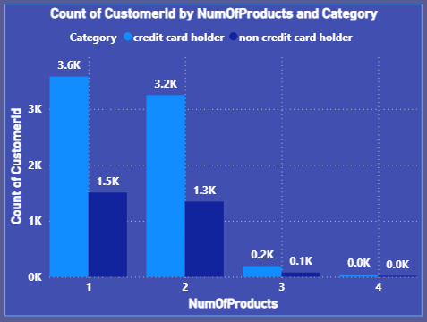

3 - Geographic Market Trends: How do economic indicators in different geographic regions correlate with the number of active accounts and customer churn rates?
Solution:
Final Answer:
Since the dataset has no external economic indicators, Balance and EstimatedSalary are used as proxies for regional economic strength. Notable patterns:
- Germany stands out with by far the highest average balance (₹1,19,730) despite having a similar/slightly higher average salary to other regions (₹1,01,113) — suggesting Germans keep proportionally more wealth in the bank. However, Germany also has the highest churn rate (32%) and the lowest active count (1,248) — nearly half of France's.
- France has the largest active customer base (2,591) and the lowest churn rate (16%), despite having the lowest average balance — high volume, low-value-per-customer, but strong retention.
- Spain sits in between on most metrics (churn 17%, balance ₹61,818).
Key insight: Higher average balance/wealth (Germany) does not correlate with better retention — in fact, it correlates with the worst churn rate here, the opposite of what you'd expect if wealthier regions were more loyal. This suggests Germany's higher-balance customers may be more price-sensitive or have more competing banking options, requiring targeted retention strategies.
Approach:
- Built a Table visual with GeographyLocation, Average Balance, Average EstimatedSalary, Active Count, and Churn Rate.
- Used Balance/Salary as proxies for regional economic strength since no true economic indicators exist in the dataset.
- Compared patterns across regions to identify correlation (or lack thereof) between wealth proxies and churn/activity.
Charts & Tables:
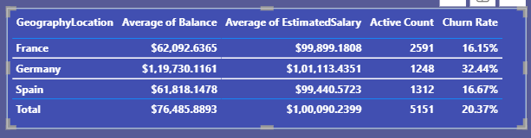

4 - Risk Management Assessment: Based on customer profiles, which demographic segments appear to pose the highest financial risk to the bank, and why?
Solution:
Final Answer:
The highest financial risk segment is "50+ customers in Germany": they combine the highest churn rate in the entire matrix (60%) with the highest average balance (₹1,20,948) — the bank is losing 6 out of 10 of its wealthiest older German customers. This is a critical risk pocket.
More broadly, age is the dominant risk driver: churn rate climbs sharply with age across every region — 18-30 (8%), 30-50 (20%), 50+ (45%) overall. Within the 50+ group, Germany (60%) and Spain (36%) far exceed France (40%)... actually France's 50+ churn (40%) is also very high — so all regions show elevated risk in the 50+ bracket, but Germany is worst across every single age bucket (12% even at 18-30, more than double France's 5%).
Highest-risk segments ranked:
- Germany, 50+: 60% churn, ₹1,20,948 avg balance — extreme risk
- France, 50+: 40% churn, ₹62,338 avg balance — high churn, lower value
- Spain, 50+: 36% churn, ₹66,720 avg balance
- Germany, 30-50: 32% churn, ₹1,19,620 avg balance — large customer base (1,700) at high value and high churn
Why: Older customers across all regions appear more likely to leave — possibly due to retirement-related account closures, competitor offers, or dissatisfaction with digital-first banking trends. Germany's consistently elevated churn across all ages suggests a region-specific issue (competition, service quality, or pricing) compounding the age-related risk.
Approach:
- uilt a Matrix visual with AgeBucket (rows) nested by GeographyLocation, showing Churn Rate, Average Balance, and Customer Count.
- Identified segments where high churn rate coincides with high balance — the costliest customers to lose.

Charts & Tables:
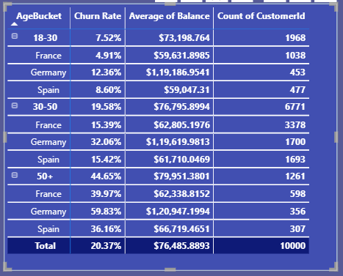

5 - Customer Tenure Value Forecast: How would you use the available data to model and predict the lifetime (tenure) value in the bank of different customer segments?
Solution:
Final Answer:
Using a proxy CLV metric (Balance × Tenure × NumOfProducts), Long-term customers (7-10 yrs) generate by far the highest lifetime value (~₹0.74M), roughly 1.5x Mid-tenure (~₹0.48M) and over 2x New customers (~₹0.32M). This makes intuitive sense since tenure is a direct multiplier — but it confirms that retaining customers longer compounds their value substantially, reinforcing why reducing churn (especially in high-risk segments like Germany 50+, identified in Q4) has outsized financial impact.
Methodology for a proper CLV/tenure-value model (beyond this proxy):
- Feature engineering: Use Tenure, Balance, NumOfProducts, IsActiveMember, CreditScore, Age, Geography as predictors.
- Survival analysis: Apply a Cox Proportional Hazards model or Kaplan-Meier curves using Tenure as the time variable and Exited as the event indicator — this predicts the probability a customer of a given profile survives (stays) beyond a certain tenure.
- Segment-level CLV formula: CLV = Average Balance × Expected Remaining Tenure × Product Margin × Retention Probability — combining survival-model output with financial data (once available) for a true dollar-value forecast.
- Regression/ML approach: Train a regression model (or gradient boosting) predicting Tenure or Balance-at-exit from customer profile features, to forecast expected value per new customer segment at acquisition.
- Data needed but missing: actual transaction/fee revenue data, product margins, and acquisition cost — without these, only relative (not absolute ₹) value can be estimated.
Approach:
- Created CLV Proxy measure: AVERAGEX(Bank_Churn, Balance * Tenure * NumOfProducts).
- Built a Clustered Column Chart by TenureGroup to visualize relative value across segments.
- Outlined the proper statistical/ML methodology (survival analysis + regression) that would be used with richer data.
Charts & Tables:
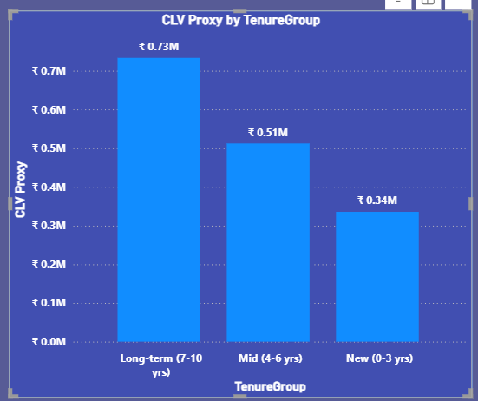

6 - Marketing Campaign Effectiveness: How could you assess the impact of marketing campaigns on customer retention and acquisition within the dataset? What extra information would you need to solve this?
Solution:
Final Answer:
The current dataset cannot assess marketing campaign impact at all — there is no campaign ID, channel, spend, exposure flag, or timestamp linking any customer to a specific marketing activity. Bank_DOJ only tells us when a customer joined, not why or through which channel.
What extra information would be needed:
- Campaign exposure data: which customers were targeted by which campaign, and when (a campaign-customer mapping table).
- Channel/source attribution: how each customer was acquired (referral, ad campaign, branch walk-in, digital ad, email) — ideally a AcquisitionChannel column in CustomerInfo.
- Campaign metadata: campaign name, type, start/end dates, spend/budget, target segment.
- Response/engagement data: whether a customer clicked, opened, or responded to a retention campaign (e.g., a win-back offer before they exited).
- A/B test or control group data: a randomly held-out group not exposed to the campaign, to compare retention/acquisition rates against the exposed group — this is essential for proving causation, not just correlation.
How we'd assess it once this data exists:
- Compare acquisition rate (new sign-ups) during campaign-active periods vs. non-campaign periods (using Bank_DOJ trend, similar to Q11's seasonality analysis).
- Compare churn/retention rate between customers exposed to a retention campaign vs. a control group who weren't.
- Calculate campaign ROI: (value retained or acquired) ÷ (campaign spend).
- Use uplift modeling to isolate the campaign's true causal effect versus customers who would have stayed/joined anyway.

Approach: NA
Charts & Tables: NA
9 - Customer Exit Reasons Exploration: Can you identify common characteristics or trends among customers who have exited that could explain their reasons for leaving?
Solution:
Final Answer:
Comparing exited vs. retained customers reveals a clear pattern:
Attribute | Exited | Retained | Difference
Average Age | 44.84 | 37.41 | +7.4 years older
Average Balance | ₹91,108.54 | ₹72,745.30 | +₹18,363 higher
Average CreditScore | 645.35 | 651.85 | -6.5 (minor)
Average NumOfProducts | 1.48 | 1.54 | -0.06 (minor)
Average Tenure | 4.87 | 4.86 | ~identical

Key characteristics of exited customers:
- Older — exited customers average ~45 years old vs. ~37 for retained, a substantial gap. This aligns with Q4's finding that churn rises sharply with age.
- Higher balance — exited customers carry ~25% more balance on average, meaning the bank is losing higher-value customers disproportionately, not just low-value ones.
- Credit score and product count are nearly identical between groups — these are NOT meaningful churn drivers.
- Tenure is identical — how long someone has been a customer doesn't predict exit; age and balance do.
Likely reasons for leaving (inferred):
Older, higher-balance customers may be shifting to retirement-focused financial products elsewhere, receiving more attractive offers from competitors given their higher value, or experiencing service/engagement gaps not suited to their life stage/needs (e.g., less engagement with digital banking).

Approach:
- Built a Table visual comparing ExitCategory against average Age, Balance, CreditScore, NumOfProducts, and Tenure.
- Identified which attributes show the largest gap between exited and retained groups as the likely drivers.
Charts & Tables:
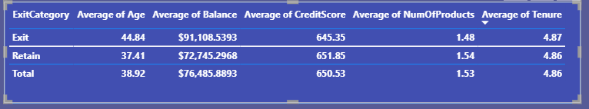

8 - Are 'Tenure', 'NumOfProducts', 'IsActiveMember', and 'EstimatedSalary' important for predicting if a customer will leave the bank?
Solution:
Final Answer:
Of the four variables, only IsActiveMember shows a meaningful difference between exited and retained customers. The other three show little to no separation and are weak standalone predictors.
Variable | Exited | Retained | Verdict
Tenure | 4.87 | 4.86 | Not a predictor — virtually identical
NumOfProducts | 1.48 | 1.54 | Weak predictor — minor gap
EstimatedSalary | ₹1,01,465.68 | ₹99,738.39 | Weak predictor — only ~1.7% difference
IsActiveMember (Active Rate) | 36% | 55% | Strong predictor — 19-point gap

Conclusion: Member activity/engagement (IsActiveMember) is the standout predictor among these four — inactive customers churn at a much higher rate. Tenure, NumOfProducts, and EstimatedSalary would add little value to a churn prediction model on their own.
Approach:
Built a single Table visual grouping by ExitCategory, showing Average Tenure, Average NumOfProducts, Average EstimatedSalary, and Active Rate side by side, then compared the gap between Exit and Retain rows for each variable.
Charts & Tables:
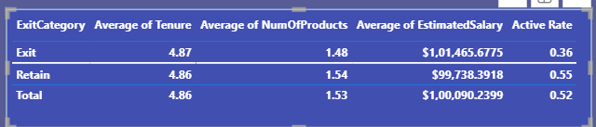

9 - Utilize SQL queries to segment customers based on demographics and account details.
Solution:
Final Answer:
Segmenting by age, gender, geography, and balance tier reveals sharp churn differences across combinations. The largest segments are dominated by 30-50 year-old French customers with relatively low churn (9-19%). The highest-risk segments are consistently in Germany:
- 30-50 Female, Germany, High Balance: 39.49% churn (worst overall)
- 30-50 Male, Germany, High Balance: 32.14% churn
- 30-50 Female, Germany, Low Balance: 25.71% churn
- 18-30 Female, Germany, High Balance: 19.23% churn
In contrast, French and Spanish segments rarely exceed ~20% churn, and the lowest-risk segment is 18-30 Male, France, Zero Balance at just 3.14%. This confirms Germany is the highest-risk market across nearly every demographic cut — the risk isn't confined to one age
or gender group, it's a consistent regional pattern.
Code:
select case when ci.age <= 30 then '18-30'
when ci.age <= 50 then '30-50' else '50+'
end as agesegment, g.gendercategory, geo.geographylocation,
case when bc.balance = 0 then 'Zero Balance'
when bc.balance <= 100000 then 'Low Balance' else 'High Balance'
end as balancesegment, count(*) as customercount,
round(avg(bc.creditscore), 2) as avgcreditscore,
round(sum(bc.exited) * 100.0 / count(*), 2) as churnratepercent
from bank_churn bc join customerinfo ci on bc.customerid = ci.customerid
join gender g on ci.genderid = g.genderid
join geography geo on ci.geographyid = geo.geographyid
group by agesegment, g.gendercategory, geo.geographylocation, balancesegment
order by customercount desc limit 20;

Approach:
- Joined Bank_Churn, CustomerInfo, Gender, and Geography.
- Created 3 segmentation dimensions: age bracket, balance tier, plus existing gender and geography.
- Grouped by all four dimensions, calculated customer count, average credit score, and churn rate per segment.
- Sorted by segment size to surface the largest customer groups first (top 20 shown).
Charts & Tables:
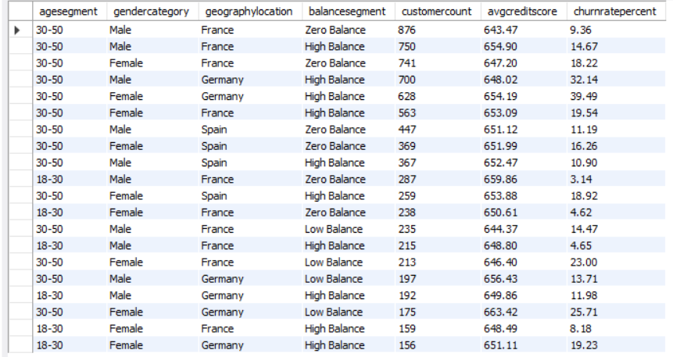

10 - How can we create a conditional formatting setup to visually highlight customers at risk of churn and to evaluate the impact of credit card rewards on customer retention?
Solution:
Final Answer:
Conditional formatting was applied to the IsActiveMember column using a Rules-based background color: red for inactive (0, at-risk) and green for active (1, low-risk). This creates an instant visual scan for identifying customers whose engagement has dropped — a key early-warning signal for churn risk.
To evaluate credit card rewards' impact on retention, the HasCrCard column was included in the same table, allowing a side-by-side view of card ownership against balance and activity status. This setup lets the bank quickly cross-check whether card holders are disproportionately represented among the red (at-risk) rows — if red rows show a similar mix of card holders and non-holders, it indicates rewards aren't meaningfully influencing retention; if red rows are mostly non-card-holders, it would suggest the card/rewards program helps retention.

Approach:
- Built a Table visual with CustomerId, Age, IsActiveMember, Sum of Balance, HasCrCard.
- Applied Conditional Formatting (Rules-based) on IsActiveMember: 0 → Red, 1 → Green.
- Set Summarization to "Average" so each row reflects its actual 0/1 value rather than an aggregate.
- Included HasCrCard in the same view for direct visual comparison against risk status.

Charts & Tables:
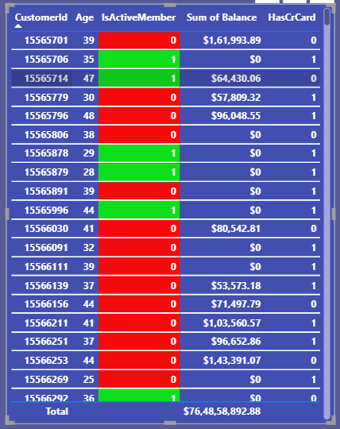

11 - What is the current churn rate per year and overall as well in the bank? Can you suggest some insights to the bank about which kind of customers are more likely to churn and what different strategies can be used to decrease the churn rate?
Solution:
Final Answer:
Churn rate by year (based on join cohort): 2016: 19.27% → 2017: 22.35% (peak) → 2018: 20.21% → 2019: 19.86%
Overall churn rate: 20.37%
Churn peaked for the 2017 join-cohort and has since gradually declined, though it remains close to 20% overall — roughly 1 in 5 customers has left the bank.
Which customers are more likely to churn:
- Older customers — churn rises sharply with age (18-30: low, 30-50: moderate, 50+: highest)
- Inactive members — customers not actively engaging with their account show a much higher churn rate than active ones
- German customers — this region consistently shows the highest churn rate across nearly every demographic segment
- Higher-balance customers — customers with larger balances churn more than lower-balance ones, meaning the bank is disproportionately losing higher-value clients
Strategies to decrease churn rate:
- Re-engagement campaigns for inactive members — since inactivity strongly correlates with churn, proactive outreach to inactive accounts could meaningfully reduce losses
- Region-specific retention program for Germany — investigate root causes (competitor rates, service gaps, pricing) and design a targeted retention offer
- Age-based relationship management — introduce tailored products/advisory services for 50+ customers, since this segment is at highest risk
- Priority retention for high-balance customers — proactively manage relationships with high-value account holders given the outsized financial impact of losing them
- Loyalty/rewards redesign — existing credit card rewards show no measurable retention benefit and may need to be restructured to actually incentivize continued engagement.
Approach:
- Built a Line Chart with JoinYear on axis and Churn Rate measure as value, with data labels enabled.
- Added a Card visual (formatted as percentage) showing overall churn rate.
- Synthesized customer risk factors and corresponding retention strategies based on patterns observed across the dataset.

Charts & Tables:
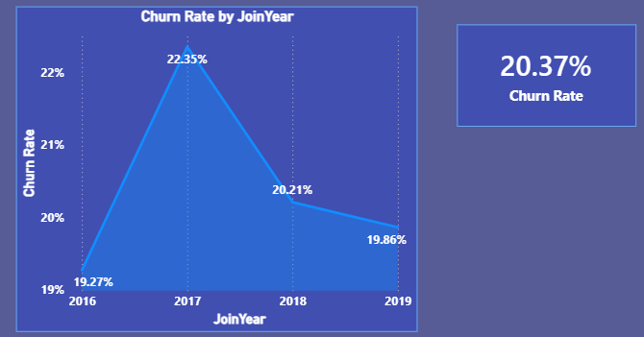

12 - Create a dashboard incorporating all the KPIs and visualization-related metrics. Use a slicer in order to assist in selection in the dashboard.
Solution:
Final Answer:
Built a 3-tab interactive Power BI dashboard with 6 charts per tab (18 in total):
- Customer Demographics: gender, age bucket, geography, average salary, tenure and salary vs credit score.
- Product Engagement: credit card usage and ownership, average credit score, active vs inactive customers, product count and average balance by product count.
- Churn Analysis: churn rate by geography, gender and salary bucket, exit category breakdown, credit score by exit status, and churn count by tenure.
Each tab carries 5 KPI cards (Total Customers 10,000, Churn Rate 20.37%, Active Members 5,151, Average Balance, Total Churned 2,037) and 4 slicers (Region, Gender, Join Year, Credit Score) that filter the page.
Approach:
- Split the analysis into three themed tabs: who the customers are, how they use products, and who churns.
- Created supporting columns and measures: AgeBucket, JoinYear, SalaryBucket, Churn Rate, Churned Count and Active Count.
- Chose the visual type to fit the data: donuts for shares, columns and bars for comparisons, and a scatter plot for the two-variable relationship.
- Kept the same KPI row, slicers, colour theme and layout on every tab.
Charts & Tables:
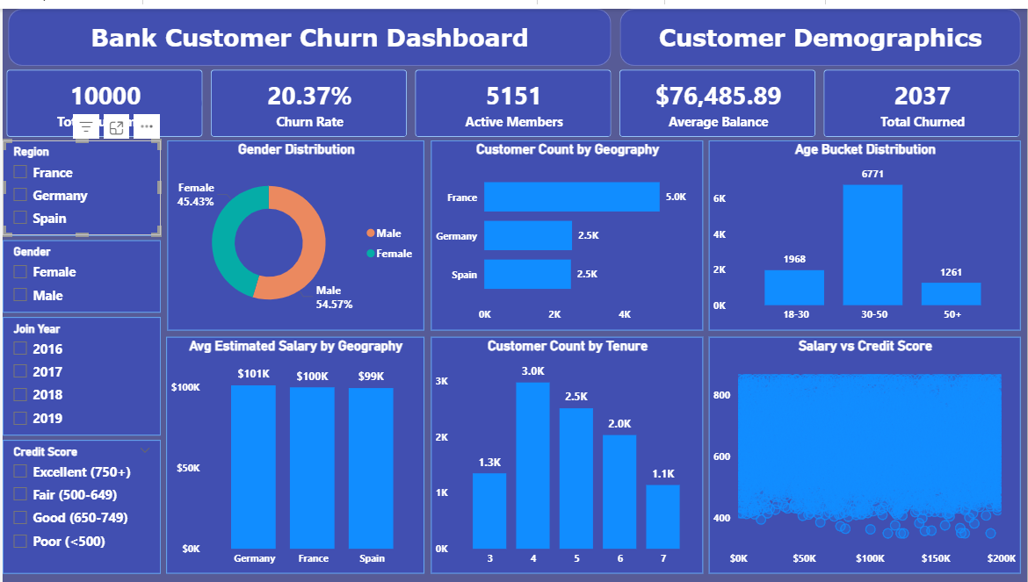
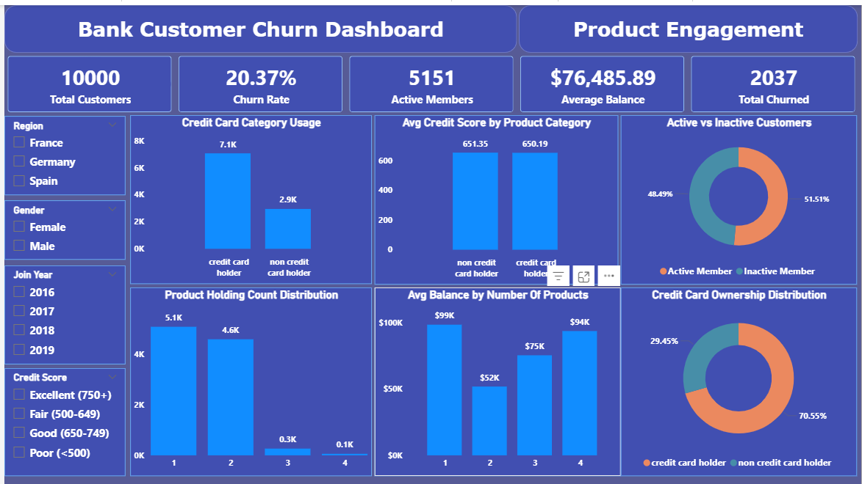
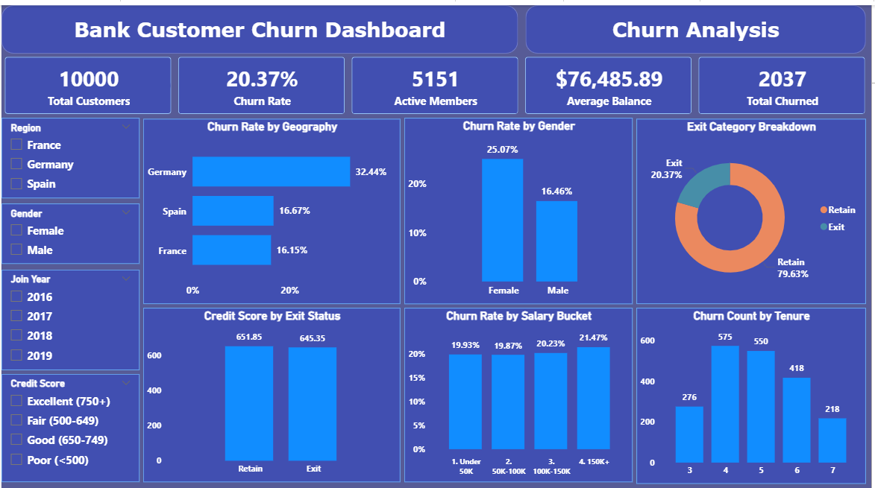

13 - How would you approach this problem, if the objective and subjective questions weren't given?
Solution:
Final Answer:
Without predefined questions, I would follow a structured, exploratory analytics approach:
- Understand the business context first — clarify the bank's core objective (reduce churn, improve satisfaction) and what "success" looks like for them, before touching the data.
- Data discovery & profiling — examine all 7 tables, understand relationships, check data types, look for missing values/inconsistencies (as done in Q24/Q26), and identify what each column actually represents.
- Exploratory Data Analysis (EDA) — systematically examine distributions of every key variable (Age, Balance, CreditScore, Tenure, Salary) and their relationship to the target variable (Exited), using summary statistics, histograms, and correlation checks — essentially reconstructing many of the same insights this project's objective questions already targeted (age vs. churn, geography vs. churn, balance vs. churn, etc.).
- Segment the customer base — group customers by demographics (age, gender, geography) and behavior (tenure, product count, activity status) to find natural risk clusters, similar to the segmentation done in Subjective Q9.
- Identify churn drivers — compare exited vs. retained customers across every variable to find which factors show the largest gap (as done across Q7, Q8, Q9) — this naturally surfaces the "important vs. unimportant" predictors without needing them to be asked explicitly.
- Build a dashboard for stakeholders — consolidate the strongest findings into a KPI-driven, interactive dashboard (as built in Q12), since a bank's decision-makers need a self-serve tool, not just a static report.
- Translate findings into actionable recommendations — for each significant pattern found, propose a concrete business action (retention campaigns, region-specific strategies, engagement programs), tying analysis directly to business impact.
- Iterate based on stakeholder feedback — present initial findings, gather questions from the business team, and refine the analysis to address their specific concerns — since without a fixed question list, priorities should be shaped by what the bank actually finds most useful.
Approach: NA
Charts & Tables: NA

14 - In the “Bank_Churn” table how can you modify the name of the “HasCrCard” column to “Has_creditcard”?
Solution:
Final Answer:
The column can be renamed using MySQL's ALTER TABLE ... RENAME COLUMN statement, which changes the column name while preserving all existing data and data types.
Code:
alter table bank_churn
rename column hascrcard to has_creditcard;
Approach:
Used the ALTER TABLE DDL command with the RENAME COLUMN clause (supported in MySQL 8.0+) to rename HasCrCard to Has_creditcard directly in the database schema.
Charts & Tables: NA

