- Do not edit/delete any heading or section with red text.
- Type /paste you answers in relevant sections (below Final Answer (in all questions , Approach (wherever required ) and Charts & tables (wherever required)) of the solution
- Link to submission guidelines
- Please note that submission not following the guidelines will not be accepted

OBJECTIVE QUESTIONS

Question 1: What is the total no. of attributes present in the data?

Solution:

Final Answer (if any):
The dataset contains 11 attributes (columns).

Approach (if any):

Charts & Tables (if any):

Question 2: Which columns have inconsistent or missing values, and what is the count of such values?

Solution:

Final Answer (if any):
After performing data cleaning and validation, no major missing or inconsistent values were found in the dataset. All columns are properly structured and mostly complete.

Approach (if any):
- Applied filter function on each column to check blank cells.
- Duplicate Ticket IDs using “Remove Duplicates.
- Invalid text entries in categorical fields (Issue Type, Severity, Priority)
- Date format consistency in Fecha column
- Verified numeric columns like:
- Resolution Time (Days)
- Satisfaction Rate
for any non-numeric or blank values.

Charts & Tables (if any):

Question 3: What is the average daily ticket volume over time?

Solution:

Final Answer (if any):
The average daily ticket volume over time is 53.36

Approach (if any):
- Created a pivot using the data and gave Fecha in Rows and Count of id ticket in Values and then applied an average formula on the result of the pivot.
- Got the answer by =AVERAGE (C10:C1836)

Charts & Tables (if any):

Question 4: What is the distribution of ticket categories (e.g., Login Access, System, Software)?

Solution:

Final Answer (if any):
So, the distribution of ticket categories is –
Hardware – 9733
Login Access – 29193
Software – 19570
System - 39002

Approach (if any):
Used Pivot Table analysis on the dataset. And put Request Category in Rows and Count of ID Ticket in Values.
Charts & Tables (if any):
Ticket Category Distribution Pivot Table
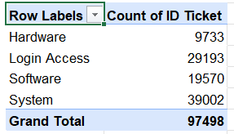

Question 5: How many tickets has each agent handled?

Solution:

Final Answer (if any):
Here is the result of the workload on agents -  A. Trejo | 1949
Alberto Casillas | 1974
Alberto Gastelum | 1889
Aldo Carrillo | 1966
Alfonso Barraza | 1984
Alfredo Barreras | 1920
Armando Sierra | 1890
Aurelio Tanori | 2027
Barbara Grijalva | 2003
Barraza Alberto | 1988
Darwin E. | 1945
Diana Rojo | 1927
Eduardo Luna | 1920
Elena Velez | 2021
Enrique Montiel | 1938
Estuardo Ocaño | 1935
EstuardoTorres | 1942
Eva Cardenas | 1943
Flores Sierra | 1963
Galindo Guadalupe | 1991
Griselda Galindo | 1856
Guadalupe Hernandez | 1915
Guadalupe Torrico | 1987
Guadalupe Villanueva | 1958
Isela Leyva | 1968
Javier D. | 1897
Jesus Contreras | 2026
Jesus Pacheco | 1931
JesusGrajeda | 1968
Leon Lourdes | 1961
Lopez Moran. | 1956
Lorena | 1966
Luis Arguello | 1929
Luis Torres | 1913
Marisol Piedrahita | 1960
Mata Lucero | 1969
Melinda | 2007
Miller Gaviria | 1892
Nurio Zepeda | 1946
Orci Carlos | 1926
Parra Luna | 1963
Ramon Macias | 1949
Reyna Santacruz | 1897
Rosa Olguin | 1950
Sandra Lujan | 1906
Segura Garcia | 1931
Silvia Morales | 1974
Velasquez Jose | 1949
Willyberto Gonzales | 2000
Yomaira Agudelo | 1933

Approach (if any):
Created Pivot Table with Agent Name in rows and Count of Ticket ID in values.

Charts & Tables (if any):

Question 6: How can you extract the domain from the email addresses in the IT Agents sheet?

Solution:

Final Answer (if any): fp20analytics
Formula -
=MID(C2, FIND("@", C2) + 1, FIND(".", C2, FIND("@", C2)) - FIND("@", C2) - 1)
Approach (if any):
To extract the domain name from the email addresses, I used the MID and FIND functions to extract the text between the @ symbol and the first dot after it, giving the domain name without the extension.
Charts & Tables (if any):

Question 7: How can you find the full name of an agent given their Agent ID?

Solution:

Final Answer (if any):
The full name can be extract by xlookup function.
Formula -
=XLOOKUP(E2,'IT Agents'!A:A,'IT Agents'!B:B)
Approach (if any):
Applied xlookup formula in main data sheet then extract the agent’s name from IT AGENTS SHEET

Charts & Tables (if any):

Question 8: What is the count of each issue type (e.g., IT Error, IT Request)?

Solution:

Final Answer (if any):
Count of each issue type -
IT Error – 24278
IT Request - 73220

Approach (if any):
Created a Pivot Table using the dataset. Kept Issue Type in Rows and Count of ID Ticket in Values.

Charts & Tables (if any):
Issue Type Count Pivot Table
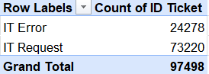

Question 9: What is the average resolution time for tickets?

Solution:

Final Answer (if any):
The average resolution time for tickets is 4.55 Days.

Approach (if any):
Using the Resolution Time (Days) column from the dataset while
Applying Excel’s AVERAGE() function to calculate the mean resolution time.
Formula -
=AVERAGE(range_of_resolution_time)

Charts & Tables (if any):

Question 10: How has the volume of tickets changed over time?

Solution:

Final Answer (if any):

The volume of tickets has been consistently increasing over the years, from 13,051 tickets in 2016 to 29,088 in 2020, showing a clear upward trend.

Approach (if any):

To analyse how ticket volume changed over time, I created a pivot table using the
Fecha column grouped by Year and Month. I then created a line chart to visualize
the trend over time.

Charts & Tables (if any):
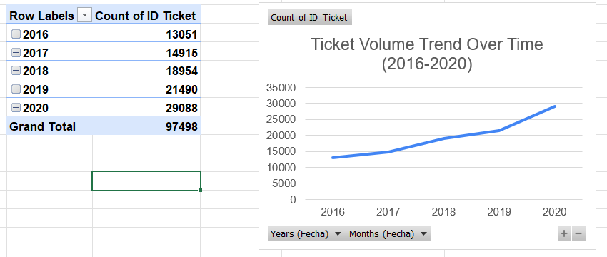

Question 11: What is the average age of the IT agents?

Solution:

Final Answer (if any):
The average age of the IT Agents is 41.4 years.

Approach (if any):
To calculate the average age of IT Agents accurately, the AVERAGE function was applied directly on the IT Agents sheet where each agent appears only once. This avoids the distortion caused by averaging at the ticket level, where agents with more tickets would be weighted more heavily. The age of each agent was derived from their Year of Birth using YEAR(TODAY()) - Year of Birth, and then AVERAGE was applied on the resulting age values.

Charts & Tables (if any):

Question 12: Is there a correlation between the severity of issues and the resolution time?

Solution:

Final Answer (if any):
The correlation value is -0.04, which indicates a very weak negative correlation between severity and resolution time, meaning severity has almost no impact on how long it takes to resolve a ticket.
Approach (if any):
To find the correlation between severity and resolution time, I first extracted the numeric severity value from the Severity column using the VALUE and MID functions. Then I used the CORREL function to calculate the correlation between numeric severity and resolution time in days.
Formula – 1
=VALUE(MID(I2,1,1))
Formula – 2
=CORREL(J2:J97499, K2:K97499)
Charts & Tables (if any):

Question 13: How many categorical columns are there in the data? [Search about categorical and continuous data, and try to answer this question]

Solution:

Final Answer (if any):
There are 9 categorical columns in the dataset.

Approach (if any):

Charts & Tables (if any):

SUBJECTIVE QUESTIONS

Question 1: If there is an investment, should it be used to hire more IT agents, improve training programs, or upgrade ticket management software?

Analysis: Perform a cost-benefit analysis using ticket resolution and satisfaction metrics.

Solution:

Approach:
To perform a cost-benefit analysis, I created a pivot table from the Cleaned IT Tickets sheet showing the Average Resolution Time and Average Satisfaction Rate by Request Category. Based on the real data, I built a comparison table for the three investment options and created a bar chart to visualize the findings.
Charts & Tables:
Cost-Benefit Analysis of Investment Options by Request Category
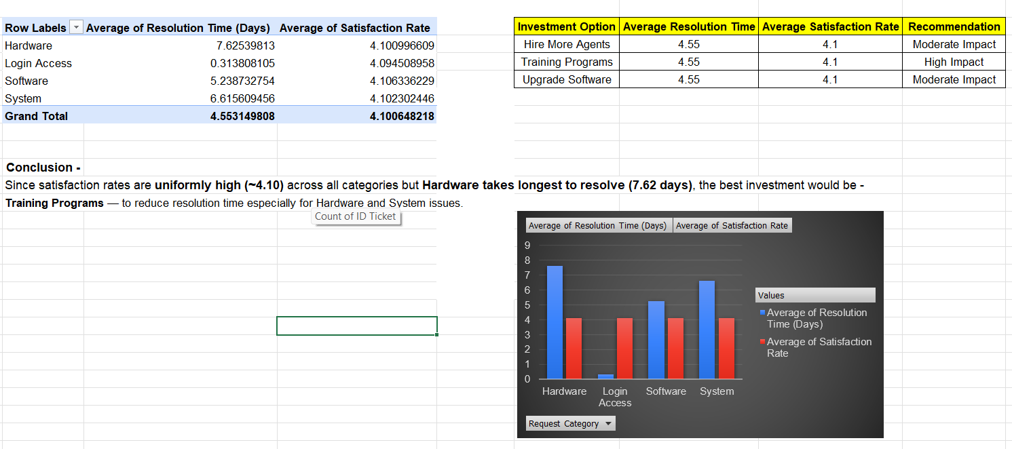

Insights:
- Hardware category has the highest average resolution time (7.62 days), indicating agents need better training for complex issues.
- Login Access resolves fastest (0.31 days), showing it is well managed.
- Satisfaction rates are consistently high (~4.10) across all categories.
- Resolution time varies significantly across categories, suggesting a training gap.
Recommendations:
Invest in Training Programs because the data shows resolution time is the biggest pain point, especially for Hardware and System issues. Training programs will improve agent performance, reduce resolution time, and maintain the already high satisfaction rates at the lowest cost.

Question 2: Which agents need additional training based on their performance metrics?

Analysis: Identify agents with the lowest satisfaction ratings and longest resolution times.

Solution:

Approach:
A pivot table was created using Agent Name with Average Satisfaction Rate and Average Resolution Time (Days). A Satisfaction-to-Resolution Ratio was then computed for each agent by dividing Average Satisfaction Rate by Average Resolution Time (Days). Agents falling in the bottom 30% of the ratio were flagged as "Yes" for additional training, ensuring the flagging is data-driven rather than based on simple thresholds.

Charts & Tables:
Agents Need Additional Training
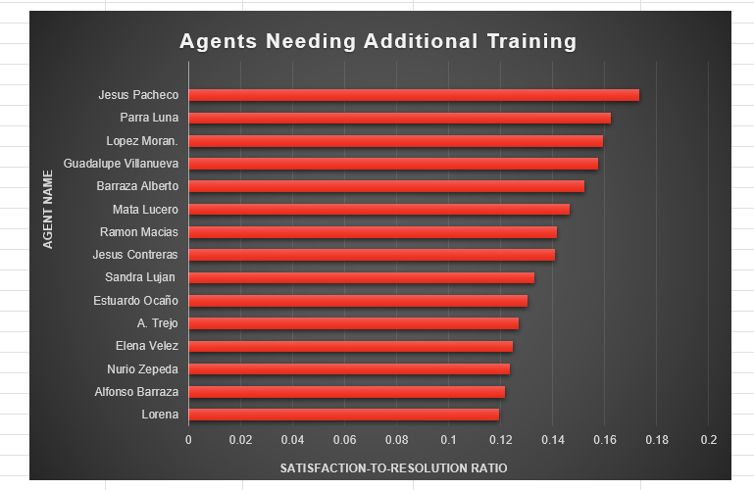
Insights:
- Lorena, Alfonso Barraza, and Nurio Zepeda have the lowest Satisfaction-to-Resolution Ratio, making them the highest priority for training.
- A total of 15 agents were flagged as needing additional training based on their ratio values.
- A lower ratio reflects both poor satisfaction scores and longer resolution times combined into a single performance metric.
Recommendations:
Provide targeted training to the 15 flagged agents to improve satisfaction scores and reduce resolution time. Priority should be given to Lorena, Alfonso Barraza, and Nurio Zepeda as they have the lowest Satisfaction-to-Resolution Ratio.

Question 3: Do certain categories of requests have longer resolution times?

Analysis: Analyze the resolution times by request category.

Solution:

Approach:
A pivot table was created with Request Category as rows and the average of Resolution Time (Days) as the value field. A bar chart was used to compare the average resolution time across categories.

Charts & Tables:
Resolution Time by Request Category
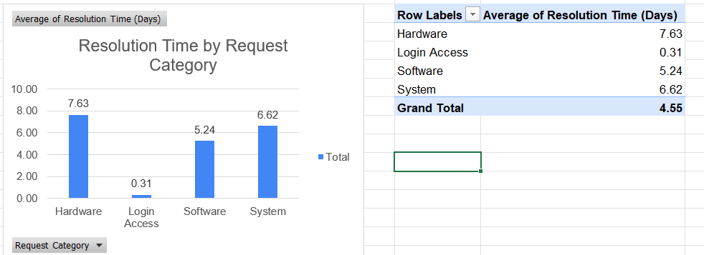
Description-
This chart shows the average Resolution Time (Days) for each Request Category.

Insights:
- Some request categories consistently take longer to resolve.
- Categories with higher resolution times likely involve more complex issues.
- These categories may require specialized skills or additional resources.

Recommendations:
Focus on the categories with the highest average resolution times by providing targeted training, creating standard procedures, and allocating experienced agents to handle these requests.

Question 4: How effective are the current software tools in managing IT tickets?

Analysis: Evaluate performance metrics before and after the implementation of new tools.

Solution:

Approach:
A pivot table was created using Year with Average Resolution Time (Days), Average Satisfaction Rate and Count of ID Ticket to track yearly trends. Additionally, a Severity-to-Priority alignment check was performed by creating a pivot table with Severity in rows and Priority in columns to evaluate how effectively tickets are being prioritized.
Charts & Tables:
Year-wise Resolution Time Trend,
Year-wise Satisfaction Rate Trend,
Severity-to-Priority Alignment
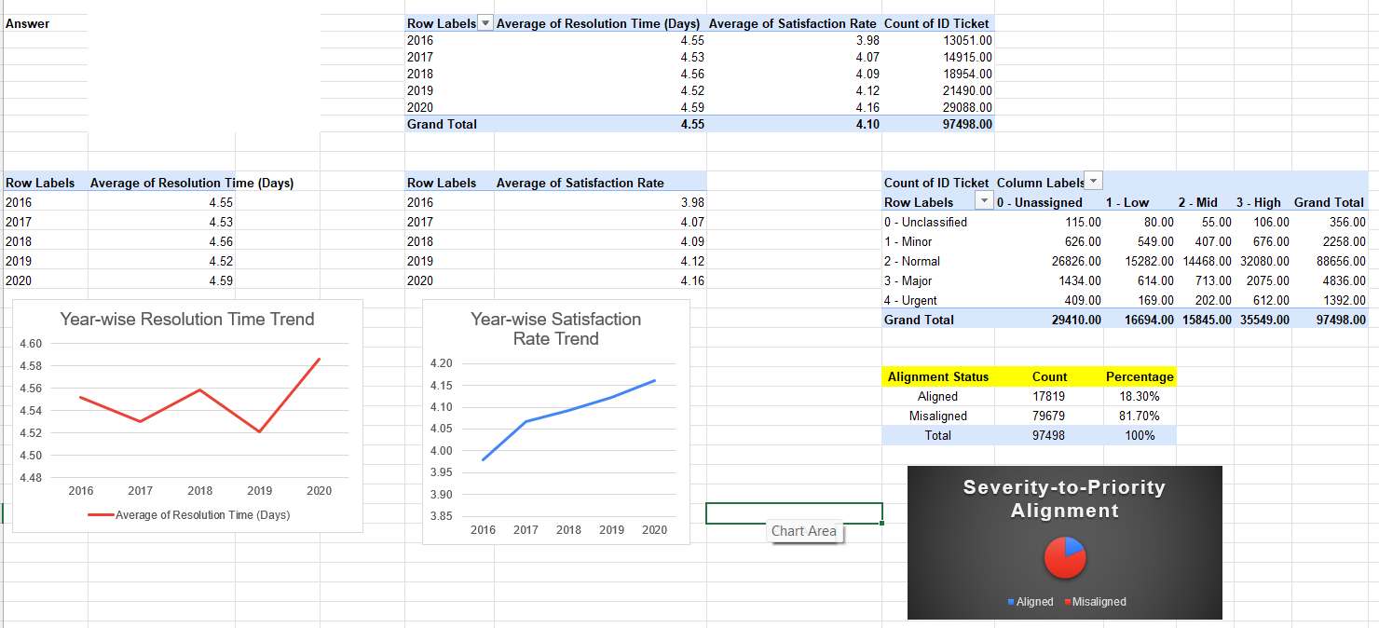
Description -
These charts display yearly trends in resolution time and satisfaction rate, along with a pie chart showing the percentage of correctly aligned vs misaligned tickets.

Insights:
- Satisfaction Rate improved steadily from 3.98 (2016) to 4.16 (2020) indicating improving tool effectiveness.
- Resolution Time remained relatively stable between 4.52 to 4.59 days across all years.
- Only 18.3% of tickets have correct Severity-to-Priority alignment while 81.7% are misaligned indicating tools are not effectively prioritizing tickets.
Recommendations:
Improve the ticket management tools to enforce automatic severity-to-priority alignment to reduce the 81.7% misalignment rate and further improve resolution time and satisfaction scores.

Question 5: How has the performance of the IT support team changed over time (e.g., monthly or quarterly)?

Analysis: Trend analysis using time series charts.

Solution:

Approach:
Quarterly IT ticket data from 2016–2020 was analyzed across three metrics — Resolution Time, Satisfaction Rate, and Ticket Volume — to identify performance trends over time.

Charts & Tables:
Quarterly Satisfaction Rate Trend Chart
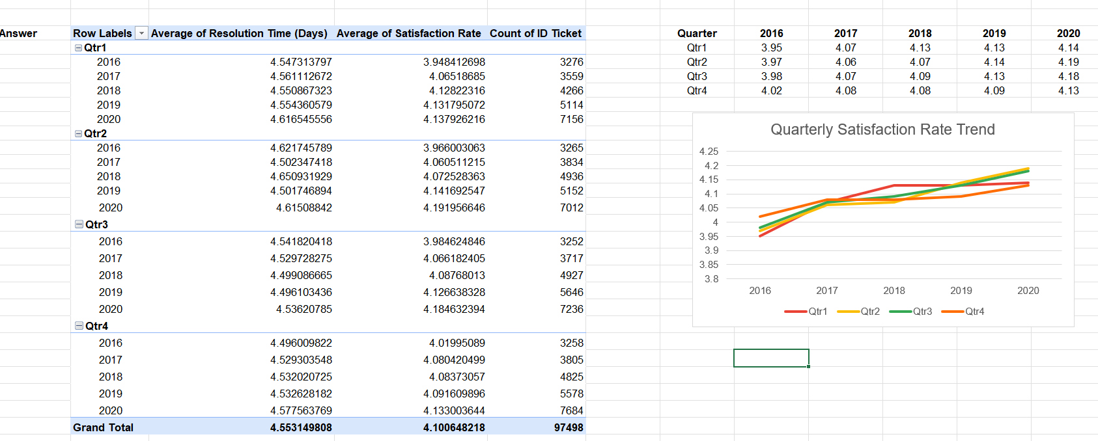
Description-
Pivot table showing average resolution time, satisfaction rate, and ticket count broken down by quarter and year. The line chart tracks satisfaction rate trends across all four quarters from 2016–2020.
Insights:
- Satisfaction rate improved consistently across all four quarters from 2016 to 2020, rising from ~3.95–4.02 to ~4.13–4.19.
- Qtr2 consistently shows the highest satisfaction rate each year, while Qtr1 tends to be the lowest.
- Total ticket volume nearly doubled across all quarters, from ~3,252–3,276 in 2016 to ~7,012–7,236 in 2020.
- Resolution time remained largely flat (~4.49–4.65 days) with no meaningful quarterly improvement.

Recommendations:
- Investigate what drives higher satisfaction in Qtr2 and replicate those practices across other quarters.
- Address the stagnant resolution time by introducing queue management or workload balancing tools.
- Plan for capacity increases each year given the consistent volume growth across all quarters.

Question 6: If we invest more on tech (Hardware, software, etc), do you think it will improve the ticket resolution times and employee satisfaction?

Analysis: Use historical data to project potential improvements.

Solution:

Approach:.
Analysed ticket data by Request Category to compare average resolution time, satisfaction rate, and ticket volume across Hardware, Login Access, Software, and System categories.

Charts & Tables:
- Table 1 shows category-wise average resolution time and satisfaction rate
- Table 2 shows year-wise ticket count per category from 2016 to 2020
- Chart 1 visually compares resolution time and satisfaction rate by category
- Chart 2 shows the growing ticket trend across all categories over the years
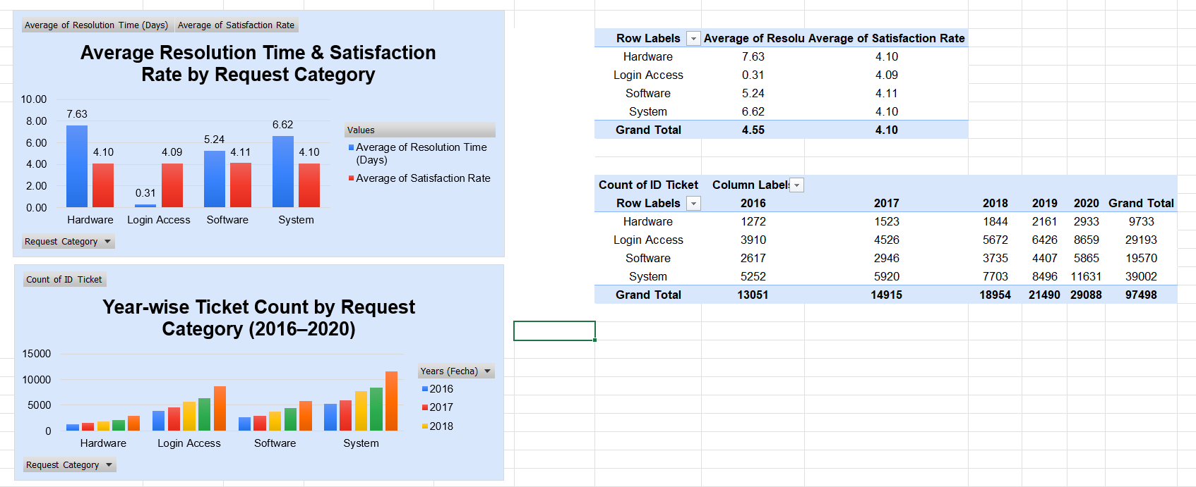
Insights:
- Hardware takes the longest to resolve (7.63 days) followed by System (6.62 days)
- Login Access resolves fastest (0.31 days)
- Satisfaction rate is nearly identical across all categories (~4.10) regardless of resolution time
- Ticket volume is consistently increasing every year across all categories especially System
Recommendations:
- Invest in tech infrastructure for Hardware and System categories as they have the highest resolution times
- Since satisfaction scores are similar across categories, tech investment alone may not boost satisfaction — process and training improvements should also be considered
- Monitor growing ticket volume in System category as it may require additional resources

Question 7: What are the key performance metrics for IT agents, and how can they be improved, do we need to fire any agents?

Analysis: Define and analyze metrics such as average handling time, satisfaction scores, and number of tickets resolved.

Solution:

Approach:
Agent-level data was analysed across Tickets Resolved, Resolution Time, and Satisfaction Rate to evaluate individual performance and identify outliers.
Charts & Tables:
Agent-wise Performance Chart
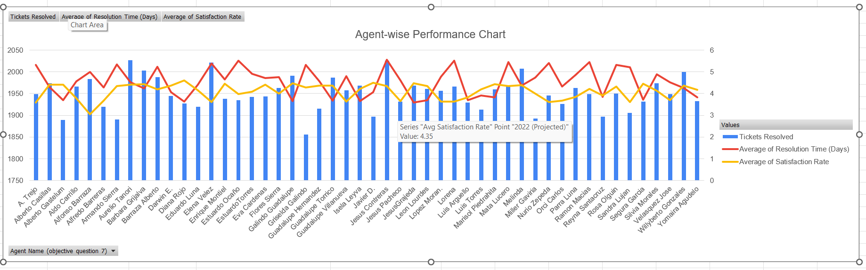
Description-
Combined bar and line chart showing each agent's tickets resolved, average resolution time, and satisfaction rate.
Insights:
- Most agents resolved 1,900–2,050 tickets, showing consistent workload distribution.
- Resolution time varies significantly — some agents spike above 5.5 days while others stay near 4 days.
- Satisfaction rate remains stable at 4.0–4.5 across most agents with few outliers.

Recommendations:
- Agents with consistently high resolution times should receive coaching before any termination decision.
- Use top performers as benchmarks for peer training.
- Set formal KPI thresholds (e.g., resolution time above 5.5 days) as performance review triggers.

Question 8: How do employee demographics (e.g., department, seniority) impact satisfaction and ticket outcomes?

Analysis: Segment analysis using filters and pivot tables.

Solution:

Approach:
Agent Age from the IT Tickets sheet was used to derive seniority groups (Young: 20–30, Mid: 31–40, Senior: 41–50) using nested IF formula. A pivot table was created to segment ticket outcomes by age group and a clustered column chart was built to visualize the impact of employee demographics on resolution time and satisfaction rate.
Charts & Tables:
Employee Demographics Impact on Ticket Outcomes
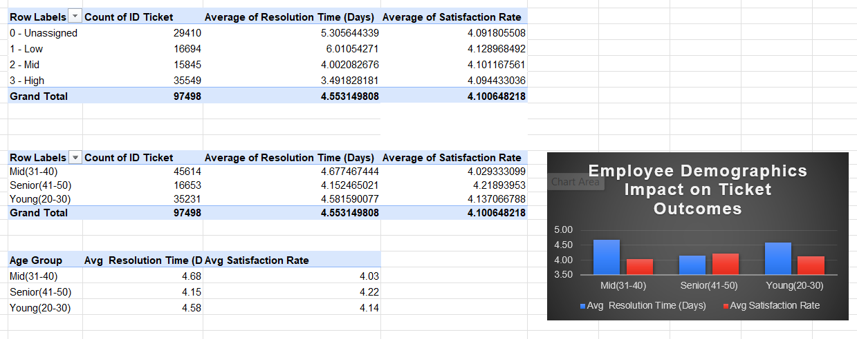
Description-
Ticket data was segmented by employee seniority (age group) derived from Agent Age column using nested IF formula. The pivot table and chart show how different age groups perform in terms of ticket volume, resolution efficiency and satisfaction outcomes.
Insights:
- Senior agents (41–50) resolve tickets fastest at 4.15 days and have the highest satisfaction rate of 4.22 indicating experience positively impacts performance
- Mid-level agents (31–40) handle the highest ticket volume (45,614) but take the longest to resolve at 4.68 days with the lowest satisfaction rate of 4.03
- Young agents (20–30) show balanced performance with resolution time of 4.58 days and satisfaction rate of 4.14
- Seniority is positively correlated with both resolution efficiency and satisfaction outcomes
Recommendations:
- Pair Mid-level agents with Senior agents for mentorship to improve resolution speed
- Provide targeted training for Mid-level agents as they show lowest satisfaction rate despite handling the most tickets
- Leverage Senior agents for complex or high priority tickets given their efficiency and higher satisfaction scores
- Monitor Young agents closely and provide early career support to maintain their balanced performance

Question 9: Identify the trends for IT support operations based on ticket volumes and satisfaction, and mention the peak and stable times?

Analysis: Use pivot tables and charts to identify peak and off-peak hours.

Solution:

Approach:
Quarterly ticket volume and satisfaction rate were analyzed to identify peak and stable periods.
Charts & Tables:
IT Support Trends by Quarter
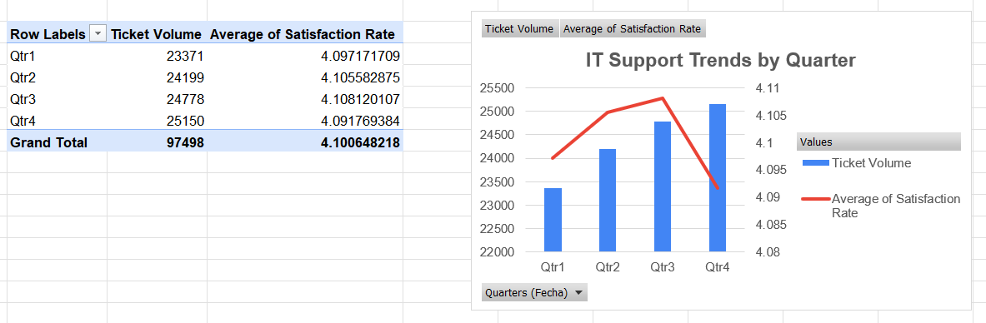
Description-
Pivot table and chart showing ticket volume and satisfaction rate across four quarters.
Insights:
- Qtr4 is peak period — highest volume (25,150) and lowest satisfaction (4.09).
- Qtr1 is most stable — lowest volume (23,371) with steady satisfaction.
- Satisfaction peaks in Qtr3 (4.11) despite high volume, indicating efficient mid-year handling.
Recommendations:
- Increase staffing in Qtr4 to manage peak demand.
- Use Qtr1 low-demand period for training and system upgrades.
- Replicate Qtr3 practices to sustain satisfaction during high-volume periods.

Question 10: What metrics should be included in the final dashboard to provide a comprehensive view of call center performance and guide investment decisions?

Solution:

Approach:
Here are the key metrics to include in the dashboard-
- Total Ticket Volume — overall and by year/quarter
- Average Resolution Time (Days) — overall and by agent
- Average Satisfaction Rate — overall and by quarter
- Tickets by Priority — Unassigned, Low, Mid, High
- Agent Performance — tickets resolved, resolution time, satisfaction per agent
- Quarterly Ticket Trend — volume and satisfaction by Qtr1–Qtr4
- Year-over-Year Growth — ticket volume and satisfaction rate change
- Projected vs Actual — resolution time and satisfaction rate targets
Charts & Tables:

Insights:

Recommendations:

