|  |  |  |  |  |  |
| --- | --- | --- | --- | --- | --- |
| DATASET | METHOD | DATA PREPROCESSING | REGULARISATION | ACCURACY | ANALYSIS |
| EXAM DATASET | LOGISTIC REGRESSION | Normalization | None | ~90% | The dataset was linearly separable, so logistic regression worked well. Computation time was small. |
| EXAM DATASET | LOGISTIC REGRESSION | Normalization | L2 | ~88% | Since the model was linear, regularization was not very effective, and accuracy was similar to non-regularized one. |
| MICROCHIP DATASET | LOGISTIC REGRESSION | None | None | ~80% | The microchip dataset was non linear, so used polynomial curve fitting.Without regularization, overfitting happened, so got less accuracy for test dataset |
| MICROCHIP DATASET | LOGISTIC REGRESSION | None | L2 | ~90% | With regularization’, overfitting was reduced. So was able to get accuracy similar to training dataset. |

PLOTS:

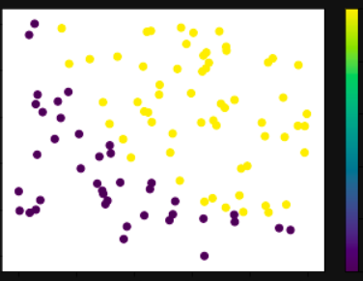

Scatterplot for the Exam Dataset

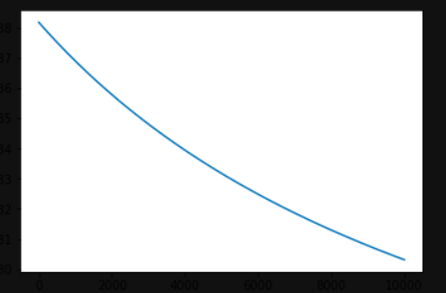

Loss plot for Exam Dataset

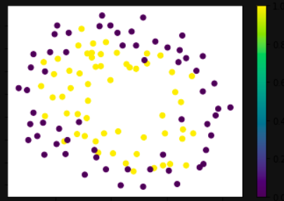

Scatterplot for Microchip Dataset

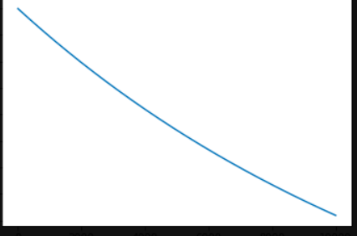

Loss function for Microchip Dataset