ANALYSIS TABLE :

|  |  |  |  |  |
| --- | --- | --- | --- | --- |
| METHOD | DATA PREPROCESSING | REGULARISATION | ACCURACY | ANALYSIS |
| LINEAR REGRESSION | None | None | - | Explode in gradients due to high value of one feature |
| LINEAR REGRESSION | Normalization | None | ~85% | After normalisation was able to fit a linear curve to the data without exploding gradients |
| LINEAR REGRESSION | Normalization | L2 (lambda = 10) | ~85% | With l2 normalization and small lambda(10), model was similar to non regularized one. |
| LINEAR REGRESSION | Normalization | L2 (lambda = 100) | ~82% | With lambda=100, model accuracy was little reduced. |
| LINEAR REGRESSION | Normalization | L2 (lambda = 1000) | ~60% | With l2 normalization, and high lambda(1000) accuracy was considerably reduced. |
| LOCALLY WEIGHTED REGRESSION | Normalization | None | ~75% | Almost similar accuracy to regularized one, but had to fit curve every time of prediction, so the computation time was really slow |
| Normal Equation | None | L2 (lambda=100) | ~80 | With regularisation, got very slight difference in accuracy. Computation time was very fast as the dataset was small. |

PLOTS:

Scatter Plot for dataset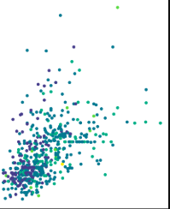

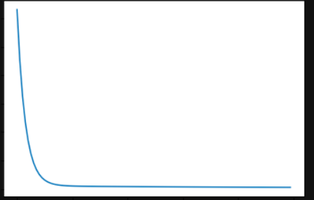

Loss curve (almost similar for each one)