**Exception and Hierarchy**

**In case of Date mutable object**

**In case of List<String>**

**For User defined object such as Address here**

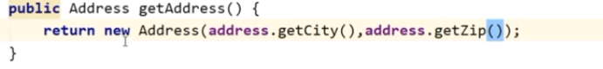

**Here second object creation is preferable,it’s example of runtime polymorphism**

