**REST:** Representational state transfer

**Benefits of REST API:**

1. Simple and Standardize
2. Scalable and Stateless
3. High performance are resources

**http://icecream.com/API/Flavours**

Cloud based server

Web Application/page

RRE request using REST API

Responds in form of JSON/

**Requests from web app/page are sent in form of CRUD** **and be mapped with corresponding HTTP methods:**

**C**reate -> Post (HTTP method)

**R**ead -> Get (HTTP method)

**U**pdate -> Put (HTTP method)

**D**elete-> Delete (HTTP method)

**Basic structure of Request sent to Cloud and respond is received in JSON format**



1. **Get Request: Get Flavors**

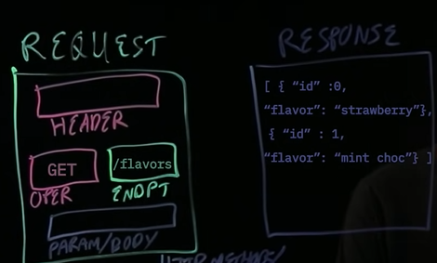

1. **Update=> update flavors**

1. Create: Create new flavor:

