Dynamic programming: DP is a methos which solves the problem by breaking down it to smaller sub problems.
We solve these subproblems and stores its solution so that next time, when we hit same sub problem, we have the solution ready.
A problem will be solved by DP only if it follows below approach:
- Optimal Substructure: A problem is said to have an optimal substructure, if an optimal solution can be constructed from optimal solutions of its sub problems.
- Overlapping subproblems: A problem is said to have an overlapping subproblems, if the problem can be broken down into subproblems which are reused several times or a recursive algorithm for the problem solves the same subproblem over and over rather than always generating new subproblems.
Normal/Naïve approach takes time complexity of (2^n)
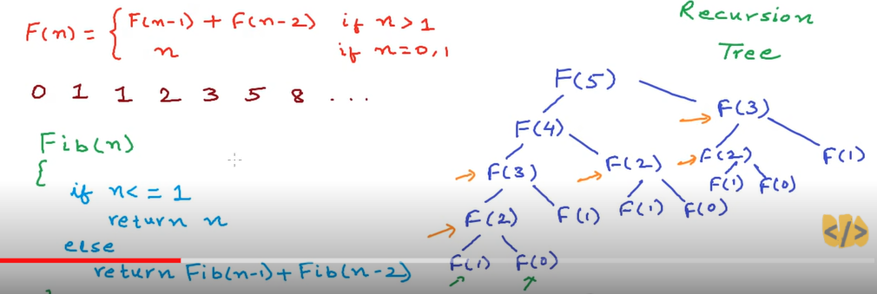
Algorithm using memorization:
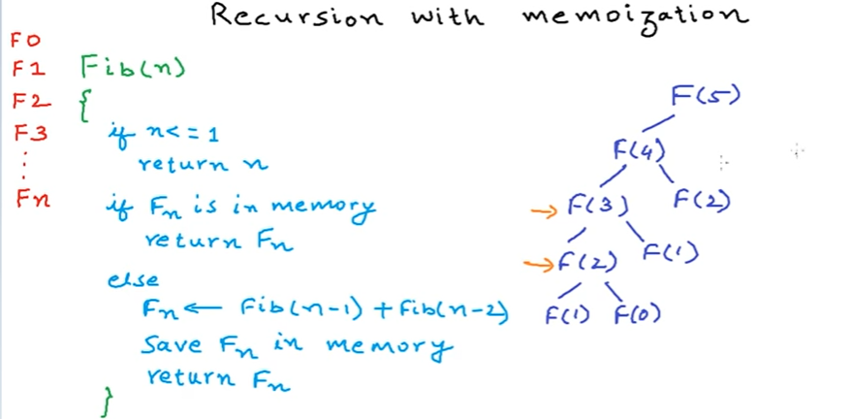

Kadane's alog: Finds maximum subarray sum in O(n) complexity.
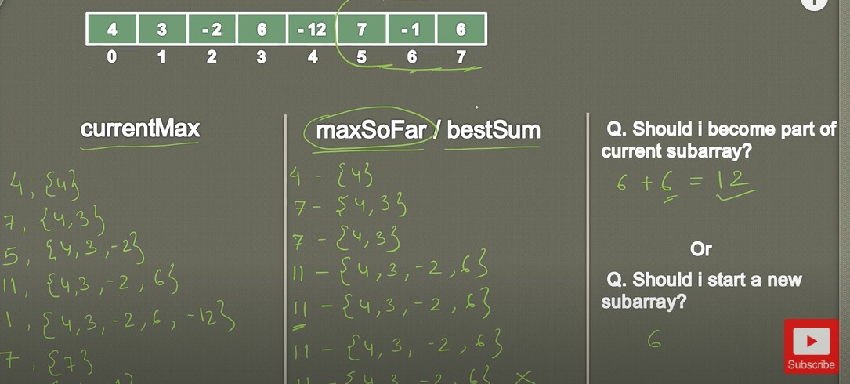
Solution:
int maxSubArray(vector<int>& nums) {

int currentSum =nums[0], totalSum = nums[0];

for(int i=1; i<nums.size(); i++) {

//Current max sum is either the current element OR current element + Previous Maximum subarray)
currentSum = max(nums[i], currentSum+nums[i]);

//If the current maximum array sum is greater than the global total. Update it
totalSum = max(totalSum, currentSum);
}
return totalSum;
}

