**MongoDB CRUD Operations**

**CRUD Operations**(Create, Read, Update, and Delete)are the basic set of operations that allow users to interact with the MongoDB server.

As we know, to use MongoDB we need to interact with the MongoDB server to perform certain operations like entering new data into the application, updating data into the application, deleting data from the application, and reading the application data.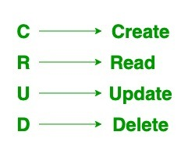

In this article, we will learn all **4 major operations**– **CREATE**, **READ**, **UPDATE**, and **DELETE**that form the CRUD operations in MongoDB.

**Perform CRUD Operations in MongoDB**

Now that we know the components of the CRUD operation, let’s learn about each individual operation in MongoDB. We will know what each operation does, and the methods to perform these operations in MongoDB.

We will create, read, update and delete documents from MongoDB server.

**1. Create Operations**

The **create or insert operations** are used to insert or add new documents in the collection. If a collection does not exist, then it will create a new collection in the database.

You can perform, create operations using the following methods provided by the MongoDB:

| **Method** | **Description** |
| --- | --- |
| **db.collection.insertOne()** | It is used to insert a single document in the collection. |
| **db.collection.insertMany()** | It is used to insert multiple documents in the collection. |
| **db.createCollection()** | It is used to create an empty collection. |

**Create Operations Example**

Let’s look at some examples of the Create operation from CRUD in MongoDB.

**Example 1:**In this example, we are inserting details of a single student in the form of document in the student collection using **[db.collection.insertOne() method](https://www.geeksforgeeks.org/mongodb-insertone-method-db-collection-insertone/" \t "_blank)**.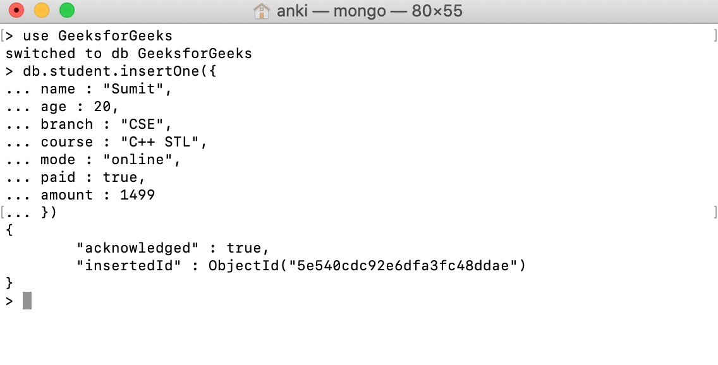**Example 2:**In this example, we are inserting details of the multiple students in the form of documents in the student collection using **[db.collection.insertMany() method](https://www.geeksforgeeks.org/mongodb-insertmany-method-db-collection-insertmany/" \t "_blank)**.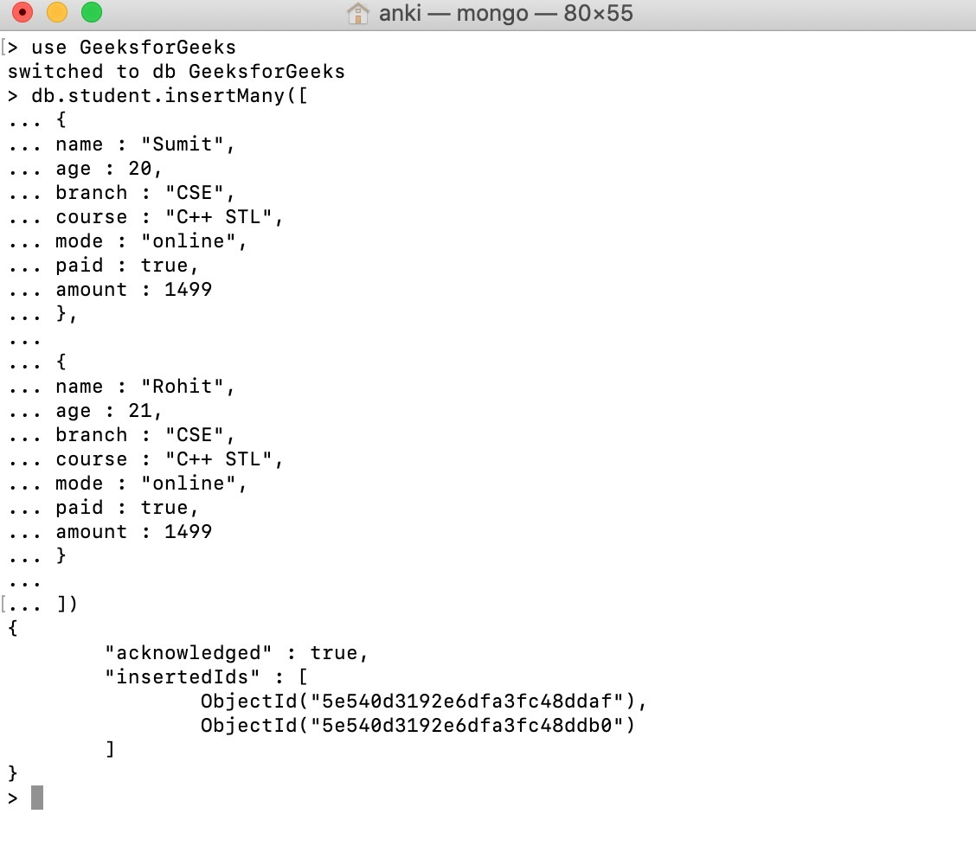

**2. Read Operations**

The Read operations are used to retrieve documents from the collection, or in other words, read operations are used to query a collection for a document.

You can perform read operation using the following method provided by the MongoDB:

| **Method** | **Description** |
| --- | --- |
| **db.collection.find()** | It is used to retrieve documents from the collection. |

**Note:** pretty() method is used to decorate the result such that it is easy to read.

**Read Operations Example**

Let’s look at some examples of Read operation from CRUD in MongoDB.

**Example:**In this example, we are retrieving the details of students from the student collection using **[db.collection.find()](https://www.geeksforgeeks.org/mongodb-db-collection-find-method/" \t "_blank)**method.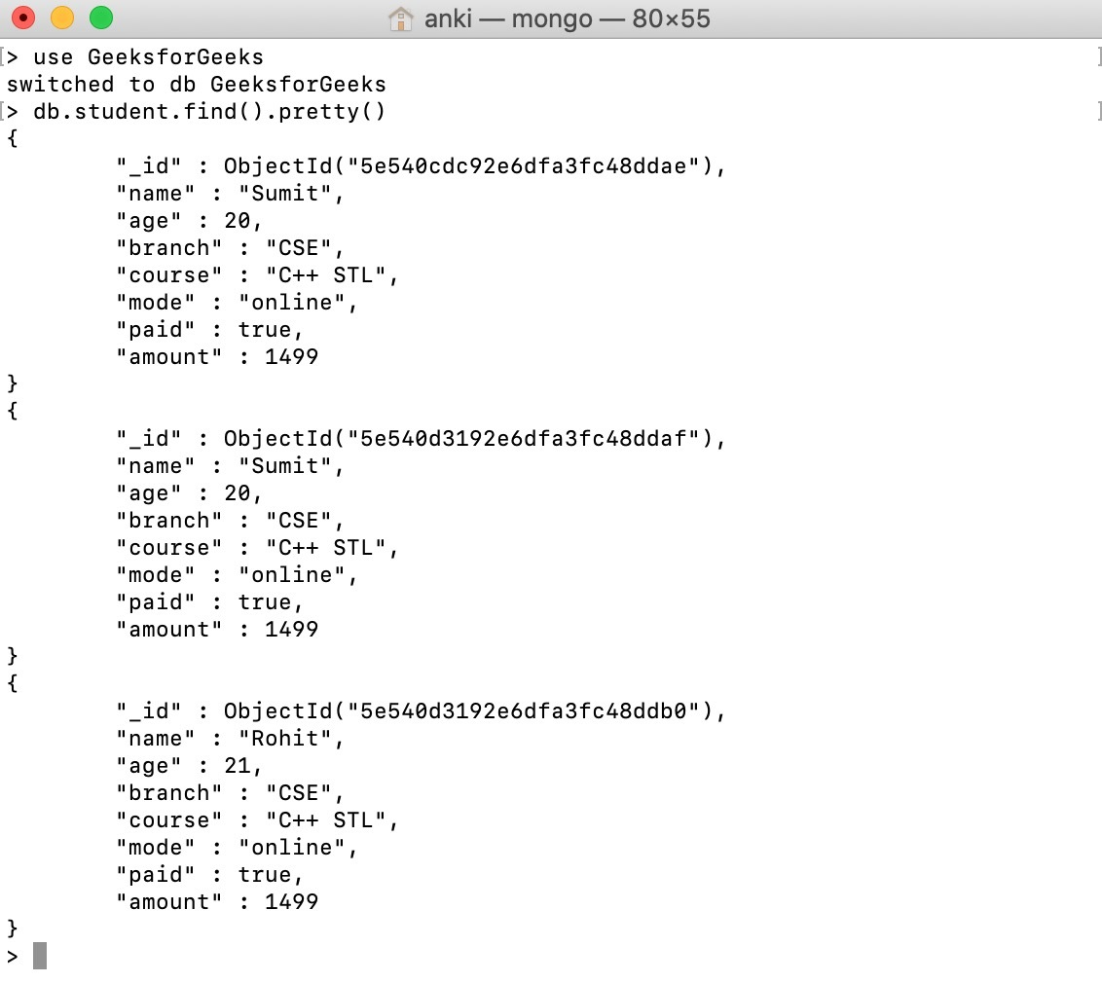

**3. Update Operations**

The update operations are used to update or modify the existing document in the collection. You can perform update operations using the following methods provided by the MongoDB:

| **Method** | **Description** |
| --- | --- |
| **db.collection.updateOne()** | It is used to update a single document in the collection that satisfy the given criteria. |
| **db.collection.updateMany()** | It is used to update multiple documents in the collection that satisfy the given criteria. |
| **db.collection.replaceOne()** | It is used to replace single document in the collection that satisfy the given criteria. |

**Update Operations Example**

Let’s look at some examples of the update operation from CRUD in MongoDB.

**Example 1:**In this example, we are updating the age of Sumit in the student collection using **[db.collection.updateOne()](https://www.geeksforgeeks.org/mongodb-updateone-method-db-collection-updateone/" \t "_blank)**method.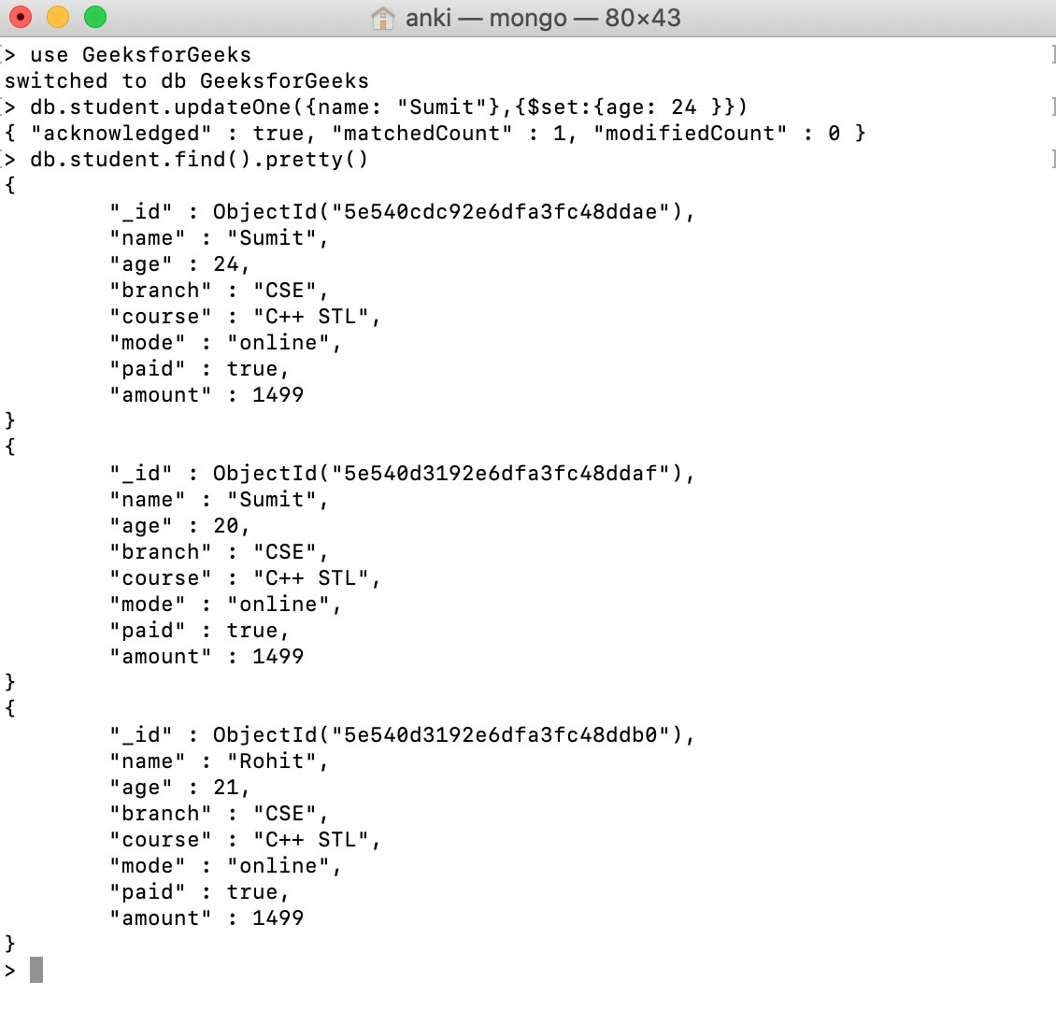**Example 2:**In this example, we are updating the year of course in all the documents in the student collection using **[db.collection.updateMany()](https://www.geeksforgeeks.org/mongodb-updatemany-method-db-collection-updatemany/" \t "_blank)**method.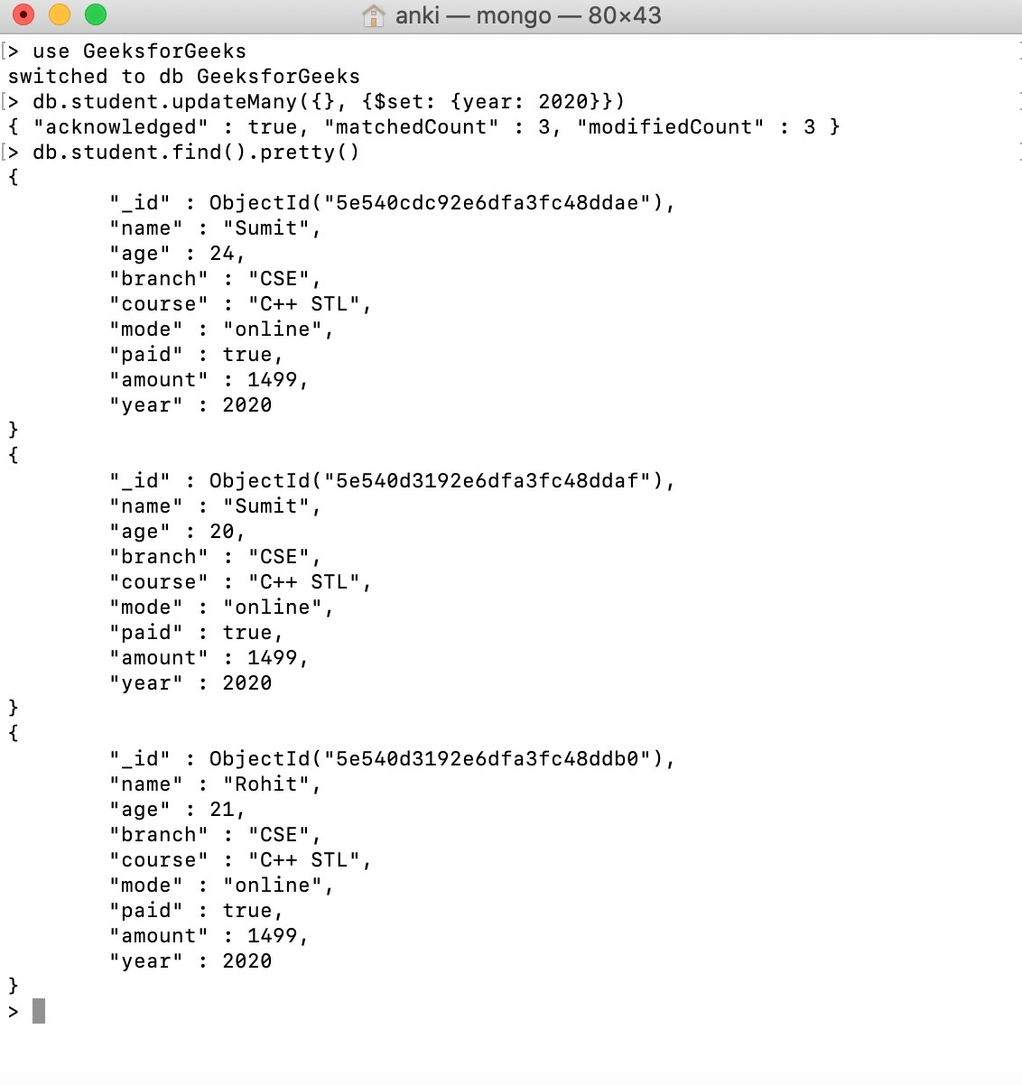

**4. Delete Operations**

The delete operation are used to delete or remove the documents from a collection. You can perform delete operations using the following methods provided by the MongoDB:

| **Method** | **Description** |
| --- | --- |
| **db.collection.deleteOne()** | It is used to delete a single document from the collection that satisfy the given criteria. |
| **db.collection.deleteMany()** | It is used to delete multiple documents from the collection that satisfy the given criteria. |

**Delete Operations Examples**

Let’s look at some examples of delete operation from CRUD in MongoDB.

**Example 1:**In this example, we are deleting a document from the student collection using **[db.collection.deleteOne()](https://www.geeksforgeeks.org/mongodb-db-collection-deleteone/" \t "_blank)**method.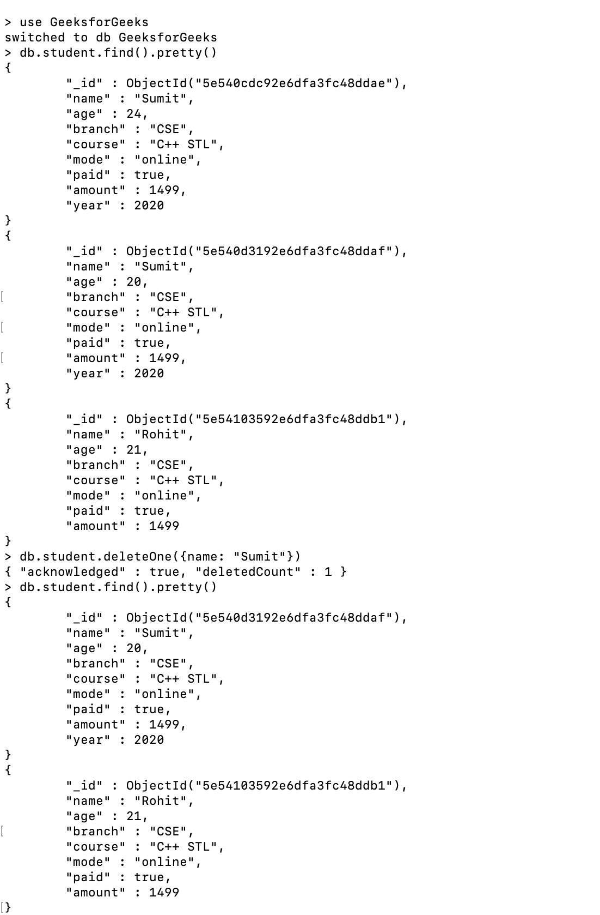**Example 2:**In this example, we are deleting all the documents from the student collection using **[db.collection.deleteMany()](https://www.geeksforgeeks.org/mongodb-delete-multiple-documents-using-mongoshell/" \t "_blank)**method.