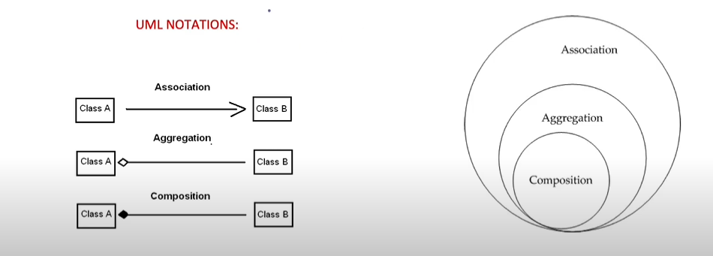
Association(By value): I have a relationship with an object. Foo uses Bar.
class Bar {};
class Foo {
void fun (Bar b)
};
-------------------------------------------------------------------------------------------------------------------------------------------------------------------
Aggregation(By reference): Type of association. I have an object which I have borrowed from someone else.
Independent. One object will carry reference of another object. One object destroy, other will not destroy. weak relationship.
Example: Person object has reference of Car object. If person object is destroyed, Car object will not be destroyed.
class Car
{ int model;
string name;
public:
Car(string name, int model): name(name), model(model){}
void printCarInfo()
{
cout<<model<<name<<endl;
}
};
class Person
{
string name;
Car *mycar;
public:
Person() = default;
Person(string name, Car* mycar):name(name), mycar(mycar)
{
}
};
int main()
{
Car c ("BMW", 134);
Person *p = new Person("Ankit", &c);
delete p;
c.printCarInfo();
return 0;
}
------------------------------------------------------------------------------------------------------------------------------------------------------------------
Composition(composed inside other class): Type of association. Dependent. One object will carry another object as a value. One object destroy, other will also destroy. Strong relationship.
Example: Car object has Engine object. If Car object is destroyed, Engine object will be destroyed.
#include <iostream>
#include <string>
using namespace std;
class Engine
{
int power;
public:
Engine(int power):power(power)
{
cout<<"Engine object is created"<<endl;
}
~Engine()
{
cout<<"Engine object is destroyed"<<endl;
}
};
class Car
{
int model;
string name;
Engine eng;
public:
Car(string name, int model, Engine eng): name(name), model(model), eng(eng)
{
cout<<"Car object is created"<<endl;
}
~Car()
{
cout<<"Car object is destroyed"<<endl;
}
};
int main()
{
Engine e(10);
Car *c = new Car ("BMW", 134, e);
delete c;
return 0;
}
---------------------------------------------------------------------------------------------------------------------------------------------------------
Composition is has-a relationship while Inheritance is is-a relationship.

