***A tree*** is also one of the data structures that represent hierarchical data. Suppose we want to show the employees and their positions in the hierarchical form then it can be represented as shown below:

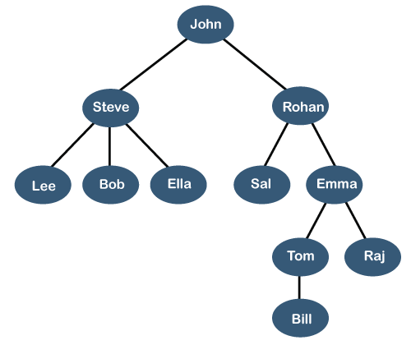

**Let's understand some key points of the Tree data structure.**

* A tree data structure is defined as a collection of objects or entities known as nodes that are linked together to represent or simulate hierarchy.
* A tree data structure is a non-linear data structure because it does not store in a sequential manner. It is a hierarchical structure as elements in a Tree are arranged in multiple levels.
* In the Tree data structure, the topmost node is known as a root node. Each node contains some data, and data can be of any type. In the above tree structure, the node contains the name of the employee, so the type of data would be a string.
* Each node contains some data and the link or reference of other nodes that can be called children.

**Some basic terms used in Tree data structure.**

Let us consider the tree structure, which is shown below:

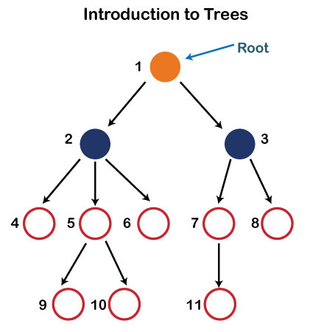

In the above structure, each node is labeled with some number. Each arrow shown in the above figure is known as a ***link*** between the two nodes.

* **Root:** The root node is the topmost node in the tree hierarchy. In other words, the root node is the one that doesn't have any parent. In the above structure, node numbered 1 is **the root node of the tree.** If a node is directly linked to some other node, it would be called a parent-child relationship.
* **Child node:** If the node is a descendant of any node, then the node is known as a child node.
* **Parent:** If the node contains any sub-node, then that node is said to be the parent of that sub-node.
* **Sibling:** The nodes that have the same parent are known as siblings.
* **Leaf Node:-** The node of the tree, which doesn't have any child node, is called a leaf node. A leaf node is the bottom-most node of the tree. There can be any number of leaf nodes present in a general tree. Leaf nodes can also be called external nodes.
* **Internal nodes:** A node has atleast one child node known as an ***internal***
* **Ancestor node:-** An ancestor of a node is any predecessor node on a path from the root to that node. The root node doesn't have any ancestors. In the tree shown in the above image, nodes 1, 2, and 5 are the ancestors of node 10.
* **Descendant:** The immediate successor of the given node is known as a descendant of a node. In the above figure, 10 is the descendant of node 5.

Properties of Tree data structure

* **Recursive data structure:** The tree is also known as a ***recursive data structure***. A tree can be defined as recursively because the distinguished node in a tree data structure is known as a ***root node***. The root node of the tree contains a link to all the roots of its subtrees. The left subtree is shown in the yellow color in the below figure, and the right subtree is shown in the red color. The left subtree can be further split into subtrees shown in three different colors. Recursion means reducing something in a self-similar manner. So, this recursive property of the tree data structure is implemented in various applications.  
  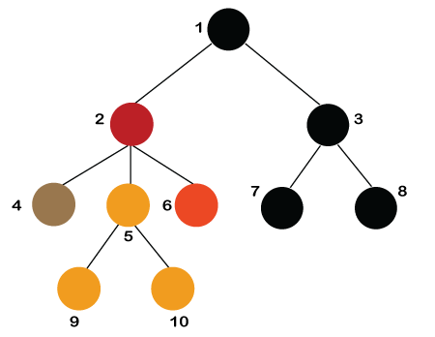
* **Number of edges:** If there are n nodes, then there would n-1 edges. Each arrow in the structure represents the link or path. Each node, except the root node, will have atleast one incoming link known as an edge. There would be one link for the parent-child relationship.
* **Depth of node x:** The depth of node x can be defined as the length of the path from the root to the node x. One edge contributes one-unit length in the path. So, the depth of node x can also be defined as the number of edges between the root node and the node x. The root node has 0 depth.
* **Height of node x:** The height of node x can be defined as the longest path from the node x to the leaf node.

Based on the properties of the Tree data structure, trees are classified into various categories.

The above structure can only be defined for the binary trees because the binary tree can have utmost two children, and generic trees can have more than two children. The structure of the node for generic trees would be different as compared to the binary tree.

Applications of trees

The following are the applications of trees:

* **Storing naturally hierarchical data:** Trees are used to store the data in the hierarchical structure. For example, the file system. The file system stored on the disc drive, the file and folder are in the form of the naturally hierarchical data and stored in the form of trees.
* **Organize data:** It is used to organize data for efficient insertion, deletion and searching. For example, a binary tree has a logN time for searching an element.
* **Trie:** It is a special kind of tree that is used to store the dictionary. It is a fast and efficient way for dynamic spell checking.
* **Heap:** It is also a tree data structure implemented using arrays. It is used to implement priority queues.
* **B-Tree and B+Tree:** B-Tree and B+Tree are the tree data structures used to implement indexing in databases.
* **Routing table:** The tree data structure is also used to store the data in routing tables in the routers.

Types of Tree data structure

**The following are the types of a tree data structure:**

* **General tree:** The general tree is one of the types of tree data structure. In the general tree, a node can have either 0 or maximum n number of nodes. There is no restriction imposed on the degree of the node (the number of nodes that a node can contain). The topmost node in a general tree is known as a root node. The children of the parent node are known as ***subtrees***.  
  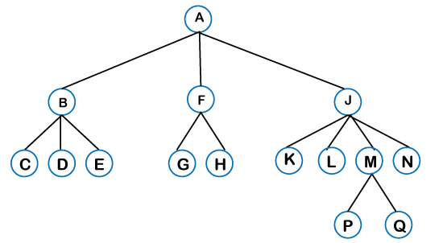  
  There can be ***n*** number of subtrees in a general tree. In the general tree, the subtrees are unordered as the nodes in the subtree cannot be ordered.  
  Every non-empty tree has a downward edge, and these edges are connected to the nodes known as ***child nodes***. The root node is labeled with level 0. The nodes that have the same parent are known as ***siblings***.
* [**Binary tree**](https://www.javatpoint.com/binary-tree)**:** Here, binary name itself suggests two numbers, i.e., 0 and 1. In a binary tree, each node in a tree can have utmost two child nodes. Here, utmost means whether the node has 0 nodes, 1 node or 2 nodes.  
  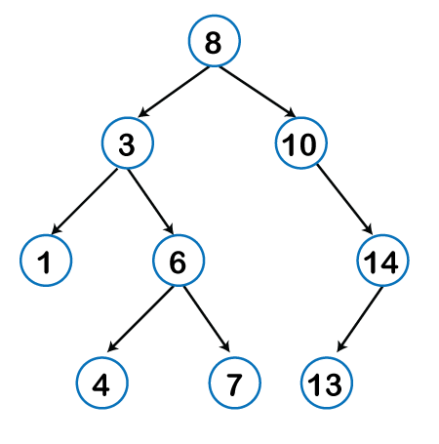  
  **To know more about the binary tree, click on the link given below:**  
  <https://www.javatpoint.com/binary-tree>
* [**Binary Search tree**](https://www.javatpoint.com/binary-search-tree)**:** Binary search tree is a non-linear data structure in which one node is connected to ***n*** number of nodes. It is a node-based data structure. A node can be represented in a binary search tree with three fields, i.e., data part, left-child, and right-child. A node can be connected to the utmost two child nodes in a binary search tree, so the node contains two pointers (left child and right child pointer).  
  Every node in the left subtree must contain a value less than the value of the root node, and the value of each node in the right subtree must be bigger than the value of the root node.
* [**AVL tree**](https://www.javatpoint.com/avl-tree)

It is one of the types of the binary tree, or we can say that it is a variant of the binary search tree. AVL tree satisfies the property of the ***binary tree*** as well as of the ***binary search tree***. It is a self-balancing binary search tree that was invented by ***Adelson Velsky Lindas***. Here, self-balancing means that balancing the heights of left subtree and right subtree. This balancing is measured in terms of the ***balancing factor***.

We can consider a tree as an AVL tree if the tree obeys the binary search tree as well as a balancing factor. The balancing factor can be defined as the ***difference between the height of the left subtree and the height of the right subtree***. The balancing factor's value must be either 0, -1, or 1; therefore, each node in the AVL tree should have the value of the balancing factor either as 0, -1, or 1.

[**Red-Black Tree**](https://www.javatpoint.com/red-black-tree)

**The red-Black tree** is the binary search tree. The prerequisite of the Red-Black tree is that we should know about the binary search tree. In a binary search tree, the value of the left-subtree should be less than the value of that node, and the value of the right-subtree should be greater than the value of that node. As we know that the time complexity of binary search in the average case is log2n, the best case is O(1), and the worst case is O(n).

When any operation is performed on the tree, we want our tree to be balanced so that all the operations like searching, insertion, deletion, etc., take less time, and all these operations will have the time complexity of ***log2n.***

***The red-black tree*** is a self-balancing binary search tree. AVL tree is also a height balancing binary search tree then **why do we require a Red-Black tree**. In the AVL tree, we do not know how many rotations would be required to balance the tree, but in the Red-black tree, a maximum of 2 rotations are required to balance the tree. It contains one extra bit that represents either the red or black color of a node to ensure the balancing of the tree.

**Splay tree**

The splay tree data structure is also binary search tree in which recently accessed element is placed at the root position of tree by performing some rotation operations. Here, ***splaying*** means the recently accessed node. It is a ***self-balancing*** binary search tree having no explicit balance condition like **AVL** tree.

It might be a possibility that height of the splay tree is not balanced, i.e., height of both left and right subtrees may differ, but the operations in splay tree takes order of **logN** time where **n** is the number of nodes.

Splay tree is a balanced tree but it cannot be considered as a height balanced tree because after each operation, rotation is performed which leads to a balanced tree.

* **Treap**

Treap data structure came from the Tree and Heap data structure. So, it comprises the properties of both Tree and Heap data structures. In Binary search tree, each node on the left subtree must be equal or less than the value of the root node and each node on the right subtree must be equal or greater than the value of the root node. In heap data structure, both right and left subtrees contain larger keys than the root; therefore, we can say that the root node contains the lowest value.

In treap data structure, each node has both ***key*** and ***priority*** where key is derived from the Binary search tree and priority is derived from the heap data structure.

The **Treap** data structure follows two properties which are given below:

* Right child of a node>=current node and left child of a node <=current node (binary tree)
* Children of any subtree must be greater than the node (heap)
* [**B-tree**](https://www.javatpoint.com/b-tree)

B-tree is a balanced **m-way** tree where **m** defines the order of the tree. Till now, we read that the node contains only one key but b-tree can have more than one key, and more than 2 children. It always maintains the sorted data. In binary tree, it is possible that leaf nodes can be at different levels, but in b-tree, all the leaf nodes must be at the same level.

**If order is m then node has the following properties:**

* Each node in a b-tree can have maximum **m** children
* For minimum children, a leaf node has 0 children, root node has minimum 2 children and internal node has minimum ceiling of m/2 children. For example, the value of m is 5 which means that a node can have 5 children and internal nodes can contain maximum 3 children.
* Each node has maximum (m-1) keys.

The root node must contain minimum 1 key and all other nodes must contain atleast **ceiling of m/2 minus 1** keys.

# **Binary Tree**

The Binary tree means that the node can have maximum two children. Here, binary name itself suggests that 'two'; therefore, each node can have either 0, 1 or 2 children.

**Let's understand the binary tree through an example.**

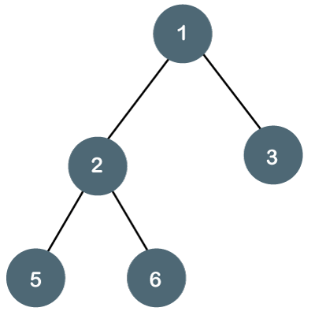

The above tree is a binary tree because each node contains the utmost two children. The logical representation of the above tree is given below:

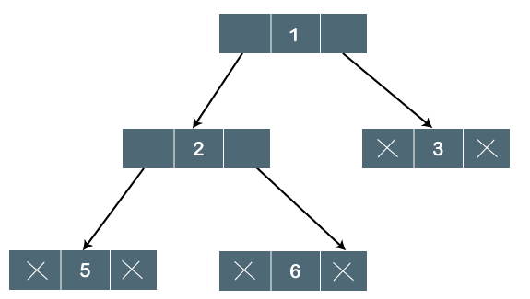

In the above tree, node 1 contains two pointers, i.e., left and a right pointer pointing to the left and right node respectively. The node 2 contains both the nodes (left and right node); therefore, it has two pointers (left and right). The nodes 3, 5 and 6 are the leaf nodes, so all these nodes contain **NULL** pointer on both left and right parts.

5.1M

105

PlayStation Announces Plan to Add In-Game Advertisements to Free-to-Play Games

### Properties of Binary Tree

* At each level of i, the maximum number of nodes is 2i.
* The height of the tree is defined as the longest path from the root node to the leaf node. The tree which is shown above has a height equal to 3. Therefore, the maximum number of nodes at height 3 is equal to (1+2+4+8) = 15. In general, the maximum number of nodes possible at height h is (20 + 21 + 22+….2h) = 2h+1 -1.
* The minimum number of nodes possible at height h is equal to **h+1**.
* If the number of nodes is minimum, then the height of the tree would be maximum. Conversely, if the number of nodes is maximum, then the height of the tree would be minimum.

If there are 'n' number of nodes in the binary tree.

**The minimum height can be computed as:**

As we know that,

n = 2h+1 -1

n+1 = 2h+1

Taking log on both the sides,

log2(n+1) = log2(2h+1)

log2(n+1) = h+1

**h = log2(n+1) - 1**

**The maximum height can be computed as:**

As we know that,

n = h+1

**h= n-1**

### Types of Binary Tree

**There are four types of Binary tree:**

* **Full/ proper/ strict Binary tree**
* **Complete Binary tree**
* **Perfect Binary tree**
* **Degenerate Binary tree**
* **Balanced Binary tree**

**1. Full/ proper/ strict Binary tree**

The full binary tree is also known as a strict binary tree. The tree can only be considered as the full binary tree if each node must contain either 0 or 2 children. The full binary tree can also be defined as the tree in which each node must contain 2 children except the leaf nodes.

**Let's look at the simple example of the Full Binary tree.**

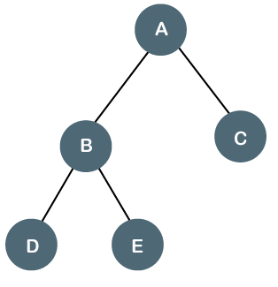

In the above tree, we can observe that each node is either containing zero or two children; therefore, it is a Full Binary tree.

**Properties of Full Binary Tree**

* The number of leaf nodes is equal to the number of internal nodes plus 1. In the above example, the number of internal nodes is 5; therefore, the number of leaf nodes is equal to 6.
* The maximum number of nodes is the same as the number of nodes in the binary tree, i.e., 2h+1 -1.
* The minimum number of nodes in the full binary tree is 2*h-1.
* The minimum height of the full binary tree is **log2(n+1) - 1.**
* The maximum height of the full binary tree can be computed as:

n= 2*h - 1

n+1 = 2*h

**h = n+1/2**

**Complete Binary Tree**

The complete binary tree is a tree in which all the nodes are completely filled except the last level. In the last level, all the nodes must be as left as possible. In a complete binary tree, the nodes should be added from the left.

Let's create a complete binary tree.

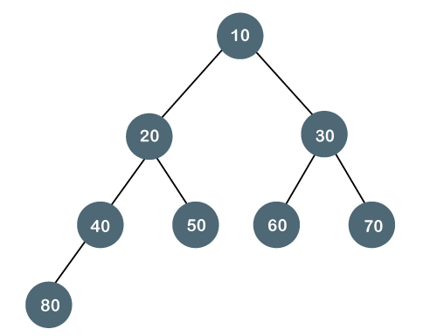

The above tree is a complete binary tree because all the nodes are completely filled, and all the nodes in the last level are added at the left first.

**Properties of Complete Binary Tree**

* The maximum number of nodes in complete binary tree is 2h+1 - 1.
* The minimum number of nodes in complete binary tree is 2h.
* The minimum height of a complete binary tree is **log2(n+1) - 1.**
* The maximum height of a complete binary tree is

**Perfect Binary Tree**

A tree is a perfect binary tree if all the internal nodes have 2 children, and all the leaf nodes are at the same level.

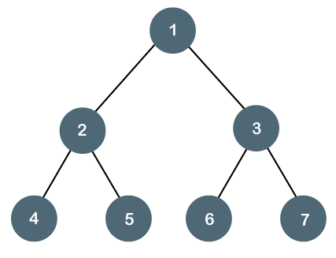

**Let's look at a simple example of a perfect binary tree.**

The below tree is not a perfect binary tree because all the leaf nodes are not at the same level.

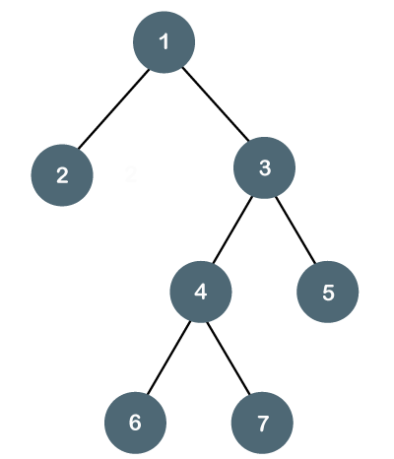

#### **Note: All the perfect binary trees are the complete binary trees as well as the full binary tree, but vice versa is not true, i.e., all complete binary trees and full binary trees are the perfect binary trees.**

### Degenerate Binary Tree

The degenerate binary tree is a tree in which all the internal nodes have only one children.

**Let's understand the Degenerate binary tree through examples.**

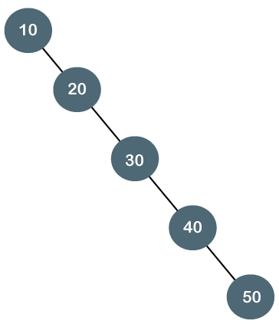

The above tree is a degenerate binary tree because all the nodes have only one child. It is also known as a right-skewed tree as all the nodes have a right child only.

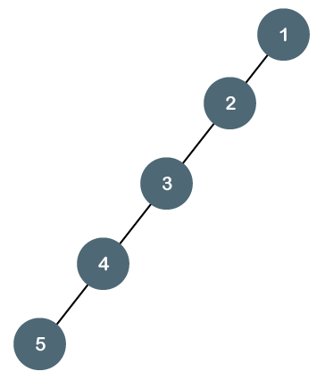

The above tree is also a degenerate binary tree because all the nodes have only one child. It is also known as a left-skewed tree as all the nodes have a left child only.

**Balanced Binary Tree**

The balanced binary tree is a tree in which both the left and right trees differ by atmost 1. For example, **AVL** and **Red-Black trees** are balanced binary tree.

**Let's understand the balanced binary tree through examples.**

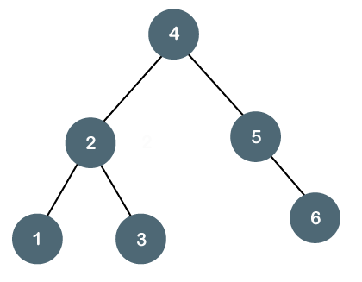

The above tree is a balanced binary tree because the difference between the left subtree and right subtree is zero.

What is a Binary Search tree?

A binary search tree follows some order to arrange the elements. In a Binary search tree, the value of left node must be smaller than the parent node, and the value of right node must be greater than the parent node. This rule is applied recursively to the left and right subtrees of the root.

Let's understand the concept of Binary search tree with an example.

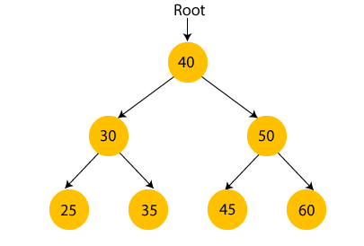

In the above figure, we can observe that the root node is 40, and all the nodes of the left subtree are smaller than the root node, and all the nodes of the right subtree are greater than the root node.

Similarly, we can see the left child of root node is greater than its left child and smaller than its right child. So, it also satisfies the property of binary search tree. Therefore, we can say that the tree in the above image is a binary search tree.

Suppose if we change the value of node 35 to 55 in the above tree, check whether the tree will be binary search tree or not.

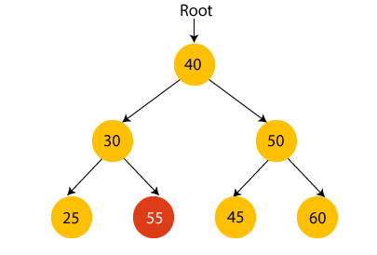

In the above tree, the value of root node is 40, which is greater than its left child 30 but smaller than right child of 30, i.e., 55. So, the above tree does not satisfy the property of Binary search tree. Therefore, the above tree is not a binary search tree.

Advantages of Binary search tree

* Searching an element in the Binary search tree is easy as we always have a hint that which subtree has the desired element.
* As compared to array and linked lists, insertion and deletion operations are faster in BST.

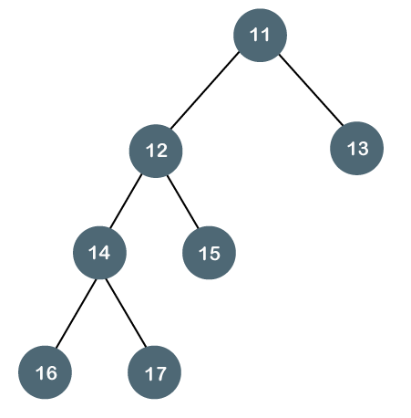

The above tree is not a balanced binary tree because the difference between the left subtree and the right subtree is greater than 1.

### Time Complexity of Binary search tree:

|  |  |  |  |
| --- | --- | --- | --- |
| **Operations** | **Best case time complexity** | **Average case time complexity** | **Worst case time complexity** |
| **Insertion** | O(log n) | O(log n) | O(n) |
| **Deletion** | O(log n) | O(log n) | O(n) |
| **Search** | O(log n) | O(log n) | O(n) |

# **AVL Tree**

AVL Tree is invented by GM Adelson - Velsky and EM Landis in 1962. The tree is named AVL in honour of its inventors.

AVL Tree can be defined as height balanced binary search tree in which each node is associated with a balance factor which is calculated by subtracting the height of its right sub-tree from that of its left sub-tree.

Tree is said to be balanced if balance factor of each node is in between -1 to 1, otherwise, the tree will be unbalanced and need to be balanced.

## Balance Factor (k) = height (left(k)) - height (right(k))

If balance factor of any node is 1, it means that the left sub-tree is one level higher than the right sub-tree.

If balance factor of any node is 0, it means that the left sub-tree and right sub-tree contain equal height.

If balance factor of any node is -1, it means that the left sub-tree is one level lower than the right sub-tree.

An AVL tree is given in the following figure. We can see that, balance factor associated with each node is in between -1 and +1. therefore, it is an example of AVL tree.

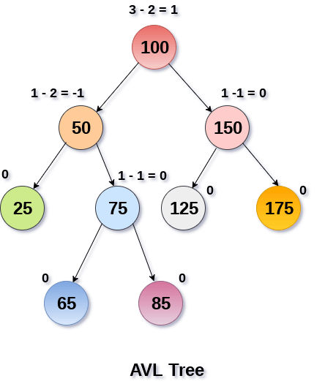

## Complexity

|  |  |  |
| --- | --- | --- |
| **Algorithm** | **Average case** | **Worst case** |
| Space | o(n) | o(n) |
| Search | o(log n) | o(log n) |
| Insert | o(log n) | o(log n) |
| Delete | o(log n) | o(log n) |

## Operations on AVL tree

Due to the fact that, AVL tree is also a binary search tree therefore, all the operations are performed in the same way as they are performed in a binary search tree. Searching and traversing do not lead to the violation in property of AVL tree. However, insertion and deletion are the operations which can violate this property and therefore, they need to be revisited.

|  |  |  |
| --- | --- | --- |
| **SN** | **Operation** | **Description** |
| 1 | [Insertion](https://www.javatpoint.com/insertion-in-avl-tree) | Insertion in AVL tree is performed in the same way as it is performed in a binary search tree. However, it may lead to violation in the AVL tree property and therefore the tree may need balancing. The tree can be balanced by applying rotations. |
| 2 | [Deletion](https://www.javatpoint.com/deletion-in-avl-tree) | Deletion can also be performed in the same way as it is performed in a binary search tree. Deletion may also disturb the balance of the tree therefore, various types of rotations are used to rebalance the tree. |

## Why AVL Tree?

AVL tree controls the height of the binary search tree by not letting it to be skewed. The time taken for all operations in a binary search tree of height h is **O(h)**. However, it can be extended to **O(n)** if the BST becomes skewed (i.e. worst case). By limiting this height to log n, AVL tree imposes an upper bound on each operation to be **O(log n)** where n is the number of nodes.

## AVL Rotations

We perform rotation in AVL tree only in case if Balance Factor is other than **-1, 0, and 1**. There are basically four types of rotations which are as follows:

1. L L rotation: Inserted node is in the left subtree of left subtree of A
2. R R rotation : Inserted node is in the right subtree of right subtree of A
3. L R rotation : Inserted node is in the right subtree of left subtree of A
4. R L rotation : Inserted node is in the left subtree of right subtree of A

Where node A is the node whose balance Factor is other than -1, 0, 1.

The first two rotations LL and RR are single rotations and the next two rotations LR and RL are double rotations. For a tree to be unbalanced, minimum height must be at least 2, Let us understand each rotation

### 1. RR Rotation

When BST becomes unbalanced, due to a node is inserted into the right subtree of the right subtree of A, then we perform RR rotation, [RR rotation](https://www.javatpoint.com/rr-rotation-in-avl-tree) is an anticlockwise rotation, which is applied on the edge below a node having balance factor -2

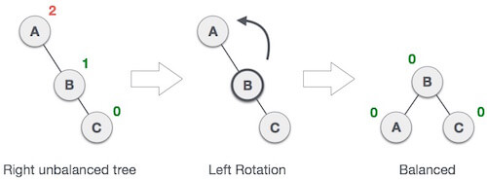

In above example, node A has balance factor -2 because a node C is inserted in the right subtree of A right subtree. We perform the RR rotation on the edge below A.

### 2. LL Rotation

When BST becomes unbalanced, due to a node is inserted into the left subtree of the left subtree of C, then we perform LL rotation, [LL rotation](https://www.javatpoint.com/ll-rotation-in-avl-tree) is clockwise rotation, which is applied on the edge below a node having balance factor 2.

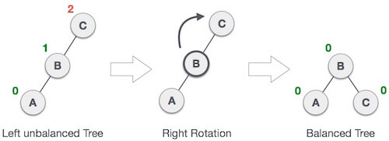

In above example, node C has balance factor 2 because a node A is inserted in the left subtree of C left subtree. We perform the LL rotation on the edge below A.

### 3. LR Rotation

Double rotations are bit tougher than single rotation which has already explained above. LR rotation = RR rotation + LL rotation, i.e., first RR rotation is performed on subtree and then LL rotation is performed on full tree, by full tree we mean the first node from the path of inserted node whose balance factor is other than -1, 0, or 1.

**Let us understand each and every step very clearly:**

|  |  |
| --- | --- |
| **State** | **Action** |
| AVL Rotations | A node B has been inserted into the right subtree of A the left subtree of C, because of which C has become an unbalanced node having balance factor 2. This case is L R rotation where: Inserted node is in the right subtree of left subtree of C |
| AVL Rotations | As LR rotation = RR + LL rotation, hence RR (anticlockwise) on subtree rooted at A is performed first. By doing RR rotation, node **A**, has become the left subtree of **B**. |
| AVL Rotations | After performing RR rotation, node C is still unbalanced, i.e., having balance factor 2, as inserted node A is in the left of left of **C** |
| AVL Rotations | Now we perform LL clockwise rotation on full tree, i.e. on node C. node **C** has now become the right subtree of node B, A is left subtree of B |
| AVL Rotations | Balance factor of each node is now either -1, 0, or 1, i.e. BST is balanced now. |

### 4. RL Rotation

As already discussed, that double rotations are bit tougher than single rotation which has already explained above. [R L rotation](https://www.javatpoint.com/rl-rotation-in-avl-tree) = LL rotation + RR rotation, i.e., first LL rotation is performed on subtree and then RR rotation is performed on full tree, by full tree we mean the first node from the path of inserted node whose balance factor is other than -1, 0, or 1.

|  |  |
| --- | --- |
| **State** | **Action** |
| AVL Rotations | A node **B** has been inserted into the left subtree of **C** the right subtree of **A**, because of which A has become an unbalanced node having balance factor - 2. This case is RL rotation where: Inserted node is in the left subtree of right subtree of A |
| AVL Rotations | As RL rotation = LL rotation + RR rotation, hence, LL (clockwise) on subtree rooted at **C** is performed first. By doing RR rotation, node **C** has become the right subtree of **B**. |
| AVL Rotations | After performing LL rotation, node **A** is still unbalanced, i.e. having balance factor -2, which is because of the right-subtree of the right-subtree node A. |
| AVL Rotations | Now we perform RR rotation (anticlockwise rotation) on full tree, i.e. on node A. node **C** has now become the right subtree of node B, and node A has become the left subtree of B. |
| AVL Rotations | Balance factor of each node is now either -1, 0, or 1, i.e., BST is balanced now. |

### Q: Construct an AVL tree having the following elements

**H, I, J, B, A, E, C, F, D, G, K, L**

**1. Insert H, I, J**

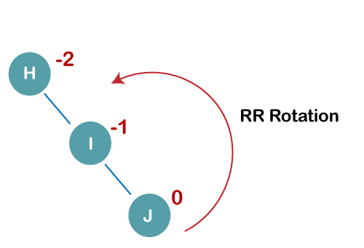

On inserting the above elements, especially in the case of H, the BST becomes unbalanced as the Balance Factor of H is -2. Since the BST is right-skewed, we will perform RR Rotation on node H.

**The resultant balance tree is:**

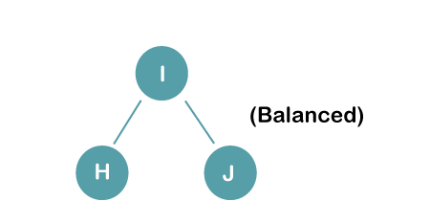

**2. Insert B, A**

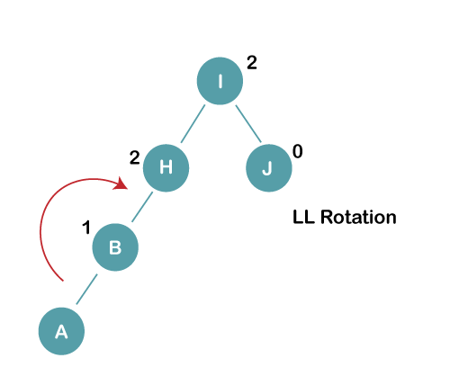

On inserting the above elements, especially in case of A, the BST becomes unbalanced as the Balance Factor of H and I is 2, we consider the first node from the last inserted node i.e. H. Since the BST from H is left-skewed, we will perform LL Rotation on node H.

**The resultant balance tree is:**

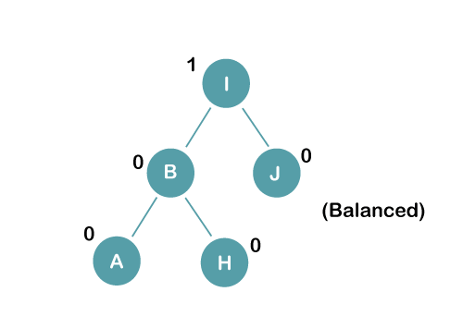

**3. Insert E**

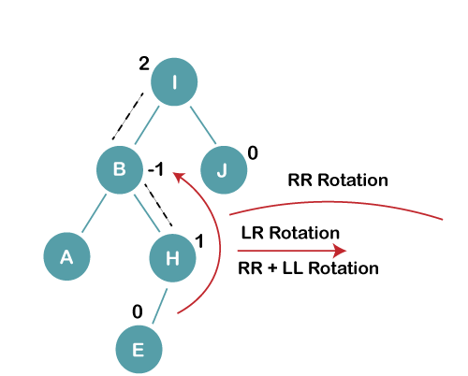

On inserting E, BST becomes unbalanced as the Balance Factor of I is 2, since if we travel from E to I we find that it is inserted in the left subtree of right subtree of I, we will perform LR Rotation on node I. LR = RR + LL rotation

**3 a) We first perform RR rotation on node B**

**The resultant tree after RR rotation is:**

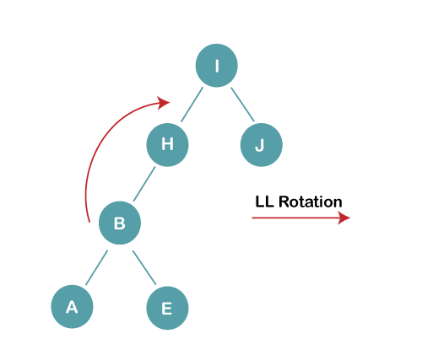

**3b) We first perform LL rotation on the node I**

**The resultant balanced tree after LL rotation is:**

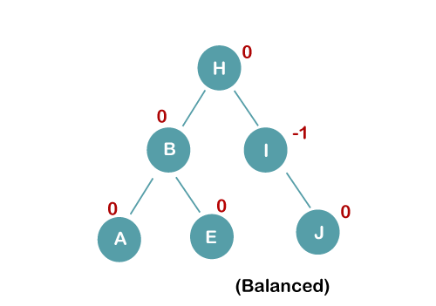

1. **Insert C, F, D**

# **B Tree**

B Tree is a specialized m-way tree that can be widely used for disk access. A B-Tree of order m can have at most m-1 keys and m children. One of the main reason of using B tree is its capability to store large number of keys in a single node and large key values by keeping the height of the tree relatively small.

A B tree of order m contains all the properties of an M way tree. In addition, it contains the following properties.

1. Every node in a B-Tree contains at most m children.
2. Every node in a B-Tree except the root node and the leaf node contain at least m/2 children.
3. The root nodes must have at least 2 nodes.
4. All leaf nodes must be at the same level.

It is not necessary that, all the nodes contain the same number of children but, each node must have m/2 number of nodes.

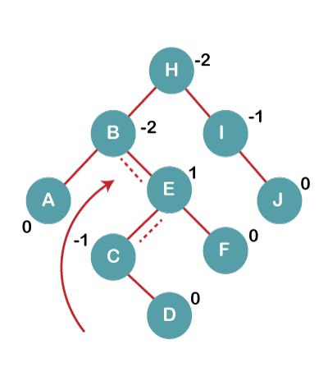

On inserting C, F, D, BST becomes unbalanced as the Balance Factor of B and H is -2, since if we travel from D to B we find that it is inserted in the right subtree of left subtree of B, we will perform RL Rotation on node I. RL = LL + RR rotation.

**4a) We first perform LL rotation on node E**

**The resultant tree after LL rotation is:**

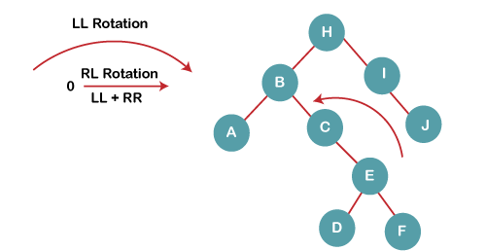

**4b) We then perform RR rotation on node B**

**The resultant balanced tree after RR rotation is:**

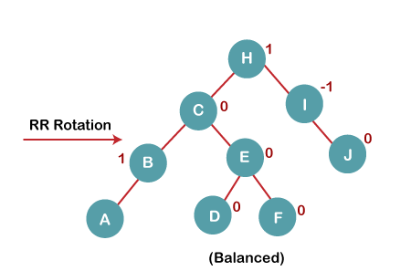

**5. Insert G**

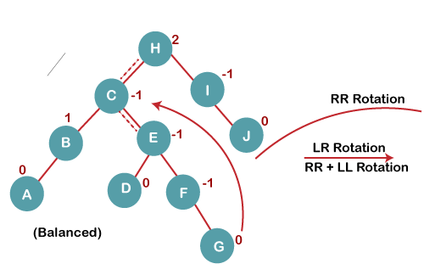

On inserting G, BST become unbalanced as the Balance Factor of H is 2, since if we travel from G to H, we find that it is inserted in the left subtree of right subtree of H, we will perform LR Rotation on node I. LR = RR + LL rotation.

**5 a) We first perform RR rotation on node C**

**The resultant tree after RR rotation is:**

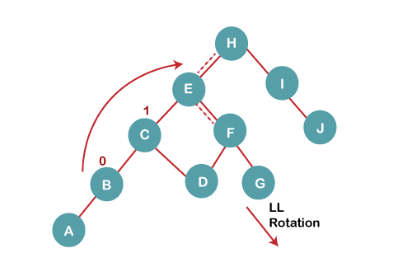

**5 b) We then perform LL rotation on node H**

**The resultant balanced tree after LL rotation is:**

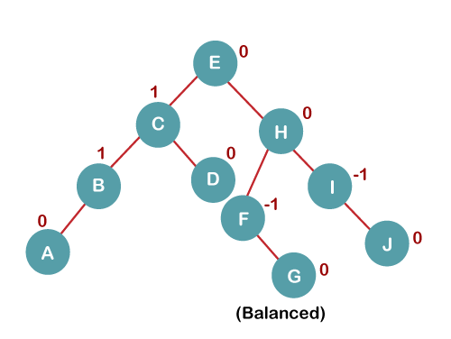

**6. Insert K**

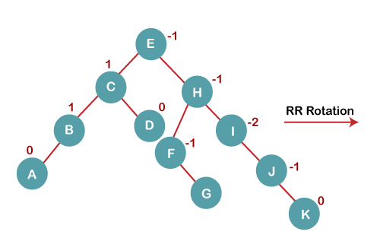

On inserting K, BST becomes unbalanced as the Balance Factor of I is -2. Since the BST is right-skewed from I to K, hence we will perform RR Rotation on the node I.

**The resultant balanced tree after RR rotation is:**

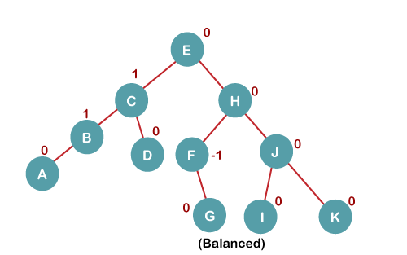

**7. Insert L**

On inserting the L tree is still balanced as the Balance Factor of each node is now either, -1, 0, +1. Hence the tree is a Balanced AVL tree

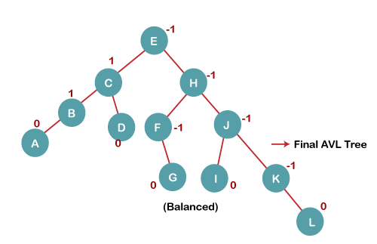

# **B+ Tree**

B+ Tree is an extension of B Tree which allows efficient insertion, deletion and search operations.

In B Tree, Keys and records both can be stored in the internal as well as leaf nodes. Whereas, in B+ tree, records (data) can only be stored on the leaf nodes while internal nodes can only store the key values.

The leaf nodes of a B+ tree are linked together in the form of a singly linked lists to make the search queries more efficient.

B+ Tree are used to store the large amount of data which can not be stored in the main memory. Due to the fact that, size of main memory is always limited, the internal nodes (keys to access records) of the B+ tree are stored in the main memory whereas, leaf nodes are stored in the secondary memory

Advantages of B+ Tree

1. Records can be fetched in equal number of disk accesses.
2. Height of the tree remains balanced and less as compare to B tree.
3. We can access the data stored in a B+ tree sequentially as well as directly.
4. Keys are used for indexing.
5. Faster search queries as the data is stored only on the leaf nodes.

## B Tree VS B+ Tree

|  |  |  |
| --- | --- | --- |
| **SN** | **B Tree** | **B+ Tree** |
| 1 | Search keys can not be repeatedly stored. | Redundant search keys can be present. |
| 2 | Data can be stored in leaf nodes as well as internal nodes | Data can only be stored on the leaf nodes. |
| 3 | Searching for some data is a slower process since data can be found on internal nodes as well as on the leaf nodes. | Searching is comparatively faster as data can only be found on the leaf nodes. |
| 4 | Deletion of internal nodes are so complicated and time consuming. | Deletion will never be a complexed process since element will always be deleted from the leaf nodes. |
| 5 | Leaf nodes can not be linked together. | Leaf nodes are linked together to make the search operations more efficient. |