**Kernel:**

A Unix kernel fulfills 4 main management tasks:

• Memory management

• Process management

• file system management

• IO management

The kernel exists as a physical file on the file system in Linux it is /boot directory

and is usually called vmlinux. **/boot/vmlinuz-2.4.18-22**

At system boot time RAM only contains the boot loader, consuming a few kilobytes

at the beginning of memory. The boot loader loads the kernel binary into memory from the hard disk, and places it at the beginning of memory.

**Main Memory is divided into two areas, kernel memory (KMEM) and user memory (UMEM)**

**KMEM**: The kernel binary itself, working tables (global open file table, process table and mount table) to keep track of status.

**UMEM**: This is for the use of user programs.

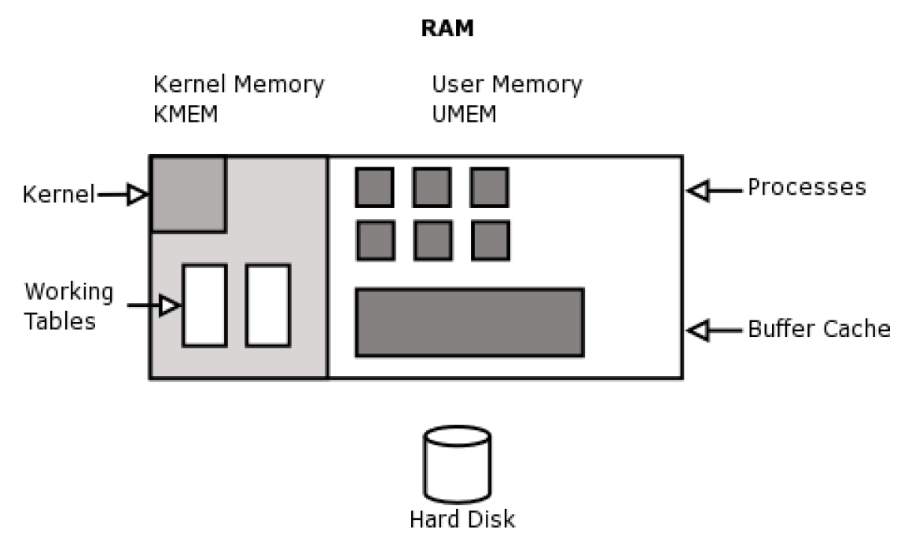

**Booting:**