*************Tree data structure******************

Binary Tree Data Structure: A tree whose elements have at most 2 children is called a binary tree. Since each element in a binary tree can have only 2 children, we typically name them the left and right child.
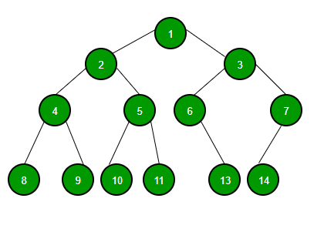
A Binary Tree node contains following parts:
- Data
- Pointer to left child
- Pointer to right child
Trees: Unlike Arrays, Linked Lists, Stack and queues, which are linear data structures, trees are hierarchical data structures.

***************************Tree Data structure****************************
Tree data structure is non liner data structure and used for hierarchal applications or File system. Linear data structure has start address, end address and next pointer.
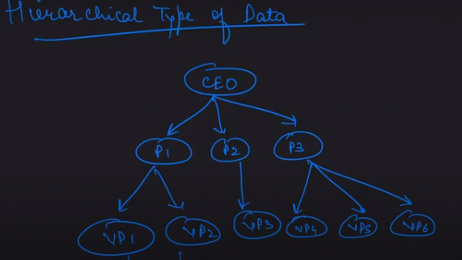
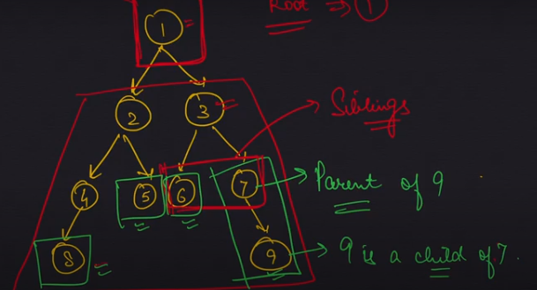
*****************************Depth and height of tree***************************
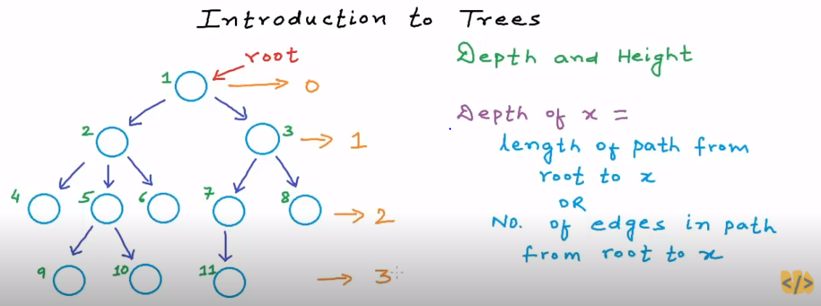
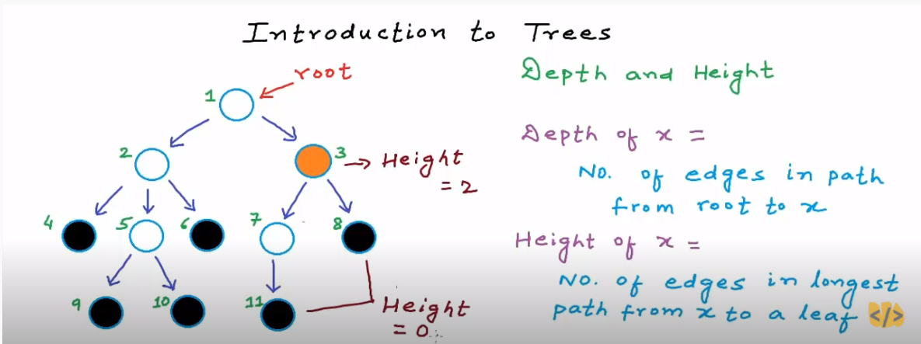
******************Binary tree*********************************************
If all the nodes of tree have <= 2 children, it is called binary tree.

Applications: File system in system
Types of Binary tree:
- Proper/strict binary tree: Every node has 2 or 0 children.
- Complete binary tree: Each level is completely filled. except the last level.
- Perfect binary tree: Each level is filled completely.
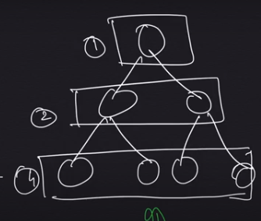
The more you reduce height of binary tree, more you reduce the time complexity. Example of worst time complexity of binary tree, where O(H) = O(N)

Full Binary Tree:A full Binary tree is a special type of binary tree in which every parent node/internal node has either two or no children.
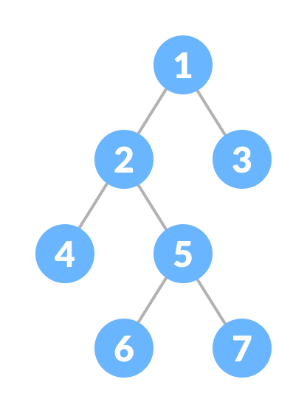

***************************Binary search tree**********************************
a binary search tree, also called an ordered or sorted binary tree, is a rooted binary tree whose internal nodes each store a key greater than all the keys in the node's left subtree and less than those in its right subtree

Working of Binary Search Tree:
- The comparison starts with the root, thereby following the left or right sub-tree depending if the value to be inserted is lesser or greater than root, respectively.
- Thus, any value which is to be inserted is compared with the value at the root. Any value less than the root gets inserted in the left child and its children, whereas any value greater than the root gets inserted in the right child and its children.
- Thus, all the values get automatically sorted as they’re inserted into the tree.

