Array vs Linkedlist: Array is of fixed size and it’s contiguous size. Linked list does not assign in contiguous manner.

Stack for reversing character array:
void reverse(char* c, int n)
{
stack<char>s;
for(int i=0; i<n; i++)
{
s.push(c[i]);
}
for(int i=0; i<n; i++)
{
c[i] = s.top();
s.pop();
}

}

//Check for balanced parenthesis:

infix: <operand> <operator> <operand> (A+B)
prefix: <operator> <operand> <operand>(+AB)
postfix: <operand> <operand> <operator>(AB+)

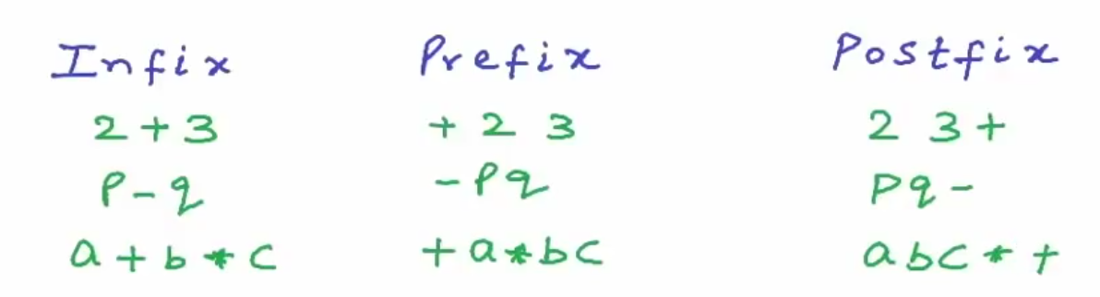
dsfgfdgf

