Graph question: Create adjacency list using c++
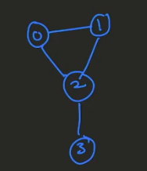

#include <iostream>
#include <list>
using namespace std;

class graph
{
int v; //vertex
list<int>*item;
public:
graph(int v): v(v), item(new list<int>[v])
{

}
void addEdge(int x, int y)
{
item[x].push_back(y);
item[y].push_back(x);
}
void printgraph()
{
for(int i=0; i<v; i++)
{
cout<<"vertex value"<<"->";
for(auto i:item[i])
{
cout<<i<<",";

}
cout<<endl;
}
}

};

int main()
{
graph g(4);
g.addEdge(0,1);
g.addEdge(0,2);
g.addEdge(2,3);
g.addEdge(1,2);
g.printgraph();
return 0;
}

Create Adjacency list for weighted graph and nodes are strings:

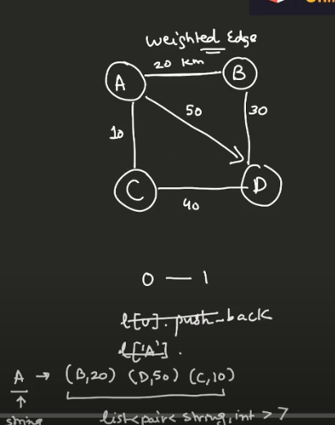
class graph
{
unordered_map<string, pair<string, int>>item

public:
void addEdge(string x, string y, bool isbidirectional, int w)
{
item[x].push_back(make_pair(y, w));
if(isbidirectional)
{
item[y].push_back(make_pair(x, w));
}

}

};

int main()
{
graph g;
g.addEdge(A,B, true, 200);
g.addEdge(0,2);
g.addEdge(2,3);
g.addEdge(1,2);
g.printgraph();
return 0;
}

BFS:
class graph
{
map<int, list<int>>item;

public:
void addEdge(int x, int y)
{
item[x].push_back(y);
item[y].push_back(x);

}
void bfs(int src)
{
map<int, bool>isvisited;
queue<int>q;
q.push(src);
isvisited[src] = true;

while(!q.empty())
{
int node = q.front();
q.pop();
cout<<node<<endl;
for(int nbr:item[node])
{
if(!isvisited[nbr])
{
q.push(nbr);
isvisited[nbr] = true;
}
}
}

}

};

int main()
{
graph g;
g.addEdge(0,1);
g.addEdge(1,2);
g.addEdge(2,3);
g.addEdge(3,4);
g.bfs(0);
return 0;
}

DFS:
class graph
{
map<int, list<int>>item;

public:
void addEdge(int x, int y)
{
item[x].push_back(y);
item[y].push_back(x);

}
Void dfs_helper(int scr, map<int, bool>isvisited)
{
Cout<<src;
isvisited[src] = true;
for(auto i: item[src])
{
If(!isvisited[src])
{
Dfs_helper(i, isvisited);
}
}
}
)
void dfs(int src)
{
map<int, bool>isvisited;
for(auto i:item)
{
int node = item.first;
isvisited[node] = false;
}

//Need function for recursion:
Dfs_helper(src, isvisited);

while(!q.empty())
{
int node = q.front();
q.pop();
cout<<node<<endl;
for(int nbr:item[node])
{
if(!isvisited[nbr])
{
q.push(nbr);
isvisited[nbr] = true;
}
}
}

}

};

int main()
{
graph g;
g.addEdge(0,1);
g.addEdge(1,2);
g.addEdge(2,3);
g.addEdge(3,4);
g.dfs(0);
return 0;
}

