Device driver programming:

How to configure and install kernel:
1) Download the kernel source code.
2) Extract the Source Code: tar xvf linux-5.9.6.tar.xz
3) Configure Kernel:
- Navigate to the code directory using the cd command(cd linux-5.9.6)
- Copy the existing configuration file using the cp command(cp -v /boot/config-$(uname -r) .config)
- To make changes to the configuration file, run the make command(make menuconfig)
4) Build the Kernel(make -j 4)
5) Install the required modules with this command(sudo make modules_install)
6) Install the kernel(sudo make install)
7)Update initramfs
8)Update grub.
Check installed kernel version: uname -r
check installed kernel date: uname -v

Kernel is installed in path: /lib/modules/$(uname-r)

lsmod – List Modules that Loaded Already
lsmod command will list modules that are already loaded in the kernel as shown beblow.
# lsmod
Module Size Used by
ppp_deflate 12806 0
zlib_deflate 26445 1 ppp_deflate
bsd_comp 12785 0
..

2. insmod – Insert Module into Kernel
insmod command will insert a new module into the kernel as shown below.
# insmod /lib/modules/3.5.0-19-generic/kernel/fs/squashfs/squashfs.ko

# lsmod | grep "squash"
squashfs 35834 0

3. modinfo – Display Module Info
modinfo command will display information about a kernel module as shown below.
# modinfo /lib/modules/3.5.0-19-generic/kernel/fs/squashfs/squashfs.ko

filename: /lib/modules/3.5.0-19-generic/kernel/fs/squashfs/squashfs.ko
license: GPL
author: Phillip Lougher
description: squashfs 4.0, a compressed read-only filesystem
srcversion: 89B46A0667BD5F2494C4C72
depends:
intree: Y
vermagic: 3.5.0-19-generic SMP mod_unload modversions 686

4. rmmod – Remove Module from Kernel
rmmod command will remove a module from the kernel. You cannot remove a module which is already used by any program.
# rmmod squashfs.ko

5. modprobe – Add or Remove modules from the kernel
modprobe is an intelligent command which will load/unload modules based on the dependency between modules. Refer to modprobe commands for more detailed examples.

II. Write a Simple Hello World Kernel Module

1. Installing the linux headers
You need to install the linux-headers-.. first as shown below. Depending on your distro, use apt-get or yum.
# apt-get install build-essential linux-headers-$(uname -r)

2. Hello World Module Source Code
Next, create the following hello.c module in C programming language.
#include <linux/module.h> // included for all kernel modules
#include <linux/kernel.h> // included for KERN_INFO
#include <linux/init.h> // included for __init and __exit macros

MODULE_LICENSE("GPL");
MODULE_AUTHOR("Ankit");
MODULE_DESCRIPTION("A Simple Hello World module");

static int __init hello_init(void)
{
printk(KERN_INFO "Hello world!\n"); //priniting to kernel buffer.
return 0; // Non-zero return means that the module couldn't be loaded.
}

static void __exit hello_cleanup(void)
{
printk(KERN_INFO "Cleaning up module.\n"); //priniting to kernel buffer.
}

module_init(hello_init);
module_exit(hello_cleanup);
Warning: All kernel modules will operate on kernel space, a highly privileged mode. So be careful with what you write in a kernel module.

3. Create Makefile to Compile Kernel Module
The following makefile can be used to compile the above basic hello world kernel module.
obj-m += hello.o

all:
make -C /lib/modules/$(shell uname -r)/build M=$(PWD) modules

clean:
make -C /lib/modules/$(shell uname -r)/build M=$(PWD) clean
Use the make command to compile hello world kernel module as shown below.
# make

make -C /lib/modules/3.5.0-19-generic/build M=/home/lakshmanan/a modules
make[1]: Entering directory `/usr/src/linux-headers-3.5.0-19-generic'
CC [M] /home/lakshmanan/a/hello.o
Building modules, stage 2.
MODPOST 1 modules
CC /home/lakshmanan/a/hello.mod.o
LD [M] /home/lakshmanan/a/hello.ko
make[1]: Leaving directory `/usr/src/linux-headers-3.5.0-19-generic'
The above will create hello.ko file, which is our sample Kernel module.

4. Insert or Remove the Sample Kernel Module
Now that we have our hello.ko file, we can insert this module to the kernel by using insmod command as shown below.
# insmod hello.ko

# dmesg | tail -1
[ 8394.731865] Hello world!

# rmmod hello.ko

# dmesg | tail -1
[ 8707.989819] Cleaning up module.
When a module is inserted into the kernel, the module_init macro will be invoked, which will call the function hello_init. Similarly, when the module is removed with rmmod, module_exit macro will be invoked, which will call the hello_exit. Using dmesg command, we can see the output from the sample Kernel module.

Output file generated when we compile our module:
modules.order
--------------------------------------------------
This file records the order in which modules appear in Makefiles. This
is used by modprobe to deterministically resolve aliases that match
multiple modules.
---------------------------------------------------------------------
If the files are present the source file is compiled to a "modulname.o", and "modulename.mod.c" is created which is compiled to "modulename.mod.o".
The modulename.mod.c is a file that basically contains the information about the module (Version information etc).
The modulename.o and the modulename.mod.o are linked together by modpost in the next stage to create the "modulename.ko" .

Network Device driver stack:
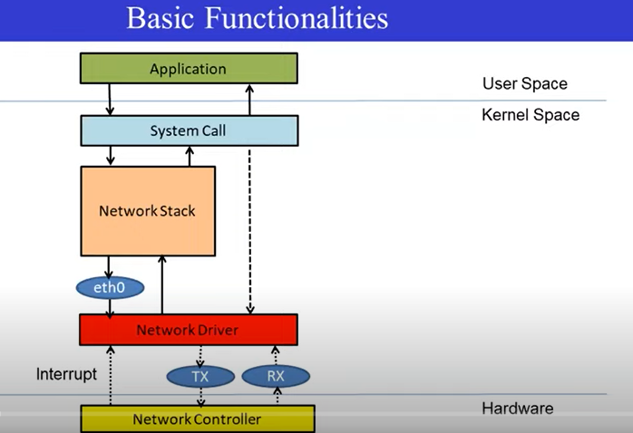
Struct net_dvice is used for network device.
Device Allocation: alloc_netdev()
Device Registration: register_netdevice()
Device Initialization

Character device driver:

