Kadane's alog: Finds maximum subarray sum in O(n) complexity.
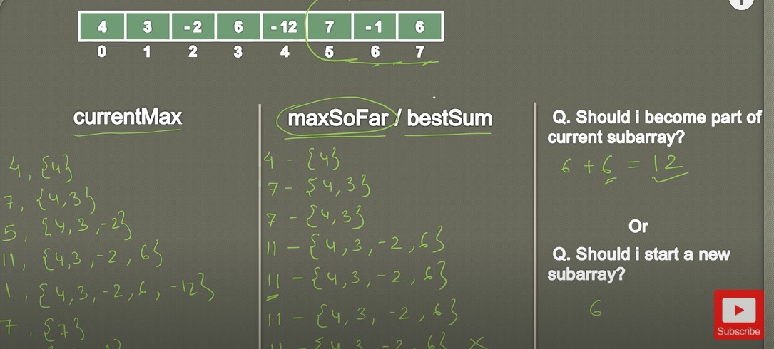
Solution:
int maxSubArray(vector<int>& nums) {

int currentSum =nums[0], totalSum = nums[0];

for(int i=1; i<nums.size(); i++) {

//Current max sum is either the current element OR current element + Previous Maximum subarray)
currentSum = max(nums[i], currentSum+nums[i]);

//If the current maximum array sum is greater than the global total. Update it
totalSum = max(totalSum, currentSum);
}
return totalSum;
}

