Linux shell receives input/command from user and converts it it binary form and sends it to linux kernel.

We have different types of SHELL:

1. BASH (Borne Again Shell)
2. C SHELL (CSH)
3. Korn Shell (KSH)

To find your shell type following command: **echo $SHELL**

**Linux Common Commands:**

**Linux Command:**

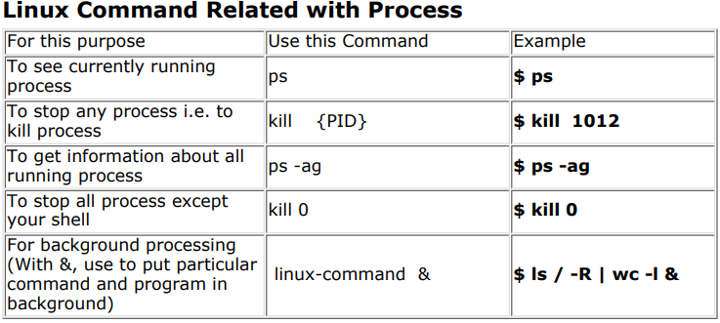

**Redirection of Standard output/input or Input - Output redirection**

1. **Linux-command > filename:**

ls > myfiles : Now if 'myfiles' file exist in your current directory it will be overwritten without any type of warning.

1. **Linux-command >> filename:** To output Linux-commands result to END of file. Note that If file exist , it will be opened and new information / data will be written to END of file, without losing previous information/data, And if file is not exist, then new file is created.
2. **Linux-command < filename:** To take input to Linux-command from file instead of key-board. For e.g. To take input for cat command give $ cat < myfiles

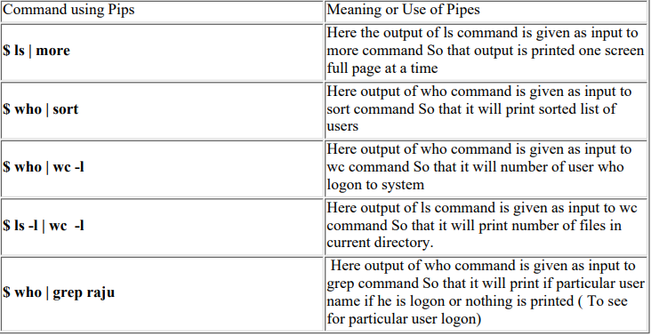

**Variables:**

1) **System variables** - Created and maintained by Linux itself. This type of variable defined in CAPITAL LETTERS.

2) **User defined variables** (UDV) - Created and maintained by user. This type of variable defined in lower LETTERS.

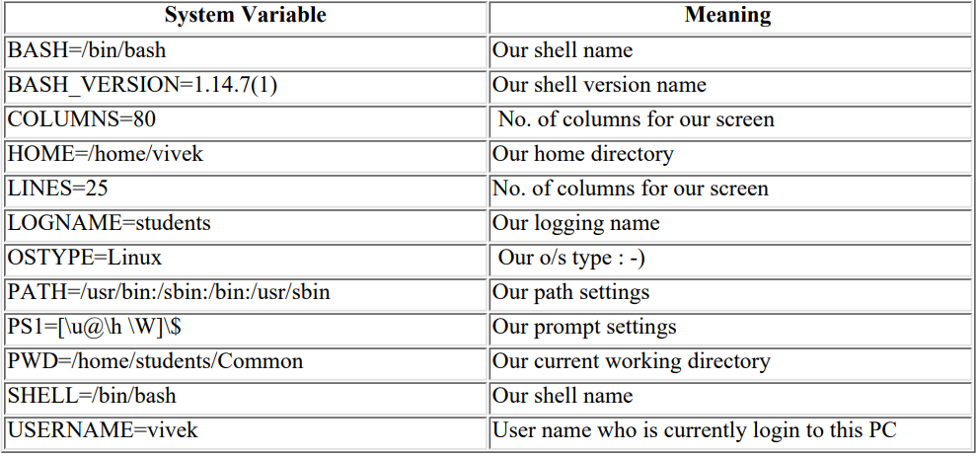

**How to define User defined variables (UDV):**

$ no=10 # this is ok

$ 10=no # Error, NOT Ok, Value must be on right side of = sign

**How to Define variable x with value 10 and print it on screen**

$ x=10

$ echo $x

**How to print sum of two numbers, let's say 6 and 3?**

expr 6 + 3

**How to Run Shell Scripts:**

chmod +x shell-script-name

chmod 777 shell-script-name

**More about Quotes:**

$ echo "Today is date" -> Can't print message with today's date.

$ echo "Today is `date`". Now it will print today's date as, Today is Tue Jan

**Perform arithmetic operations:**

$ expr 1 + 3

$ expr 2 - 1

$ expr 10 / 2

**Command Line arguments:**

**$#** will be 2 (Since foo and bar only two Arguments)

At a time such 9 arguments can be used from $0..$9

You can also refer all of them by using $* (which expand to `$0,$1,$2...$9`) Now try to write following for commands, Shell Script Name ($0), No. of Arguments (i.e. $#), And actual argument (i.e. $1,$2 etc)

**To check the status of last command: echo $?**

**---Start from page 46..**