**TCP:** The Transmission Control Protocol (TCP) is **an Internet protocol that connects a server and a client**. Together, TCP and Internet Protocol (IP) are the set of networking protocols that enable computers to connect over the Internet. Data travels over the Internet in packets.

Due to its reliable transmission, error control, and in order receiving of the data, It is used in **WhatsApp, Instagram, Google Chat, iMessage**. TCP is used in File transfer when we cannot tolerate the loss of data and receiving the data incorrect order is of utmost importance.

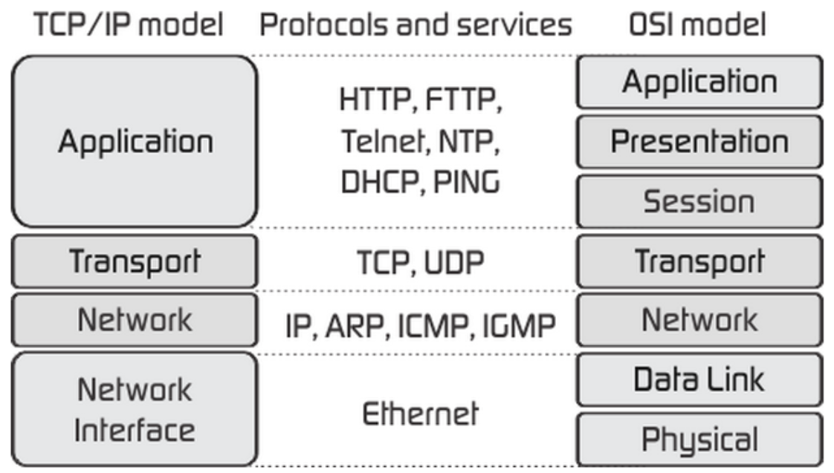

**UDP protocol:** The User Datagram Protocol, or UDP, is **a communication protocol used across the Internet for especially time-sensitive transmissions such as video playback or DNS lookups**. It speeds up communications by not formally establishing a connection before data is transferred.

**SPI**: Serial Peripheral Interface (SPI) is an interface bus commonly used **to send data between microcontrollers and small peripherals such as shift registers, sensors, and SD cards. SD card reader modules, RFID card reader modules, and 2.4 GHz wireless transmitter/receivers** all use SPI to communicate with microcontrollers. **SPI is better for high speed, low power applications. T**he SPI bus can run at high speed, transferring data at **up to 60 Mbps** over short distances like between chips on a board.

The four basic signals of SPI devices are denoted by **SO (serial output) or MOSI (master out slave in), SI (serial input) or MISO (master in slave out), SCK (serial clock) or SCLK, and CS or SS (slave select)**, although various other similar nomenclature is quite common.