# **GENETIC ALGORITHM FOR OPTIMAL**

**BANK LENDING DECISIONS**

OPTIMISATION AND HEURISTIC METHODS PROJECT

(IM39003)

***Ashutosh Kumar 191M30026***

***Industrial and Systems Engineering Department IIT Kharagpur***

1

# CONTENTS

Introduction 3

Use of Genetic Algorithms 3

Problem Parameters 4-5

Encoding a solution 5

Fitness Function 6

Steps in Genetic Algorithm (GA) 7-8

Amalgamation of Genetic Algorithm with Tabu Search 9

Results and Comparisons 10-12

# Introduction

At the time of financial crisis, a bank’s ability to continue with its traditional bank lending strategies are fore concerned. During a financial crisis, the most important problem is how will a bank manage to distribute the limited credit available in a way that maximizes their profits in the time of crisis.

The insolvency of some banks can lead to a reduction in bank loans, not only because of the bad bank failures but also because the healthy banks tend to be more cautious in their lending practices through cutting back on lending.

The inability of banks to manage loan portfolios efficiently may result in a credit crunch. A credit crunch is often caused by a sustained period of careless and inappropriate lending, resulting in losses for lending institutions and investors in debt when the loans turn sour and the full extent of bad debts becomes known. These challenges have led to a rise in more formal and accurate methods and models to optimize the lending decision and minimize loan risks.

The goal is to make lending decisions in a credit crunch environment where all applicable borrowers are eligible to get the desired loans. This is an NP-hard optimization problem which can be solved using meta-heuristic algorithms such as population-based algorithms.

The Paper proposes an intelligent model based on Genetic Algorithm (GA) to organize bank lending decision.

# Use of Genetic Algorithms

Multiple factors including loan characteristics, creditor ratings and expected loan loss can be easily integrated to GA chromosomes. Each borrower can, therefore, be represented by a gene in the GA chromosome.

The Genetic Algorithm (GA) model aims to systematically stabilise banks while achieving maximum profit and to establish the capital base so that banks can increase lending efficiently.

# Problem Parameters

The basic assumption for the model is that the borrowers which are considered are eligible for the required loans. The model is used to search for the best selection of loans depending on borrower factors such as:

* Loan Age (α): With an assumption that the maximum number of years for any loan is 20 years, the loan age is divided into four categories depending on its expected period time.

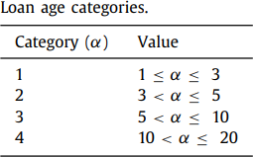

* Loan Size (L): Depending on the credit limit, the loan size is determined. The loan size determines the amount of loan requested by a specific customer.

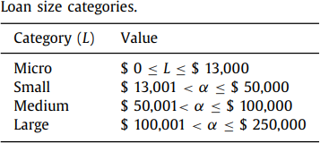

* Loan Type (ϕ): There are three types of loans assumed: Mortgage (M), Personal (P), and Auto (A).
* Credit Rating: Borrow Credit Rating is used to measure the range of the expected loan loss.

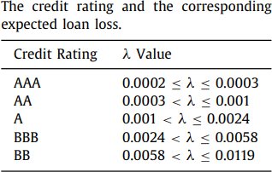

* Credit Limit: The credit limit represents the maximum loan amount that can be given to the customer based on his income and occupation.
* Loan interest rate (rL): Based on the values of ϕ and α, the loan interest rate

rL is assigned.

* Expected Loan Loss (λ): The expected loan loss from different borrowers is calculated by the credit rating assigned to them.

# Encoding

The genes of the chromosomes are binary encoded with the length of string being the number of eligible borrowers. The value stored is each gene is Boolean. If the loan is provided to a particular borrower then the value of the gene is 0 for that solution, 1 otherwise. Each customer is identified by their index number in the chromosome. Therefore, each chromosome with combinations of 0s and 1s represent a loan allocation solution.

The figure below is an example of such chromosomes.



# Fitness Function

The fitness function (Fx) consists of the following components:

1. Loan Revenue (V): The value of the loan revenue is calculated using the loan interest rate (rL), loan size (L), and the expected loan loss (λ).

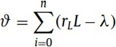

1. Loans Cost (μ): The value of the loan cost is determined using the loan size

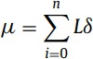(L) and the predetermined institutional cost (δ).

1. Total Transaction Cost (omega): The value of the total transaction cost is determined using institute transactional cost (T) and the customer transaction rate (rT). The value of rT has been assumed to be 0.01 for the purpose of this project.



1. Cost of Demand deposit (β): The value is determined using the bank’s deposit

interest rate (rD) and the bank’s deposit (D).



Final Fitness function (Fx):



# The Genetic Algorithm

GA is a evolutionary algorithm which simulates some of the natural processes: selection, inheritance via genetic crossover and random mutation.

After generation of initial solutions, the next steps in GA are as follows:

1. **Selection**: Selection of parent pool for reproduction based on the fitness values of the current generation individual. There are different ways of forming the reproduction pool like proportionate selection, roulette wheel selection, tournament selection etc. In our model, we have use roulette wheel selection.

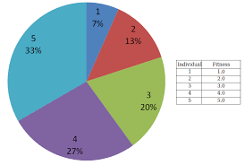

1. **Crossover**: It is the process of concatenating two chromosomes to generate a new two chromosomes by switching genes. The input of this process is two chromosomes while its output is two different chromosomes which inherit the genes of the parent chromosomes. In our model, a simple single-point crossover is used by randomly obtaining a single pivot point.

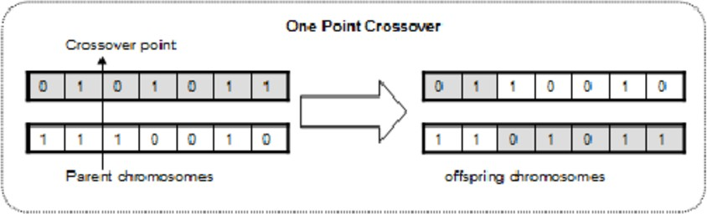

1. **Mutation:** It is the process of randomly revers the value of one gene in a chromosome. So, the input is a single chromosome and the output is different one. This has a lot of significance on the exploration factor of the algorithm. In our model, the whole string is traversed and if the random number generated is less than the mutation probability, the Boolean value at the gene is reversed. The mutation probability is usually very low.

**Above processes are repeated until the stopping criteria is reached, which in our case is to stop after a certain number of generations.**

The pseudocode adopted in the paper is as follows:

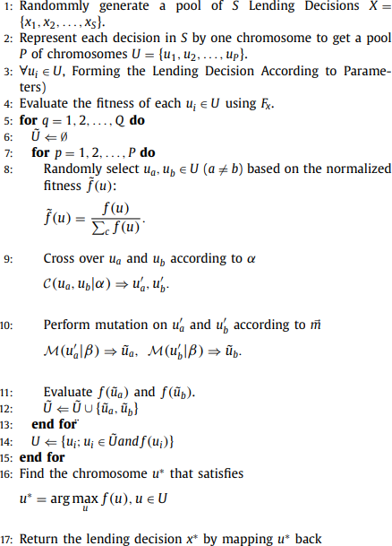

Code : 19IM30026_Genetic Algorithm.ipynb

Next, we incorporate some features of a random-search method algorithm called Simulated Tabu search into the above.

# AMALGAMATION OF GENETIC ALGORITHM WITH TABU SEARCH

1. **Selection:** Randomly generate an initial population of chromosomes which are feasible Solutions. Each borrower is therefore represented by a gene in the chromosome. A 0 in the gene means that the loan was not provided to the borrower. 1 in the gene means that the loan was provided to the borrower. Calculate Fitness of the initial Population which is then used for selection of population by Roulette wheel selection. Using the method of Roulette Wheel Selection, Select mating pool from the original population on the basis of ﬁtness values.
2. **Mutation:** Generate List of 5 neighborhood solution which is called candidate list, by performing mutation operation with probability of mutation=0.5. Choose a neighborhood solution (chromosome) from the candidate list such that the chromosome has the maximum ﬁtness value from the list
3. **Selection of Neighborhood Solution:**

If the chosen chromosome is not already present in the Tabu list, this chromosome gets updates as the neighborhood solution

If it is present in the Tabu list, Aspiration Criteria is checked and if the chromosome in Tabu list leads to better solution, it gets updated as neighborhood solution.

Fitness value of the neighborhood solution is calculated and if the ﬁtness of neighborhood solution is better, the current chromosome is updated and equals to neighborhood solution. Add the chromosome to Tabu list and update the Tabu counter List. Repeat the above Until termination criteria reached

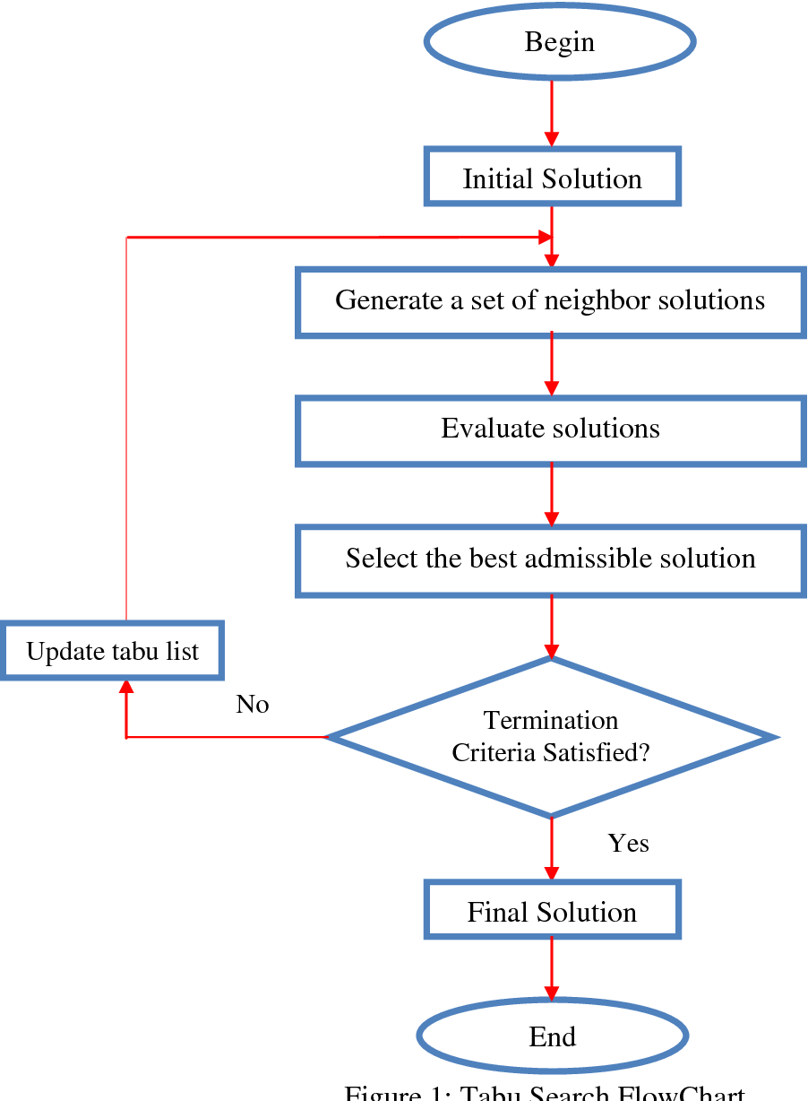

# RESULTS AND COMPARISON

**Genetic Algorithm:**

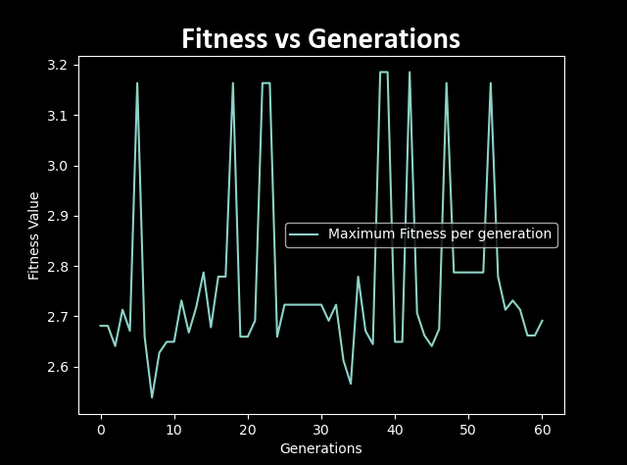

**Best Solution Obtained:**

[1, 0, 1, 1, 0, 1, 0, 0, 1, 1]

**Best Solution Fitness Value:**

3.1854

So, customers 1,3,4,6,9, and 10 will have their loan sanctioned.

**Amalgamation of Genetic Algorithm and Tabu Search:**

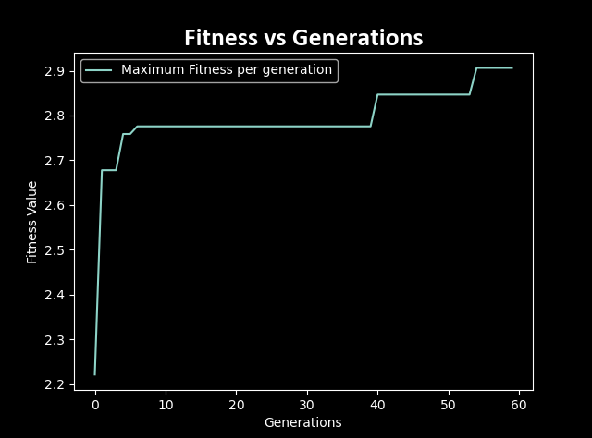

**Best Solution Obtained:**

0, 0, 0, 1, 1, 1, 0, 0, 1, 1]

**Best Solution Fitness Value:**

2.7872

So, customers 4,5,6,9 and 10 will have their loan sanctioned.

Comparing the Algorithms:

|  |  |  |
| --- | --- | --- |
|  | Best Fitness | |
| Iteration Number | GATS | GA |
| **25** | 2.9147 | 3.2911 |
| **50** | 2.9147 | 3.3029 |
| **60** | 2.9063 | 3.3029 |
| **75** | 2.9147 | 3.3029 |
| **100** | 3.3029 | 3.3029 |
| **125** | 3.3029 | 3.3029 |

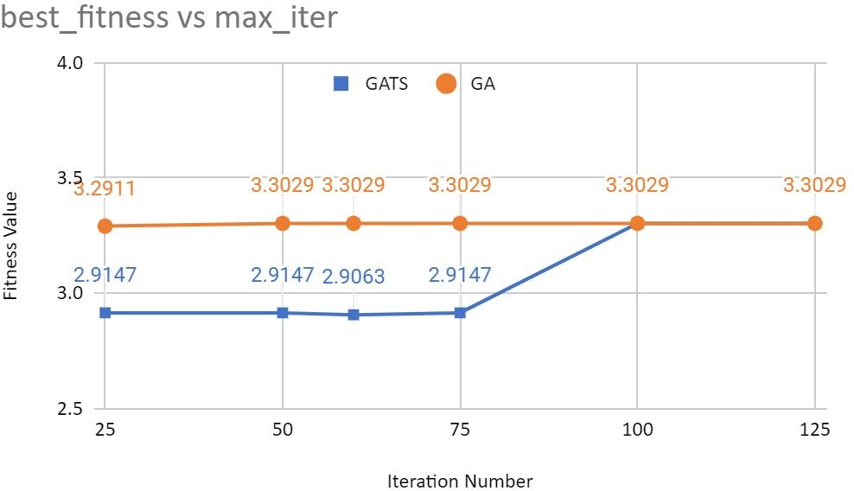

Inference:

1. Convergence rate of GA is better than GATS. Reason for Convergence of GATS is lesser than GA is that maintaining Tabu list reduces exploration.
2. At max iterations = 60, GA achieved optimal solution, fitness value =3.1854, where as GATS solution has fitness value of 2.7872. Thus, performance of GA is better than GATS.

Performance of GATS could be improved by:

1. Having better aspiration criteria
2. Better method of choosing neighborhood solution.
3. Tweaking probability of mutation