Basic things before evry website

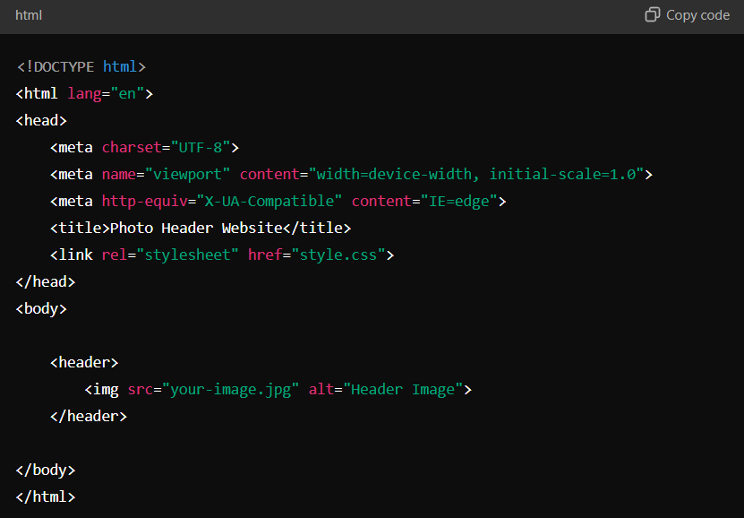

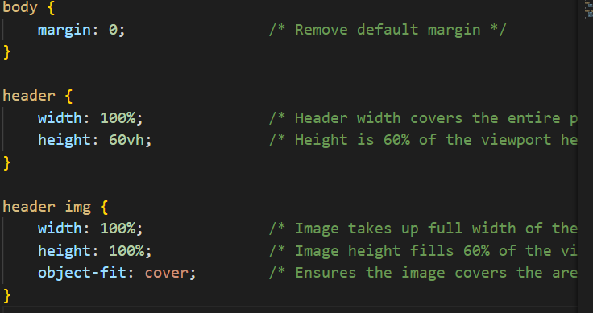

For writing over an image

<div class="overlay-text">Your Left-Aligned Text Here</div> in the html file.

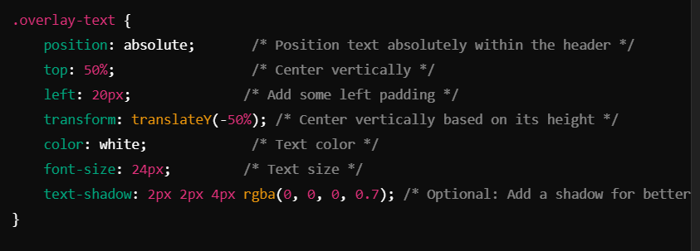

In the style.css

<nav class="top-nav">

            <a href="index.html">Intro</a>

            <a href="projects.html">Projects</a>

        </nav>

The above is to navigate from one page to other in the same website

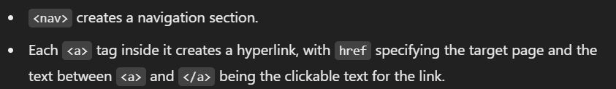

Using <div>

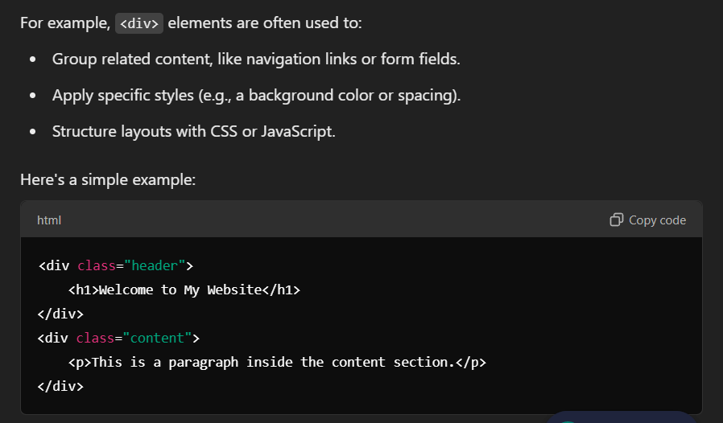

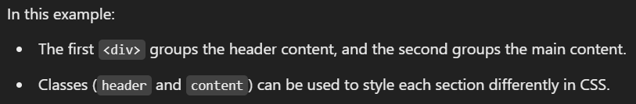

When you want anything with a different styling or font just use a different div for it

Use of <p>

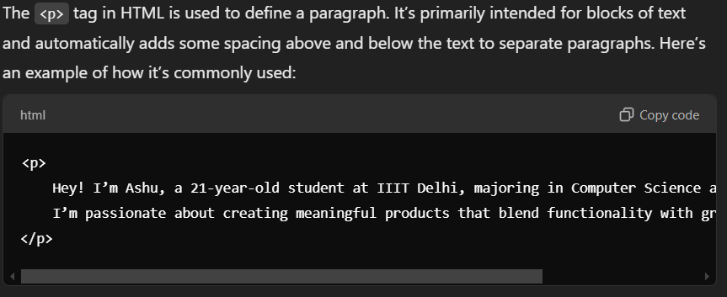

So if we make different div then its easy to do whatever we want but if we add div in a div in a div then the previous div becomes the margin.