Timer

=====

This is timer for keeping time at various events. Use is with care.

Two versions

============

1. Fancy Timer - animation and more.

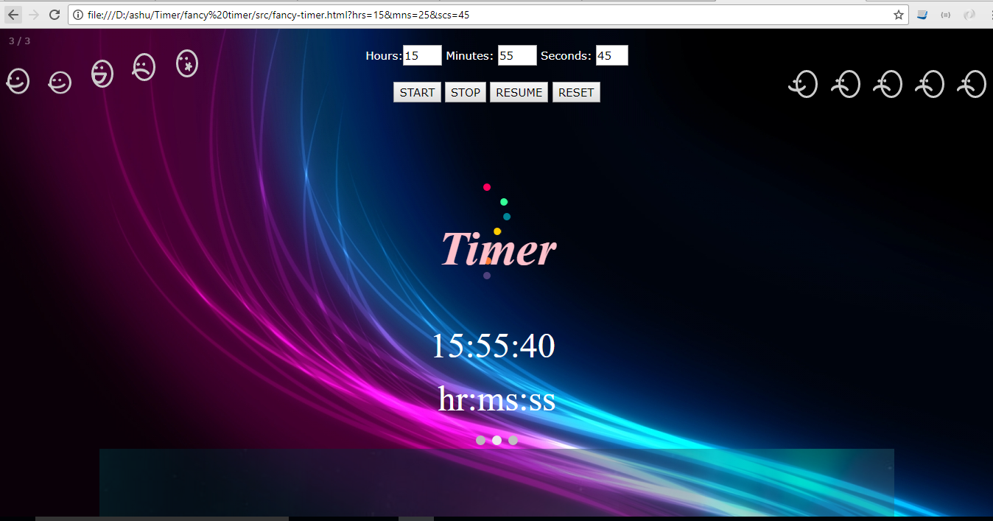

2. Simple Timer - plain old simple timer.# timer

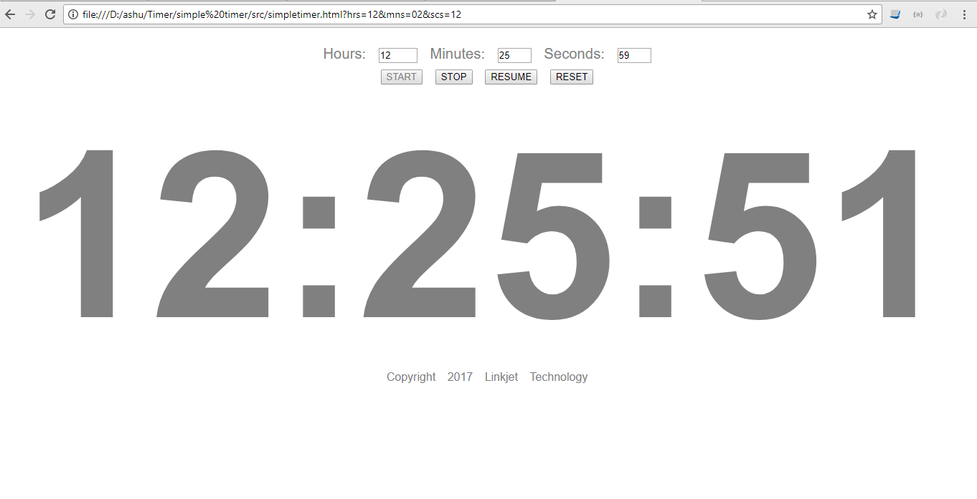

License and copyright

====================

Licensed under the [MIT License](LICENSE)