**DATABASES 4**

**JDBC Assignment**

**FOOTBALL FIELD**

**BOOKING SYSTEM**

ASHUTOSH MISHRA

A00268734

1. INTRODUCTION

Through this project, a football field booking system has been created using JDBC, Java Swing and MySQL Workbench. The football field booking system is an application which can be used by football field manager to book the football field for practice or even for a tournament. The football clubs have to inform the admin about the date and time they want the booking on, and depending on the availability, the admin confirms the booking. This application will allow the admin to book, cancel, edit and view field booking details for various football clubs. If the any football club wants to view or update the booking details, they have to inform the admin. The admin also has the option of exporting the database into a CSV file for later reference.

1. APPLICATION SCREENSHOTS
2. Application GUI

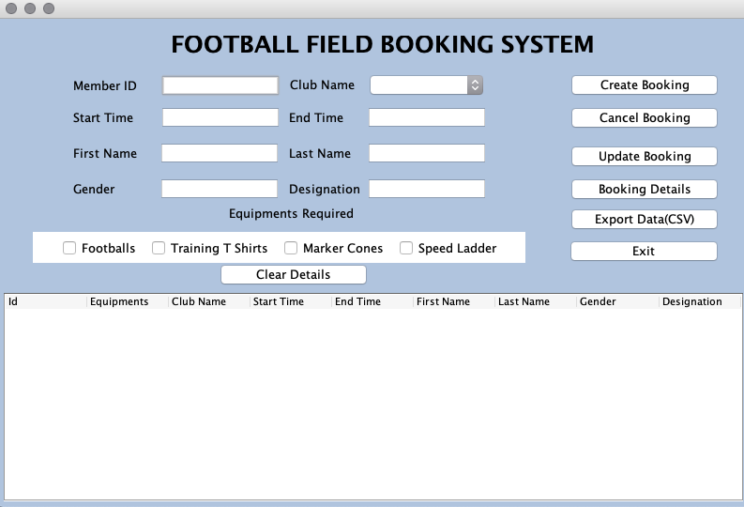

1. Create Booking

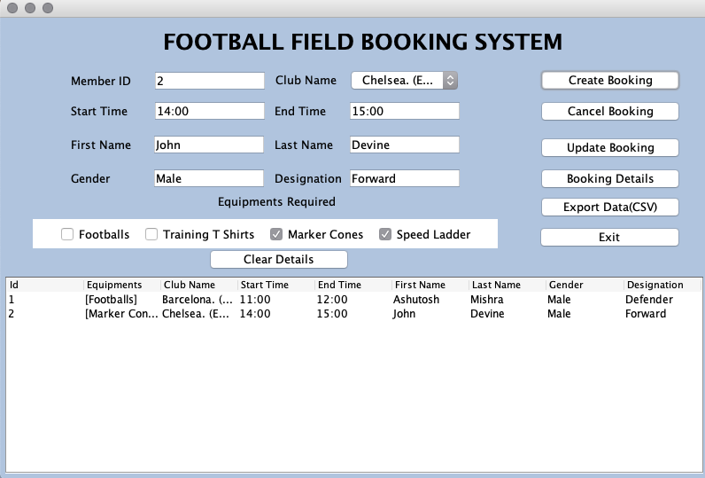

1. Update Booking

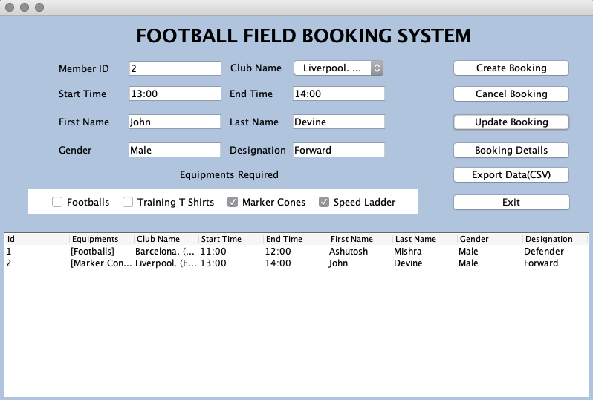

1. Booking Details

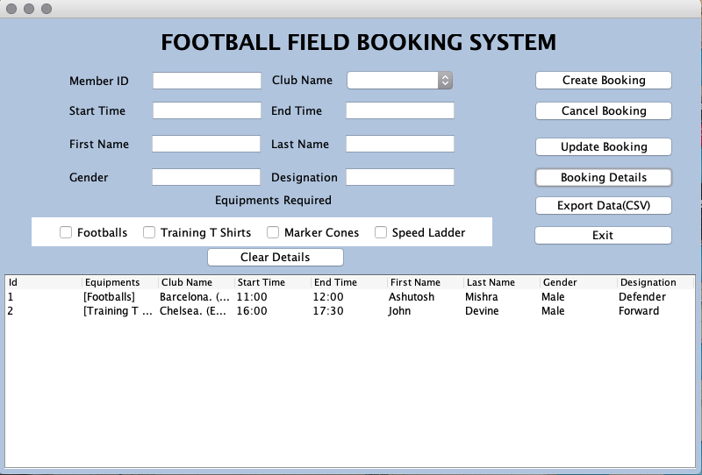

1. Delete Booking

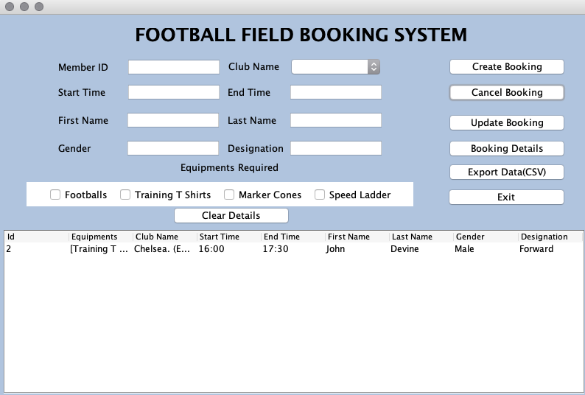

1. Database

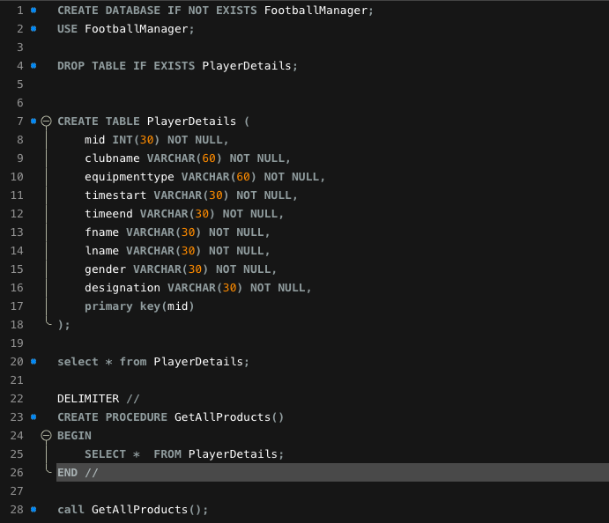

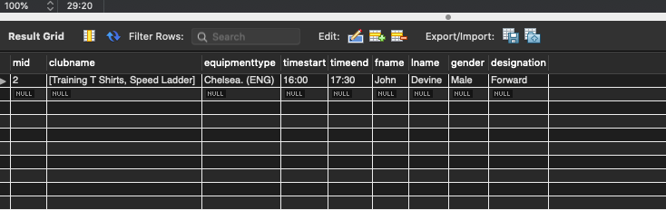

1. Exported CSV File

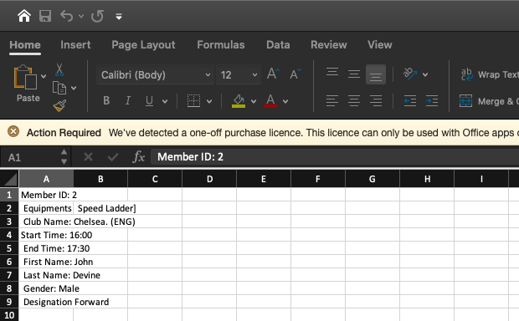

1. EXTRA FEATURES

I have used MySQL Workbench for this project. I have created the database for football field management which can be accessed by the admin to operate booking related options. I have used CRUD operations for database operations and Stored Procedure for getting the details of all the bookings. I have used 2 Buttons which can be used to clear the form details and to exit the application.

1. CONCLUSION

This application can be used by users to book football field for practice or for playing tournaments. The user has to share the details with the admin who will in turn book the field for the particular time and date.

While building this application I have learnt how to create real time applications using JDBC and Java Swing using MySQL Database while performing different SQL operations. Also, I have learned how to use BufferedWriter and FileWriter to write the data into the files in csv format.