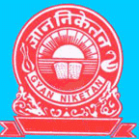

CO-CURRICULAR ACTIVITIES 


To inculcate leadership qualities, sportsmanship and co-operation among the Gyanis through games and sports, we have a large play ground of our own with facilities for Basketball, Volleyball, Football and Cricket. Our teams regularly take part in all the inter-school competitions in our area and have been doing fairly well in these tournaments.
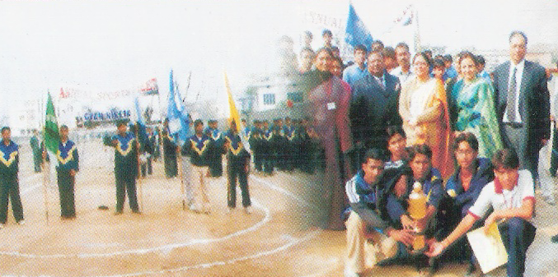

The school plans regular picnics and educational tours for the pupils. They are taken to historical places, museums, factories etc. to give them a first hand knowledge in all these fields.
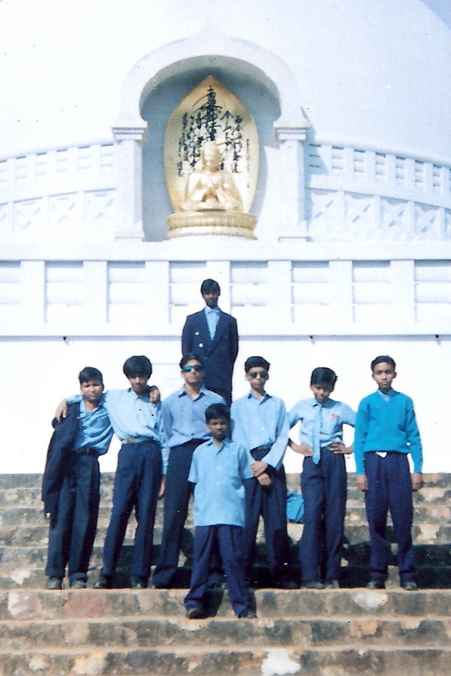

The school organizes an exhibition every year for Art, Crafts & Science.

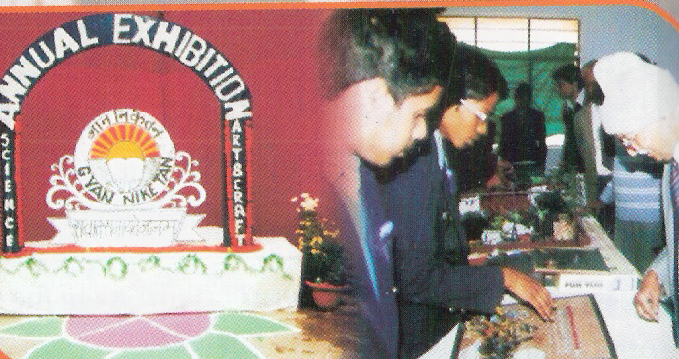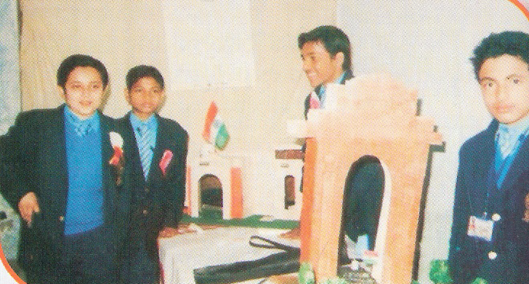
Co-Curricular Activities (VIDEO)

