

FACULTY ——————Biology

TEACHERS 

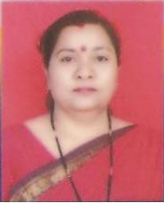
M.Sc.(Botany), B.Ed.

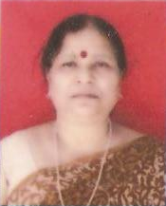
M.Sc.(Botany), B.Ed.

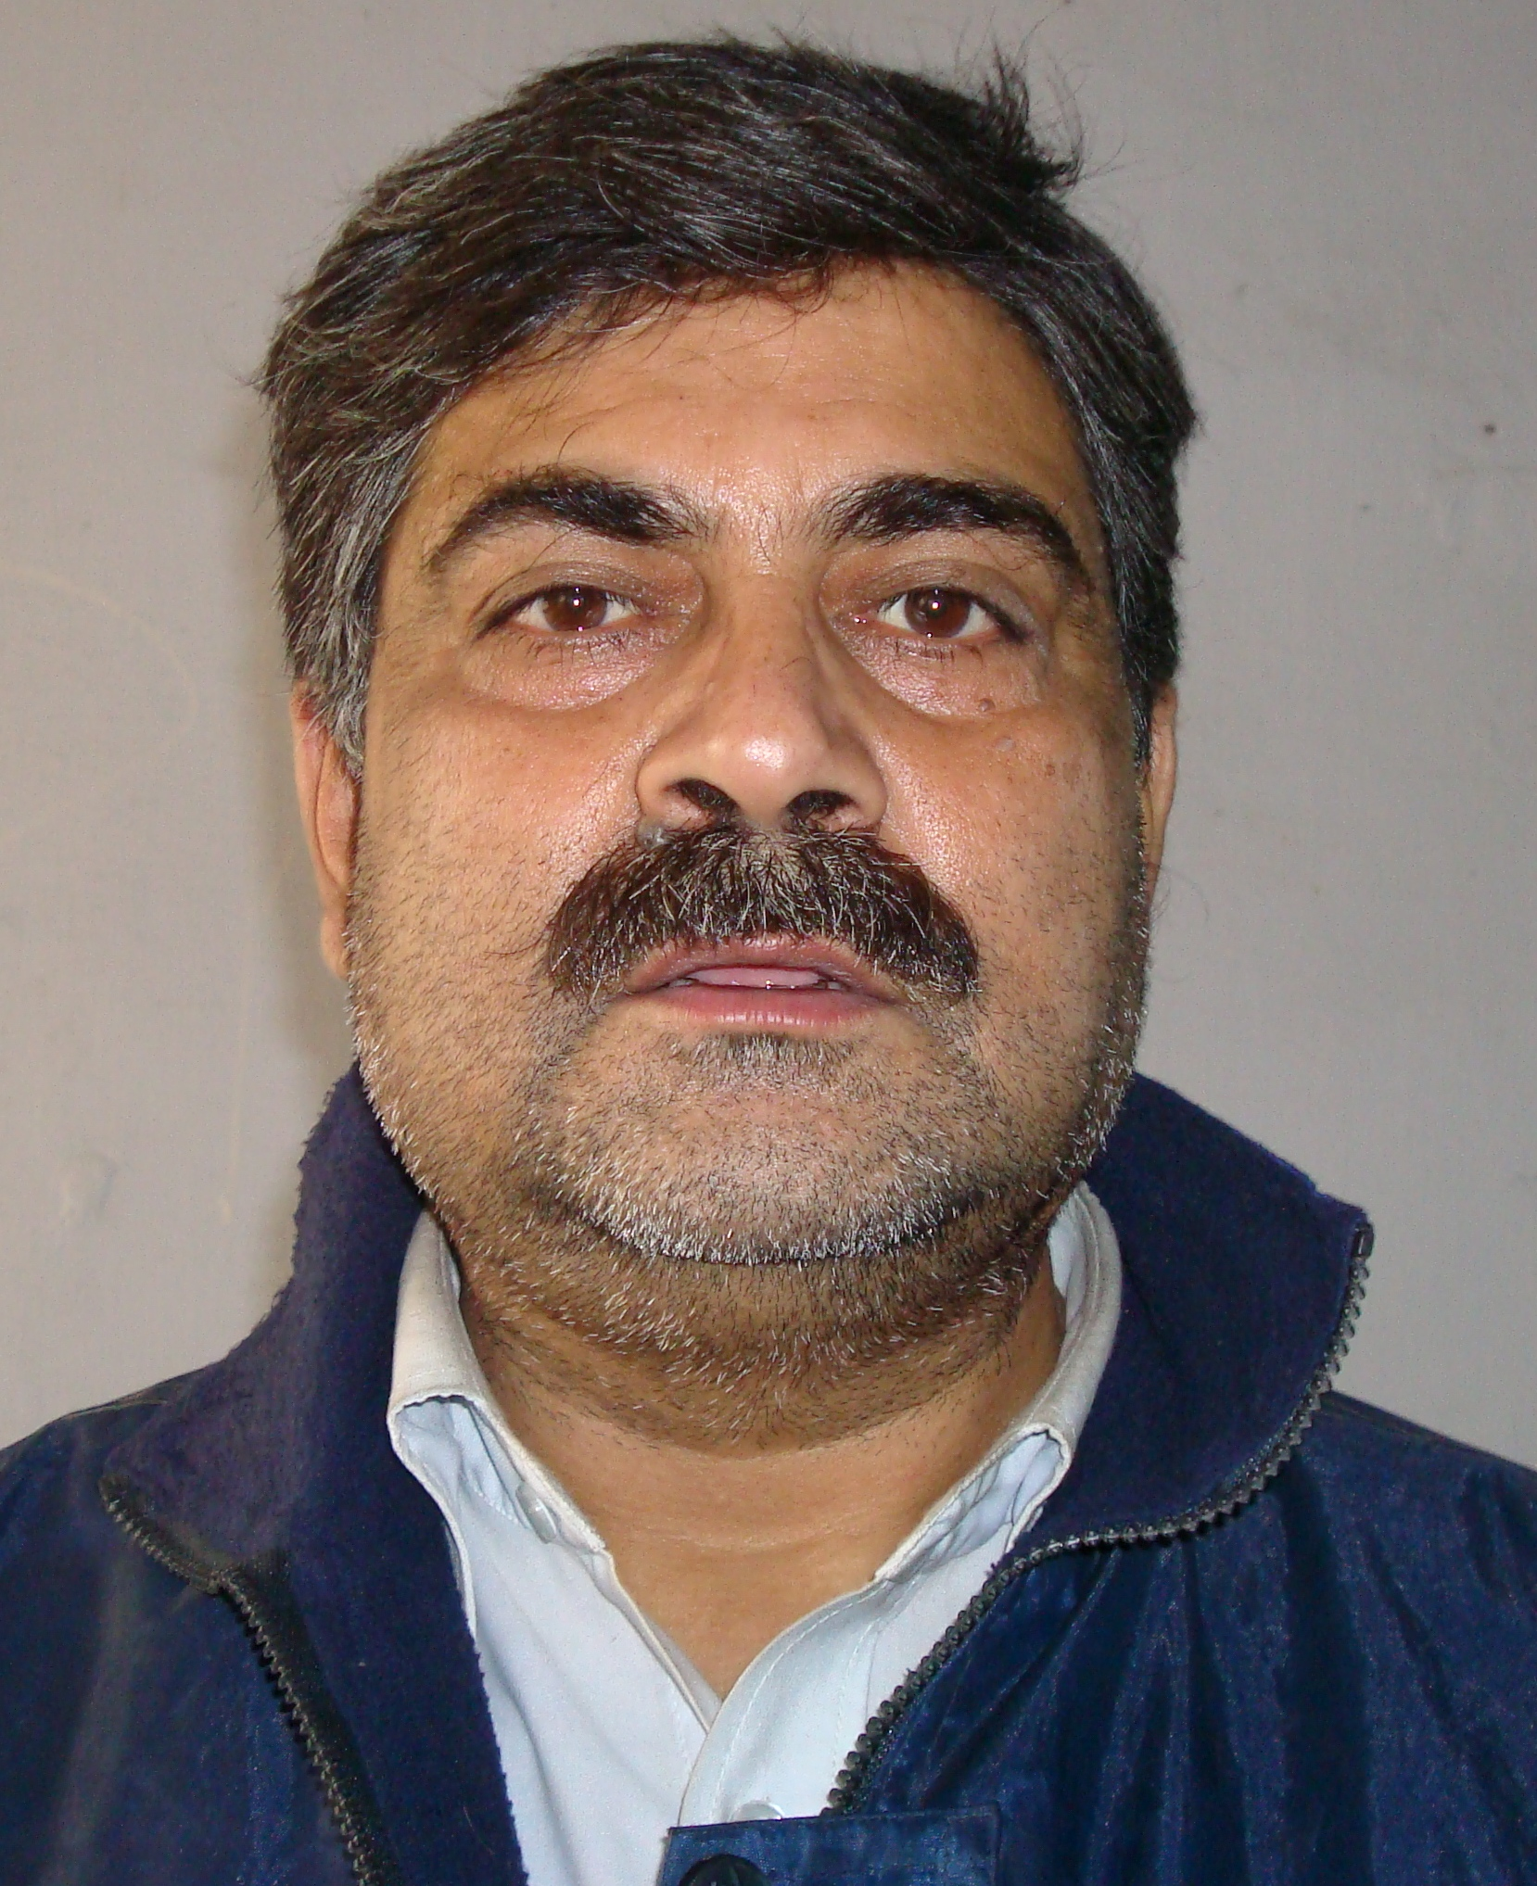
M.Sc. (Zoology), B.Ed.


M.Sc. (Zoology), B.Ed.


B.Sc., B.Ed.


B.Sc., B.Ed.

