

FACULTY ——————Chemistry

TEACHERS 

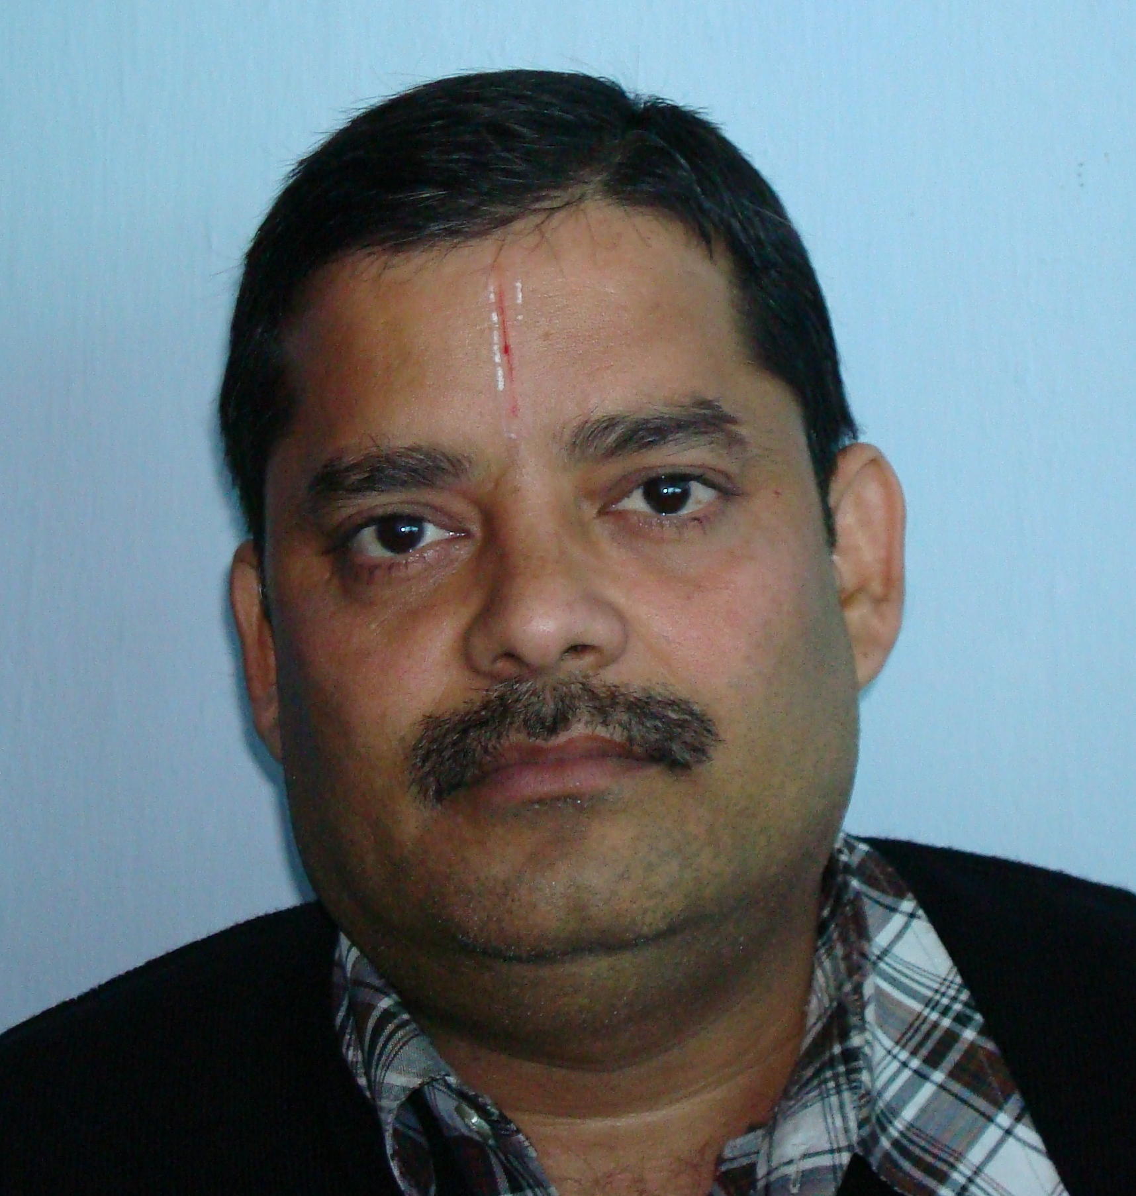
M.Sc. (Chem), B.Ed.

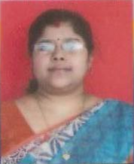
M.Sc.

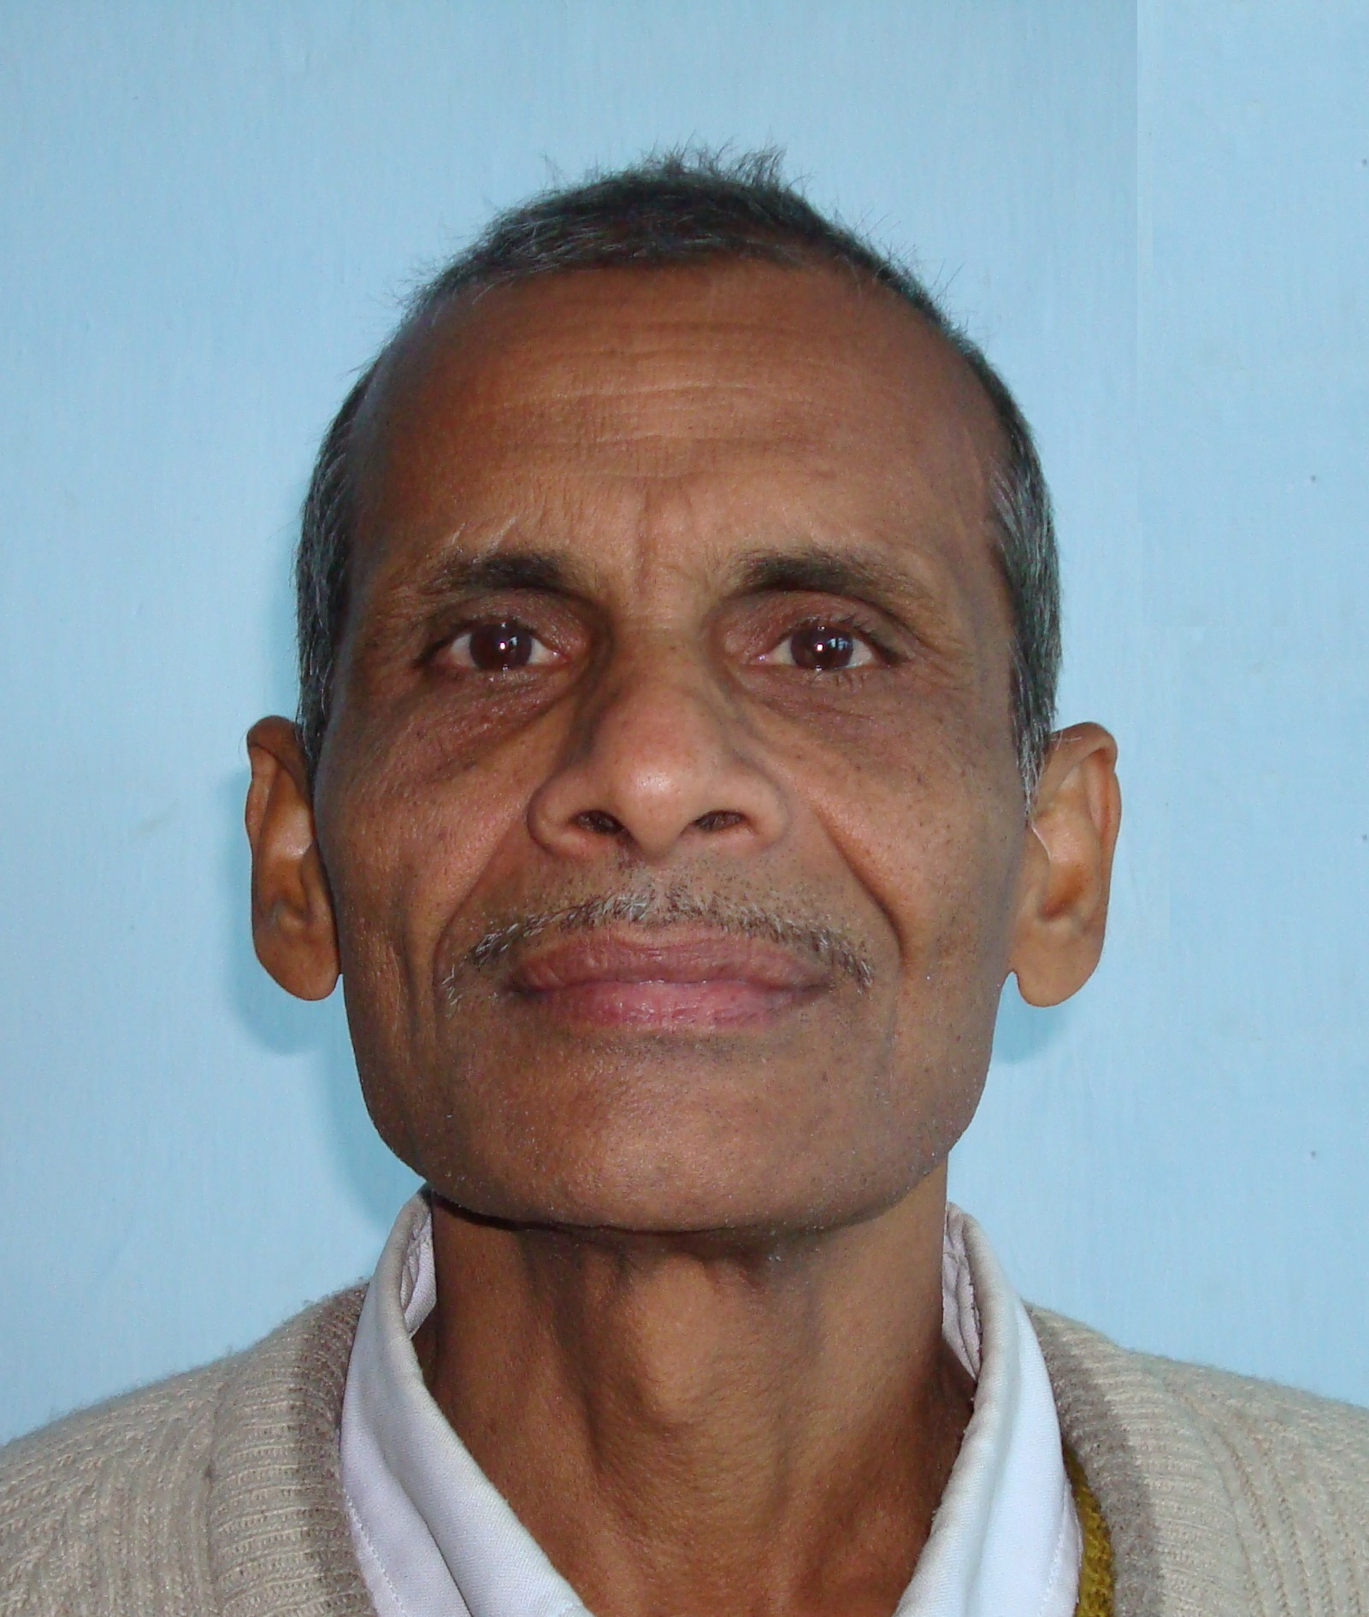
M.Sc., B.Ed.

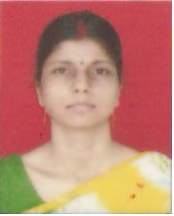
M.Sc., B.Ed.

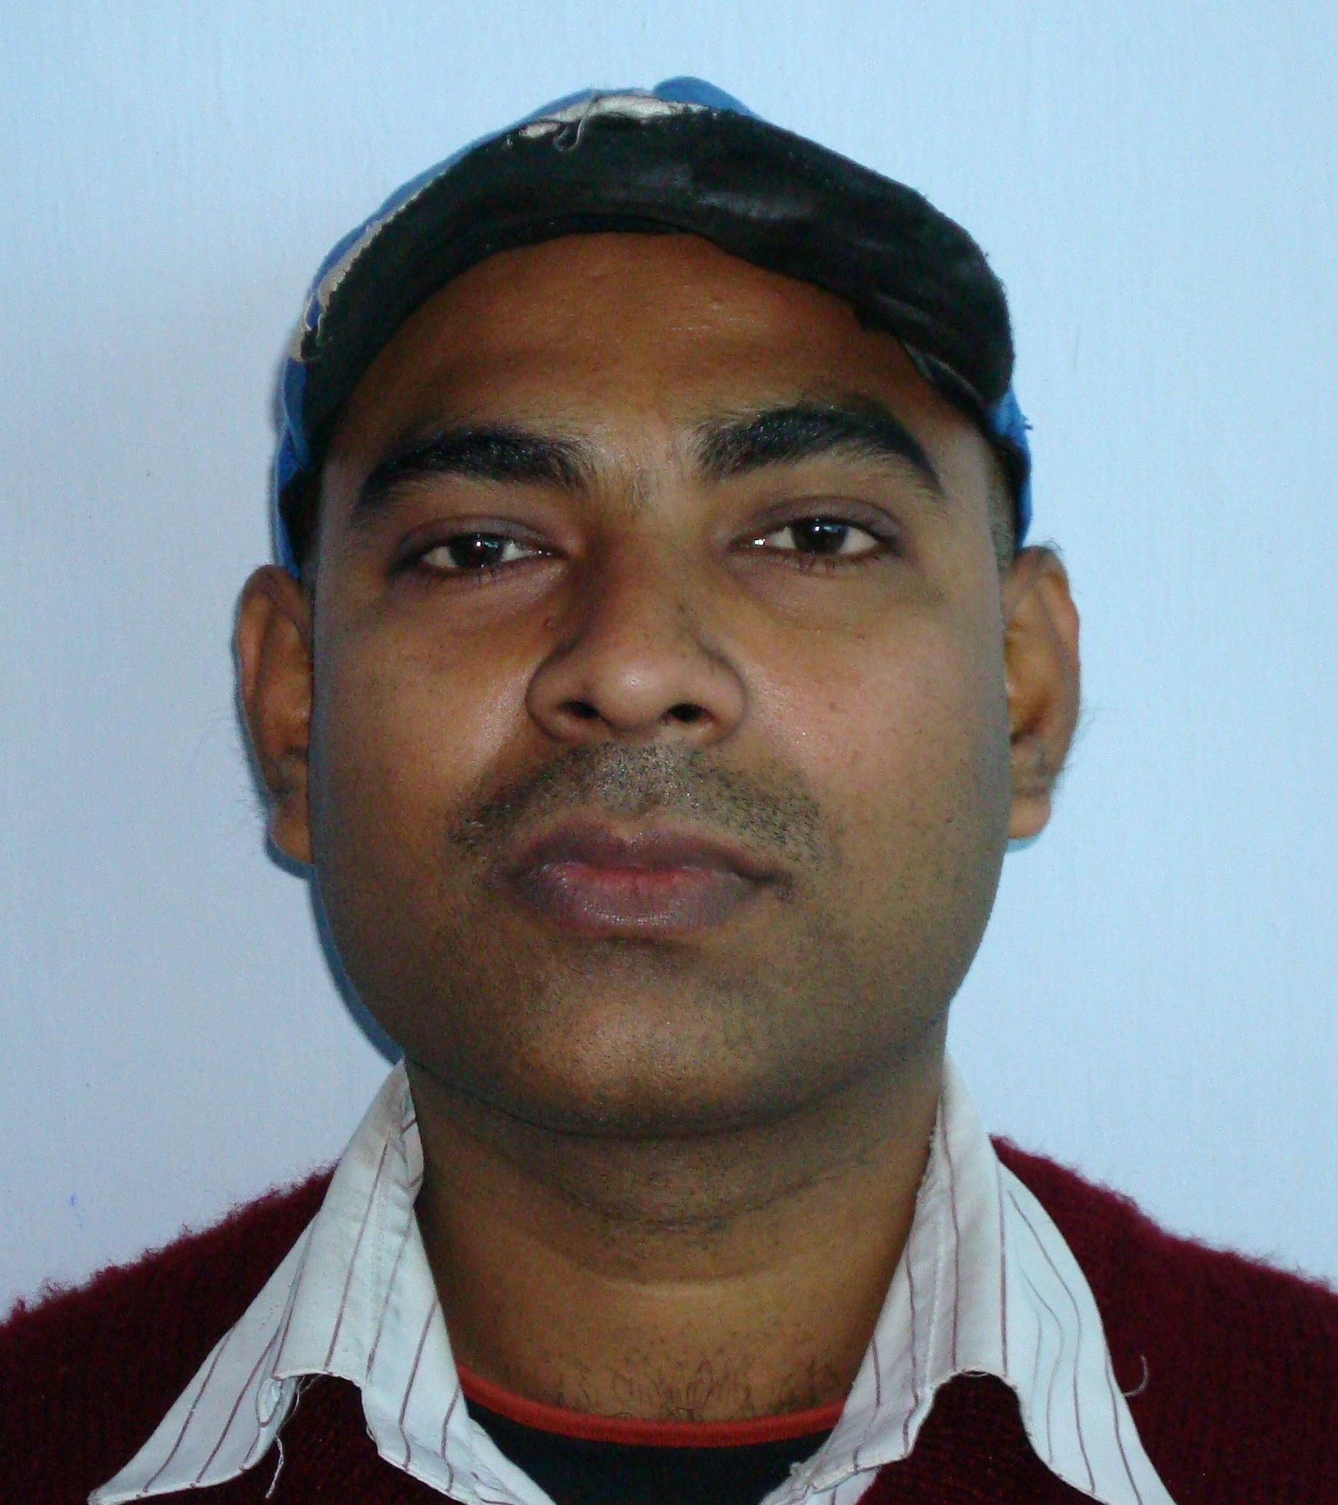
M.Sc., NET

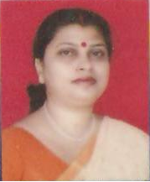
B.Sc. Hons.(Chem), B.Ed.,Shiksha Visharad

