

FACULTY ——————Commerce

TEACHERS 

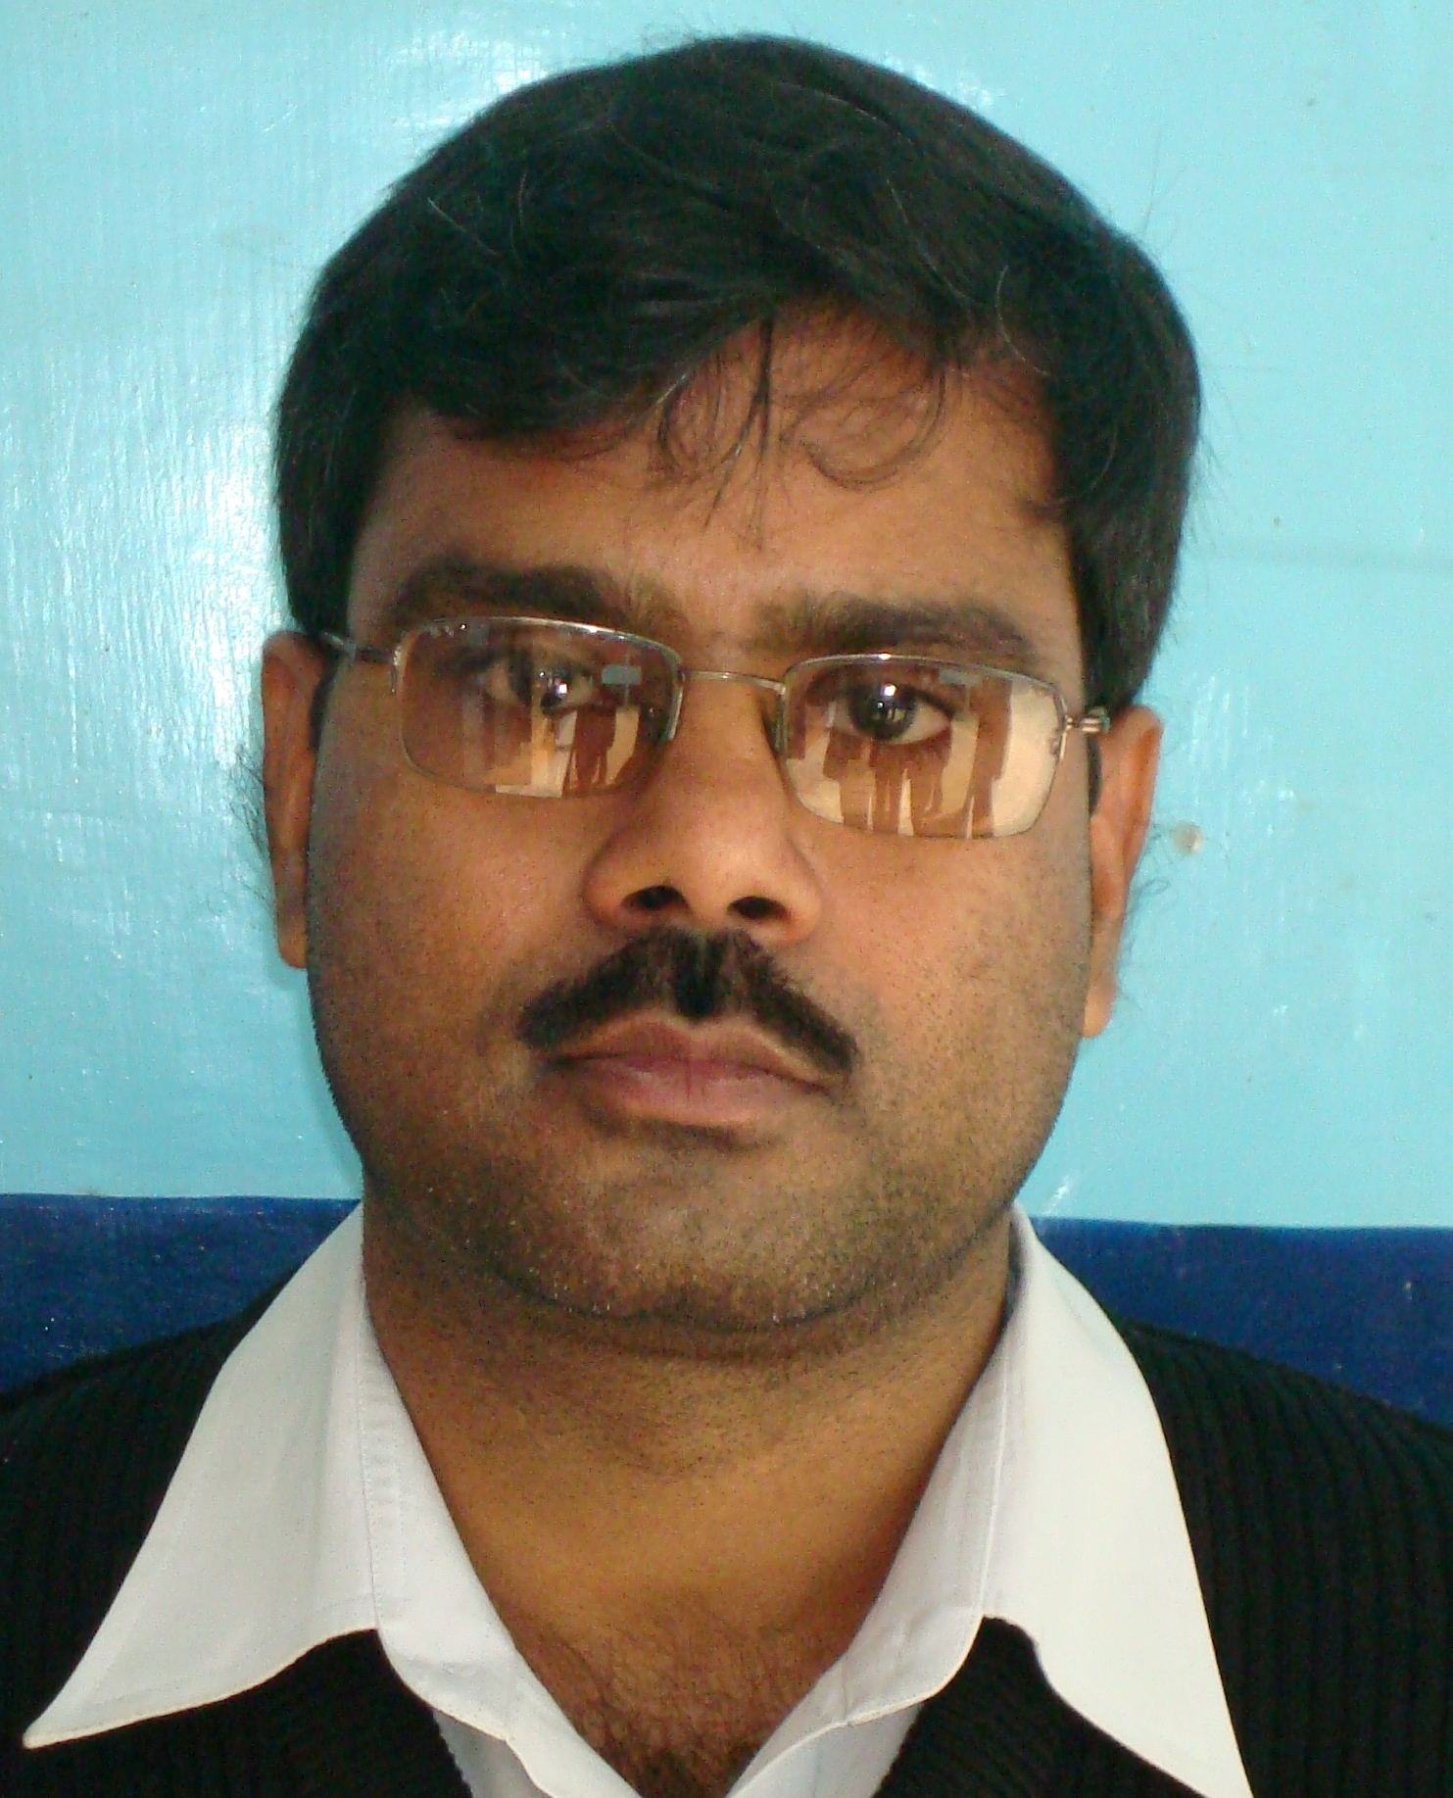
B.Com., C.S. (Inter)

