

FACULTY ——————Computer Science

TEACHERS 

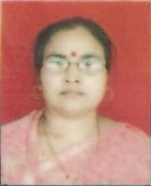
M.Sc.(Phy),Ph.D. , B.Ed., Computer(PGDCA),

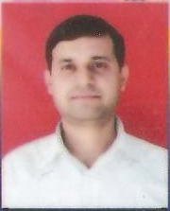
B.Sc.(Zoo) Hons.,CDAC,TISM,HDCS,PGDCA

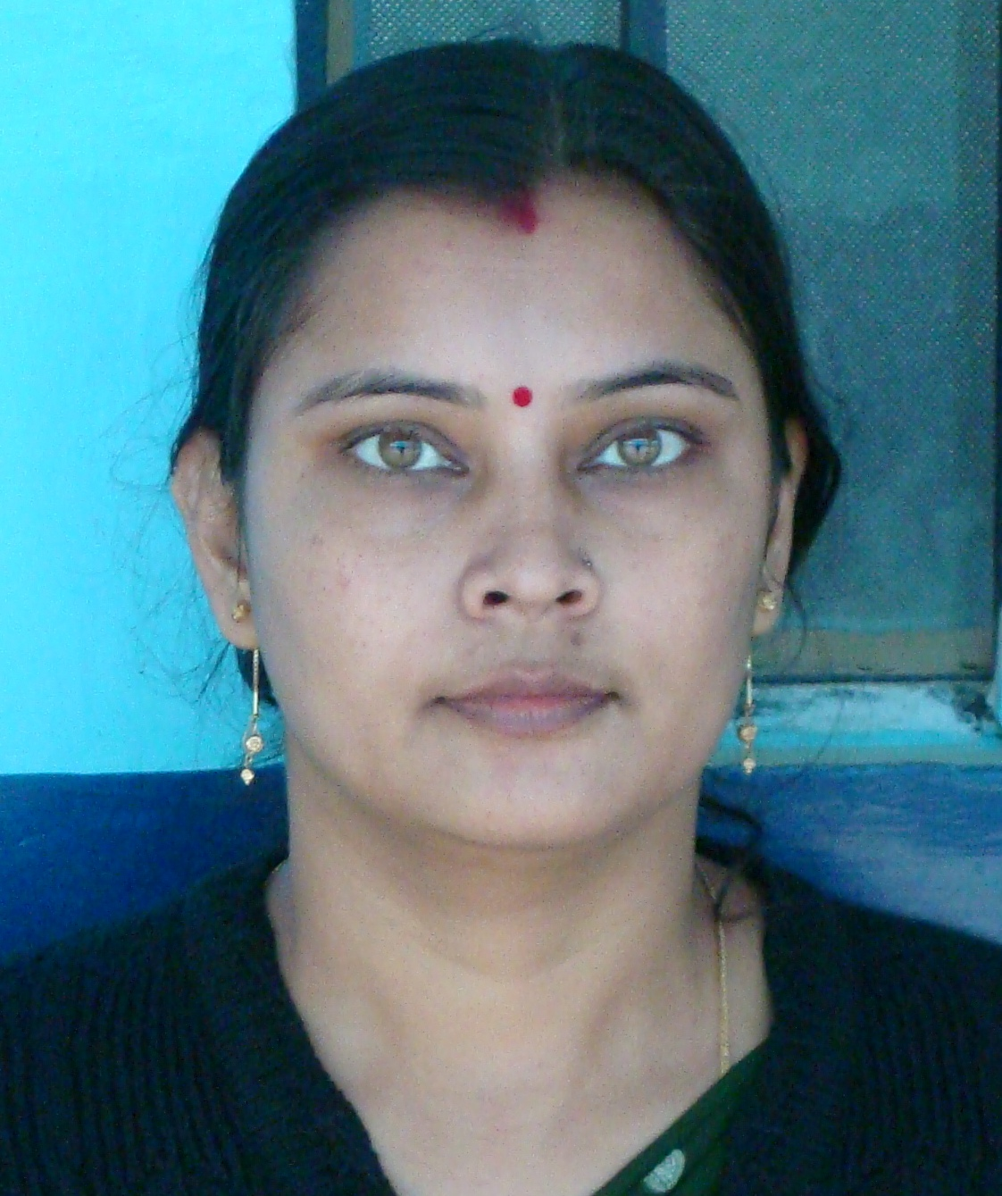
M.Sc.(Phy), M.C.A.

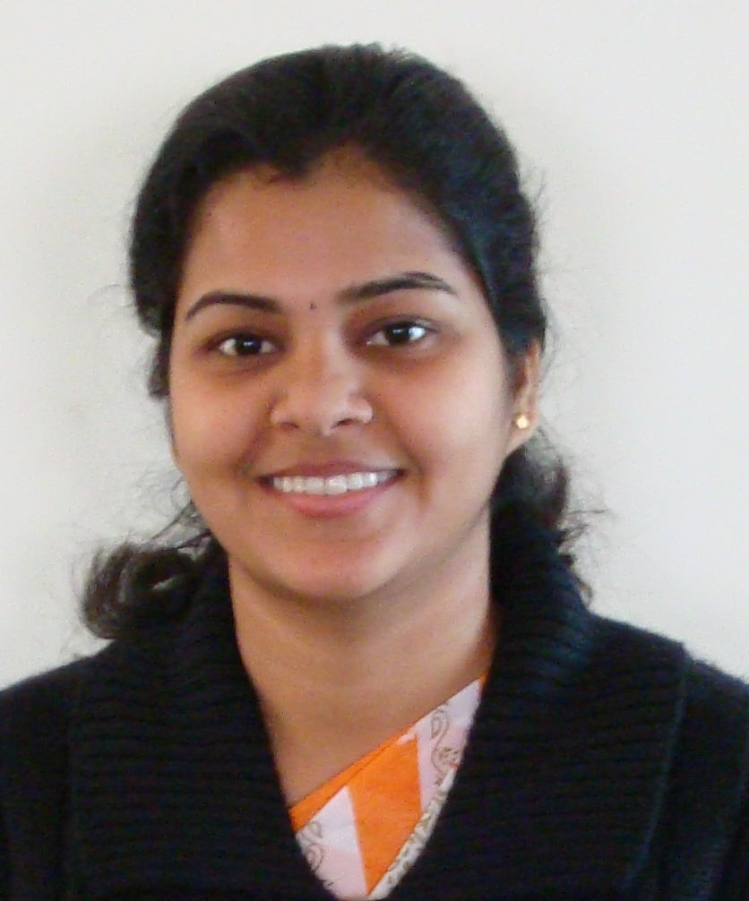
B.C.A.

