

FACULTY ——————Economics

TEACHERS 

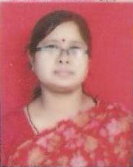
M.A.(Eco), B.Ed., Ph.D.

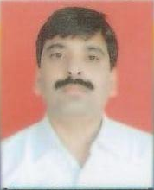
M.A.(Eco), B.Ed., C.S.(Inter)


M.A.(Eco), B.Ed.

