

FACULTY ——————Geography

TEACHERS 

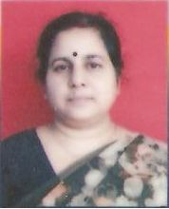
M.A.(Geog), B.Ed.

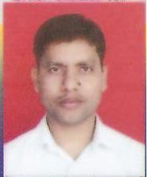
B.A.(Hons Geog), B.Ed.

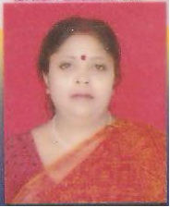
M.A.(Geog), B.Ed.

