

FACULTY ——————Hindi

TEACHERS 

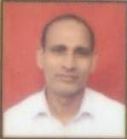
M.A.(Hindi), B.Ed.,Ph.D.

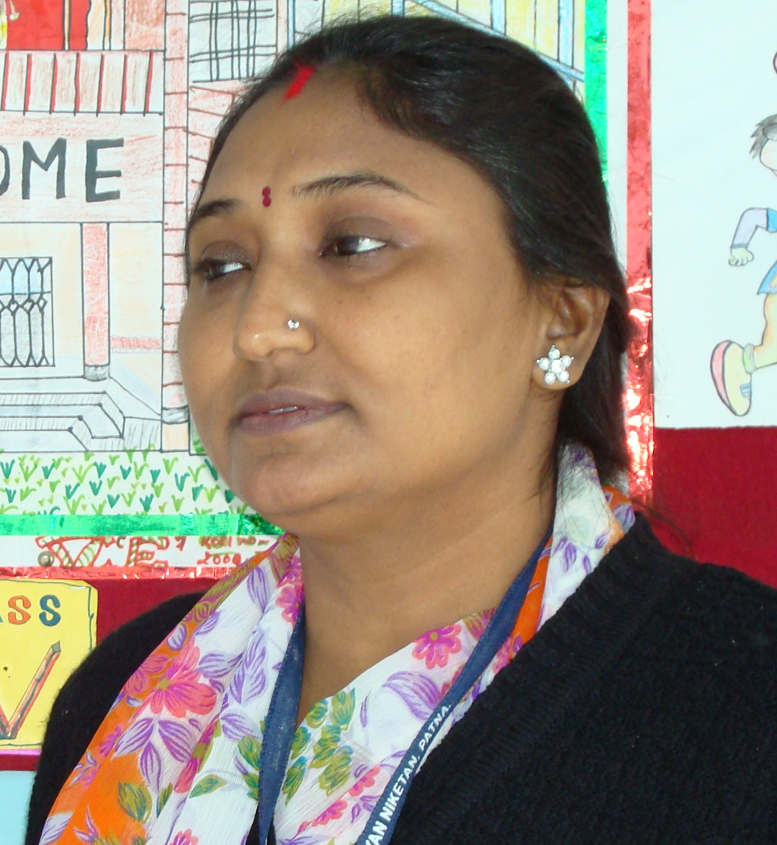
B.A.(Hindi), B.Ed.

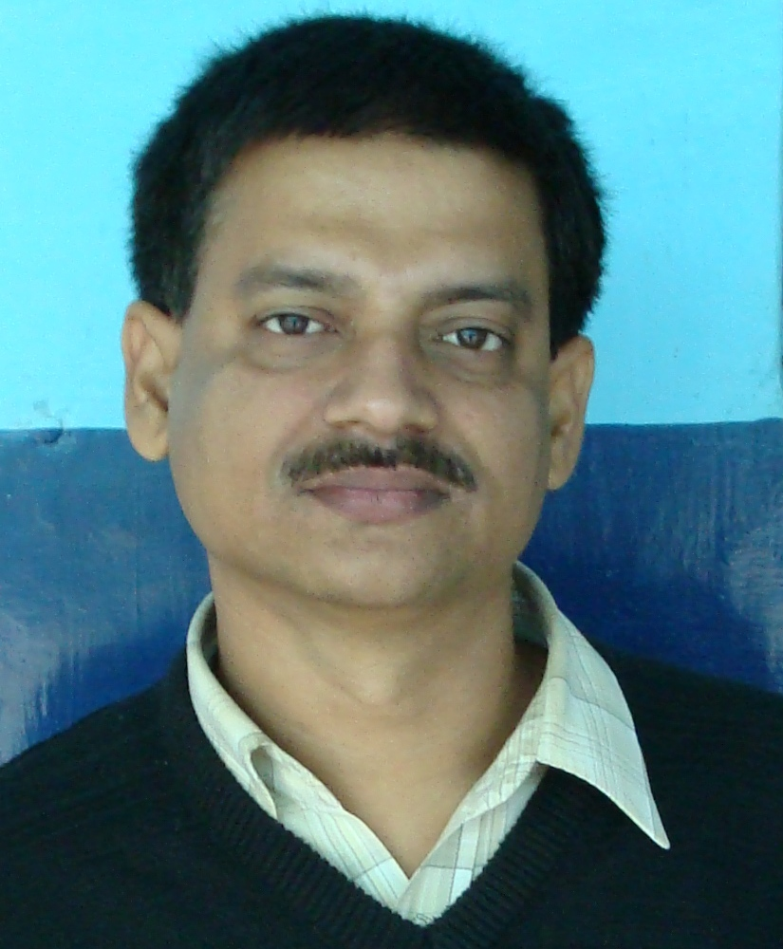
M.A.(Hindi),Acharya(Sans)

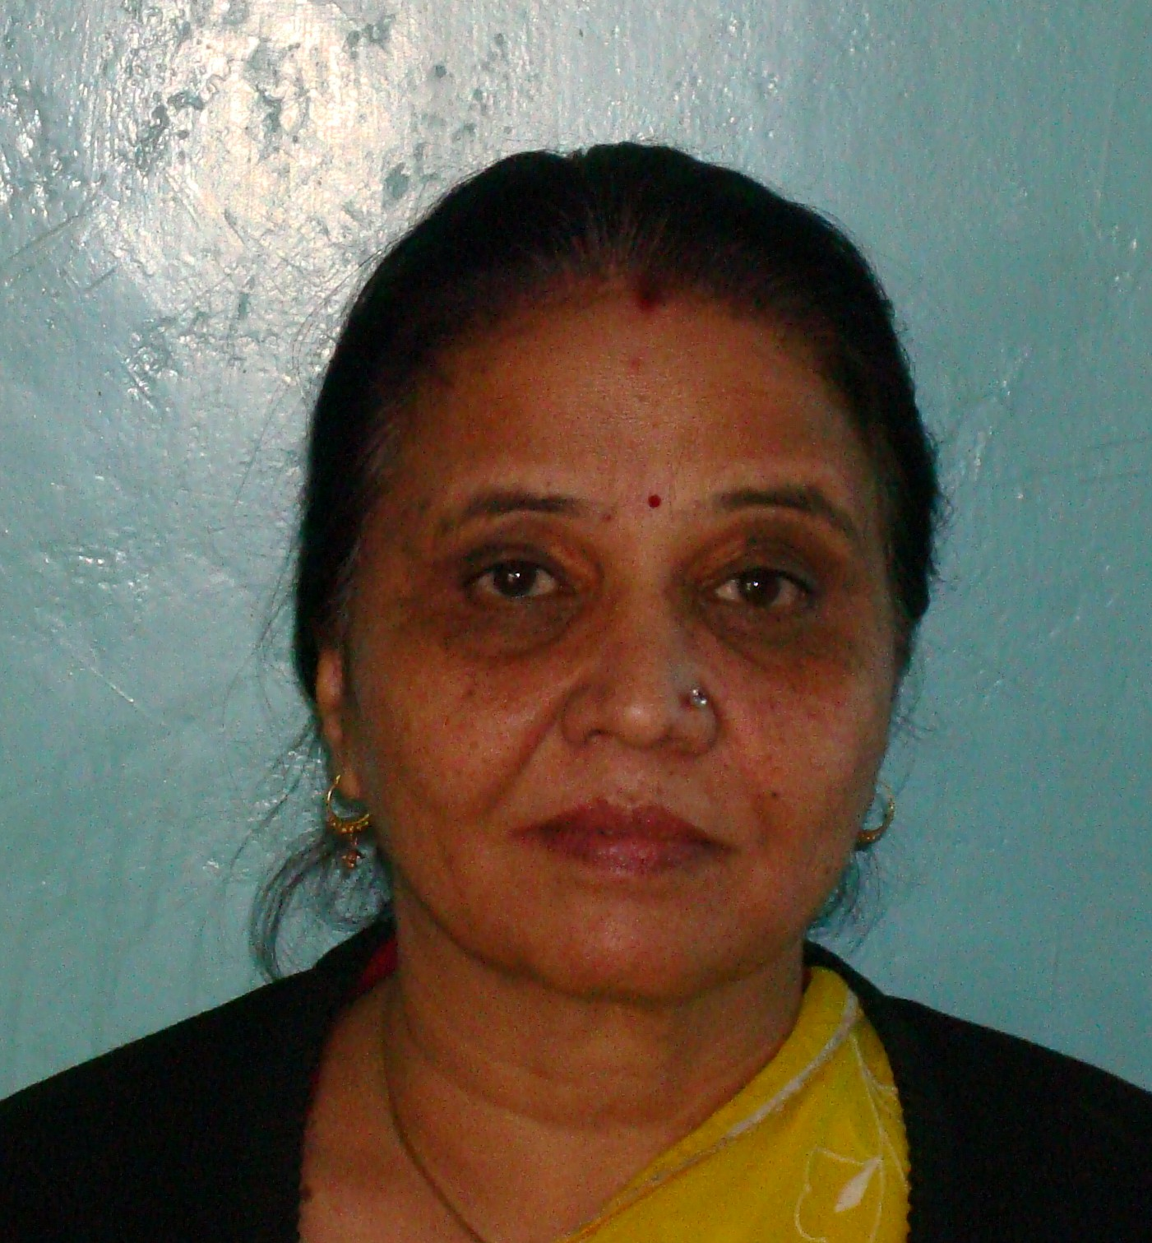
M.A.(Hindi), B.Ed.


M.A.(Hindi), B.Ed.

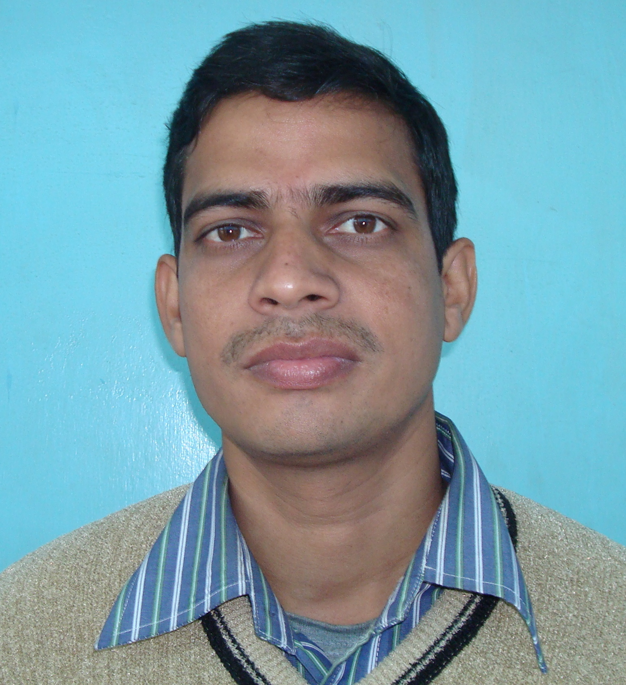
M.A.(Hindi), B.Ed.

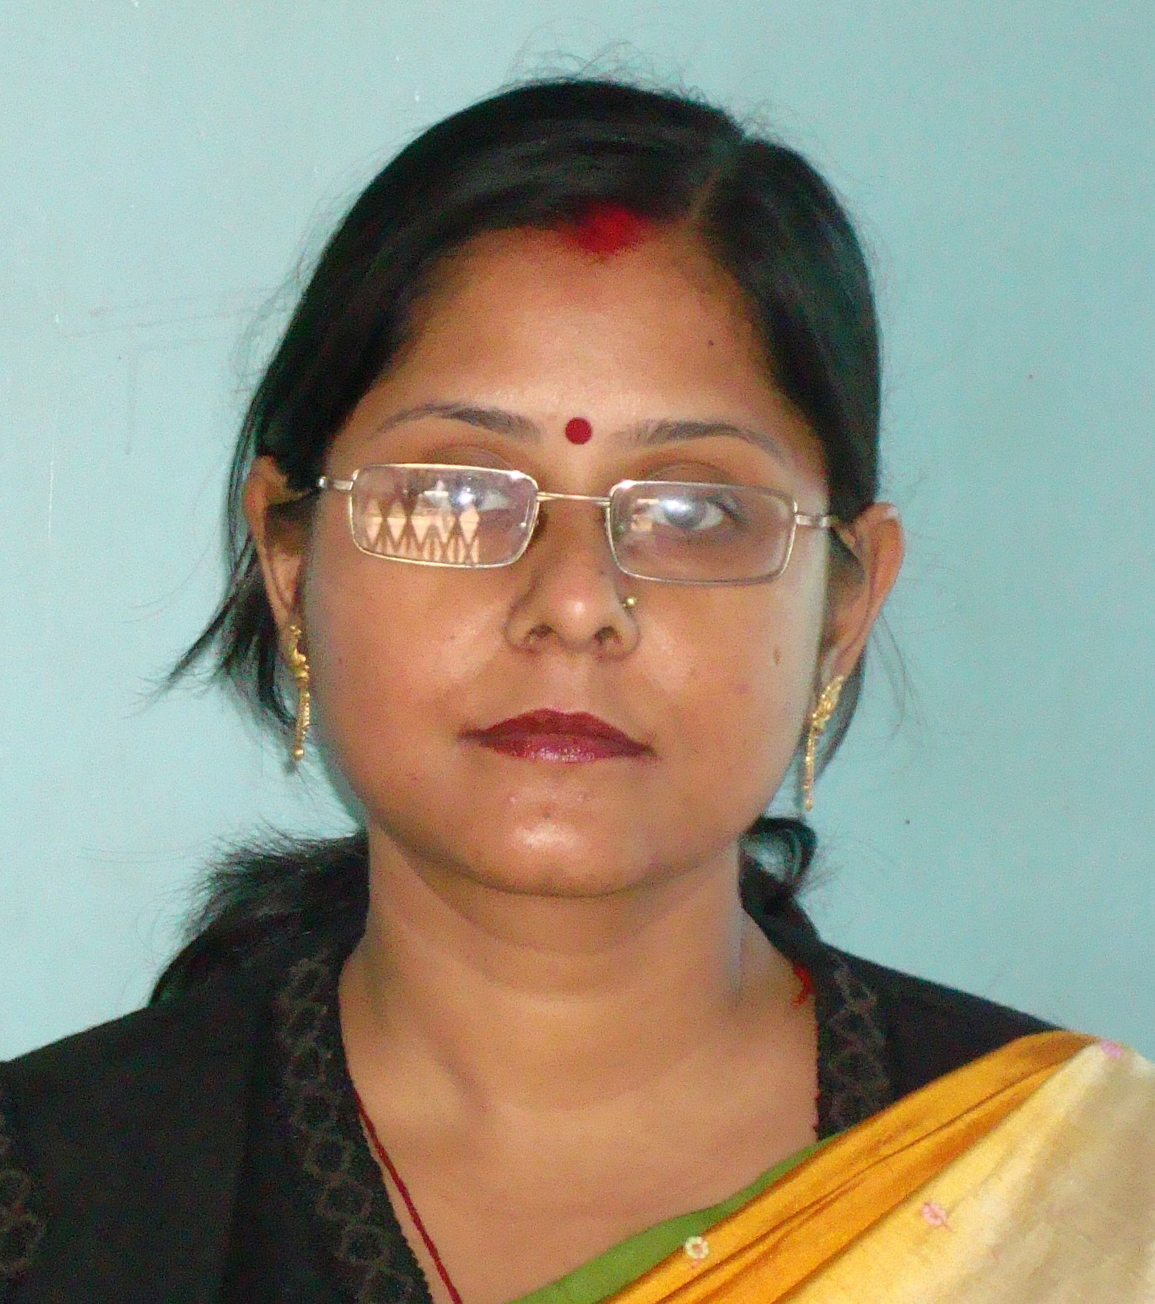
M.A.(Hindi), B.Ed.

