

FACULTY ——————History and Civics

TEACHERS 

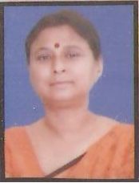
M.A.(History), B.Ed.

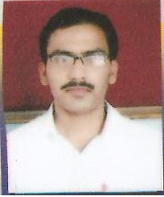
M.A., PGDAM

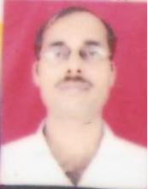
M.A., B.Ed.

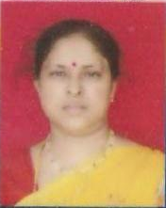
M.A.(Pol Sc), M.Ed.

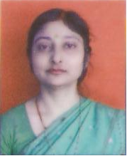
M.A.(Pol Sc), B.Ed.

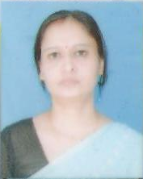
B.A., B.Ed.

