

FACULTY ——————Mathematics

TEACHERS 

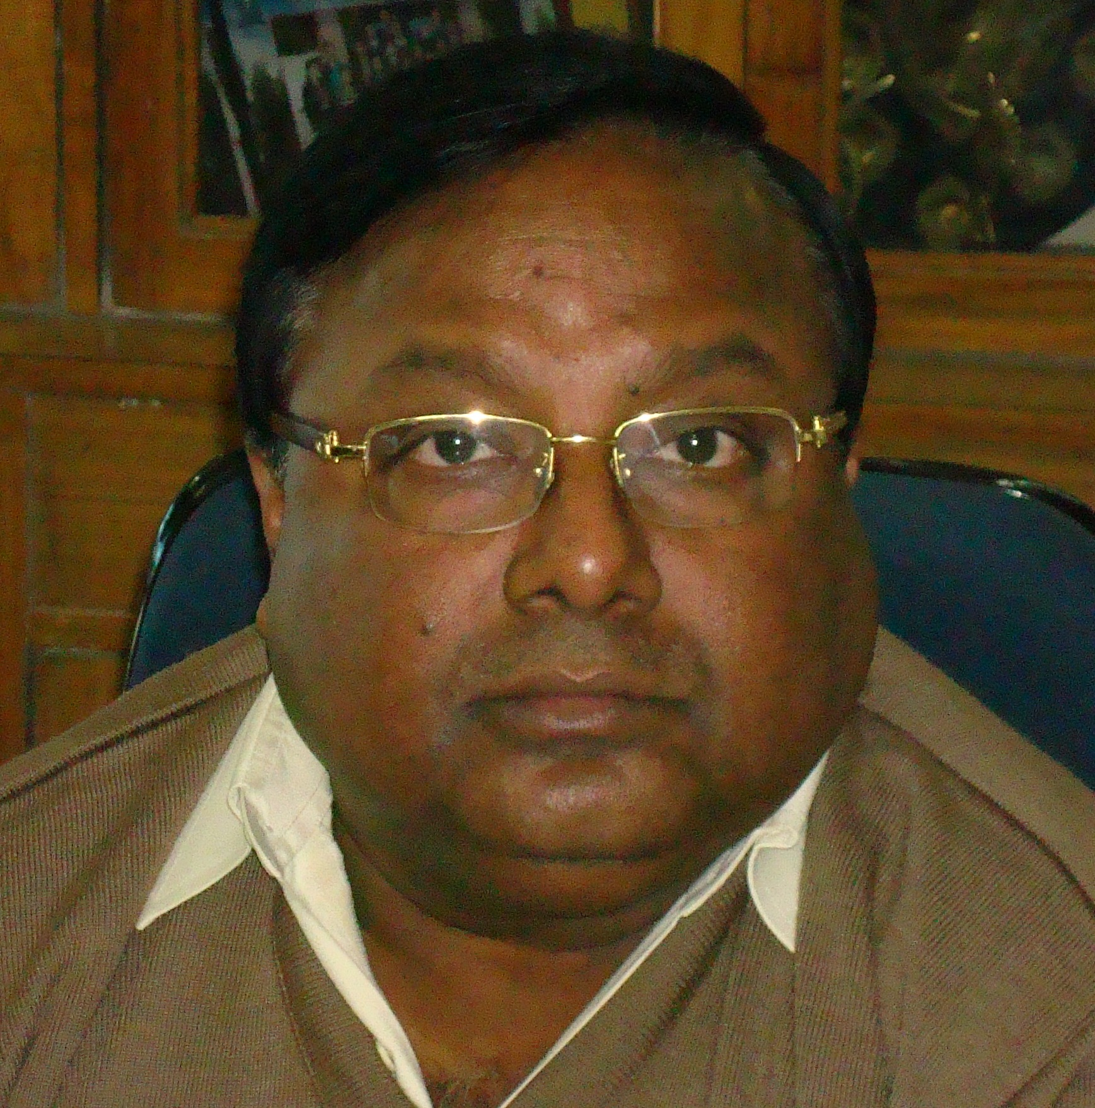
M.Sc.(Maths), B.Ed.

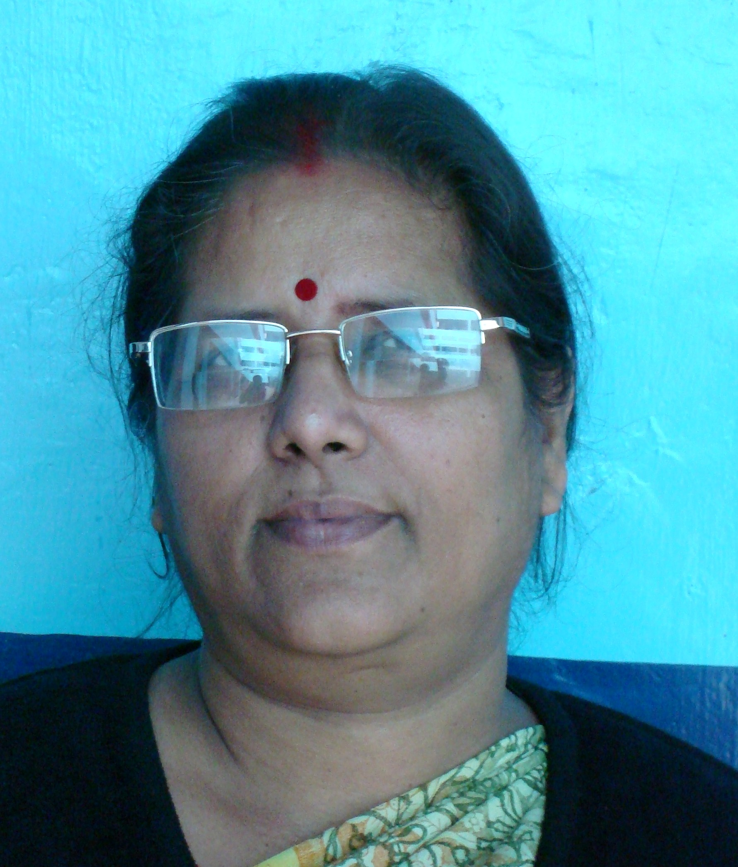
M.Sc.(Stat), B.Ed., Ph.D.

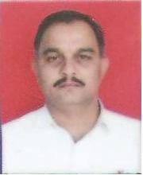
M.Sc.(Maths), B.Ed., Ph.D.

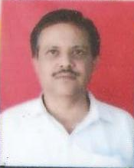
M.Sc.(Maths), Ph.D.

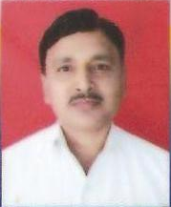
M.Sc.(Maths), B.Ed.

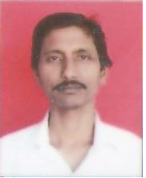
B.Sc.(Maths), B.Ed.

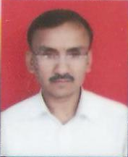
M.Sc.(Maths), B.Ed.

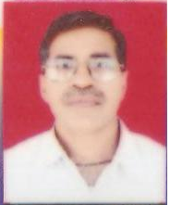
B.Sc.(Maths), C.T.P.M.(IGNOU)

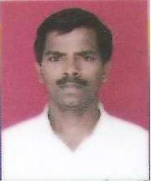
M.Sc.(Maths), D.P.C.S.

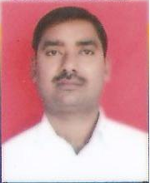
M.Sc.(Maths), B.Ed., DIPIETE

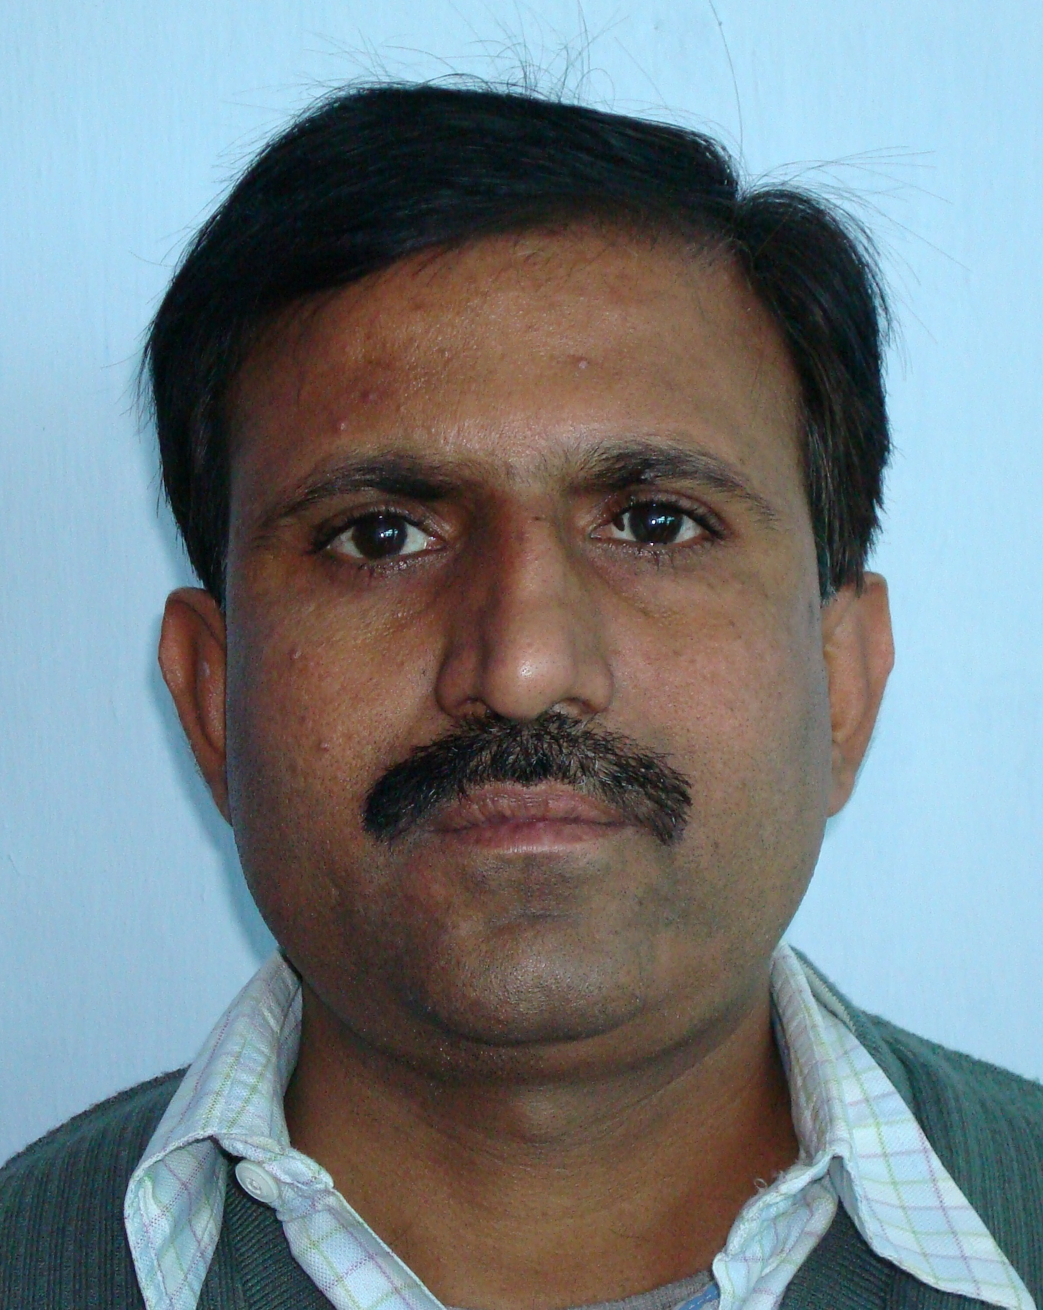
B.Sc., B.Ed.

