

FACULTY ——————Music

TEACHERS 

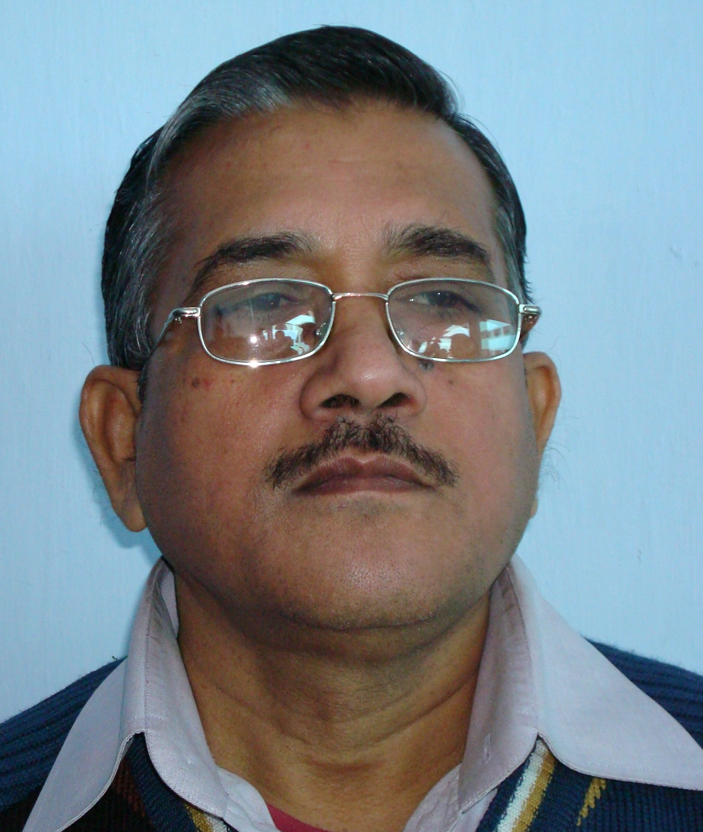
Sangeet Prabhakar, Visharad & Bhaskar

