

FACULTY ——————Physical Education

TEACHERS 

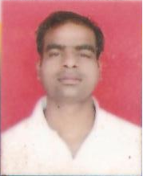
S.S.C.E., M.P.E.

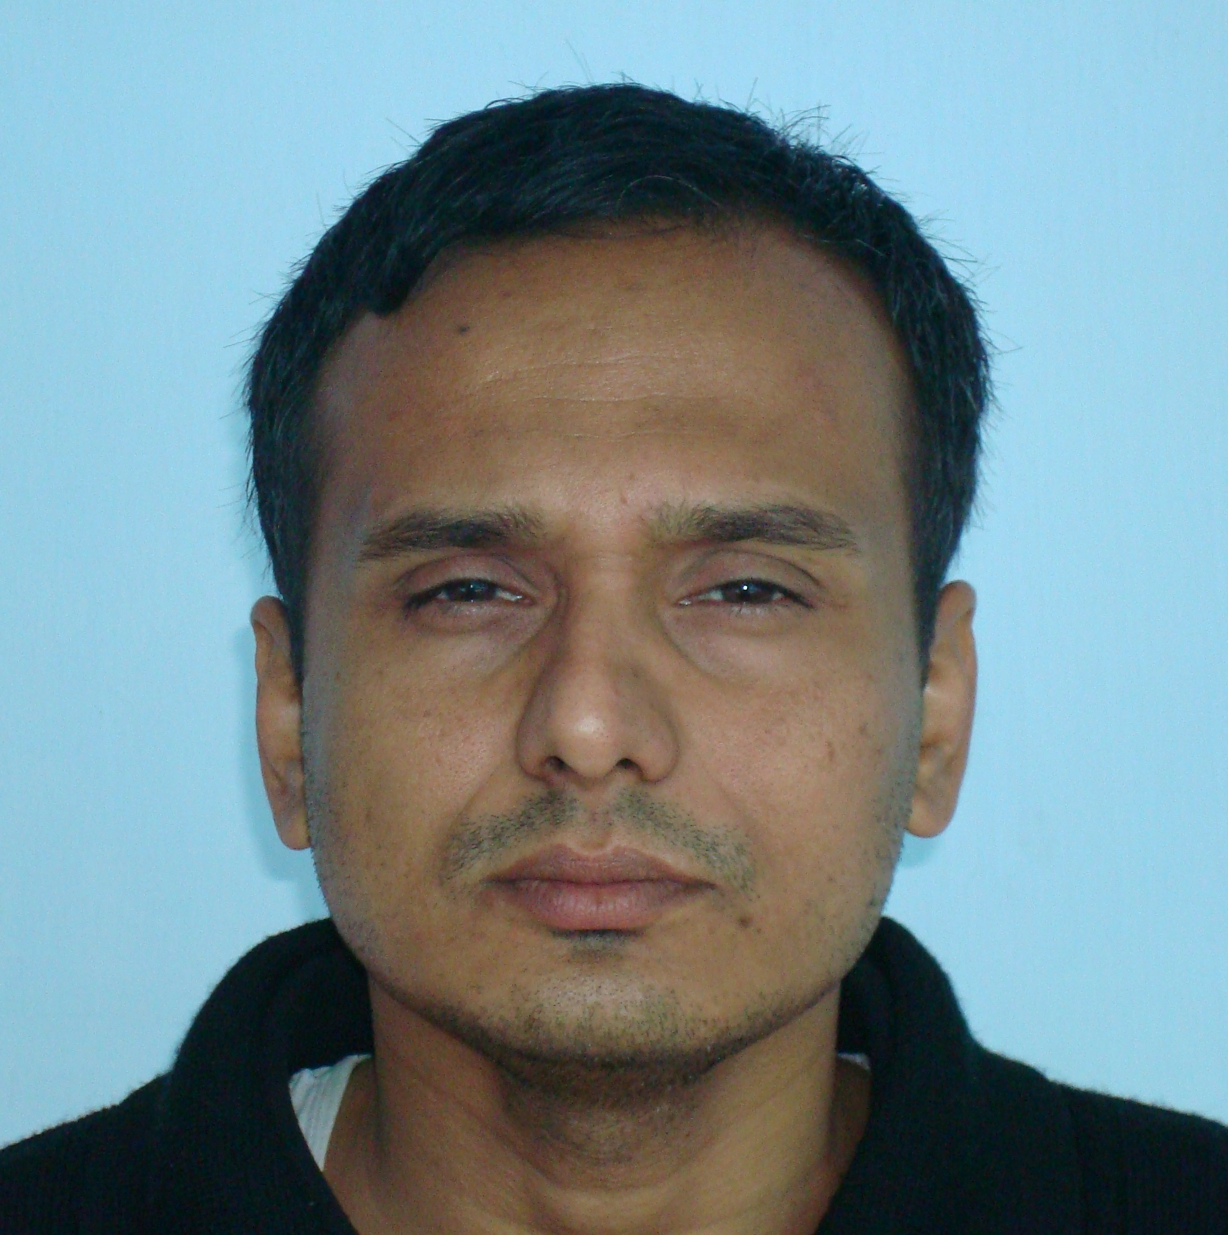
English (Hons), B.P.Ed., IRPM

