

FACULTY ——————Physics

TEACHERS 

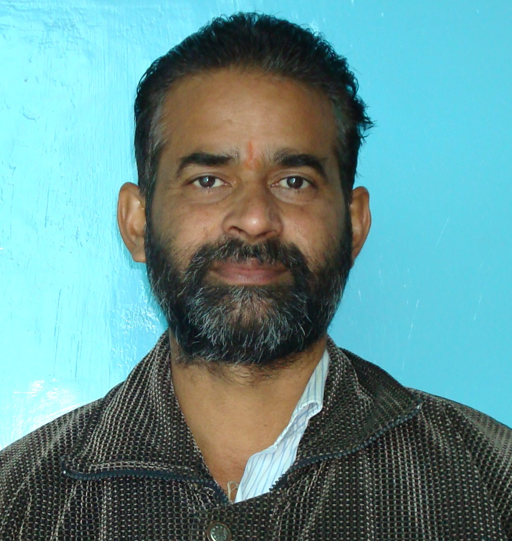
M.Sc.(Phy), B.Ed.


M.Sc. (Physics)


M.Sc.(Phy), JEST Score (NCRA, Pune)


M.Sc.

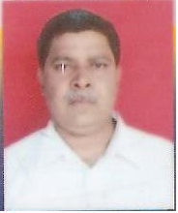
M.Sc., B.Ed.


M.Sc.(Physics)

