

FACULTY ——————Sanskrit

TEACHERS 


M.A.(Sans), Ph.D., NET

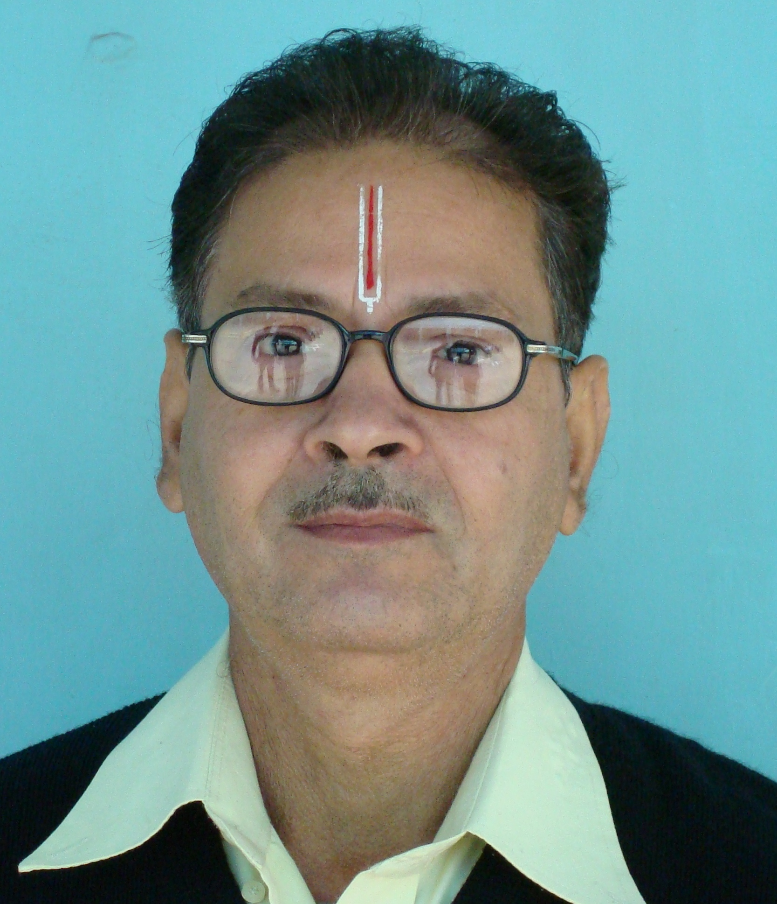
M.A., B.Ed.


M.A., B.Ed.


M.A., B.Ed.

