

FACULTY ——————Urdu

TEACHERS 

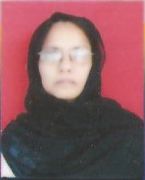
M.A.(Urdu), B.Ed.

