##### Experiment-08:Cross – Site Request Forgery (CSRF)

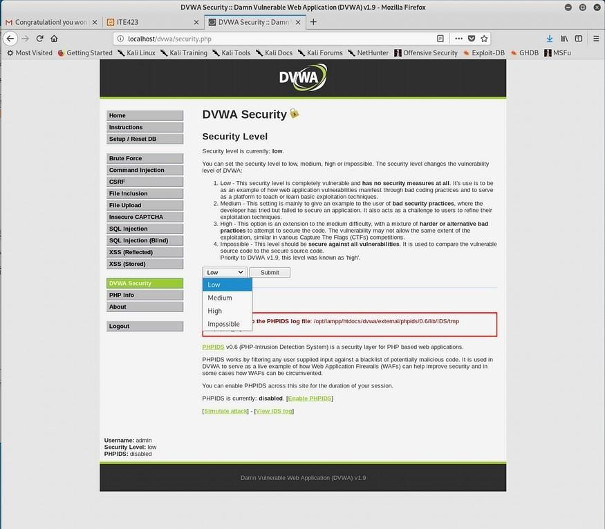**Changing Security Level to low**

**find the HTTP request on Burp-suite**

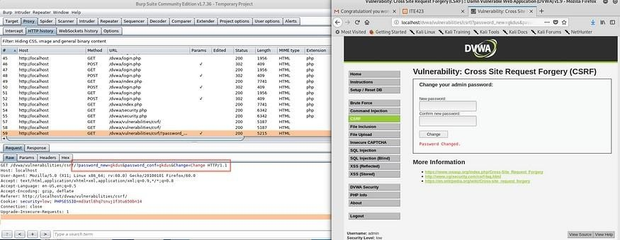

**Get method to transfer new password being used On left, you can find request has successfully transferred / On right is the screen of csrf.html**

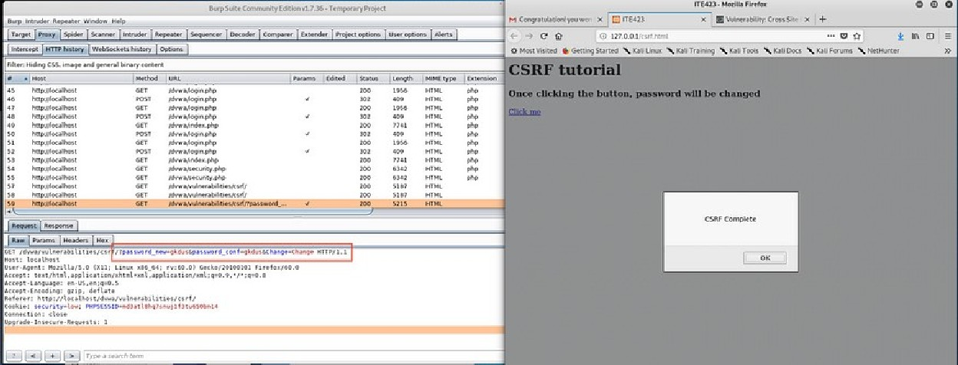

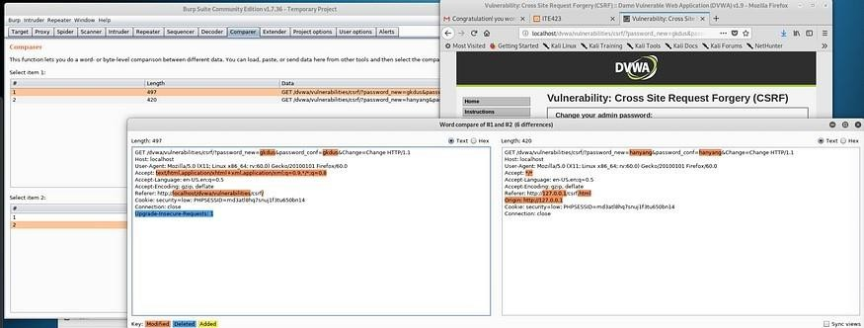

**Try to distinguish between normal request (left) and malicious request(right)**

**Checking the response — it fails to change password after Changing security level to medium**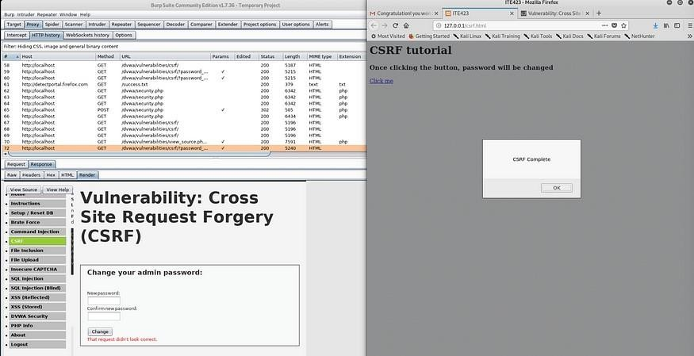

**Changing file name makes attack successful!**

