##### Experiment-09: File Inclusion Vulnerabilities

**Go to file inclusion tab**

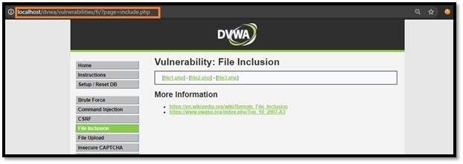

**Change the URL from incude.php to ?page=../../../../../../etc/passwd.**

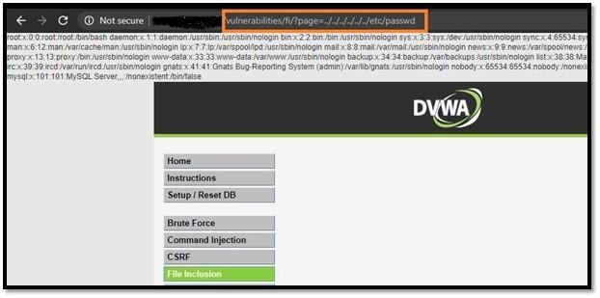

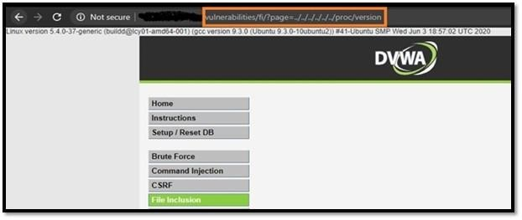**Change the URL from?page=../../../../../../etc/passwd to ?page=../../../../../../proc/version.**

###### File Inclusion Source (Security Level: MEDIUM)

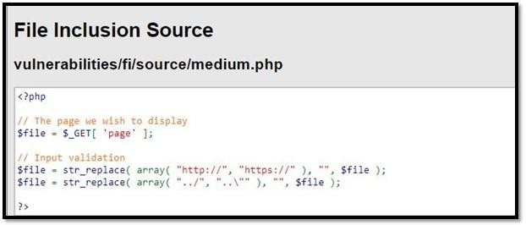

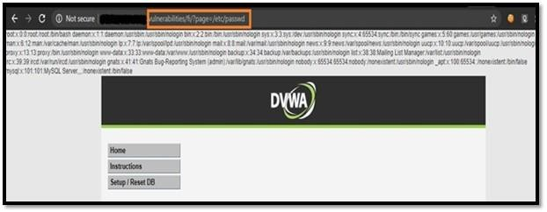**Change include.php to /etc/passwd**

**Now,change the URL from?page=/etc/passwd to ?page=/proc/version.**

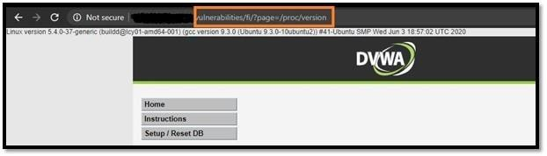

###### Security Level: HIGH

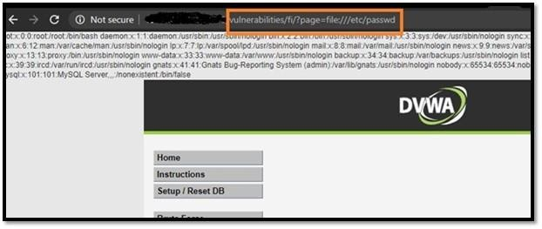**Change the URL from include.php to ?page=file:///etc/passwd, You will get the data of /etc/passwd file.**

**Security Level- Low.**

**Change the security level to low and go to file inclusion tab.**

**change include.php to** [**http://www.google.com**](http://www.google.com/) **so the final URL will look something like this,**

**?page=**[**http://www.google.com**](http://www.google.com/)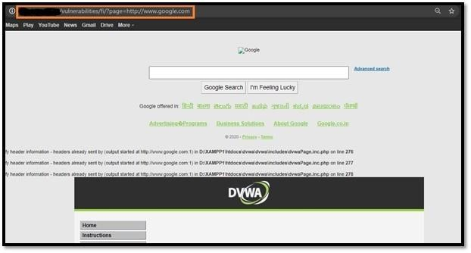

###### Security Level: MEDIUM

**Check as we did it in the low difficulty. You’ll notice, it’s not working anymore. The target is now filtering “http” and “https” as shown in source page.**

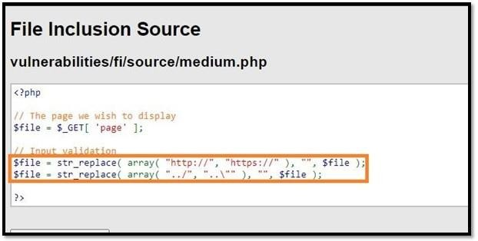

##### ?page=http://imdb.com