NAME : HERATH H.M.K.U.A.
REG NO : EG/2023/5634
DATE : 20/04/2026

EC3404: GUI PROGRAMMING
Mini Project: The Modern Single Page Application (SPA)
CTF Knowledge Hub SPA

Contents
1. Project Overview 3
2. Features Implemented 3
Core Features 3
Walkthrough System 3
Authentication 3
Bookmarks 4
Dark Mode 4
UI / UX Enhancements 4
3. Architecture & Component Design 4
Component Hierarchy 4
Composables 5
State Management (Pinia) 5
4. Technologies Used 5
5. API Integration 5
DummyJSON 5
Local Backend 5
6. Learning Outcomes 6
7. AI Usage 6
8. Screenshots 6
9. Conclusion 6

1. Project Overview
This project is a Single Page Application (SPA) developed using Vue 3, TypeScript, and Tailwind CSS.
The application simulates a CTF (Capture The Flag) learning platform, where users can:
- Browse cybersecurity challenges
- View detailed challenge descriptions
- Read and add walkthroughs
- Bookmark challenges
- Learn via curated resources
The system integrates both:
- DummyJSON API (for challenges & authentication)
- Local backend (json-server) (for walkthroughs)

2. Features Implemented

Core Features
- Fetch challenges from DummyJSON (/products)
- Display challenges in responsive cards
- Search challenges by title
- Filter challenges by category
- Challenge detail page (/challenge/:id)
- Dynamic routing using Vue Router

Walkthrough System
- Fetch walkthroughs from local backend (/posts)
- Display walkthroughs per challenge
- Add new walkthroughs dynamically
- View full walkthrough (/posts/:id)

Authentication
- Login using DummyJSON /auth/login
- Store user session in localStorage
- Manage login/logout using Pinia store

Bookmarks
- Add/remove bookmarked challenges
- Persist bookmarks using localStorage
- Global state using Pinia

Dark Mode
- Toggle between light and dark themes
- Implemented using Tailwind dark: classes
- Theme state managed via Pinia

UI / UX Enhancements
- Animated landing page
- Background image slider
- Smooth transitions and hover effects
- Responsive layout (mobile, tablet, desktop)
- Premium login modal overlay
- Resources page with embedded YouTube tutorials

3. Architecture & Component Design
The application follows a component-based architecture with separation of concerns.

Component Hierarchy
App.vue
├── Navbar.vue
├── HomeView.vue
├── ChallengesView.vue
│ ├── ChallengeCard.vue
├── ChallengeDetailView.vue
│ ├── Walkthrough Section
├── PostDetailView.vue
├── ResourcesView.vue
├── LoginView.vue (Modal)

Composables
Reusable logic is handled using composables:
- useChallenges.ts → Fetch & filter challenges
- useChallenge.ts → Single challenge data
- usePosts.ts → Manage walkthroughs

State Management (Pinia)
- auth.ts → Authentication
- theme.ts → Dark mode
- bookmarks.ts → Bookmark system

4. Technologies Used
- Vue 3 (Composition API)
- TypeScript (strict typing, no any)
- Tailwind CSS (utility-first styling)
- Pinia (state management)
- Vue Router (navigation)
- DummyJSON API
- json-server (local backend)

5. API Integration

DummyJSON
- /products → challenges
- /products/:id → challenge details
- /auth/login → authentication

Local Backend
- /posts → walkthroughs

6. Learning Outcomes
This project helped achieve:
- Strong understanding of TypeScript interfaces
- API handling using async/await
- Building scalable UI with Vue components
- State management with Pinia
- Responsive design using Tailwind CSS
- Effective use of AI tools for development

7. AI Usage
AI (ChatGPT) was used to:
- Debug TypeScript issues
- Improve UI design
- Generate Tailwind layouts
- Optimize architecture (composables & stores)
All prompts are documented in prompts.txt.

8. Screenshots

- Home Page
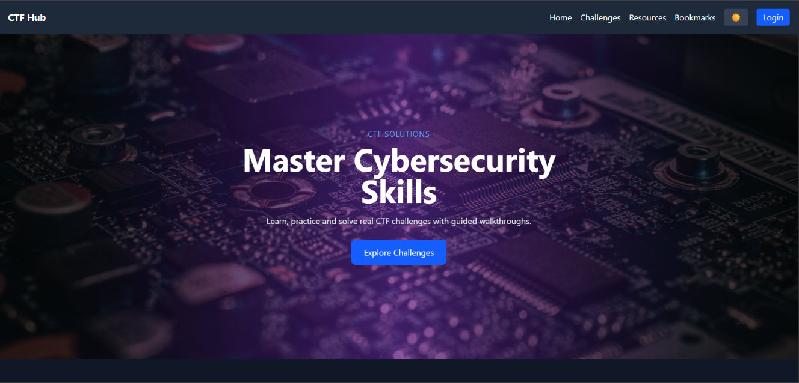
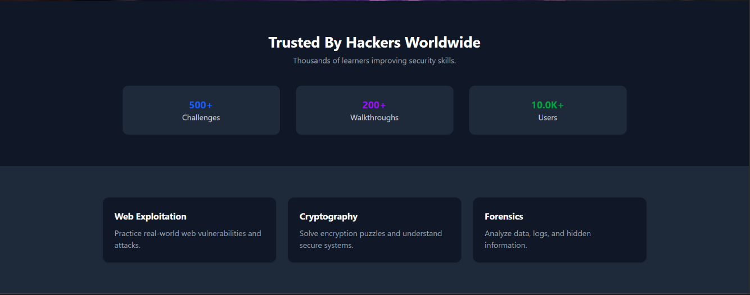

- Challenge List
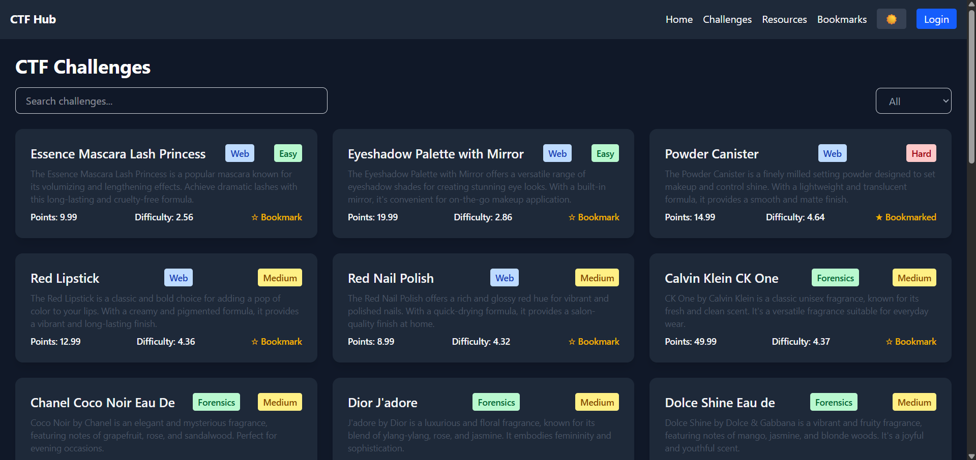

- Challenge Detail
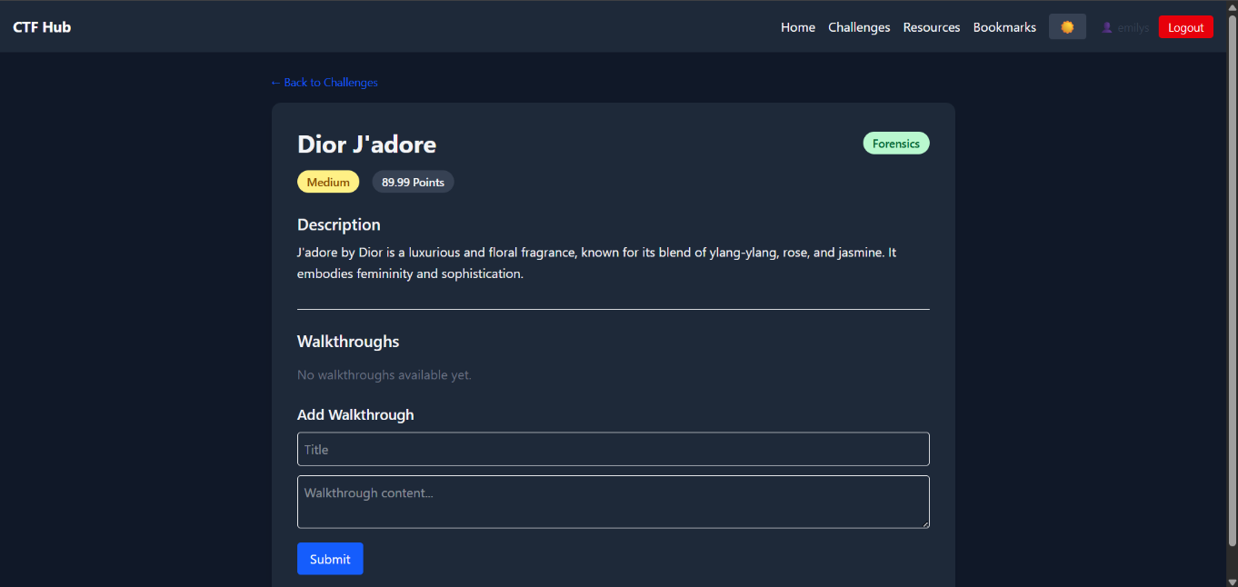
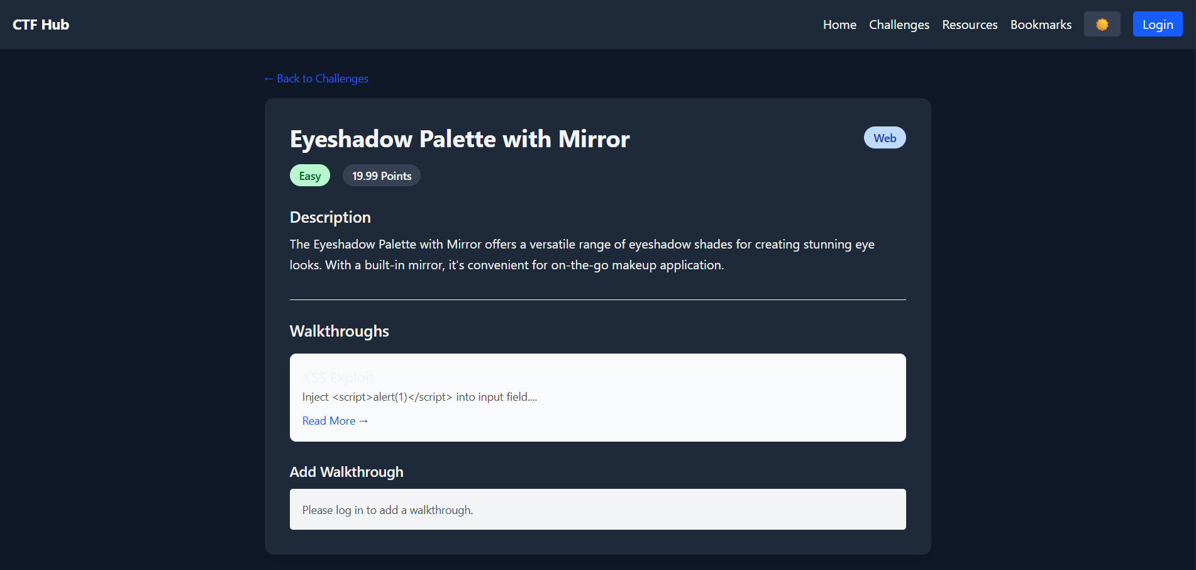

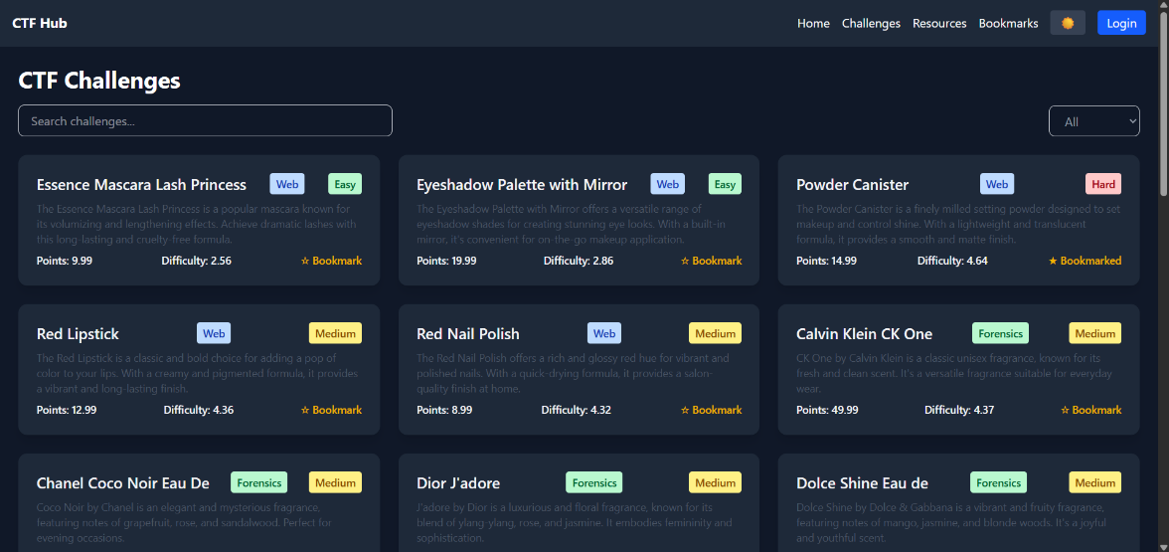
- Dark Mode/Light Mode View

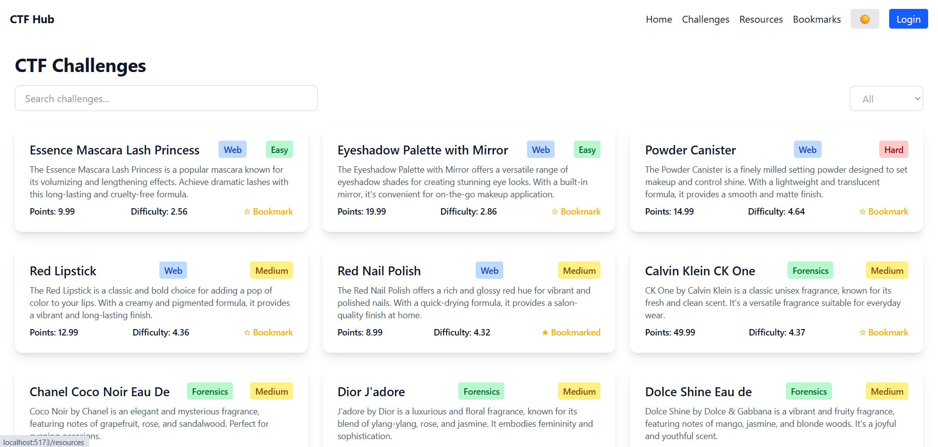

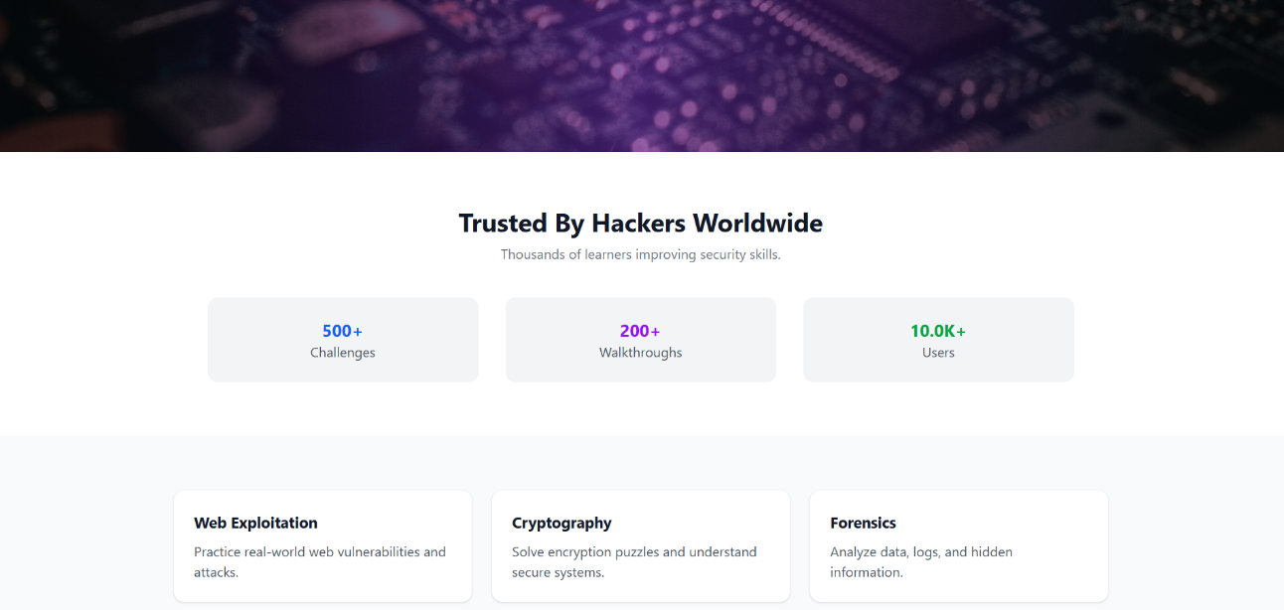
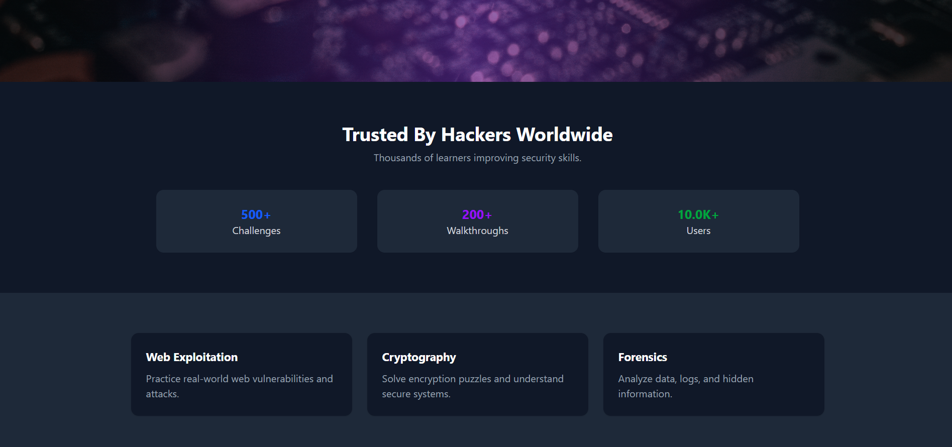

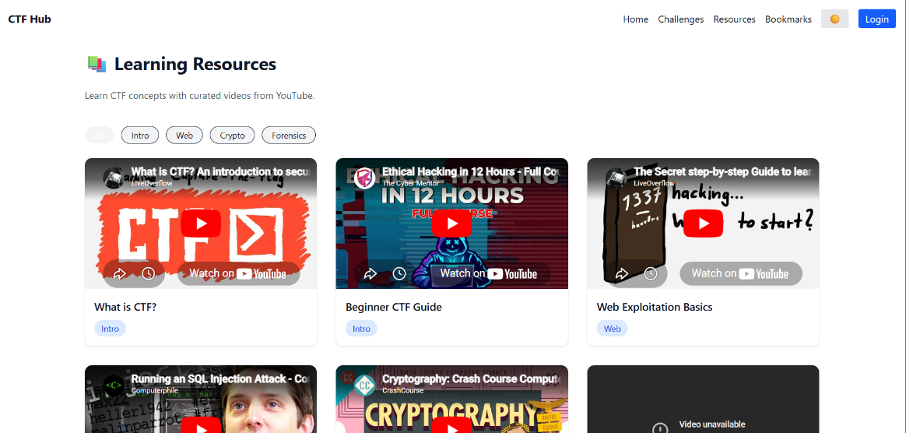
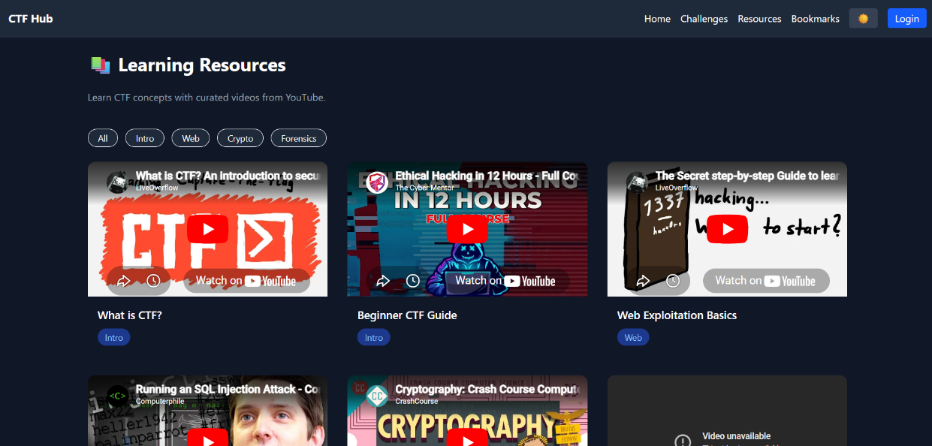

9. Conclusion
The application successfully demonstrates a modern SPA architecture with real-world features such as authentication, state management, and dynamic data handling.
It simulates a production-level frontend system with clean architecture and polished UI.

