Day-1: Introduction to Data Analytics & Data Science Tasks
Thursday,10/09/26
*Here we come learn the basic concepts of data analytics and Data science
Basic concepts: -
• What is Data?
Data is raw, unorganized facts and figures that by itself has no meaning.
It can be numbers, text, images, audio, video etc. which is collected for processing.

• What is Data Analytics?
Data Analytics is the process of examining, cleaning, and analyzing raw Data to find useful information, patterns, and trends to make better decisions.

• What is Data Science?
Data Science is a field that uses scientific methods, algorithms, and tools to extract knowledge and insights from Data.

• Data Analyst vs Data Scientist
Aspect 1 :- Primary Role
* Data Analyst :-
Analyses past data to understand what happened.
*Data scientist:-
Builds models to predict what will happen in the future.
Aspect 2: -Focus Area
*Data Analysis
Reporting, and Visualization.
*Data scientist
Machine Learning, AI, and Predictive Modelling.
Aspect 3: -Tools & Skills
*Data analysis
SQL, Excel, Power BI, Tableau, Basic Python.
*Data science
Python, R, SQL, Machine Learning, Deep Learning, AI.
Aspect 4: -Output
*Data analysis
Dashboards, Reports, and Graphs.
*Data scientist
Predictive Models and AI Systems.
Aspect 5: - Example Task
*Data analysis
Why did sales drop last month?
*Data science
How much sales will we have next month?

• Data Engineer vs ML Engineer
Aspect:- Primary Role
*Data Engineer (DE)
Build ML and maintains the data infrastructure.
*ML Engineer (ME)
Builds and deploys Machine Learning models to production.
Aspect: --Main Question
DE: --How to get and store data efficiently?
ME: --How to make ML models accurate and scalable?
Aspect: --Focus Area
DE: --Data Pipelines, Data Warehouses, ETL
ME: --Model Training, Model Deployment, MLOps
Aspect: --Tools & Skills
DE: --SQL, Python, Spark, Hadoop, Kafka, AWS/GCP, Airflow
ME: --Python, TensorFlow, PyTorch, Scikit-learn, Docker, Kubernetes
Aspect: -Output
DE: -Clean, reliable, and accessible data for everyone.
ME: -Production-ready ML models / AI features.
Aspect: -Works With
DE: --Data Analysts, Data Scientists
ME: --Data Scientists, Software Engineers
Aspect: --Example Task
DE: --Create a pipeline that brings all Flipkart sales data into one warehouse daily.
ME: --Build a model that predicts which Flipkart user will buy a product and deploy it on the app.

•Structured vs Unstructured Data
1.Structured Data
- Meaning: Data that is highly organized in a fixed format (rows and columns).
- Format: Tables, Excel sheets, SQL databases.
- Example: Customer ID, Name, Age, Salary.
- Storage: Relational Database (MySQL, SQL Server).
- Analysis: Very easy to analyse using SQL.
- Share: Only 20% of total world data.
2. Unstructured Data
- Meaning: Data that has no fixed format or structure.
- Format: Text, Images, Audio, Video, Social Media posts.
- Example: Instagram photos, YouTube videos, customer reviews, emails.
- Storage: Data Lake, NoSQL Database.
- Analysis: Difficult, requires AI and Machine Learning.
- Share: 80% of total world data.

• Types of Analytics
• Descriptive, Diagnostic, Predictive and Prescriptive Analytics

1.Descriptive Analytics – What happened?
Meaning: It explains what has happened in the past by looking at old data.
Tools: Reports, Dashboards, Excel, Power BI
Example: A Flipkart sales report showing sales were 10 lakhs last month.
Question it answers: What happened?

2. Diagnostic Analytics - Why did it happen?
Meaning: It finds the reason behind what happened.
Tools: Drill-down, Data Mining, Correlation
Example: Sales dropped last month because the website was down for 3 days.
Question it answers: Why did it happen?

3. Predictive Analytics - What will happen?
Meaning: It uses past data to predict the future.
Tools: Machine Learning, Statistics, Python
Example: Based on past data, next month sales will be 15 lakhs.
Question it answers: What will happen in the future?

4. Prescriptive Analytics - What should we do?
Meaning: It suggests the best action to take for the predicted future.
Tools: AI, Optimization, Simulation
Example: To achieve 15 lakhs sales, increase ads by 20% and give a 10% discount.
Question it answers: What action should be taken?

• Complete data project lifecycle
Complete Data Project Lifecycle
This is the end-to-end process of a data science project.
- Business Understanding Meaning:
Understand the business problem.
Work: Meet clients and define the goal.
Example: Client says "We want to increase sales".
Question: What do we want to solve?
- Data Understanding
Meaning: Identify what data we need.
Work: Find data sources.
Example: Sales history, customer data, website data.
- Data Collection
Meaning: Collect data from different sources.
Sources: Databases, APIs, Excel, Websites, Sensors.
Tools: SQL, Python, Web Scraping.
- Data Cleaning / Data Wrangling
Meaning: Most important and time-consuming step (70-80% time).Work:
a) Remove duplicate data
b) Handle missing values
c) Correct wrong data
d) Fix data formats
Tools: Python (Pandas), SQL, Excel
- Exploratory Data Analysis (EDA)
Meaning: Analyze and visualize data to find patterns.
Work: Create charts, graphs, find correlation.
Tools: Python (Matplotlib, Seaborn), Power BI, Tableau
Output: Insights like "Sales are high on weekends".
- Model Building
Meaning: Build Machine Learning model.
Work:
a) Select features
b) Split data into Training and Testing
c) Train model
d) Test model
Tools: Python (Scikit-learn, TensorFlow)
- Model Evaluation
Meaning: Check how good the model is.
Metrics: Accuracy, Precision, Recall, RMSE
Work: If accuracy is low, go back and improve model.
- Model Deployment
Meaning: Make the model live for real users.
Tools: Flask, Docker, AWS, Azure
Example: The recommendation model goes live on Flipkart app.
- Monitoring and Maintenance
Meaning: Keep checking model performance.
Work: Retrain model with new data if performance drops.
Simple Flow:
Business Understanding -> Data Collection -> Data Cleaning -> EDA -> Model Building -> Evaluation -> Deployment -> Monitoring

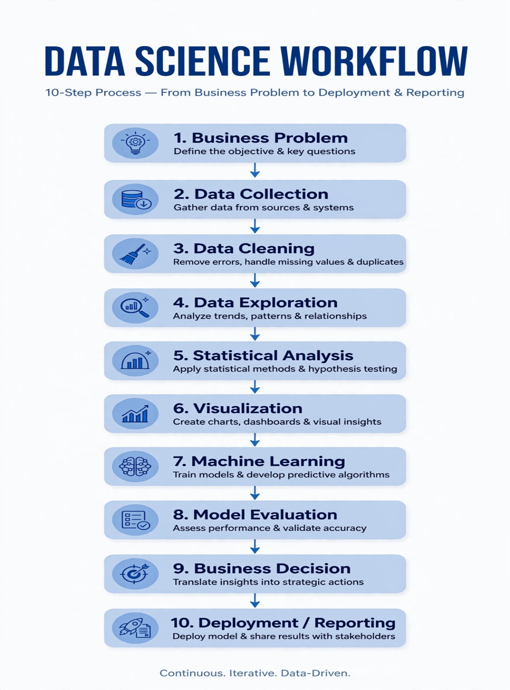

DAY2: - PYTHON BASICS FOR DATA ANALYTICS
Friday,11/09/26
*Here we learn about the basic concepts of python which is used to write the code
Basic concepts of python as below:-
1. VARIABLES
Variable is a container to store data value.
Example:
name = "Amit"
age = 21
salary = 50000.50
2. DATA TYPES
Types of data stores.
Main Types: int, float, str, bool, list, tuple, set, dict
Check type: type(age)
It returns “str”
3. STRINGS
Text data inside quotes.
name = "Data Science"
print(name.upper()) # DATA SCIENCE
print(name.lower()) # data science
print(len(name)) # 12String concatenation: "Data Science"
4. INTEGERS
Whole numbers without decimal.
a = 10
b = 20
print(a + b) # 30
5. FLOAT
Numbers with decimal point.
price = 99.99
rating = 4.5
6. BOOLEAN
True or False value. Used in conditions.
is_pass = True
is_fail = False
print(10 > 5) # True
7. LISTS
Ordered, changeable collection. Allows duplicates.
fruits = ["apple", "banana", "mango"]
fruits.append("orange")
print(fruits[0]) # apple
print(fruits) # ['apple', 'banana', 'mango', 'orange']List functions: append(), remove(), sort(), len()
8. TUPLES
Ordered, unchangeable collection. Round brackets.pythoncolors = ("red", "green", "blue")
print(colors[1]) # green
# colors[1] = "yellow" -> Error, tuple cannot change
9. SETS
Unordered, no duplicates allowed. Curly brackets.
nums = {1, 2, 2, 3, 4}
print(nums) # {1, 2, 3, 4} duplicate removed
10. DICTIONARIES
Key-value pair storage.
student = {
"name": "Amit",
"age": 21,
"city": "Mumbai"
}
print(student["name"]) # Amit
print(student.keys())
print(student.values())
11. OPERATORS
A) Arithmetic: + - _ / % __ (power)
B) Comparison: ==!= > < >= <=
C) Logical: and, or, not
D) Assignment: = += -= _=
Example:
a = 10
b = 3
print(a % b) # 1 remainder
print(a ** b) # 1000
12. CONDITIONS
(if-elif-else):Used to take decisions.
age = 18
if age >= 18:
print("Adult")
elif age >= 13:
print("Teenager")
else:
print("Child")
13. LOOPS
- FOR LOOP - When you know how many times to repeat
for i in range(5):
print(i)
# 0,1,2,3,4
fruits = ["apple", "banana", "mango"]
for fruit in fruits:
print(fruit)
- WHILE LOOP - When condition is true
i = 1
while i <= 5:
print(i)
i += 1
LOOP CONTROL:
break - stop loop
continue - skip current iteration
for i in range(10):
if i == 5:
break
print(i)
Deliverables:-day02_python_basics.py
Write programs for:
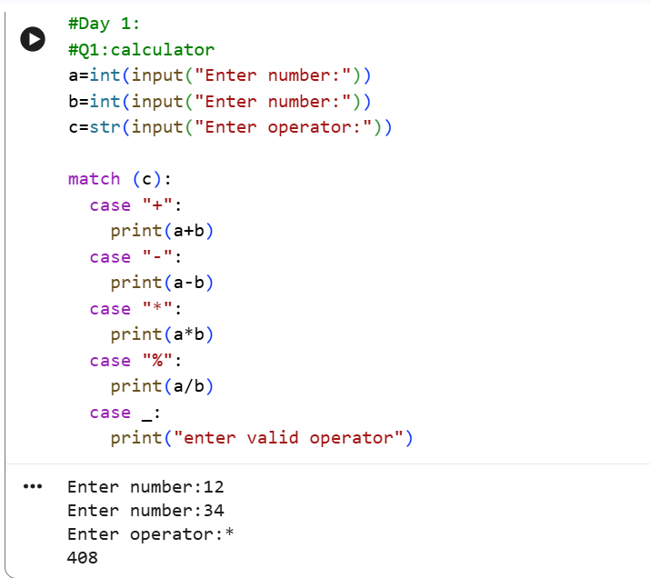
Here we take 2 numbers as input and using match case provide operators as we choose and printed the result by performig operation
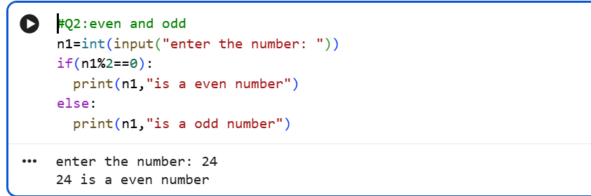
In this question we take a number as input and by applying condition i.e. (number/2==0) by using if-else statement provide the appropriate result according to input.
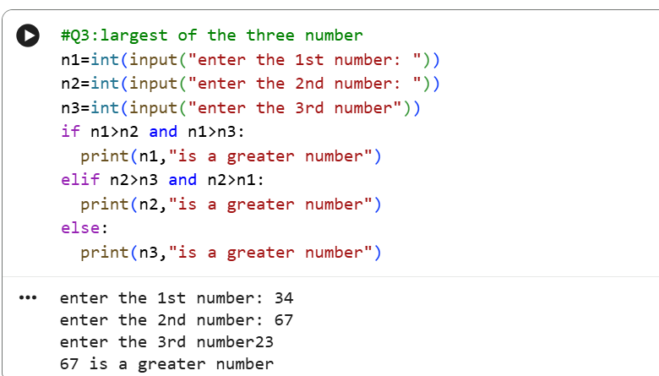
To find the largest of three number we take 3 numbers as input and using “ if-elif-else” as well as “and” giving the coditions for finding greater number
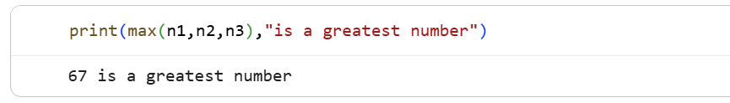
To reduce the line of code here we using simply max() to return the greatest of three
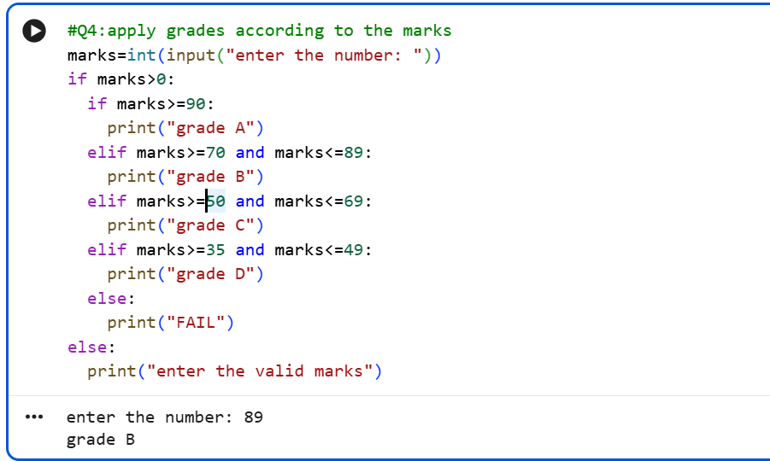
Here simply we take the marks as input and use the nested if for giving the result as grade
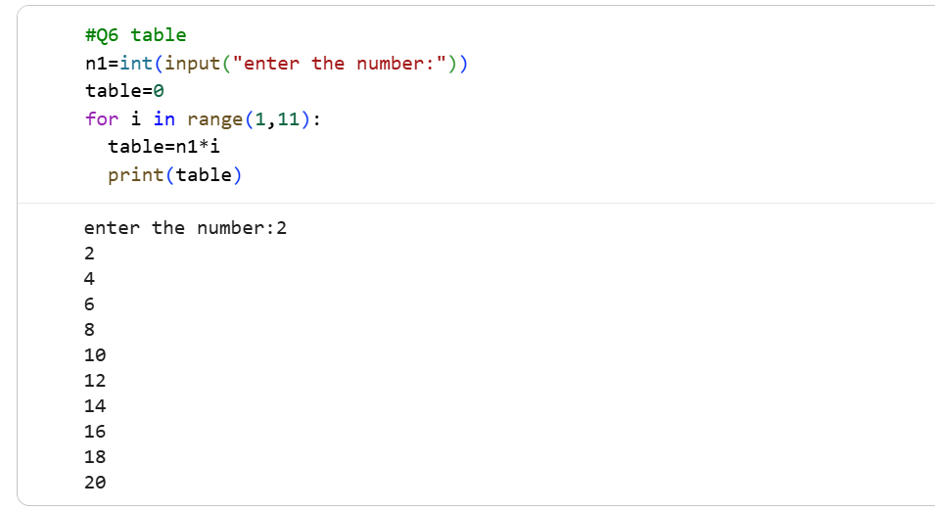
We want to print the table we just use for loop for iteration and inside loop print the product of number and iteration from(1-11) so it will be returns table upto 10 iteration.
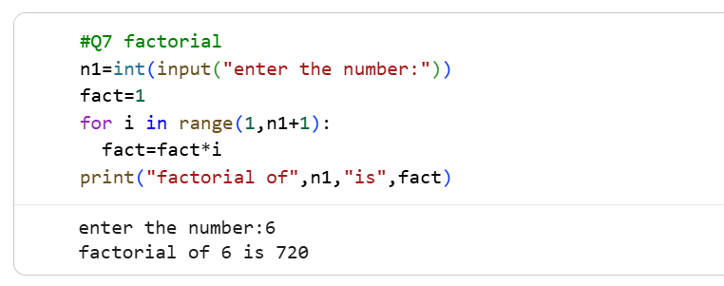
Here we have to print factorial so we iterate the for loop from(1,n+1) and apply logic of fact=fact*I where i=1 and fact=1 and print final result stored in fact out of the for loop
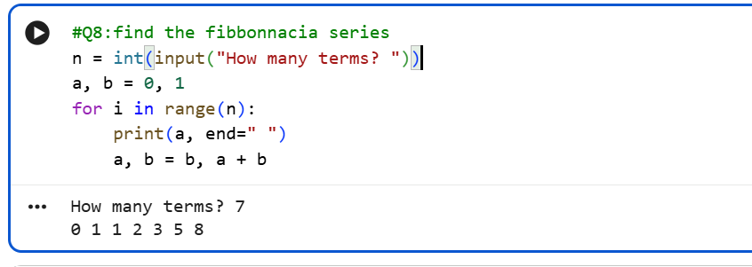
To give the Fibonacci series we consider a,b and give the expression a,b=b,a+b where (a,b=0,1) as initials and then print a which iterate in range of n
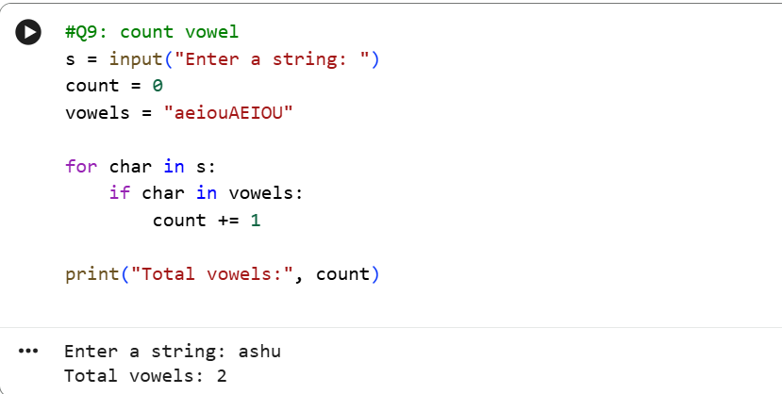
Here we count the vowels in given word so we stored lower and upper case of vowels in variable name as vowel and using for loop iterate the characters in string also using if we increase count if character is vowel and final count print out of the for loop.
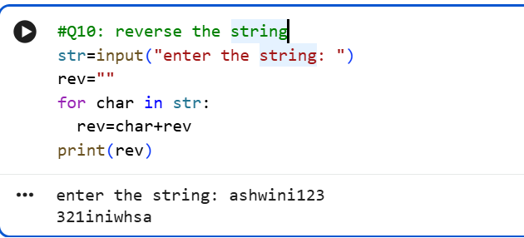
To reverse the string we use empty string as rev and iterate characters in the string using for loop where condition are rev=char +rev which store characters reversly in the string.

DAY 3 – FUNCTIONS + ADVANCED PYTHON
Saturday,12/09/26
*Here we are learning about the concepts of advance python
Concepts of advance Python is as below:-
1. FUNCTIONS
Function is a block of code that runs only when called. Used for reusability.
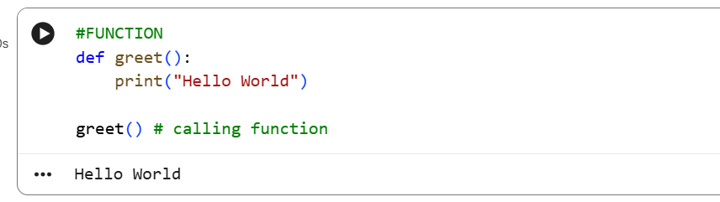
2. PARAMETERS
Values passed to function
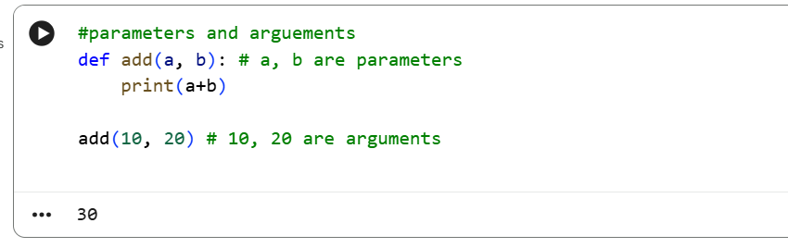

3. RETURN VALUES
Function sends back value using return.
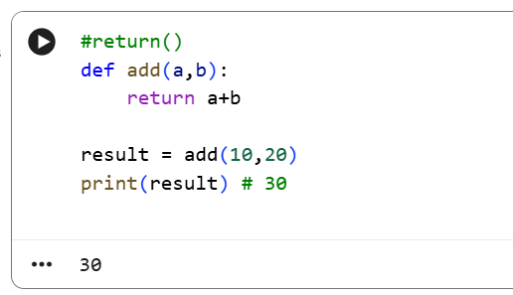
4. LAMBDA
Small anonymous function in one line.
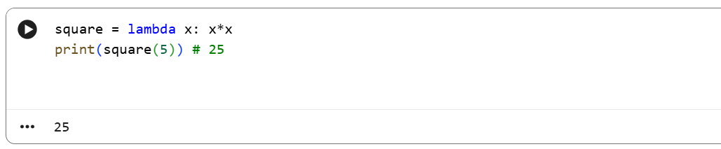
# Normal function vs Lambda
def add(a, b): return a+b
add_lambda = lambda a,b: a+b
5. map()
Applies function to each item in list.
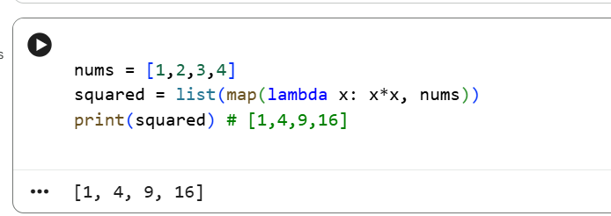
6. filter()
Filters items based on condition.
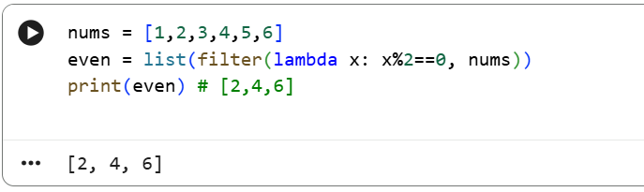

7. LIST COMPREHENSION
Short way to create list.
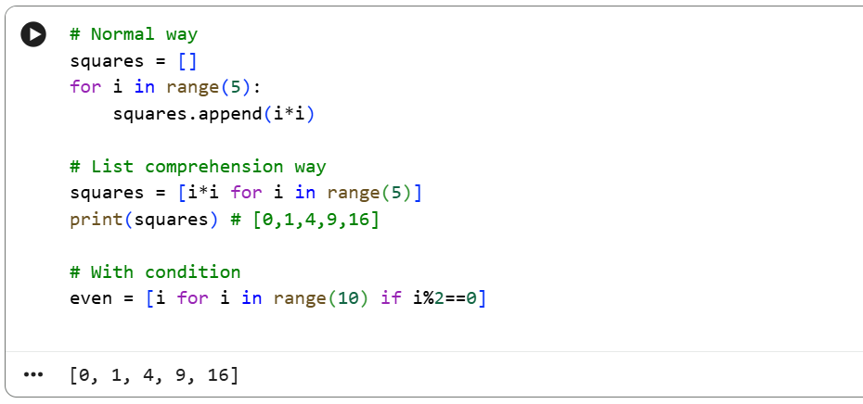
8. DICTIONARY COMPREHENSION
Short way to create dictionary
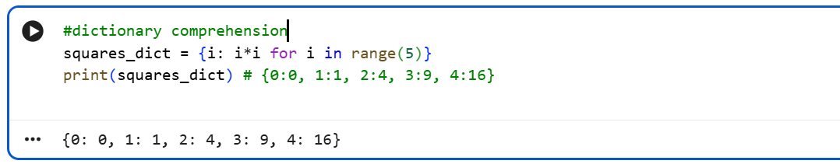

9. EXCEPTION HANDLING
Handles errors without crashing program.
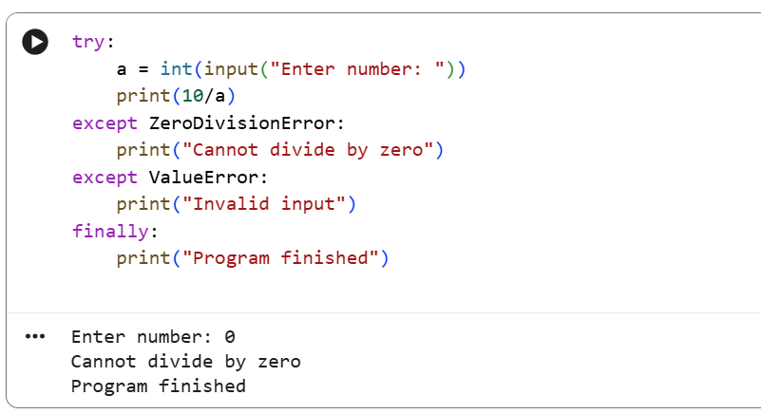
10. MODULES
Module is a Python file with functions. You can import it.
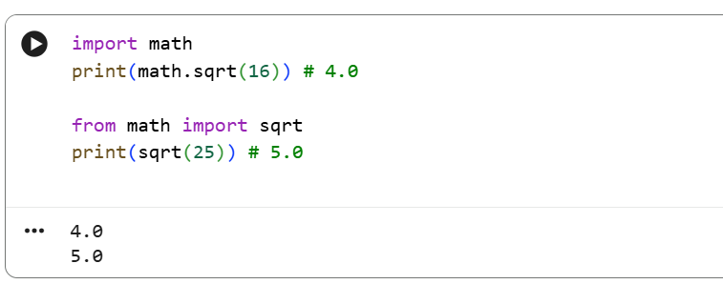

DELIVERABLE :- day03_python_functions.py
# Student Marks Analyzer using Functions

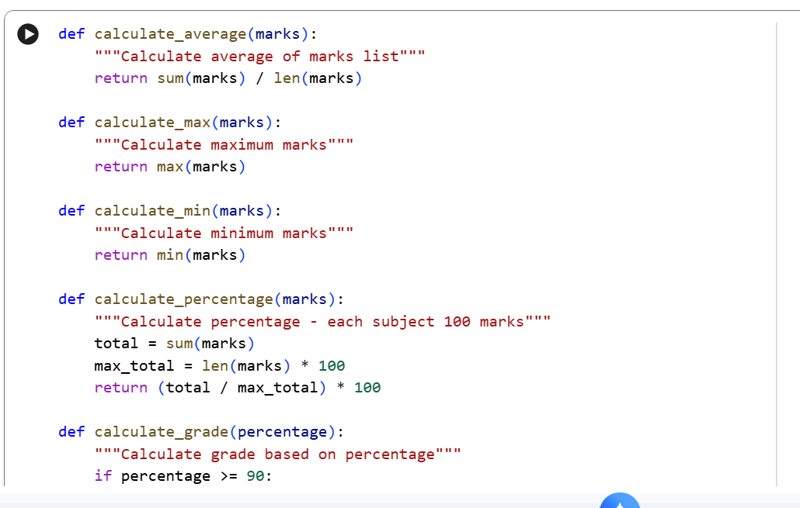
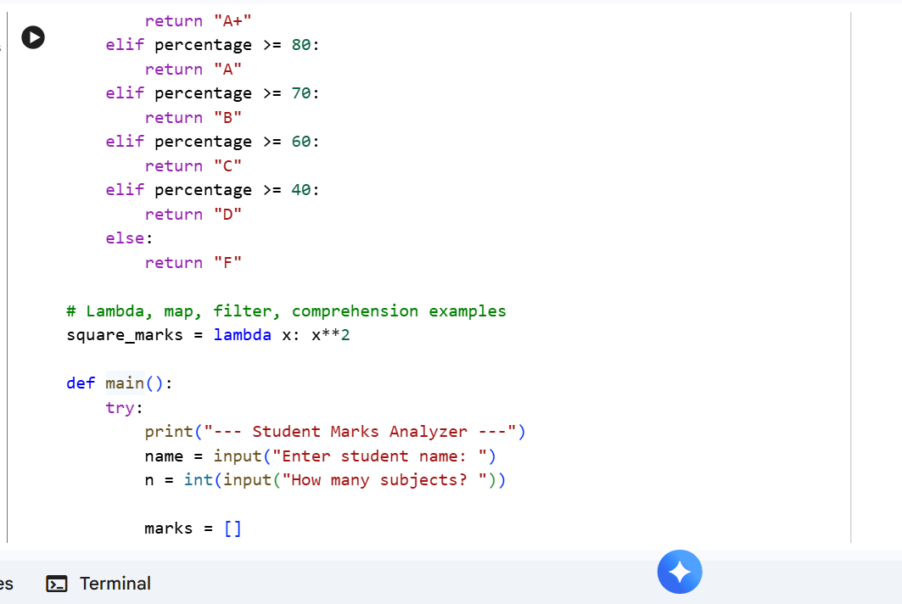
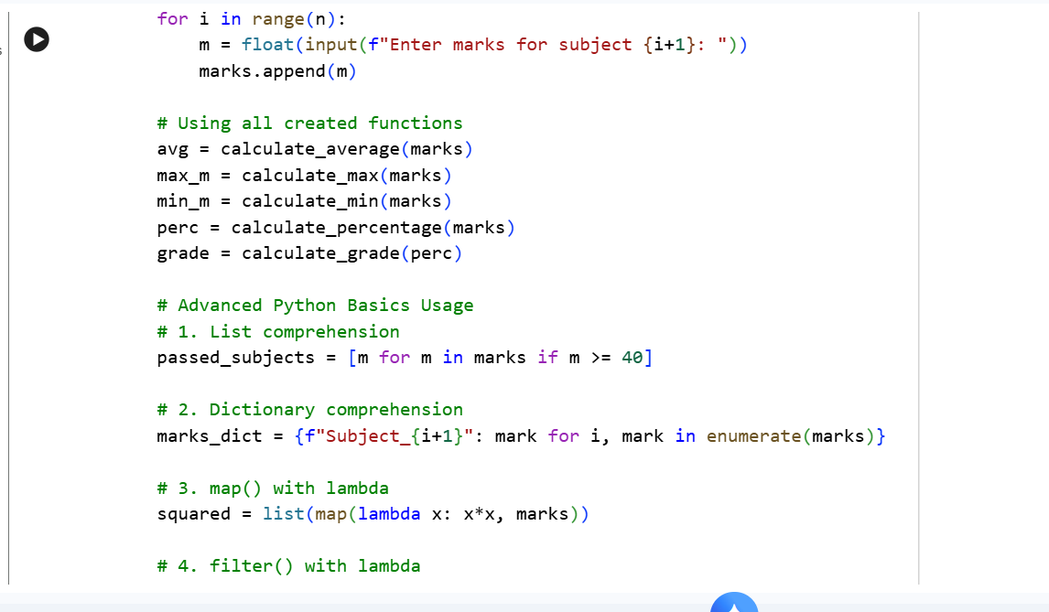
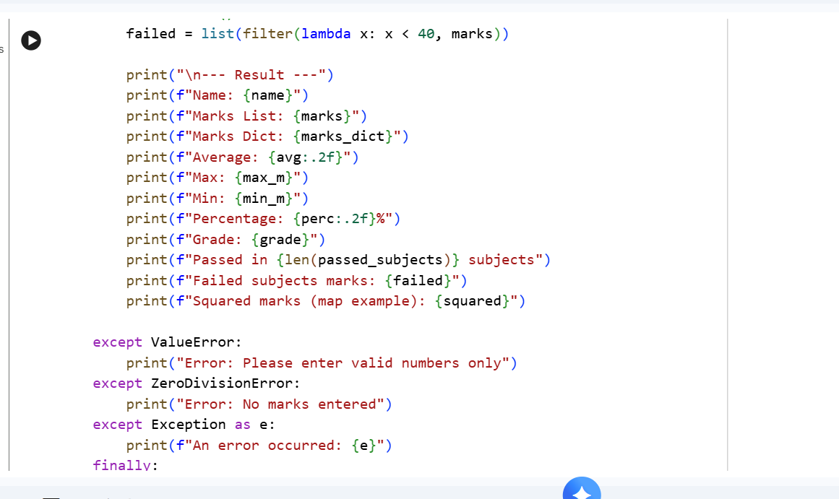
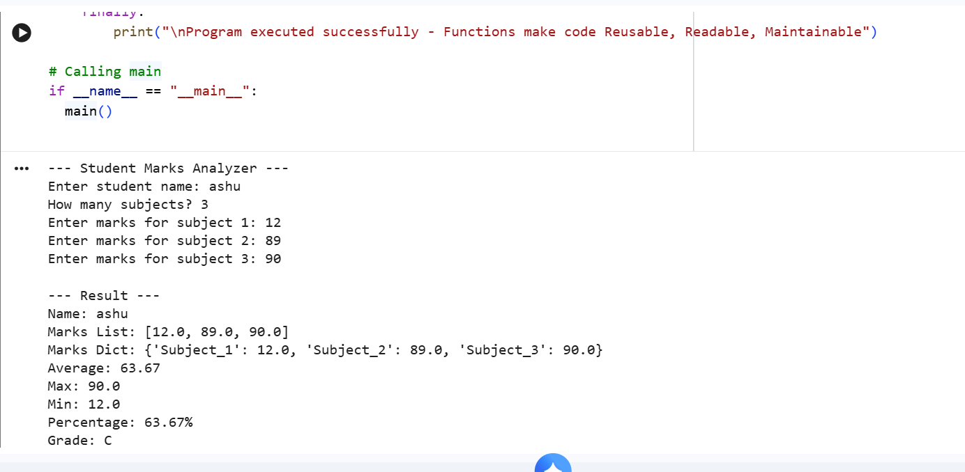
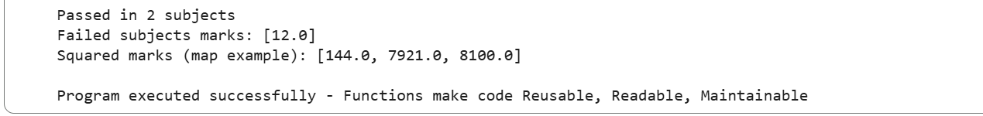
Why Functions?
Large projects cannot be written as one huge script
because:
Reusable - Write once, use many times
Readable - Code is divided into small parts
Maintainable - Easy to fix bugs

Day4: -NumPy
Tuesday,15/09/26
*Here we are learning about the one of the python libraries which is NumPy.
NumPy stands for numerical python which mainly deals with arrays.
Concepts of NumPy is as below: -
- Array:
array is collection of homogeneous elements and like list but faster.
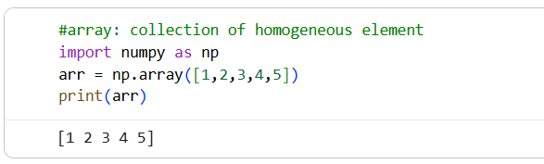
- Dimensions:
1D=single list,2D=table(rows ,columns),3D=cube
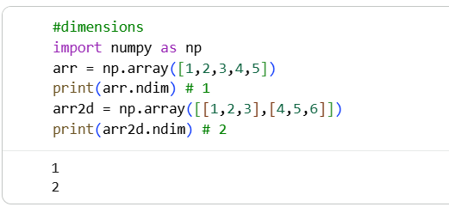
- Shape:
Shows structure of array i.e. rows, columns.
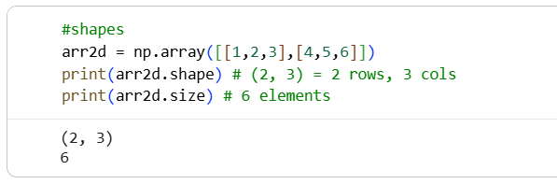

- Indexing:
Accessing the element using their index.
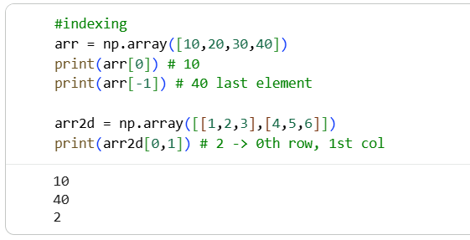
- Slicing:
Extracting the selected element or part of array. (start, step, stop)
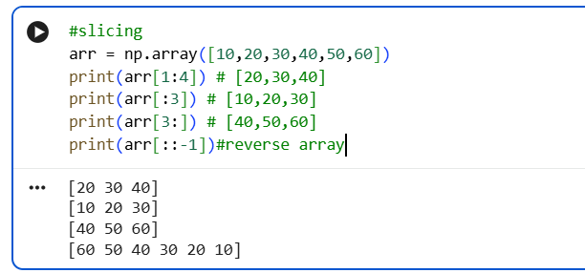
- Reshape:
Changing shape of array without changing data
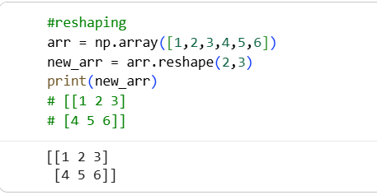

- Arithmetic operations:
Operations on full array at once.
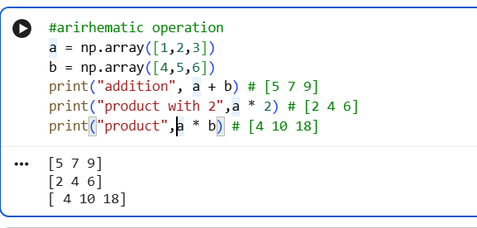
- Aggregations ,mean ,median ,standard deviation:
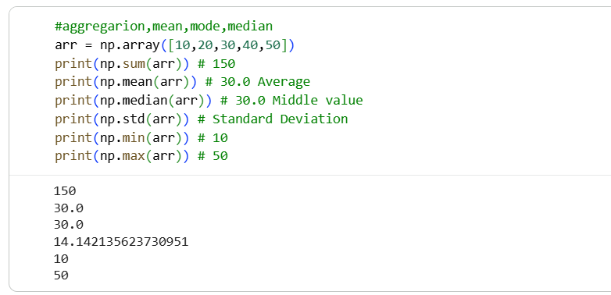

Deliverables :- Day04_Numpy.ipynb

#Create a NumPy array containing sales data and perform
(total sale ,average sale ,maximum sale, minimum sale, standard deviation ,median ,25th percentile, 75th percentile)

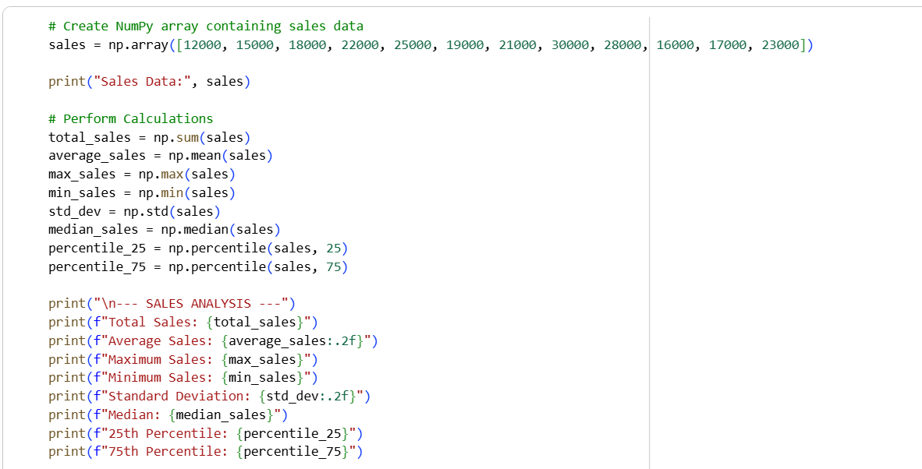

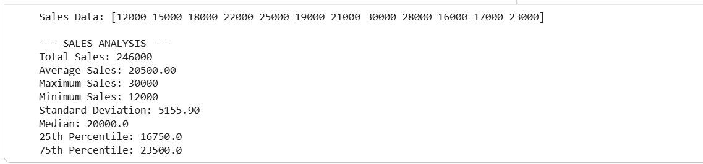
# 1D Array: 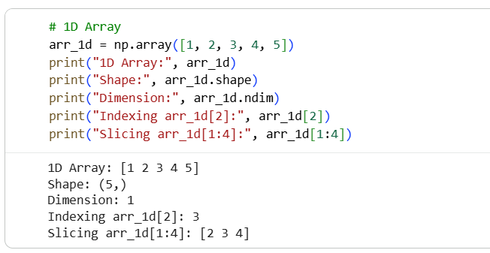
# 2D Arrays:
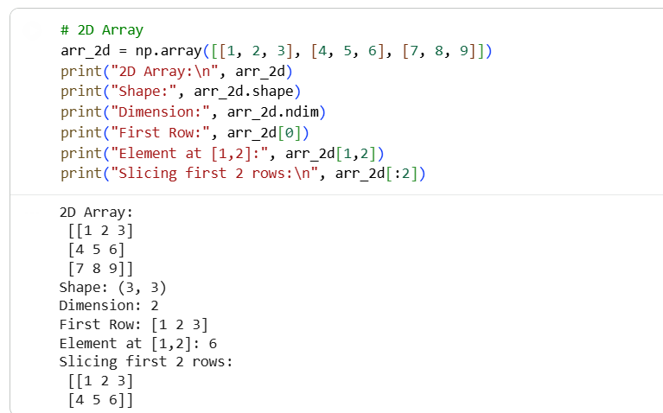

#Matrix multiplication:

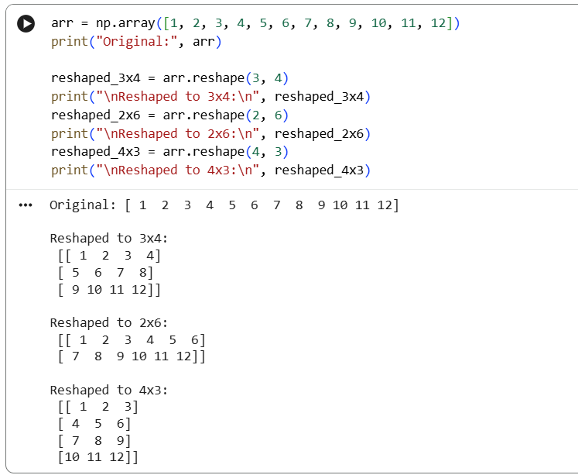
#reshape
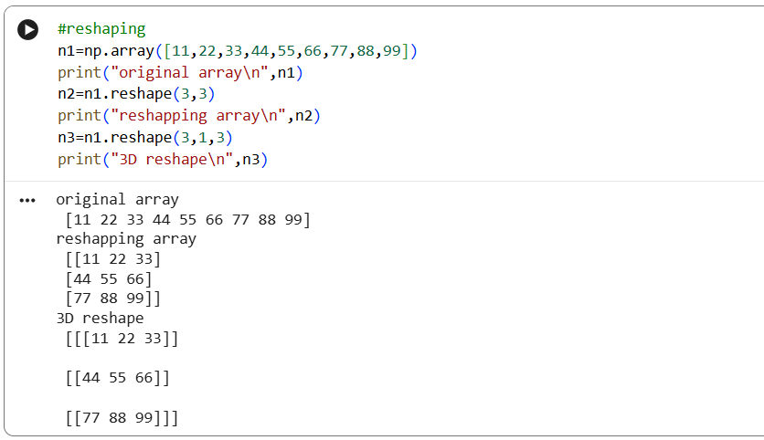

*Why NumPy provide numerical foundation used by many data-science library?
1. NumPy is 50x faster than normal Python lists
2. Foundation for Pandas, Matplotlib, Scikit-Learn
3. Uses less memory
4. Vectorized operations - no need for loops

DAY 5 :- Pandas basic
Wednesday,16/09/26
*Pandas is a python library where it is known as python data analysis library and it is used for data analysis ,data cleaning, handling csv/excel files.
1. Series
One-dimensional labeled array, single column.
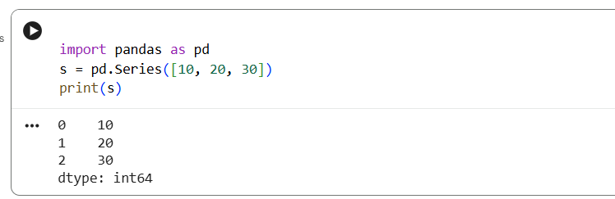

2. DataFrame
Two-dimensional table with rows and columns.
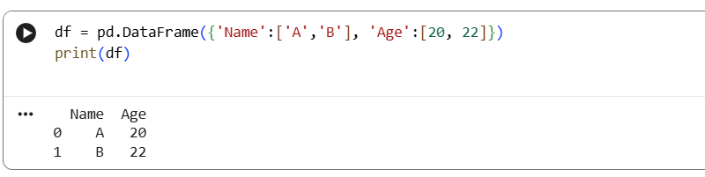
3. read_csv()
Loads CSV file into DataFrame.
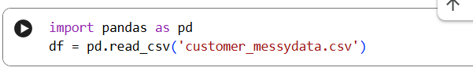

4. head()
Shows first n rows (default 5).
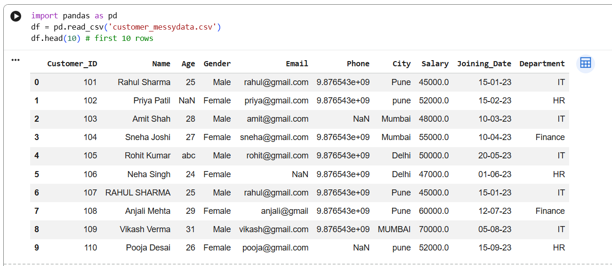

5. tail()
Shows last n rows.
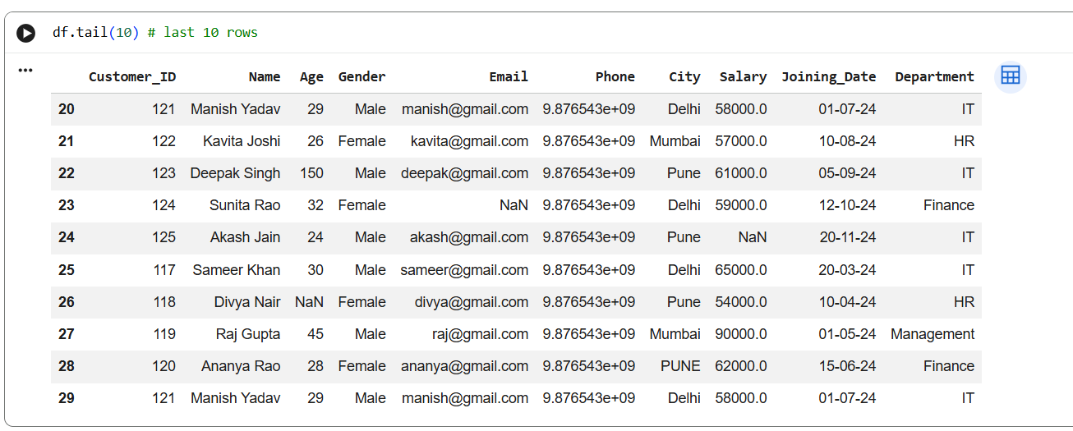
6. info()
Shows summary of DataFrame like rows, cols, data types, non-null counts.
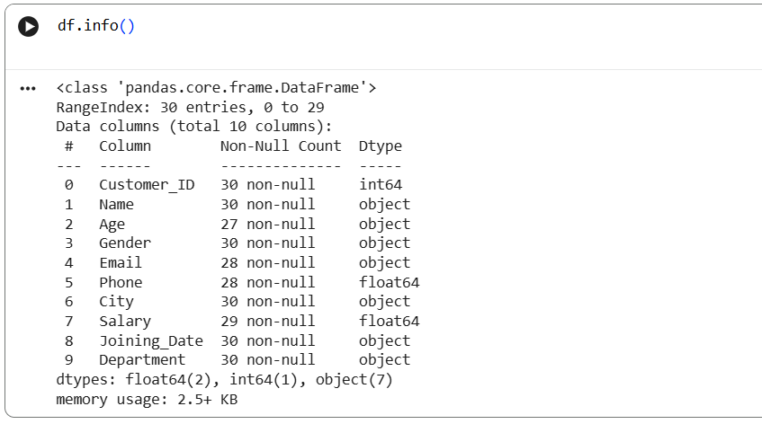

7. describe()
Generates statistics: count, mean, std, min, max, quartiles.
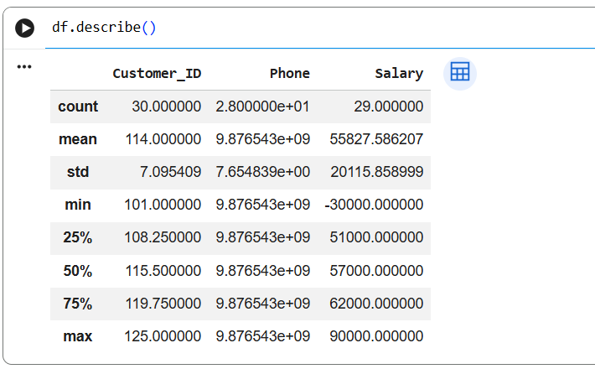
8. shape
Returns (number of rows, number of columns).
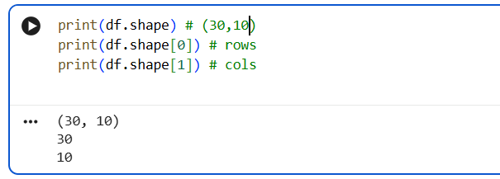

9. columns
Lists all column names.
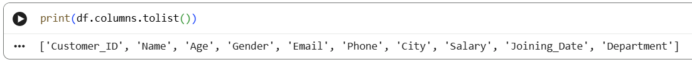
10. dtypes
Shows data type of each column.
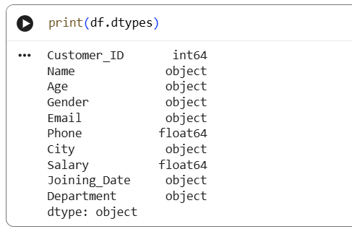

Deliverables: Day05_Pandas.ipynb

- Load dataset
- Display first 10 rows
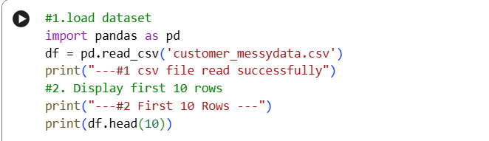
Output:-
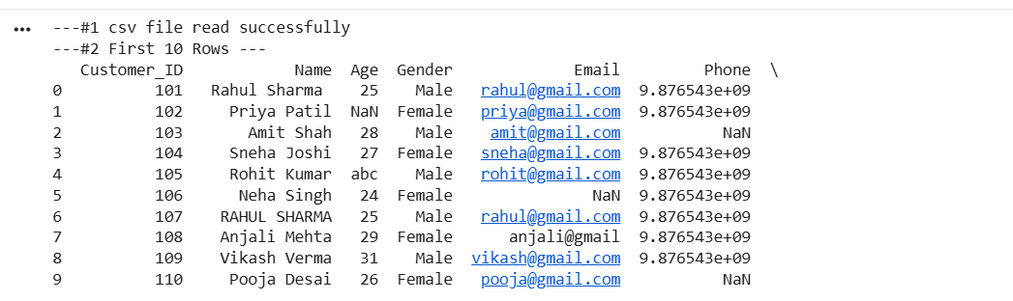

- Display last 10 rows
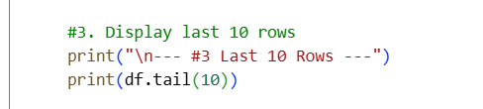

Output:
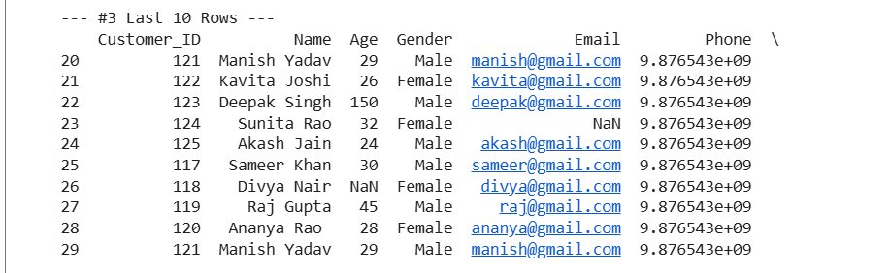
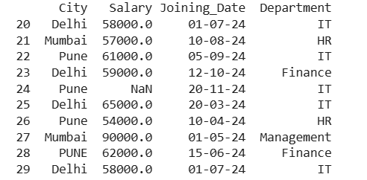

- Find number of rows
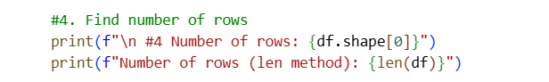
Output:-
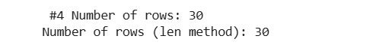
- Find number of columns
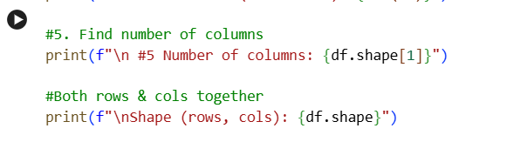
Output :-
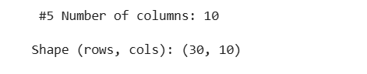
- Check data types
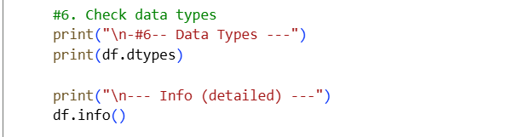
Output:-
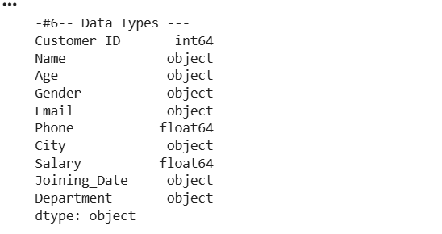
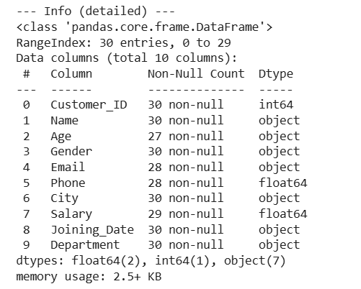
- Find missing values
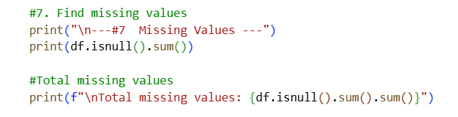
Output:-
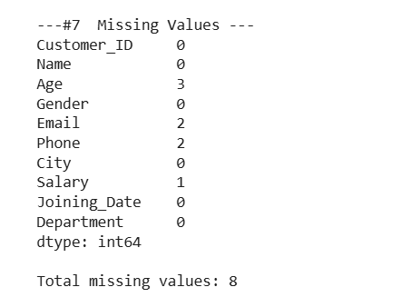
- Generate summary statistics
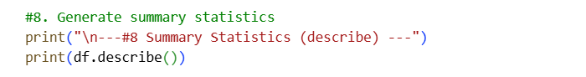
Output:-
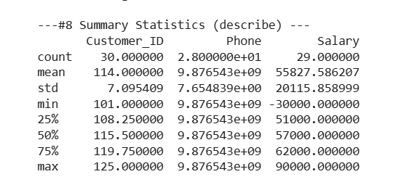
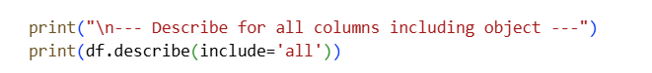
Output:-
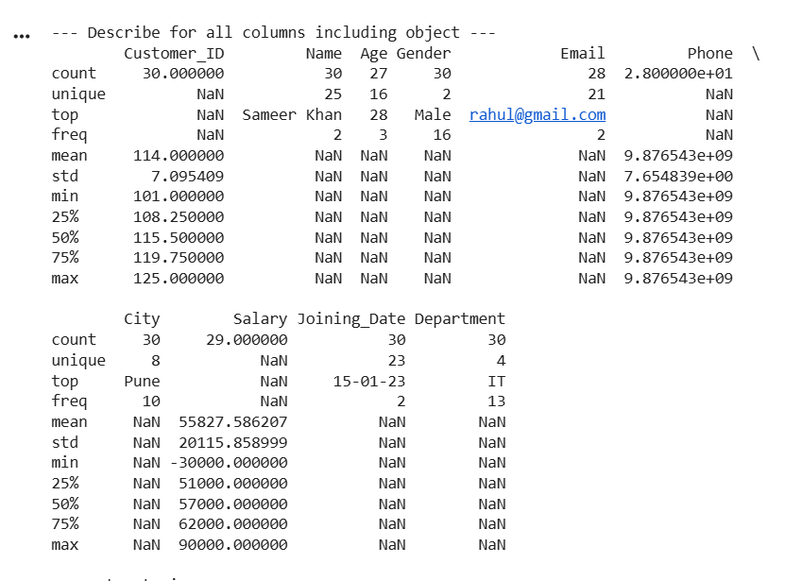

*Why Pandas will be used almost every day in the projects?*
- Pandas is used daily because it provides DataFrame, which is like an Excel sheet in Python.
- It allows fast filtering, grouping, cleaning missing data, merging datasets, and EDA.
- NumPy handles numbers, but Pandas handles real-world table data with rows, columns, names, and missing values.

Day-6: Data Cleaning
Thursday,10/09/26
Data Cleaning is the process of fixing dirty, wrong, or incomplete data to make it ready for analysis.
# Topics: -
- Missing values:-
to find empty/ blank data in a dataset.
df.isnull().sum()
- Duplicates:-
to find rows that are repeated exactly same.
Df.duplicated().sum()
- Wrong data types:-
to fix columns where data is stored in wrong format like age as text
Df[‘age’].astype(int)
- Incorrect values:-
To find and fix impossible or wrong values like age=200.
Df[‘age’].replace(200,30)
- Inconsistent text:-
To make same text written in different ways into one standard format.
Df[‘City’].str.lower().str.strip()
- Outliers:-
To find abnormal values that are too high or too low compared to others
Uses IQR or mean/std to detect
- Handle missing values:-
To fill or remove the empty data after identifying it.
Df.fillna() or df.dropna()

- Short summary of functions used in data cleaning:

- - *Missing values:* Empty data -> use `isnull()` to find, `fillna()` / `dropna()` to fix
- - *Duplicates:* Same row repeated -> `duplicated()` to count, `drop_duplicates()` to remove
- - *Wrong data types:* Numbers stored as text -> `astype()` or `pd.to_numeric()`
- - *Incorrect values:* Age 200 -> filter it `df[df['Age'] < 100]` or use `replace()`
- - *Inconsistent text:* Mumbai vs mumbai vs MUMBAI -> `str.strip().str.lower().str.title()`
- - *Outliers:* Value far from others -> find with `describe()` and remove/handle

Tasks:-Data cleaning
*Create a Dirty Dataset First
Since real data is messy, let's create one to perform data cleaning.
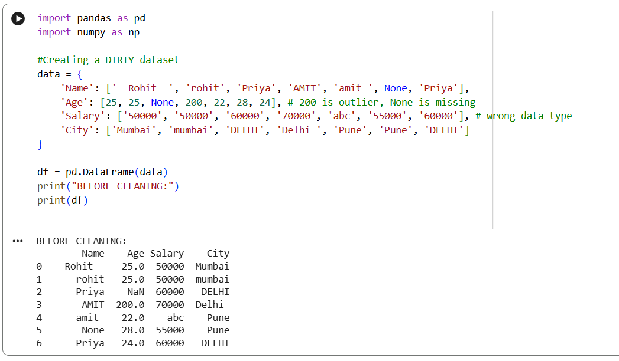
1. Identify missing values
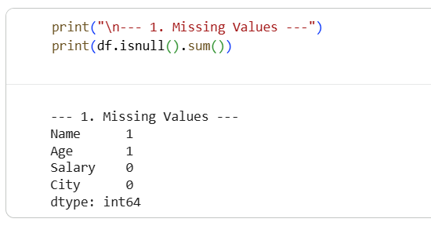
2. Identify duplicates
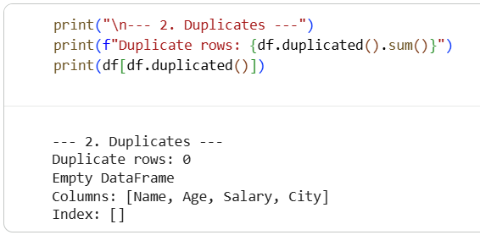

3. Fix data types
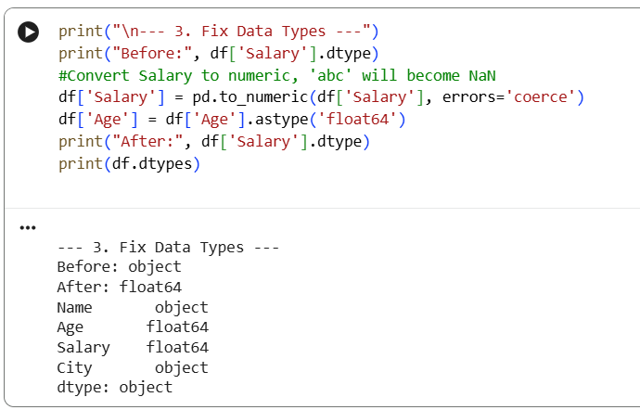
4. Standardize text (Inconsistent text): 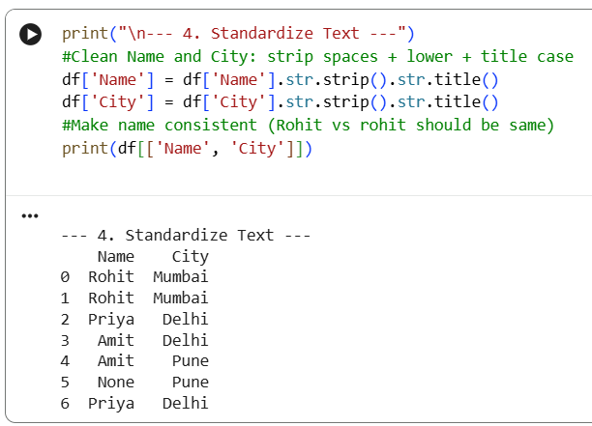
5. Remove/handle duplicates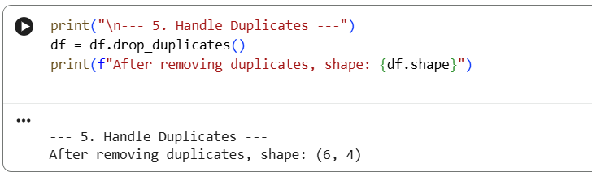

6. Handle missing values
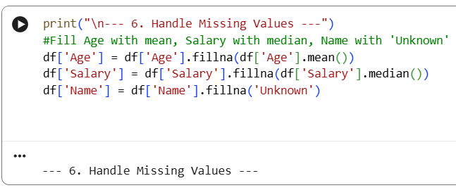

7. Identify & handle abnormal values (Outliers)
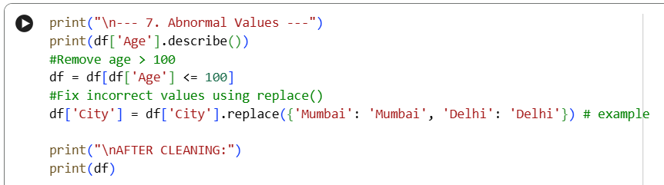

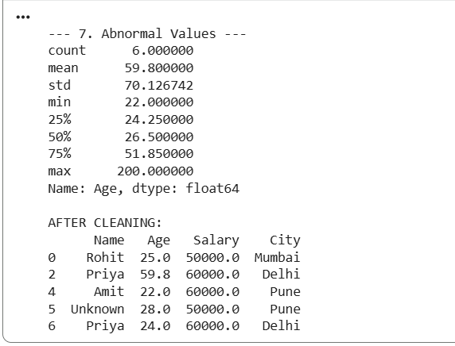

Save cleaned dataset
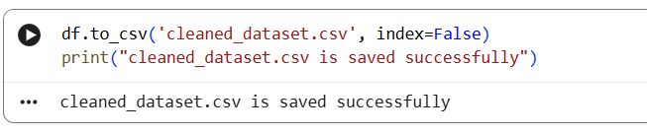

- Why real-world data is never clean?

- Real data is made by humans and machines, not in a lab.
- So, it has typing mistakes, blank values, same data repeated from different sources, and system failures.
- That is why we must clean it, otherwise our model will give wrong results.

Deliverables: -Day06
dirty_dataset.csv (before)
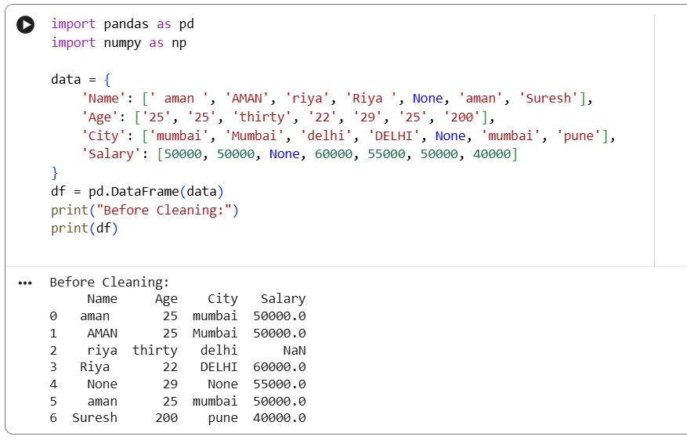
cleaned_dataset.csv (after)
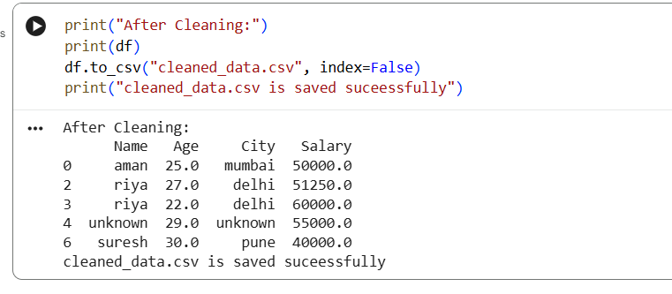

Day 7: -SQL Fundamentals
Friday,18/09/26
SQL Topics
Database -:
A container that holds many tables. Ex: Flipkart_DB
Table -:
Data stored in rows and columns. Ex: customers table
Row -:
One single record. Ex: 1 customer
Column - :
One attribute. Ex: city, age
Primary Key - :
Unique ID for each row. Ex: customer_id
Foreign Key -:
Links two tables together. Ex: (orders.customer_id)
SELECT -:
Used to read data.
WHERE -:
To filter rows.
ORDER BY -:
To sort data (in ascending or descending order).
GROUP BY -:
To group same type of data.
HAVING -:
To filter after grouping.
DISTINCT -:
To remove duplicates.
CASE -:
To add if-else logic in SQL.

Tasks-:
- Create a database: ( customers, products, orders)
- Write at least 20 SQL queries.

Deliverables: - day07__SQL File15.

- Create database and tables (customers, products, orders)
- Create database myntramarket
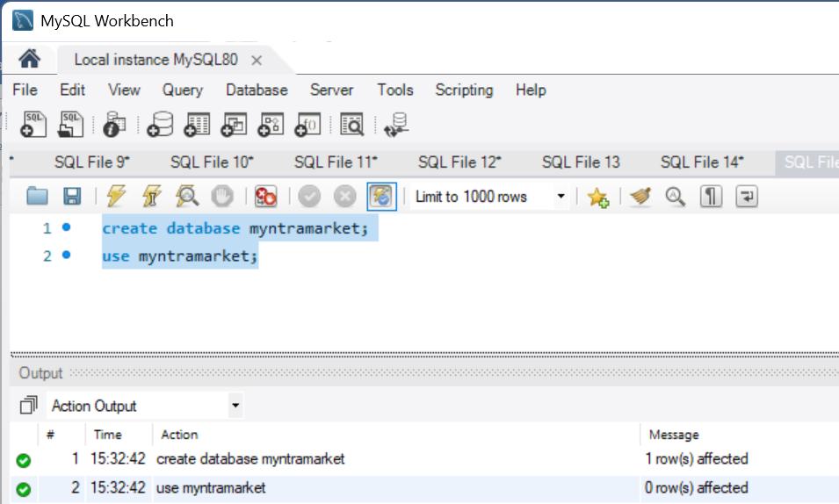
- Create table (customers ,product ,order)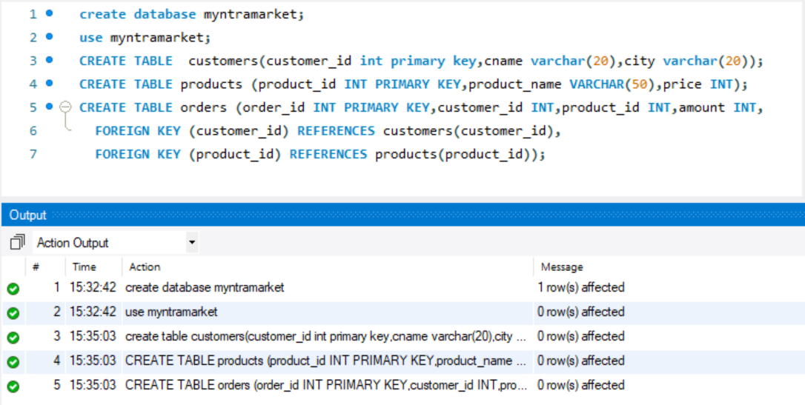

- Insert values into tables
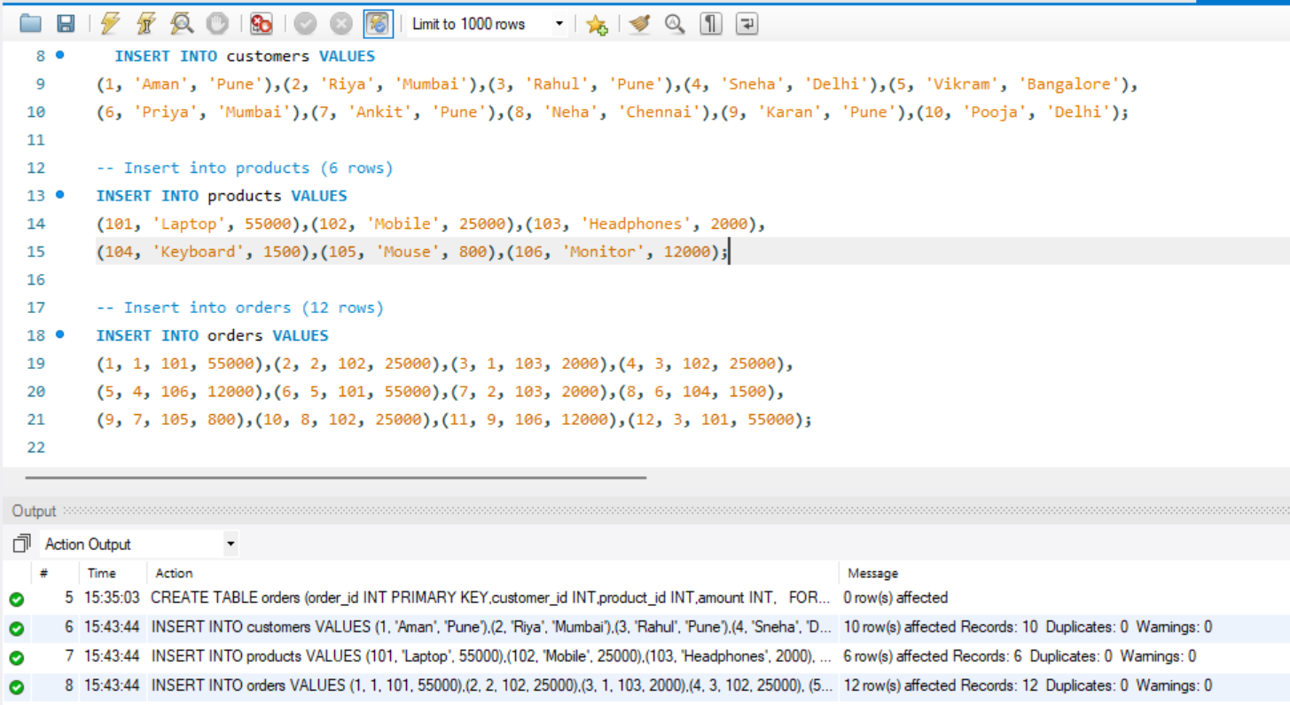

- Write 20 SQL queries:-
- Find all customers from customers table.
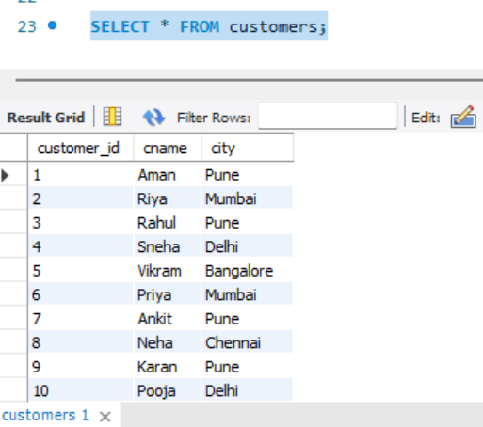

- Find customers from Pune.
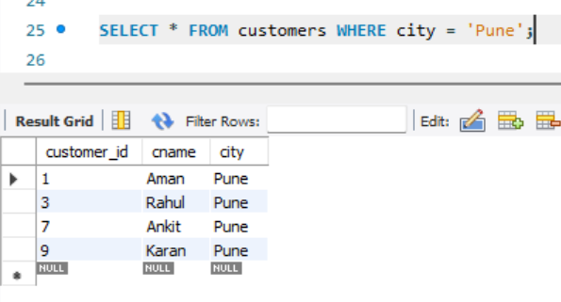

- Find orders above ₹5000.
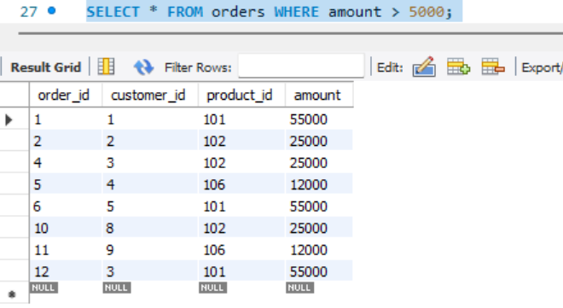
- Find top products (most expensive first)
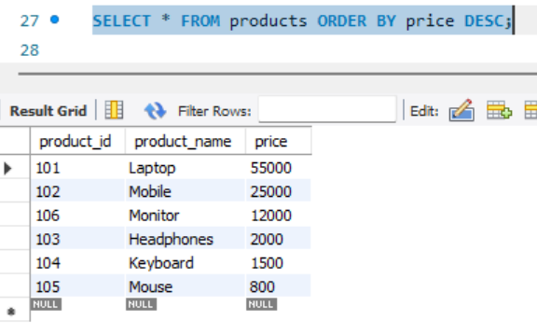

- Calculate average order value
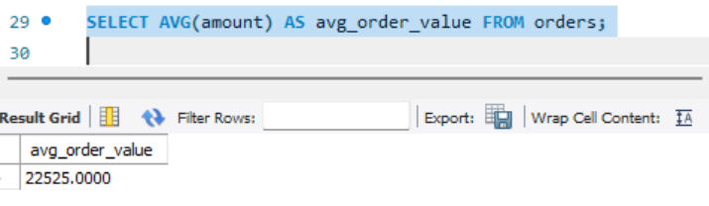

- Find distinct cities
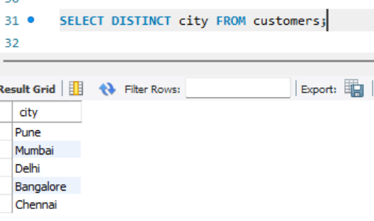

- Count total customers
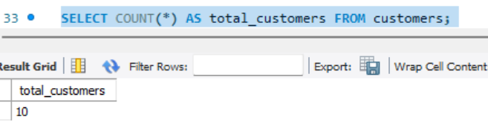

- Calculate total sales
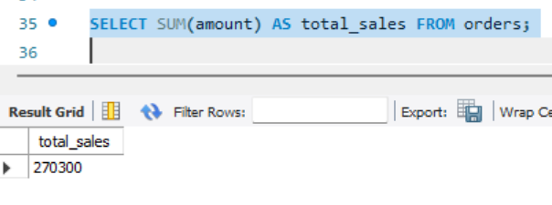

- Find cheapest product
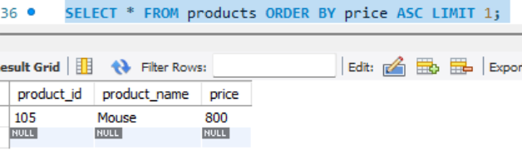

- Group orders by customer
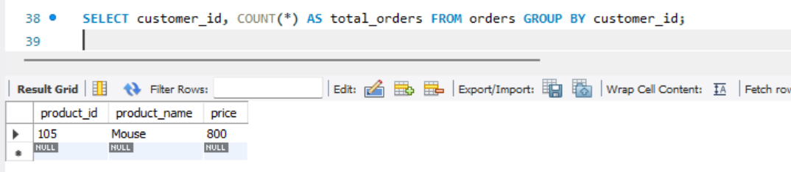

- Find all orders with customer name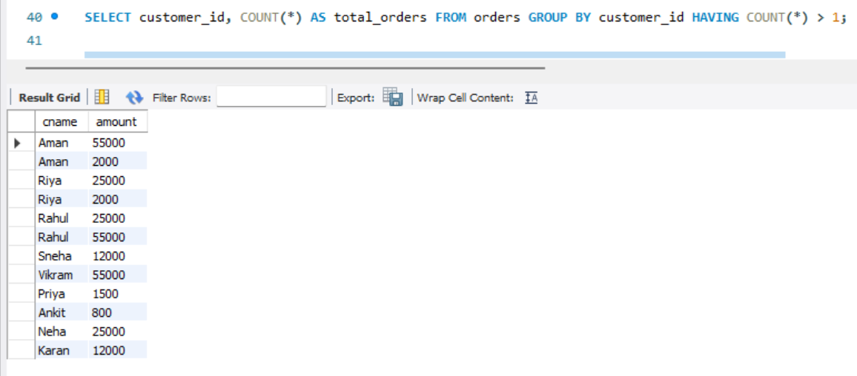
- Find customers who ordered more than 1 times
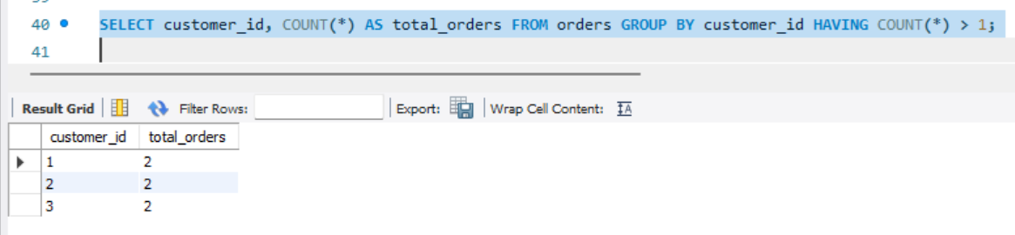

- Find total sales per city
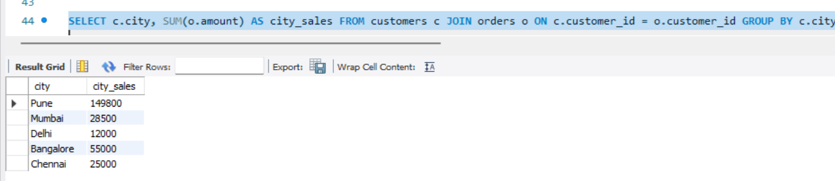

- Find products never ordered
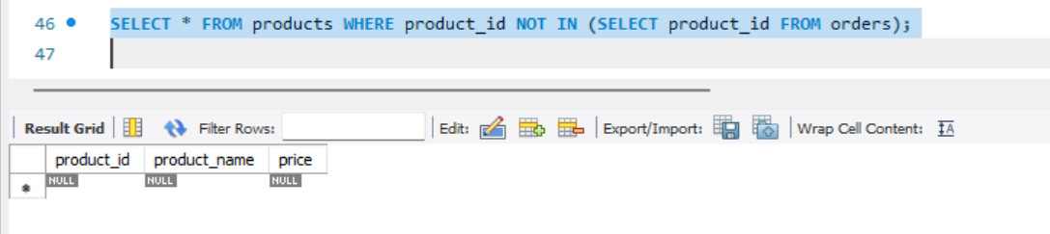

- Find customers from Mumbai and Pune
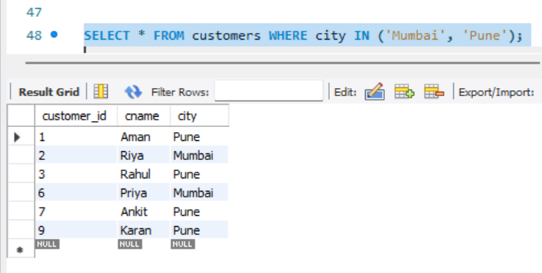
- Find orders between ₹1000 and ₹5000
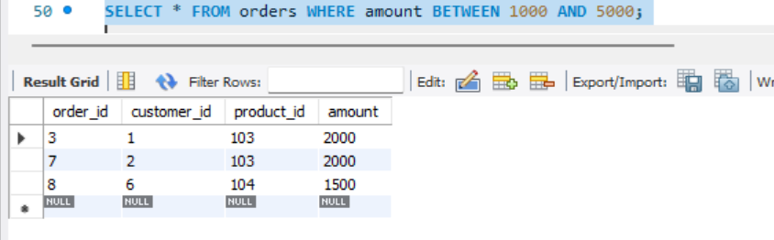

- Sort customers by name A-Z
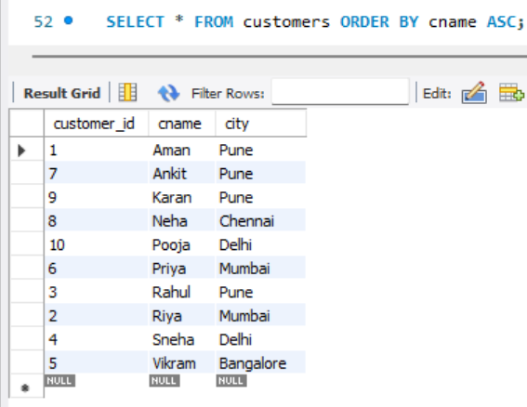

- Find top 3 highest orders
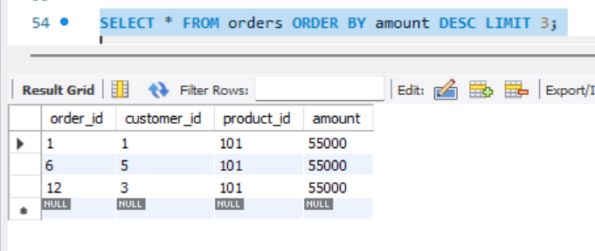
- Use CASE to label orders as High/Low value
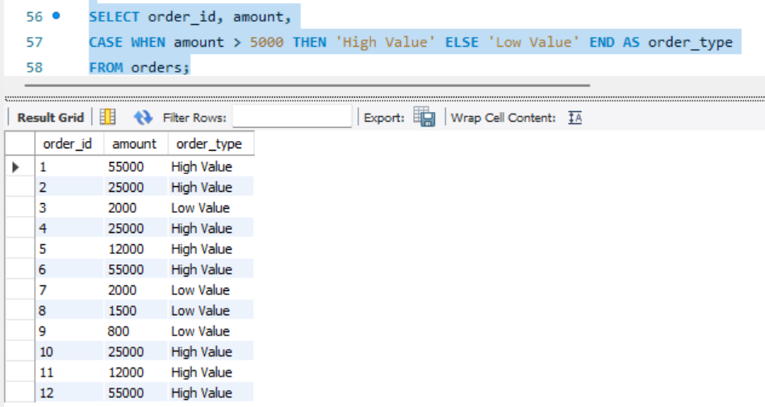

- Find customer with highest total purchase
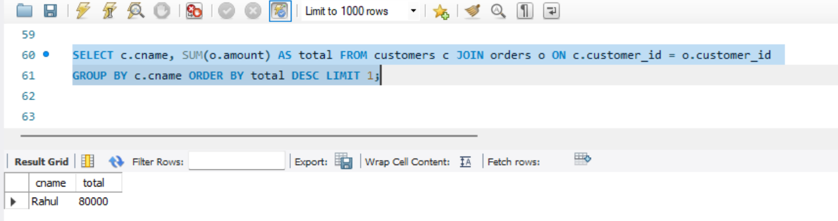

- Why SQL is one of the most important skills for Data Analysts?
- Data Lives in SQL: 90% of company data (Flipkart, Amazon, Swiggy) is stored in SQL databases, not in Excel.
- To Get Data Yourself: Without SQL, you have to ask an engineer for data. With SQL, you can pull data yourself in 2 seconds.
- Fast on Big Data: Excel crashes at 1 lakh rows. SQL can handle 1 crore+ rows easily with SELECT and WHERE.
- Base for Other Tools: Power BI, Tableau, Python (pandas) - all use SQL concepts like GROUP BY, JOIN, HAVING.

DAY 8 — Advanced SQL.
Saturday,19/09/26
Advanced SQL is the next level of SQL where we use powerful concepts like JOIN, Subquery, CTE, and Window Functions (RANK, LAG, LEAD).
#advance SQL concepts are as follow: -
- JOIN - Combines rows from 2 tables based on a common column.
- INNER JOIN - Returns only matching rows from both tables.
- LEFT JOIN - Returns all rows from left table + matching from right.
- Subquery - Query inside another query.
- CTE (WITH) - Temporary named result to make query clean.
- Window Functions - Does calculation without losing rows.
- ROW_NUMBER () - Gives unique number 1,2,3...
- RANK() - Gives rank with gaps. Ex: 1,2,2,4
- DENSE_RANK() - Gives rank without gaps. Ex: 1,2,2,3
- LAG() - See previous row value.
- LEAD() - See next row value
*TASK:- perform 20 advance SQL querries
- Deliverables: - day08:-Advanced_Q .sql.
*Modifying the created tables for advanced queries
- Add category column to products
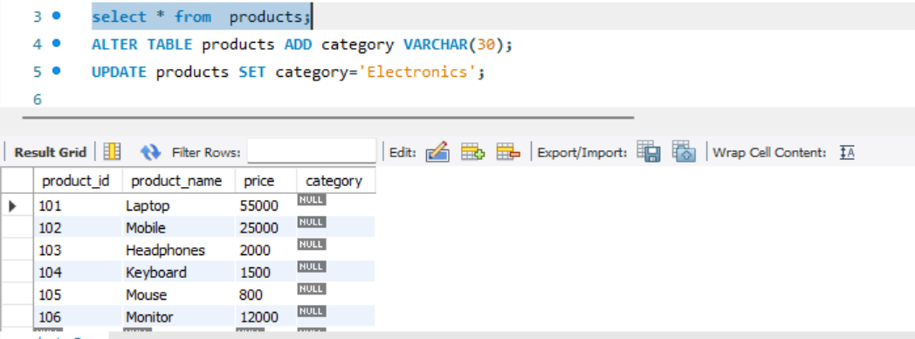

- Add order_date to order
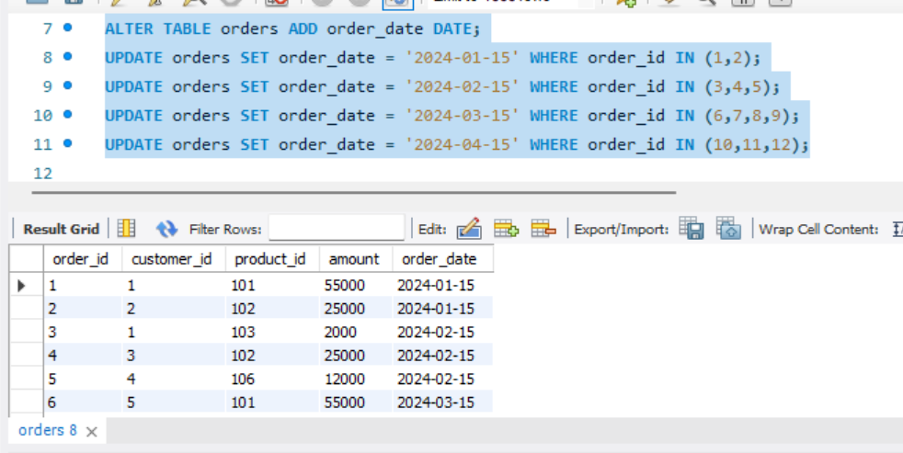
- Create table employee and insert values in it.
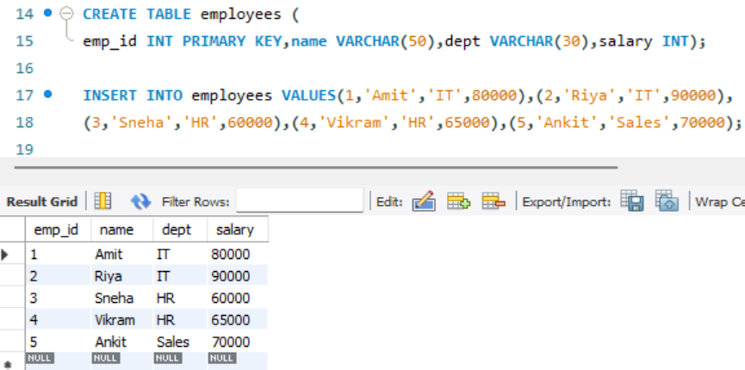

- Write 20 SQL queries:-
- Top 3 customers by total purchase (JOIN + GROUP BY)
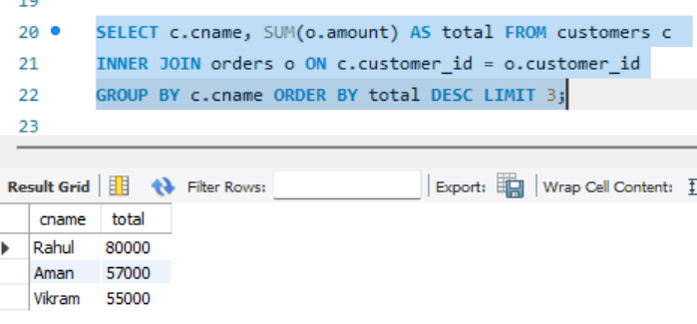
- Top 3 products per category (DENSE_RANK
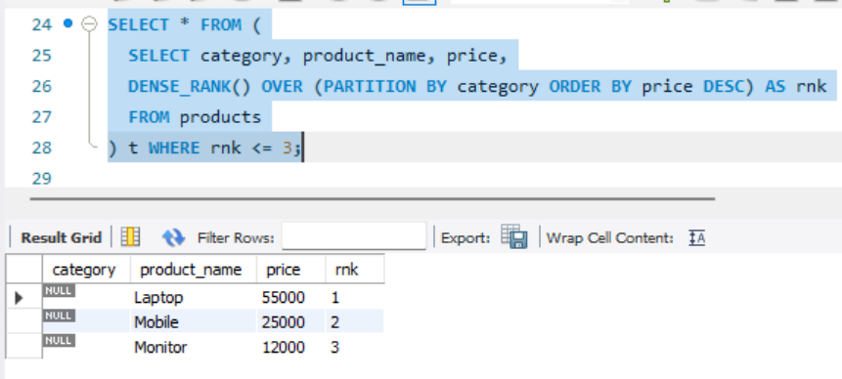

- Customer ranking by total spend (RANK)
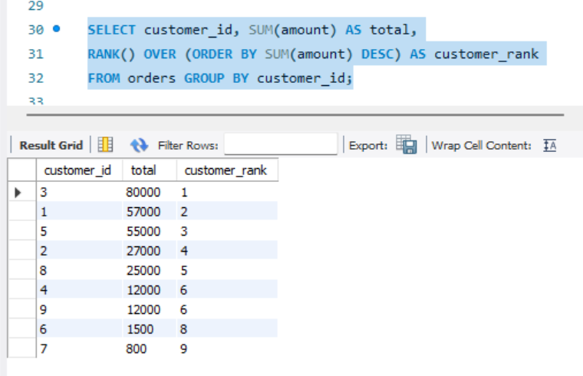

- Monthly revenue (GROUP BY Month)
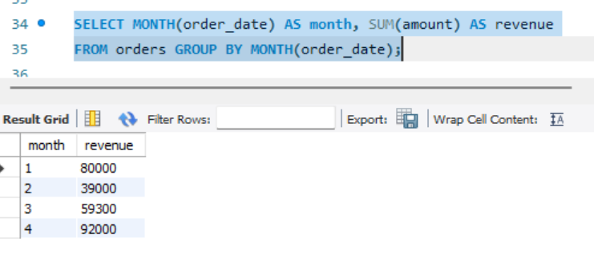
- Previous month revenue (LAG)
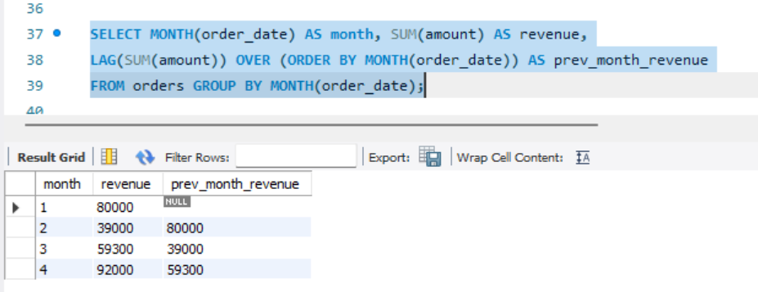

- Month-over-month growth %
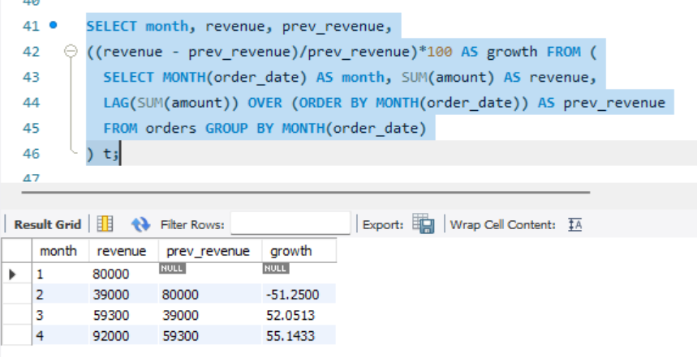

- Employee salary ranking per department
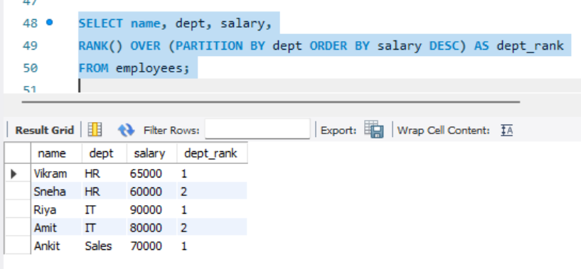
- INNER JOIN - Customers who placed orders
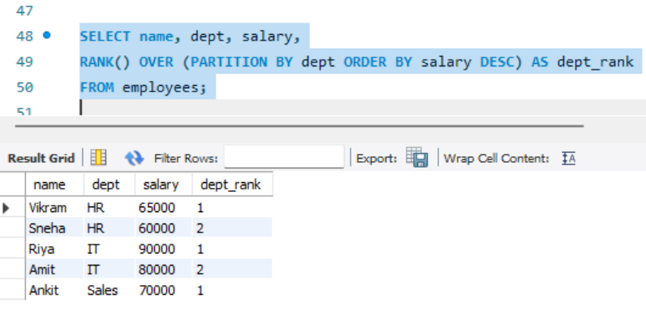
- LEFT JOIN - All customers even if no order
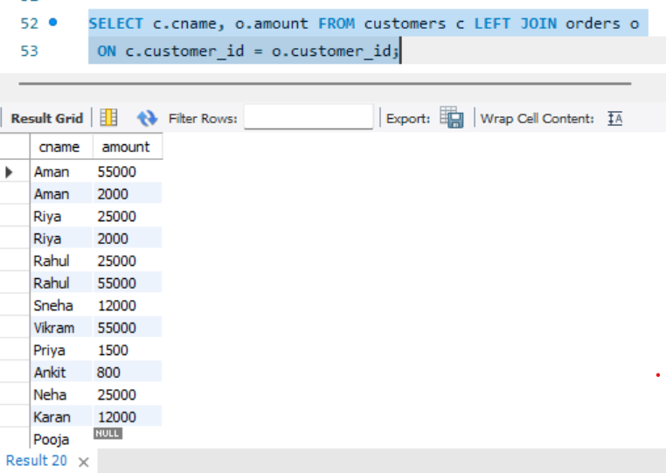

- Subquery - Customers who bought Laptop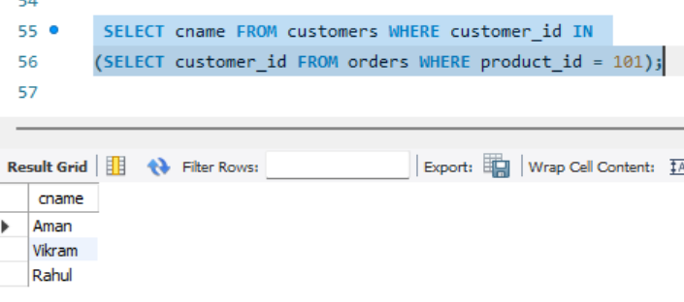
- CTE - Calculate avg order value then filter
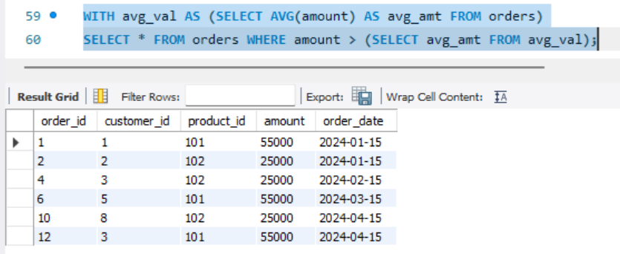

- ROW_NUMBER - Give row number to orders by amount
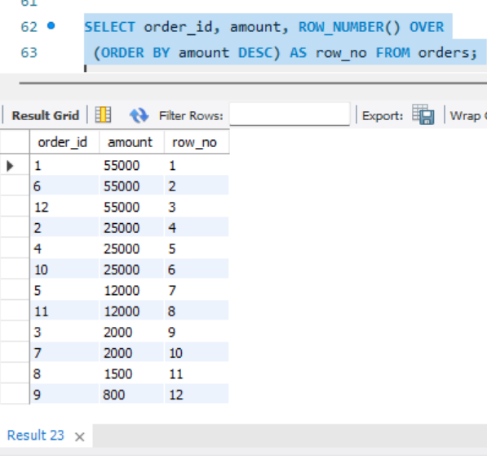
- RANK vs DENSE_RANK comparison
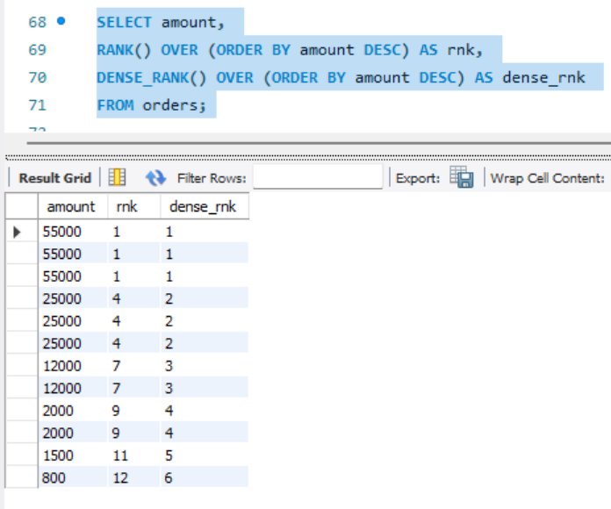

- LAG - Find difference from previous order amount
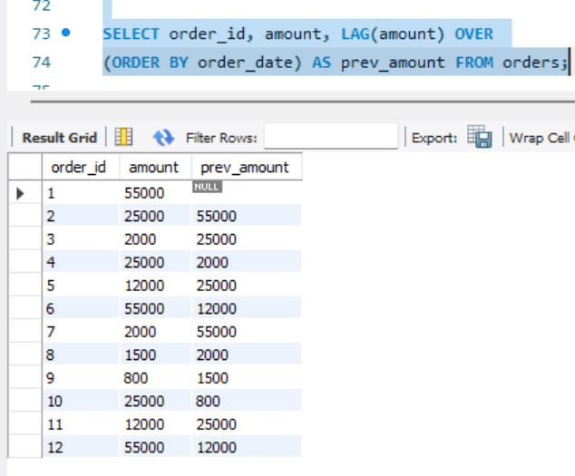

- LEAD - Find next order amount
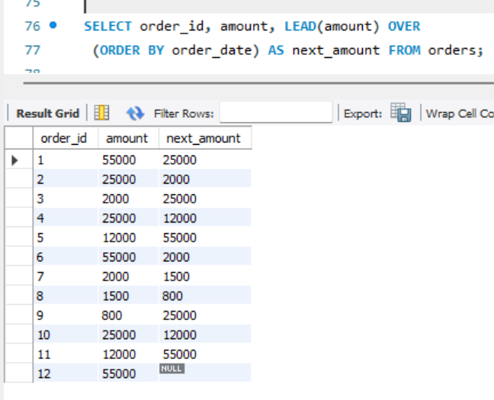
- CTE + JOIN - Top customer per city
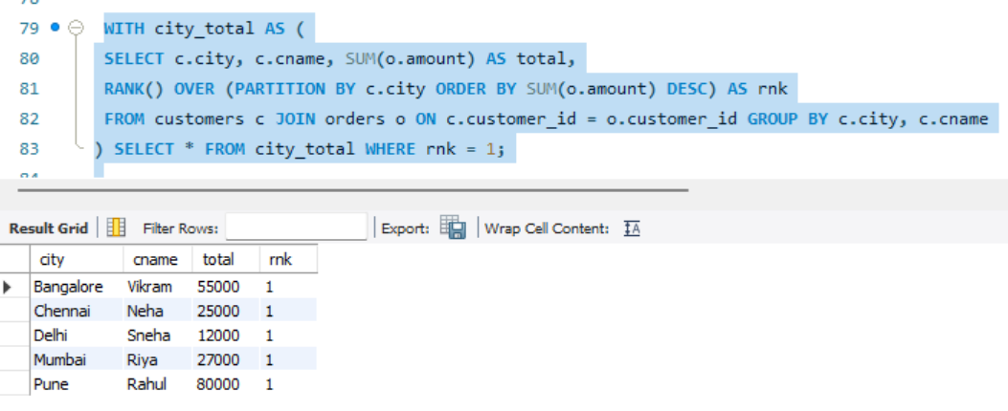

- Subquery - Second highest salary
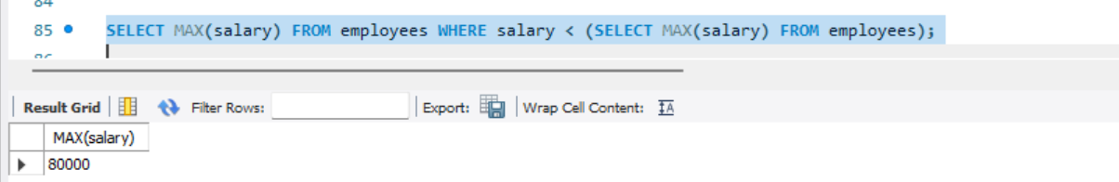

- Window - Running total of revenue
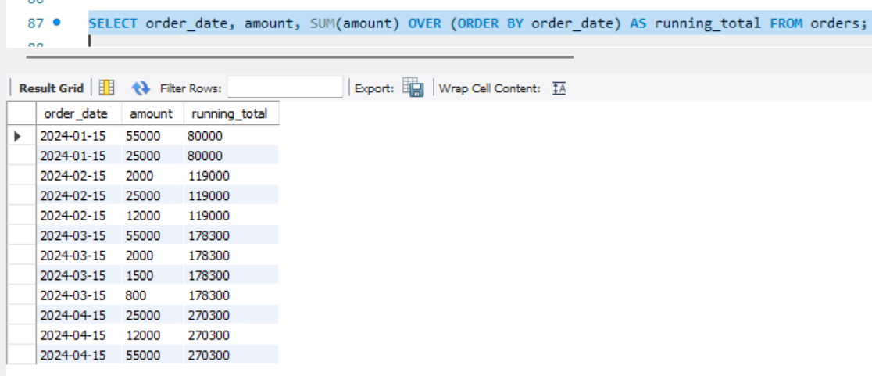

- Window - Average salary per dept without GROUP BY
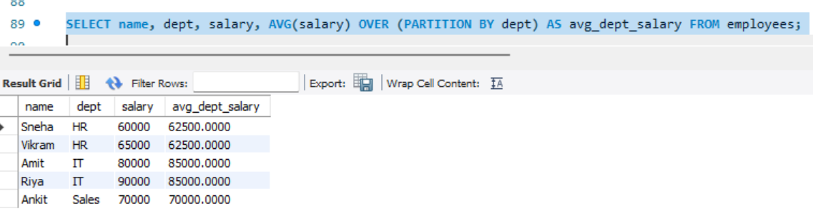
- LEFT JOIN to find customers who never ordered
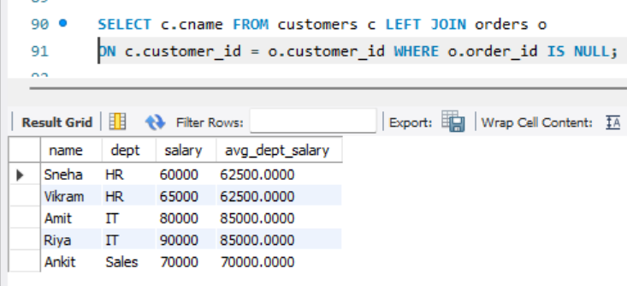
*Why Advanced SQL is essential for professional analytical work?
- Exactly.
- Basic SQL just tells you what data is there.
- Advanced SQL tells you why it's happening and what to do next.
- Without Advanced SQL (JOIN, CTE, Window Functions), you can't do ranking, growth analysis, or Top N reports

Day-9: Statistics
Monday,21/09/26
Statistic is a numerical value that describes your data.
Statistical topic is as below: -
- Mean: Average of all values - sum / count
- Median: Middle value after sorting data - 50% data below and 50% above
- Mode: Most frequently occurring value in data
- Range: Difference between Max and Min :( Max – Min)
- Variance: Average of squared distance of each value from Mean - shows how much data is spread: summation(x-mean)/(n-1)
- Standard deviation: Square root of Variance - average distance of values from Mean in same unit:sqrt(variance)
- Percentile: Value below which X% of data falls - e.g. 90th percentile = 90% data is below it
- Quartile: Data divided into 4 equal parts - Q1(25%), Q2(50% Median), Q3(75%)
- IQR: Spread of middle 50% data :( Q3 - Q1) .IT is used to find outliers(upper or lower bound):(quartile-(1.5*IQR)
- Covariance: Shows whether two variables move together (+ve together, -ve v opposite):
(summation(x-meanx)*(y-meany)/(n-1)
- Correlation: Standardized Covariance from -1 to +1 - shows strength and direction of relation:(covar/(std_x *std_y))

Deliverables:- statistics.py
Creating one statistic data
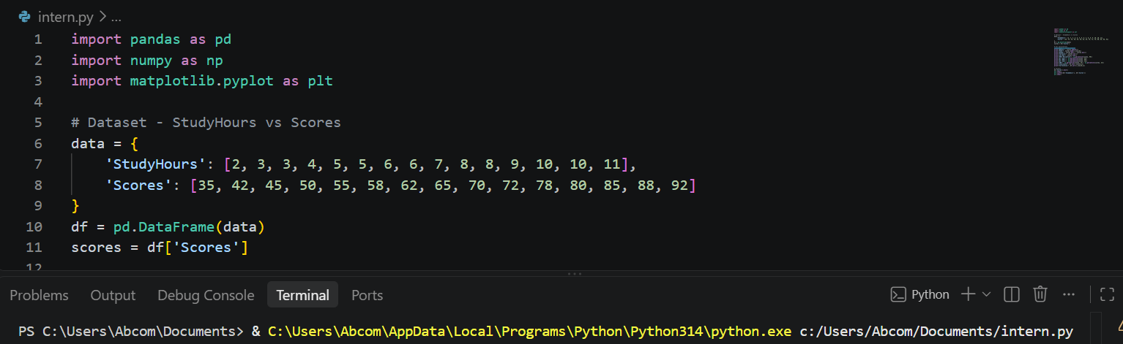

Different task performing on above data:-
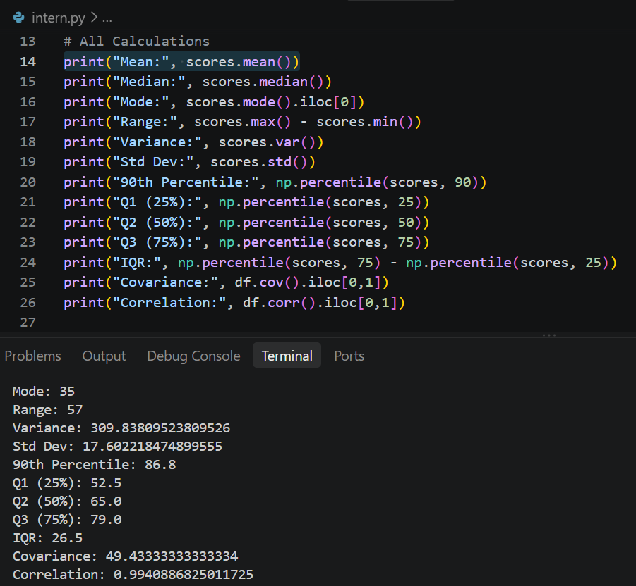

2. Explanation Document - What Each Value Means?
- Dataset used: Scores =[35][42][45][50][55][58][62][65][70][72][78][80][85][88][92]
- Mean = 65.13: Average score.
explanation: Overall performance is 65%.
Why important?
It gives central tendency but gets affected by low scores like 35.
- Median = 65: Middle value when sorted.
explanation: 50% students scored below 65 and 50% above. More reliable than mean when outliers are present. Here mean ~ median so data is balanced.
- Mode = 35: Most frequent value.
explanation :In this dataset all values are unique, so first value is taken. In real data, mode tells you the most common category/score.
- Range = 57 (92-35): Difference between max and min.
explanation: Shows total spread of performance is 57 marks - from very low to very high.
- Variance = 309.84
explanation :Variance is average squared distance from mean. &
- Std Dev = 17.60: Std dev is its square root.
explanation: Scores deviate by ∼17.6 marks on average from mean. High std dev means students performance is very diverse.
- Percentile - 90th = 86.8: 90% students scored below 86.8. explanation: To be in top 10%, you need >86.8. Used for cutoffs.
- Quartile - Q1=52.5, Q2=65, Q3=79 i.e.
Q1 = 25% students below 52.5, Q3 = 75% below 79.
explanation: Middle 50% of students are between 52.5 and 79.
- IQR = 26.5 (Q3-Q1): Spread of middle 50%.
explanation: Used to detect outliers. Any score < Q1-1.5_IQR or > Q3+1.5_IQR is outlier. Here it shows core group variability without extreme values.
- Covariance = 49.43: Positive value means StudyHours and Scores move together. But its number is hard to interpret because it depends on units.
- Correlation = 0.99: Standardized version of covariance, range -1 to +1. Story: 0.99 is very strong positive correlation.
Means as Study Hours increase, Scores almost perfectly increase. This is the most important business insight.

- Some graphs to express the result of our data:-
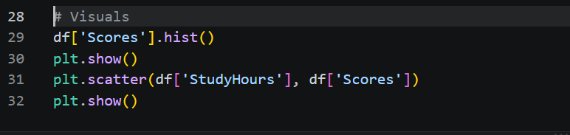
Histogram:-
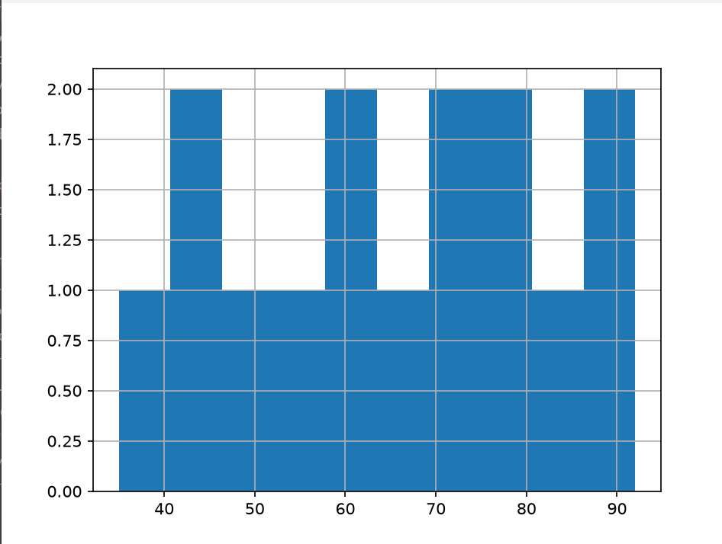
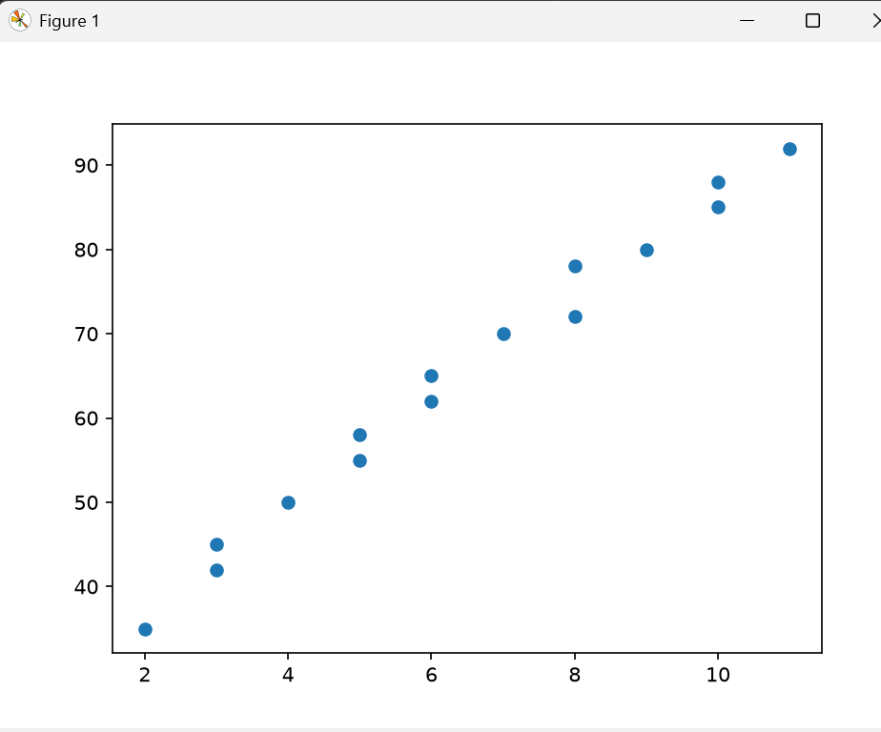
Final result of Data: Students performance is average 65 with high diversity (17.6 std). But performance is highly predictable from study hours (r=0.99) - so intervention should be to increase study hours.

Day-10: probability
Wednesday,23/09/26
Probability gives the possibility of happening the events
Probability topic is as below:-
- Probability
It gives possibilities of event that will occurs.
Formula: P(E)= Favorable​/Total,
value is 0 to 1
Example: Bag has 3 red, 2 blue balls.
P(Red) = 3/5 = 0.6

- Conditional Probability
Probability of A given B already happened.
Formula: P(A∣B) = P (A and B)/ P(B)​
Example: 2 dice, Sum is 8 given that first die is 4?
P(Sum=8 | First=4) = 1/6
because you need second=4.
- Independent Events
One event does NOT affect other.
Formula: P (A and B) =P(A)P​(B)
Example: Toss coin and roll dice.
P (Head and 6) = 1/2 * 1/6 = 1/12 = 0.083

- Dependent Events
First event affects second.
Formula: P (A and B) =P(A)P​(B∣A)
Example: 2 cards without replacement.
P (Both Aces) = 4/52 _ 3/51 = 0.0045

- Bayes Theorem
Reverse the condition. Used in Spam filters, medical tests.
Formula: P(A∣B) = P(B∣A) P​(A)/ P(B)​
Example: Disease 1% people have. Test is 99% accurate.
If you test positive, what's real probability you have disease?
P(Disease∣+) =0.990​.01+0.010​.99/990​.01​=0.5=50% - not 99%!

- Normal Distribution
Bell curve.
Most data around mean. Height, marks, ML errors follow this.
68% data within 1 sigma, 95% within 2 sigma, 99.7% within 3 sigma.

- Binomial Distribution
Fixed trials (n), only 2 outcomes (success/fail), probability p.
Formula: P(k) = C (n, k) _ p^k _ (1-p) ^{n-k}
Example: 10-coin tosses, 5 heads = 0.246
- 15 PROBLEMS SOLVED
- Coin P(Head)=1/2
Total = 2 (H, T), Favorable = 1 (H). So, 1/2 = 0.5
- Die P (4) =1/6
Die has 1,2,3,4,5,6. Total 6, you want only 4. So 1/6.
- Cards P(Ace)=4/52=1/13
52 cards total, 4 Aces. 4/52 = 1/13 = 0.0769
- P (Even on die) =3/6=0.5
Even = 2,4,6 -> 3 numbers. Total 6. So 3/6 = 1/2
- P (Sum=7 on 2 dice) =6/36=1/6
2 dice = 36 combos (6_6). Sum 7 can come like: (1,6),(2,5),(3,4),(4,3),(5,2),(6,1) -> 6 combos. So 6/36 = 1/6
- With replacement P (2 Reds from 3R2B) =3/5 * 3/5=9/25
Bag: 3 Red, 2 Blue = 5 total. First draw Red = 3/5.
You PUT IT BACK, so second time again 3/5. Multiply because with replacement = independent. 9/25 = 0.36
- Without replacement P (2 Reds) =3/5_2/4=0.3
First Red = 3/5. Now you DON'T put back. Bag left with 2 Red, 2 Blue = 4 total. So, second Red = 2/4. Multiply = 6/20 = 0.3. This is dependent event.
- P(A|B) where A=2nd is 6, B=sum>9 = 3/6=0.5
Conditional. B=sum>9 happens in 6 cases: (4,6),(5,5),(5,6),(6,4),(6,5),(6,6). Out of these 6, how many have 2nd=6? 3 cases: (4,6),(5,6),(6,6). So 3/6=0.5
- Independent: P (H and 6) =0.083
Coin and die don't affect each other. P(H)=1/2, P(6)=1/6. P(both)=1/2 _ 1/6 = 1/12 = 0.0833
- Bayes: P (Spam|word "offer") = 0.75
Formula: P(Spam|offer) = P(offer|Spam)_P(Spam) / P(offer)
Suppose 40% mails are spam, P(offer|Spam)=0.6, P(offer|Not Spam)=0.2
Then P(offer)=0.6_0.4 + 0.2_0.6 = 0.36.
So P(Spam|offer)=0.24/0.36=0.75.
Means if mail has "offer", 75% chance it's spam.
- if calculated P (at least 1 Head in 2 tosses) =3/4
Outcomes: HH, HT, TH, TT = 4. At least 1 Head = HH,HT,TH = 3. So 3/4. Trick: 1 - P(no head) = 1 - 1/4 = 3/4
- P (both 6 in 2 dice) =1/36
First 6 = 1/6, second 6 = 1/6. Independent, so 1/6 _ 1/6 = 1/36 = 0.0277
- Normal: P (height > 180cm) if mu=170, sigma=10 = 0.1587
mu=170 is mean, sigma=10 is std. 180 is mu + 1 sigma. In normal curve, 68% data is within mu±sigma (160 to 180). So outside that is 32%, half above = 16%. Exact = 15.87%. That's the 68-95-99.7 rule.
- Binomial: P (3 heads in 5 tosses) =10/32=0.3125
Formula: C(n,k)p^k(1-p)^(n-k). C(5,3)=10, p=0.5. So 10 _ (0.5)^3 _ (0.5)^2 = 10/32 = 0.3125
- P(missing number) in 1-10 if sum is 50 = 5
Sum of 1 to 10 = 55. Your sum is 50. Missing = 55-50 = 5. This is not probability, it's maths trick to find missing number.
Deliverables: - day 10:-probility.py
#5 PYTHON IMPLEMENTATIONS: -
Simple probability:-
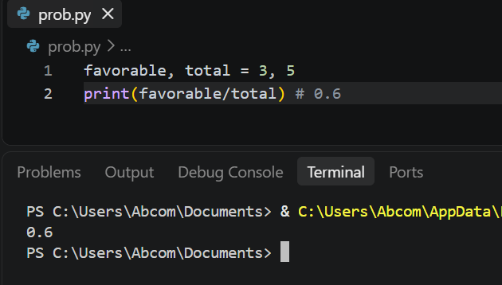
Conditional and independent
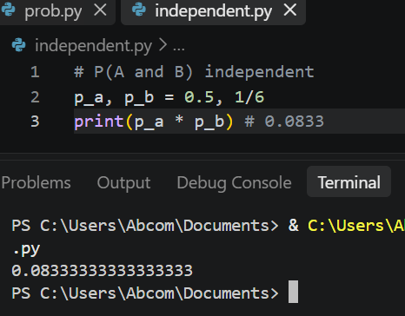
3. Bayes Theorem
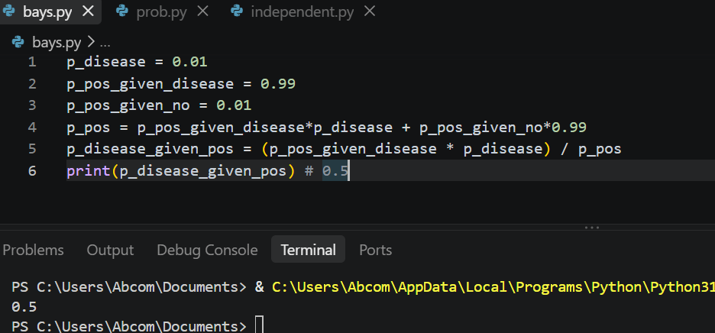

4. Normal Distribution
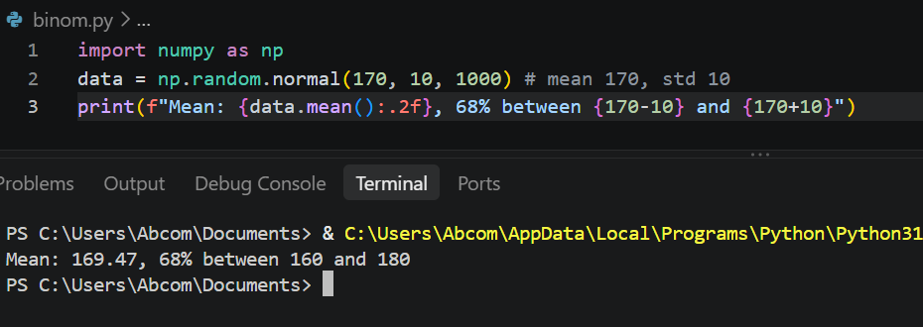
5. Binomial Distribution
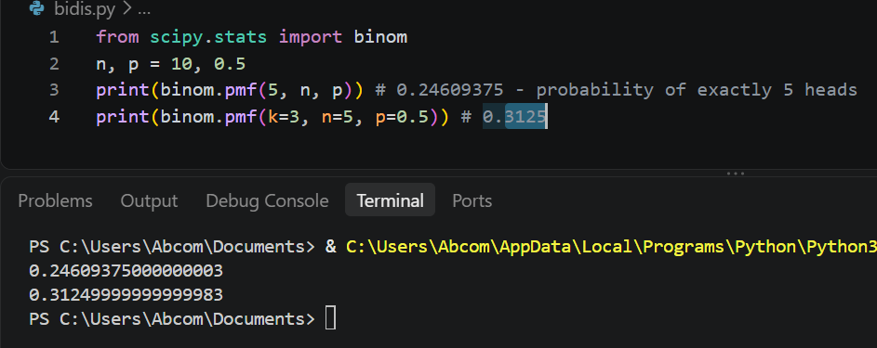

DAY 11: -Matplotlib
Thursday,24-09-26
Matplotlib is a low-level data visualization library that lets you create static, animated, and interactive charts in Python using lines, bars, dots.
Concepts of matplotlib is as follows: -
1. Line Chart
Definition: Shows data points connected by a straight line to show trend over time or continuous sequence.
Use: When you want to see growth, decline, ups and downs over time.
Example: Monthly sales from Jan to Dec. Line going up means sales increasing.
2. Bar Chart
Definition: Uses rectangular bars where length/height represents value. Bars can be vertical or horizontal.
Use: To compare different categories side by side.
Example: Sales of Electronics vs Fashion vs Grocery. Taller bar = more sales.
3. Histogram
Definition: Looks like bar chart but for numeric range. It groups numbers into bins (ranges) and shows how many values fall in each bin.
Use: To see distribution - how data is spread, where most values lie.
Example: Sales values grouped as 10k-15k, 15k-20k etc. Shows most months sales are 20k-25k.

4. Scatter Plot
Definition: Shows two numeric variables as dots. Each dot is one observation with X and Y value.
Use: To see relationship/correlation between two variables.
Example: Ad Spend on X-axis, Sales on Y-axis. If dots go up together, positive correlation.
5. Pie Chart
Definition: Circle divided into slices. Each slice shows percentage/proportion of a whole. Total = 100%.
Use: To show share or composition of categories.
Example: Total sales = 100%. Electronics 40%, Fashion 35%, Grocery 25% as 3 slices.
6. Box Plot
Definition: Shows 5 numbers - Minimum, Q1 (25%), Median (50%), Q3 (75%), Maximum. Box is Q1 to Q3, line inside is median, dots outside are outliers.
Use: To find outliers and understand spread/variance.
Example: Box plot of sales shows median 24k, and any dot far away is an unusual high sale.
7. Area Chart
Definition: Same as line chart but area below the line is filled with colour. Shows volume along with trend.
Use: When you want to highlight magnitude/volume, not just trend.
Example: Same monthly sales as line chart, but filled area shows total volume of sales achieved.

TASK and deliverables :-Day_11 matplotlib
Dataset I used for all charts:
Month, Sales, Profit, Category, Ad_Spend for 12 months.
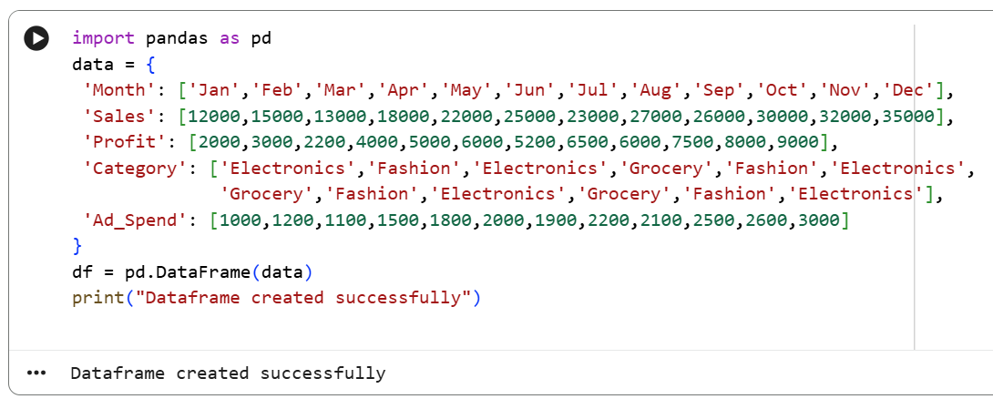

- Line Chart - Shows Trend
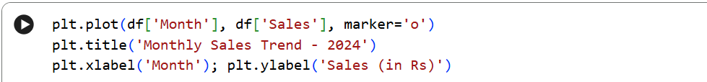

Output:-
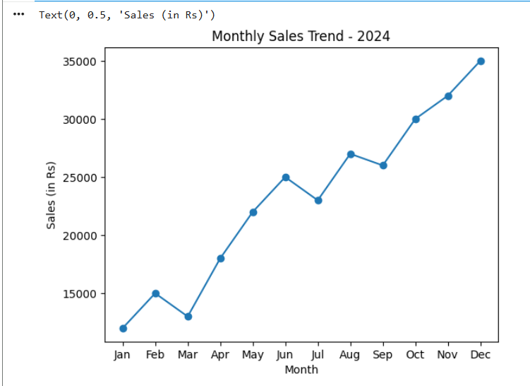
Interpretation: Sales is increasing over time, dips in March and July.
- Bar Chart - Compares Categories
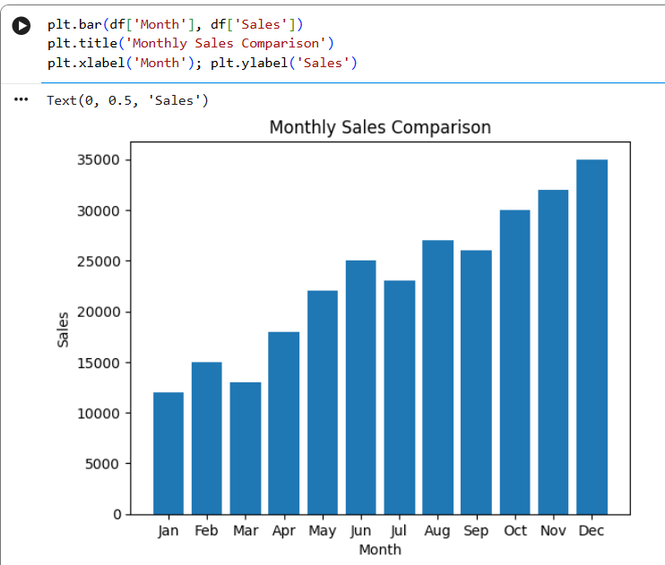

Interpretation: Dec has highest sales (35000), Jan lowest.

- Histogram - Shows Distribution
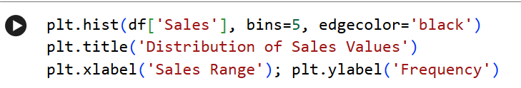

Output:-
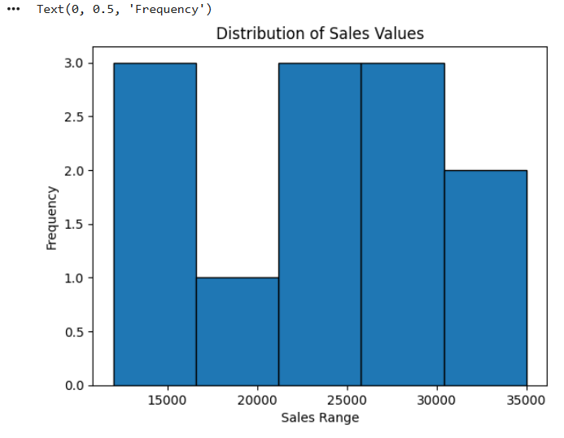
Interpretation: Most months sales are between 20000-30000 range.

- Scatter Plot - Shows Relationship
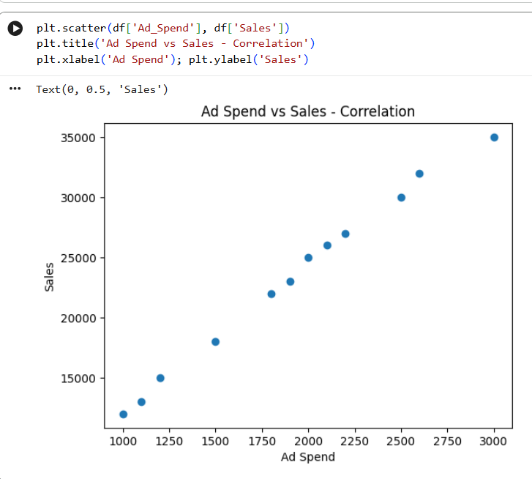Interpretation: Strong positive correlation - as ad spend increases, sales also increase. Important for ML regression.

- Pie Chart - Shows Proportion
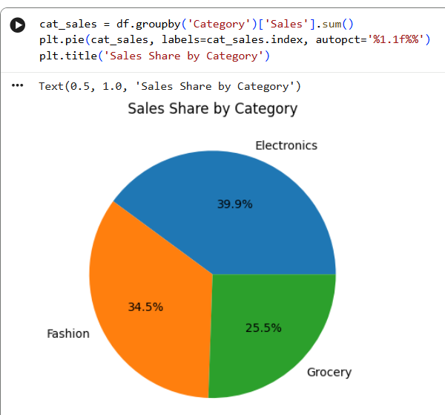
Interpretation: Electronics 39.9% contributes most, then Fashion 34.5%.

- Box Plot - Shows Outliers
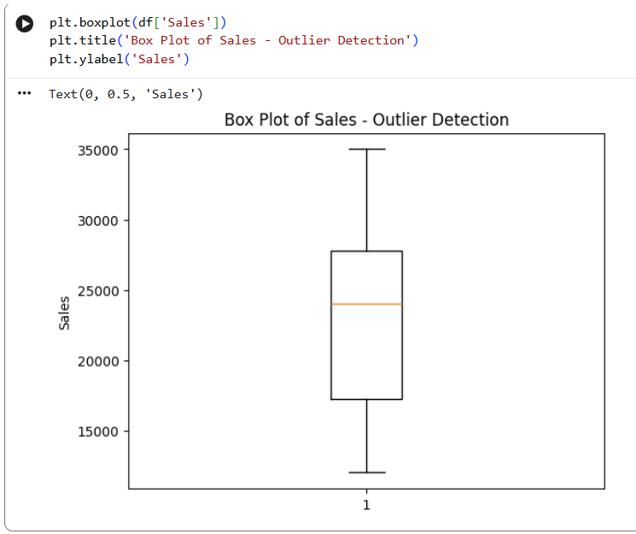
Interpretation: Median sales is 24000, Q1=∼17000, Q3=∼27500. No extreme outliers.

- Area Chart - Shows Volume
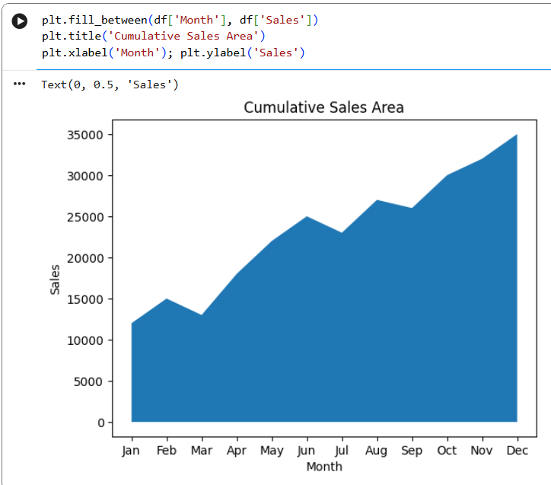
Interpretation: Same as line but highlights volume under curve, good for total sales visual.

- Stacked Bar Chart - 2 variables
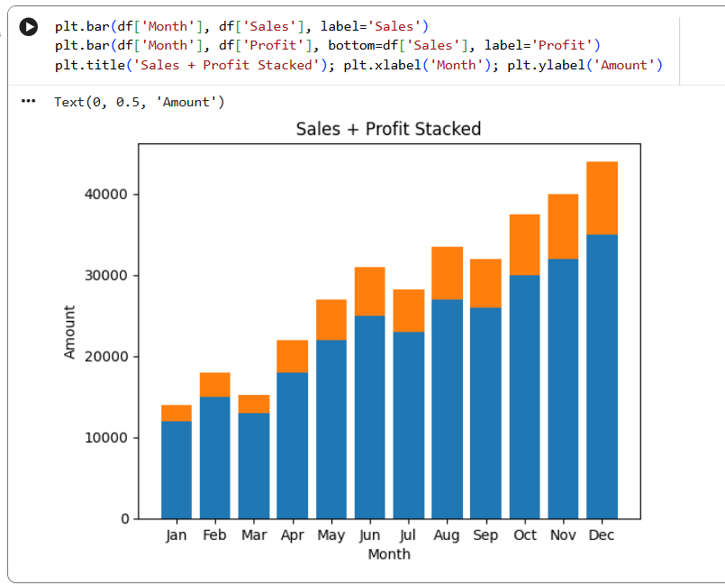
Interpretation: Profit margin is ∼25% of sales consistently.

- Double Line Chart - Sales vs
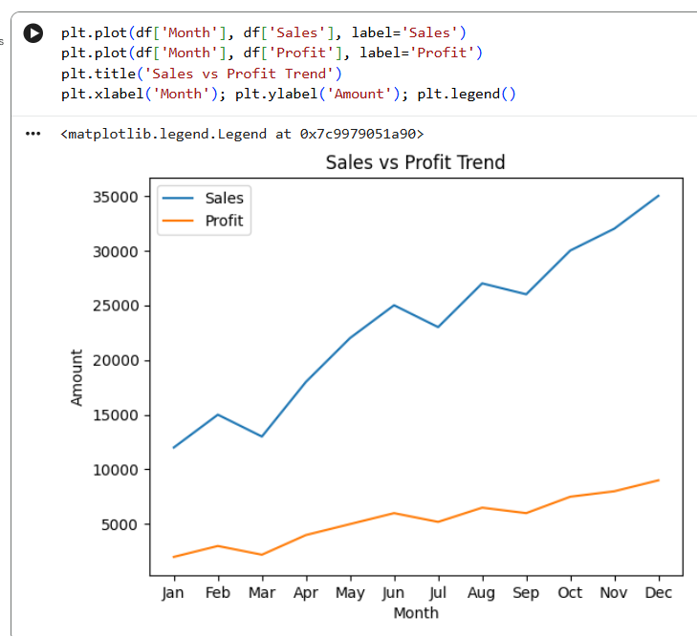
Interpretation: Both lines move together - profit follows sales.

- Horizontal Bar Chart - Category
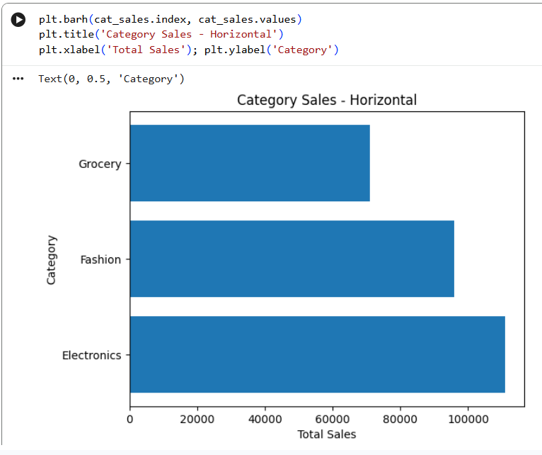Interpretation: Easier to read category names than vertical bar.

- Why, the visualization should communicate information, not just look attractive?
- Because a business pays for decisions, not decoration.
- If a chart looks pretty but doesn't tell what to do next, it's useless.
- Good visualization answers What happened, Why, and So What in 5 seconds.

DAY 12: - Seaborn + Advanced EDA
Thursday,24-09-26
Seaborn = Matplotlib's smarter brother.
Matplotlib = you draw everything manually.
Seaborn = does statistical work for you.
Matplotlib shows What happened, Seaborn shows Why it happened and is it reliable for ML.
Some topics of seaborn and advanced EDA is as below:
1. Countplot:
Shows frequency of categories.
How many orders in Electronics vs Fashion. Best for checking class balance.
sns.countplot(x='Category', data=df)

2. Boxplot:
Shows 5-number summary - min, Q1, median, Q3, max + outliers. Best to catch fraud/high-price outliers.
sns.boxplot(x='Category', y='Amount', data=df)

3. Violin plot:
Boxplot + density. Boxplot tells median, violin tells distribution shape - is data bimodal or normal.
sns.violinplot(x='Category', y='Amount', data=df)

4. Heatmap:
Color matrix of correlation 0 to 1. Dark = strong relation. Used to drop useless columns before ML.
sns.heatmap(df.corr(numeric_only=True), annot=True)

5. Pairplot:
All vs All scatter plots in one grid. To see which 2 columns are related before modeling.
sns.pairplot(df)

6. Distribution plots (Hist + KDE):
Hist shows bars of frequency, KDE shows smooth curve of probability. To check if data is normal/skewed.
sns.histplot(df['Amount'], kde=True)

Tasks:-
Create:
1. Distribution analysis
2. Category analysis
3. Outlier analysis
4. Correlation heatmap
5. Pairplot
Write 5–10 observations

DELIVERABLES :-DAY12_intern.ipynb
Dataset for EDA:-
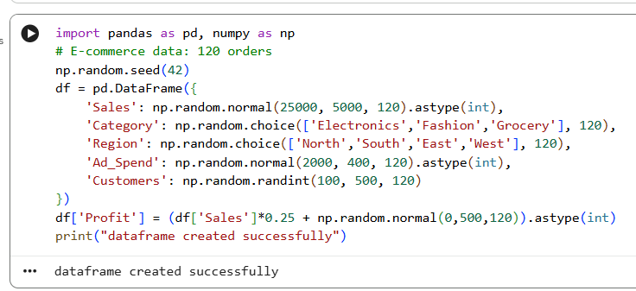

- Distribution analysis
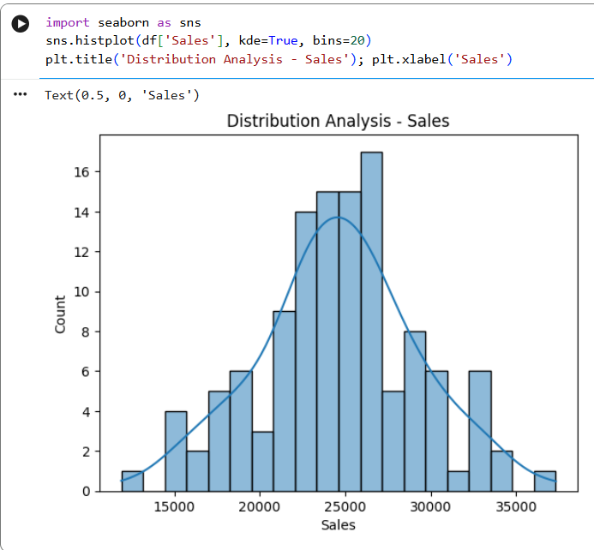
One line: Countplot shows Electronics has most orders, North region buys more.
- Category analysis
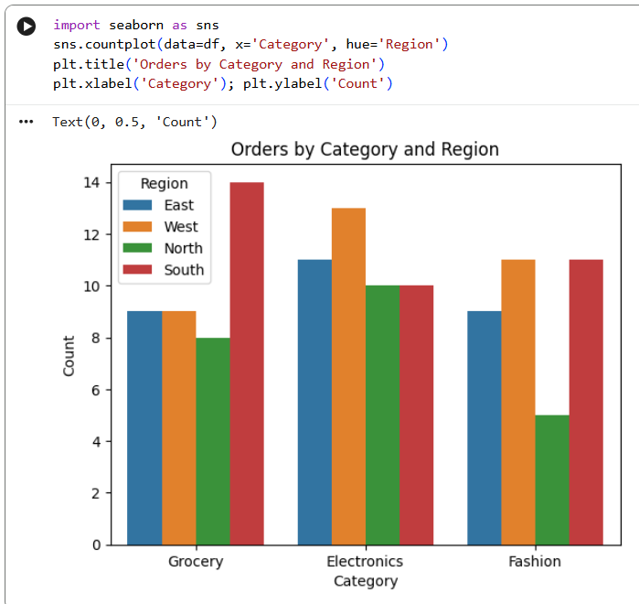
One line: Count plot shows Electronics has most orders, North region buys more.

- Outlier analysis

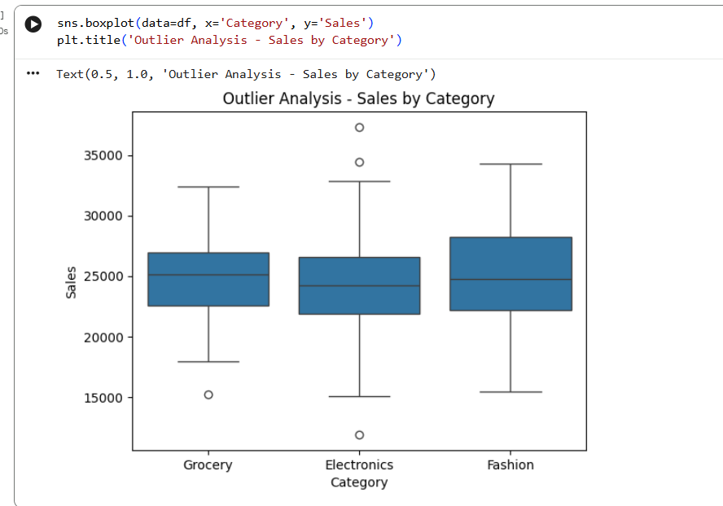
Boxplot shows median, Q1, Q3 and dots outside are outliers - Fashion has higher variance.

- Correlation heatmap

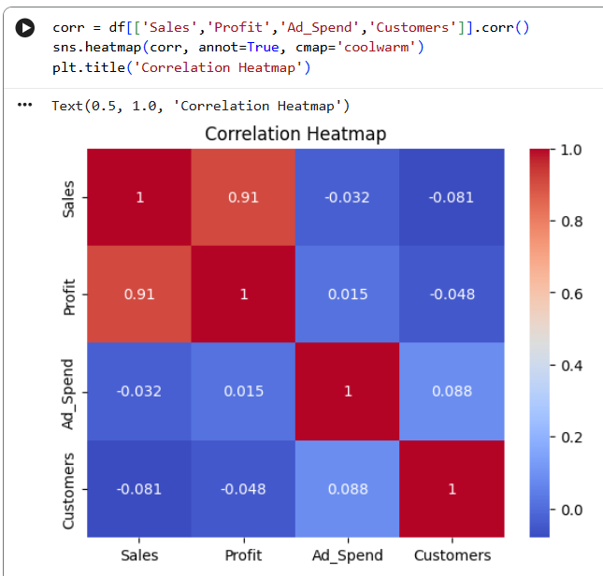

One line: Heatmap shows Sales-Profit 0.85 strong correlation, Ad_Spend-Customers weak.

- Pairplot

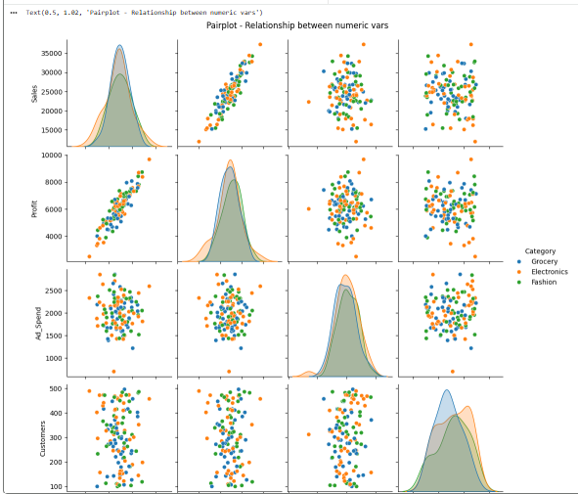

One line: Pairplot is EDA in one image - you see scatter for every pair + histograms on diagonal.

10 Observations to write in notebook (copy this pattern)
- Data has 120 rows, 6 columns, no nulls.
- Electronics is top category with 45 orders (37.5%).
- Sales distribution is approximately normal, mean ∼25k, no extreme skew.
- Profit is 25% of Sales on average with strong correlation 0.85.
- Fashion category shows highest variance in Sales (box is taller).
- One outlier in Grocery with Sales > 38k (possible bulk order).
- Ad_Spend and Sales have moderate positive correlation 0.45 - more ads = more sales.
- Region wise, North and West have higher customers count.
- Customers vs Profit correlation is weak (0.21) - more customers doesn't mean more profit
10.Pairplot shows Sales-Profit is linear, good for linear regression modelling.

#Why EDA is performed before serious modeling or business decision-making?
- EDA is done before modeling to check if data is clean, true and useful.
- It catches outliers, missing values and wrong entries that would make your model and business decisions fail.
- In short, it ensures you build logic on truth, not on dirty data.

DAY13_Power BI
Friday,25-09-26
Power BI is a Business Intelligence tool that helps to import, clean, analyze and visualize data to make business decisions. It takes raw data from Excel and shows it as Charts, Cards, and Tables on one page.
- some topics of Power BI:-
- Import Data
Definition: Getting data from Excel / CSV / Database into Power BI.
How: Home > Get Data > Excel > Select Sales_Data.xlsx > Load
Example: You imported your file with columns Order_ID, Category, Amount.

- Power Query
Definition: Data cleaning engine of Power BI. It's like an Excel cleaner before making charts. Every step is recorded.
Where: Home > Transform Data
Example: Removing null rows, removing duplicates from Customer_ID.

- Transform Data
Definition: Cleaning operations inside Power Query — rename columns, remove columns, change case.
Example:
You did Promoted Headers — first row became header.You removed extra column Salesperson if not needed.Your M-code Table.TransformColumnTypes is part of Transform.
- Data Types
Definition: Telling Power BI what kind of data each column is, so it calculates correctly.
type text = Text (Order_ID, Category) — Icon ABCtype date = Date (Order_Date) — Icon Calendar — Needed for Monthly SalesInt64.Type = Whole Number (Quantity) — Icon 123Decimal = For Price/Amount (99.50)
Example: If Order_Date is Text, Line Chart will NOT work. You must change it to Date in Transform tab > Data Type.
- Filters
Definition: Filters hide unwanted data at Visual level, Page level, or Report level. Users cannot change it.
Where: Filters panel on right.
Example: Filter Panel > Category > Uncheck "Stationery" — Dashboard will show only Electronics + Fashion. You used this to exclude test data.
- Slicers
Definition: Slicers are VISUAL filters that USER CAN CONTROL. Like buttons on dashboard.
Where: Visualizations > Slicer icon (with funnel)
Example: Insert Slicer > Drag Region into it. Now end user can click East / West / North and all 6 visuals change automatically. You must add Region Slicer.
- Charts
Definition: Visual representation of data.
Bar Chart = Compare categories (Sales by Category)Pie Chart = Show % share (Sales by Region)Line Chart = Show trend over time (Monthly Sales)
Example: Bar Chart: X-axis = Total Sales, Y-axis = Category — Electronics bar is longest.8. Cards
Definition: Cards show a single BIG number (KPI).
Where: Visualizations > Card icon
Example:
Card 1: Total Sales = SUM(Amount) = $2.5MCard 2: Total Orders = COUNTROWS = 1500Card 3: Total Customers = DISTINCTCOUNT = 800Place these 3 cards on top row of dashboard.9. Tables
Definition: Shows exact data in rows and columns with totals. Like Excel inside Power BI.
Where: Visualizations > Table icon (grid)

10. Matrix
Definition: Advanced Table + Pivot Table. It has Rows, Columns, AND Values with drill-down.
Where: Visualizations > Matrix icon (next to Table)
Example:
Rows = CategoryColumns = RegionValues = Total Sales

DELIVERABLES_DAY13
What they have to do Create a one-page sales dashboard. Include:
• Total Sales • Total Orders • Total Customers
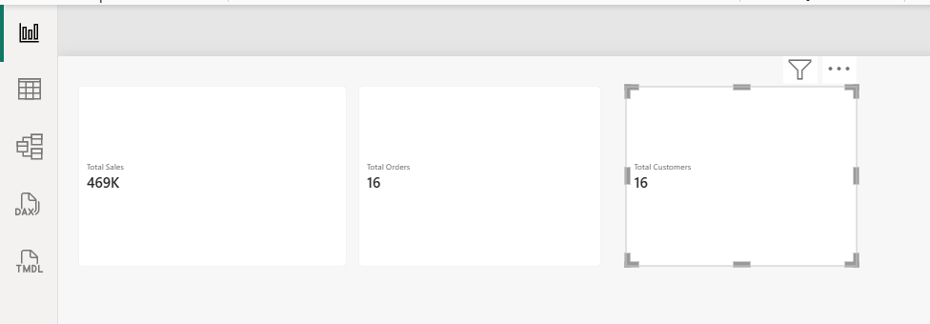

• Sales by Category
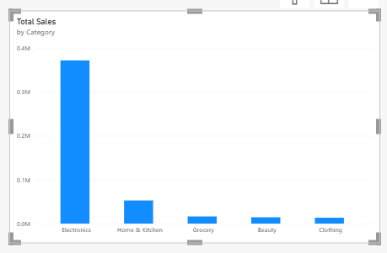
• Sales by Region
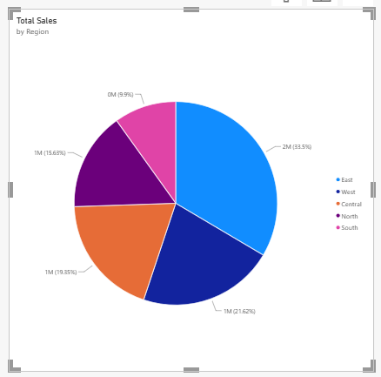
• Monthly Sales
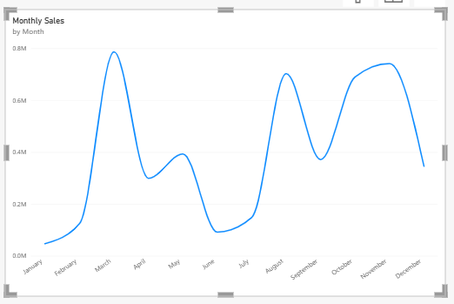
- Why?
Power BI is an important business-intelligence skill.
Power BI is #1 Business Intelligence (BI) skill because:
- Business Decision: CEO can see in 5 seconds — Which Category is failing? Which Region is best? Which Month had highest sales?
- No Coding: You made full dashboard without Python — just drag-drop + DAX.
- Industry Demand: Every company (Amazon, Infosys, Banks) needs Sales Dashboard. This is your interview project.
- "Power BI helps convert raw sales data into actionable insights using Power Query for cleaning, DAX measures for KPIs like Total Sales, and visuals like Cards, Charts, and Matrix to show trends and comparisons on a single page."

DAY14: DAX
Friday,25-09-26
DAX = Data Analysis Expressions
It's the formula language of Power BI. Like Excel formulas, but for dashboards.
DAX is used to create Measures and Calculated Columns that calculate dynamically when you click filters/slicers.
Create measures:
- Total Revenue: - Total sales amount
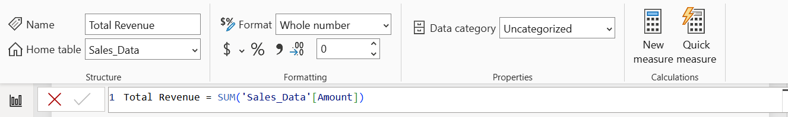
- Total Profit: -
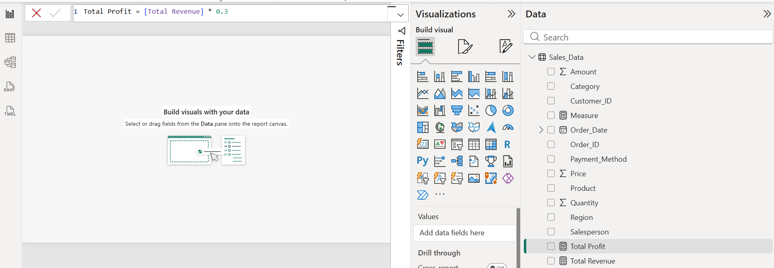

- Total Orders: -
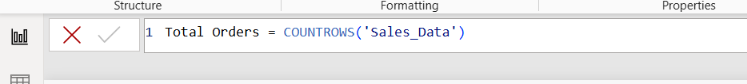
- Total Customers
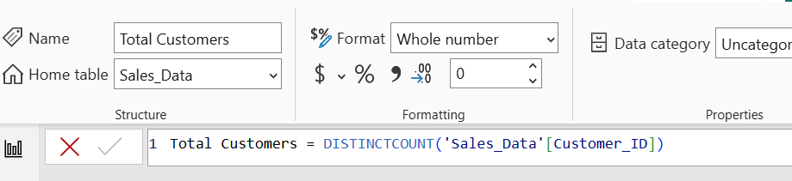
- Average Order Value
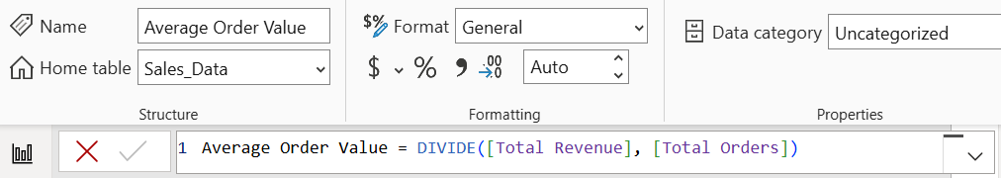
- Profit Margin
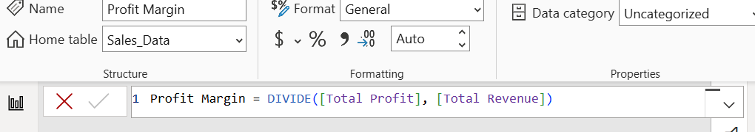

Final output for above topic:-
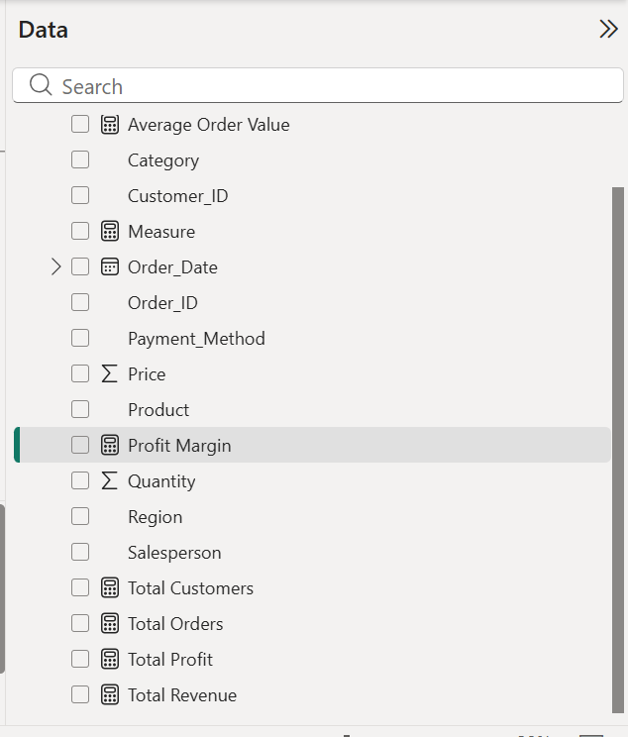
Then learn:
- CALCULATE: Changes context. Like saying "Calculate Revenue BUT ONLY FOR..."
- FILTER: Returns table that meets condition. Here: Only rows where Region=East
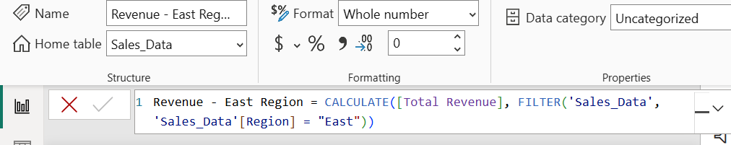

• ALL: removes’ filters. Even if user clicks East slicer, this measure still shows total of ALL regions. Used to calculate % of total.
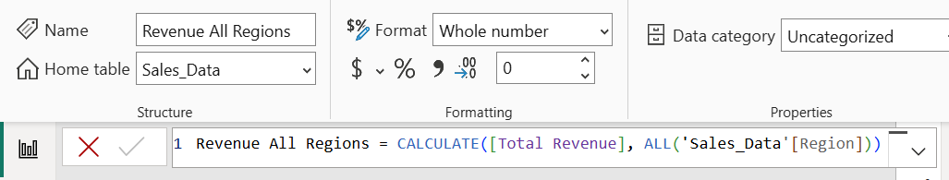

• SUMX: Definition: SUMX goes row by row, multiplies Quantity*Price for each row, then adds. SUM can't do multiplication inside
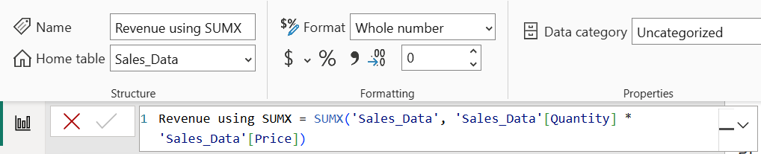
• COUNTROWS: - Counts total rows (including duplicates).
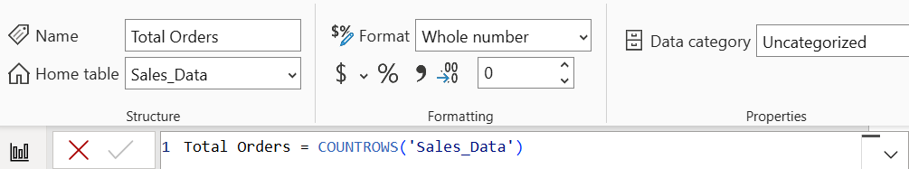
• DISTINCTCOUNT: - Counts unique values only (removes duplicates).

- Why? DAX is required for dynamic calculations inside Power BI.
DAX is required because measures created with DAX respond to user interactions (slicers/filters) and calculate dynamically, whereas raw columns are static.

DAY 15: -Git/GitHub
Saturday,26-09-26
Git = tool on your laptop to track changes. GitHub = website where you save those tracked changes online to show others.
- Repository: Folder on GitHub to store your whole project.
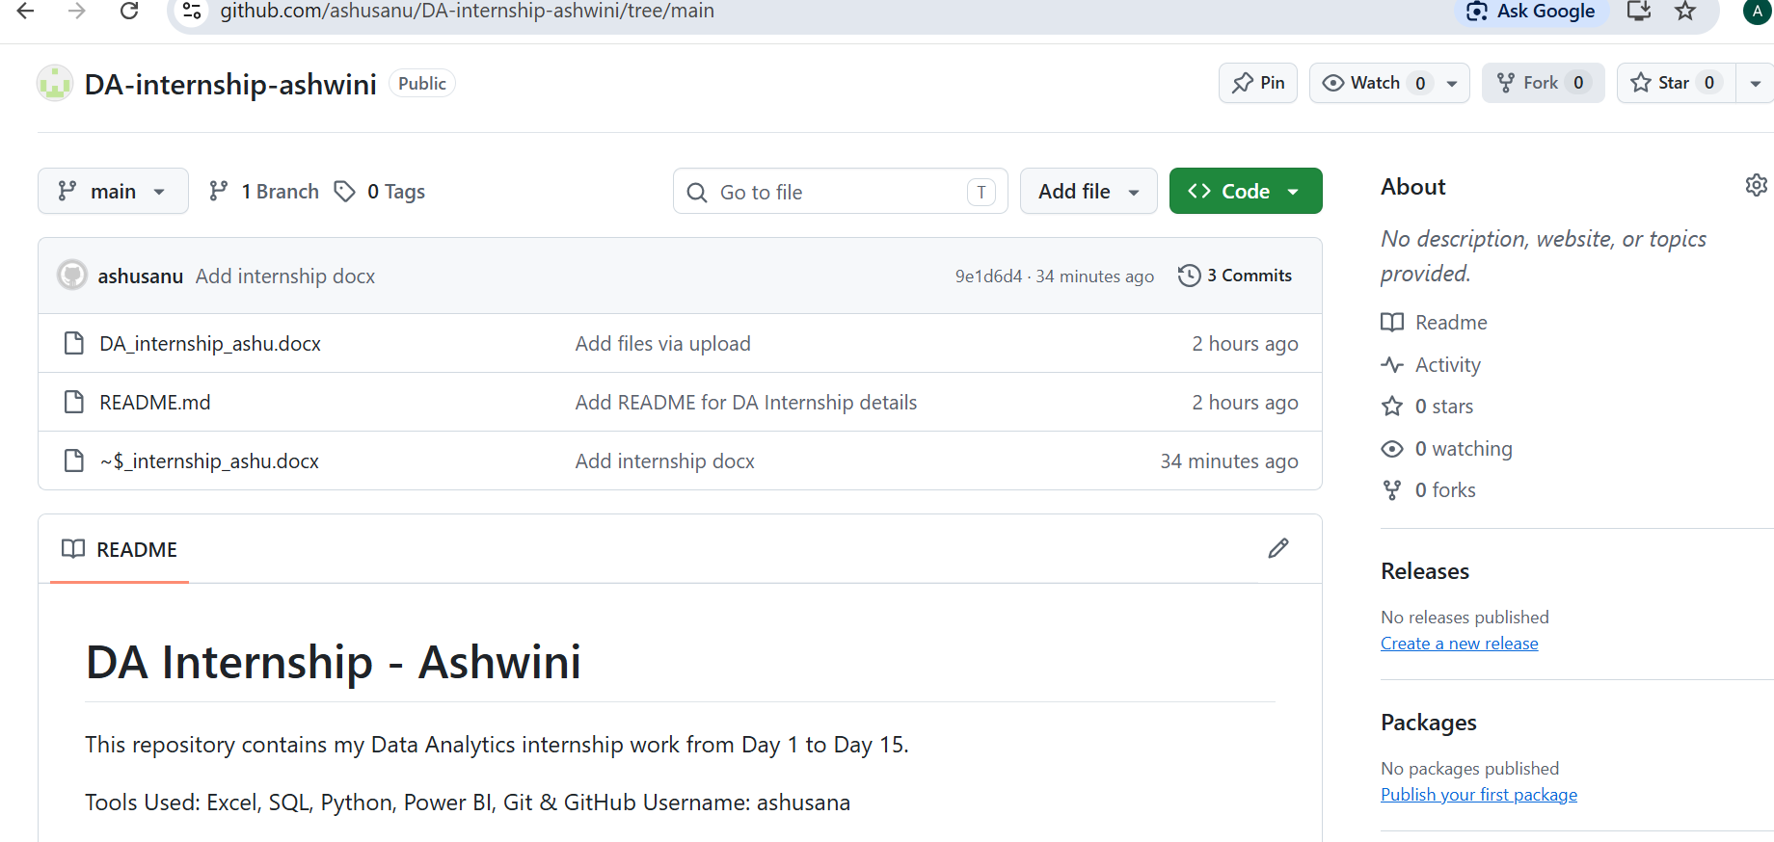

- Clone: Download GitHub repo to your laptop. git clone <link>
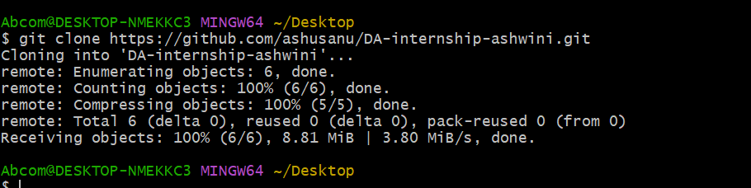

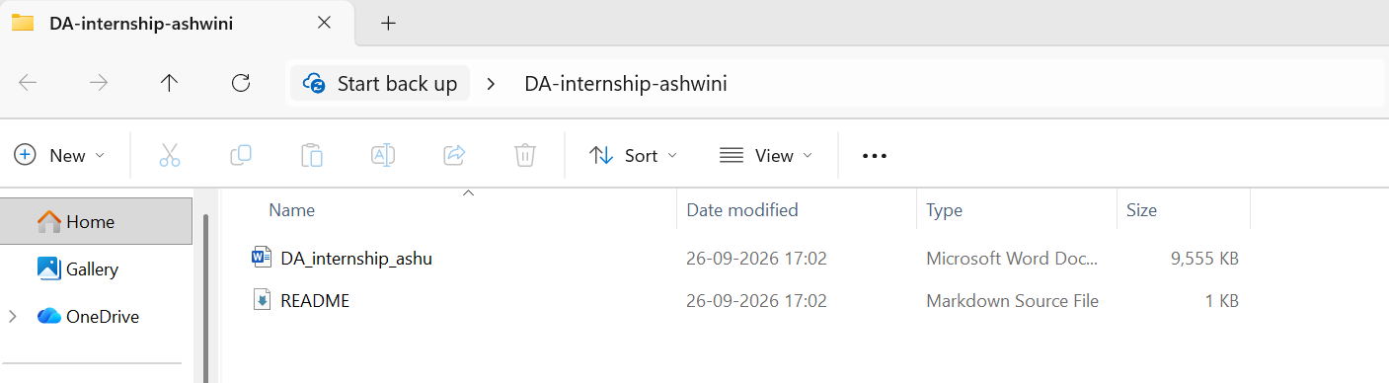
- Commit: Save your changes locally with a message. git commit -m "Day 1 done"
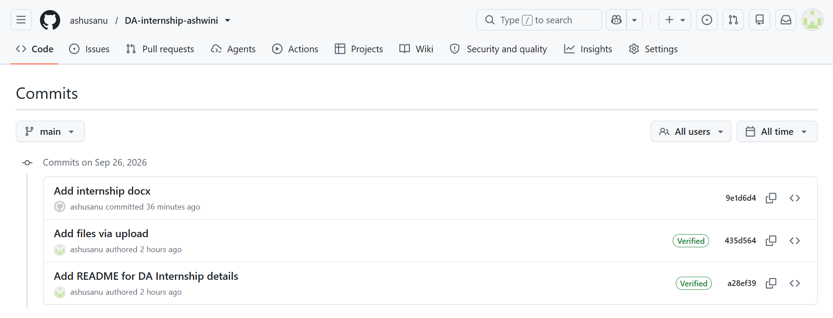

- Push: Upload your local saved changes to GitHub. git push
Push = UPLOAD to GitHub
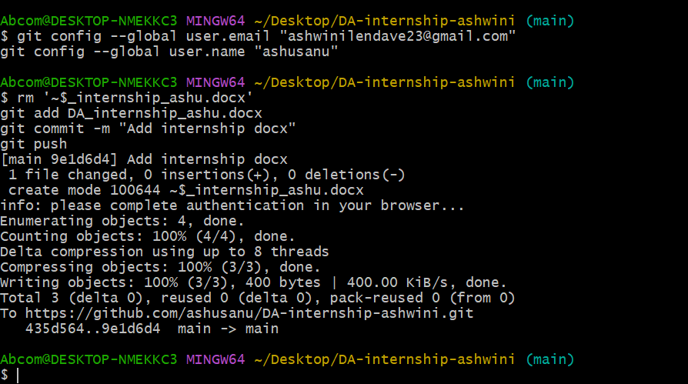
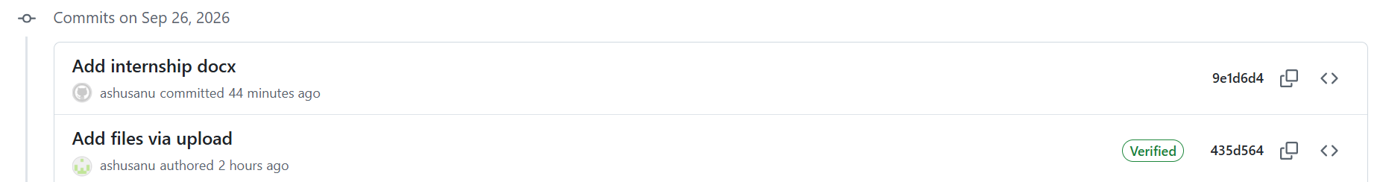

- Pull: Download latest changes from GitHub to your laptop. git pull
Pull = DOWNLOAD from GitHub to Laptop
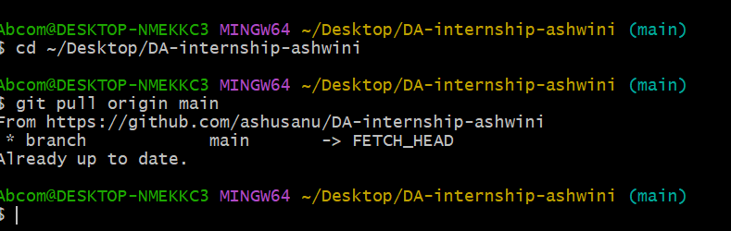

- Branch: Copy of your code to work separately. git branch feature
Branch = A copy/version of your project.
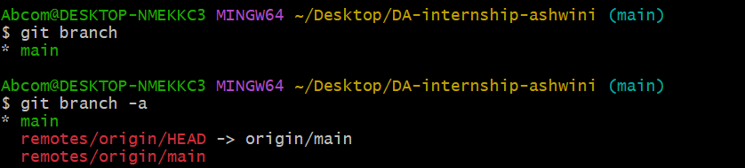
- Merge: Combine branch code into main. git merge feature.
- gitignore: File that tells Git which files/folders NOT to upload.
- README: Front page of your repo — describes your project.

DAY 16: -machine learning
Saturday,26-09-26
Machine learning (ML) = Simple meaning: Instead of you writing all the rules, you show a lot of data to computer and computer learns the rule by itself.
Normal Programming:
You give Rule + Data = Answer
Machine Learning:
You give Data + Answer = Computer finds Rule
Basic Terms AI > Machine Learning > Deep Learning
- AI: Making computer act like human
- Machine Learning: AI by learning from data
- Deep Learning: ML using big Neural Networks (for images, voice, text)
- Supervised vs Unsupervised
- Supervised: You have Label / Answer in data. You teach computer with Q&A.
- Unsupervised: You have NO Label. Computer finds hidden pattern itself.
- 3 Main Types for you:
- Regression: Supervised, Target is Number (Price, Salary, Marks)
- Classification: Supervised, Target is Category (Yes/No, Spam/Not Spam, Pass/Fail)
- Clustering: Unsupervised, Target is NONE, Goal is to make Groups

- Use this formula for every problem:
Problem -> Do we have Target/Label?
Yes -> Supervised.
- Is Target Number? -> Regression.
Is Target Category? -> Classification.
No -> Unsupervised -> Clustering.
#10 REAL-WORLD PROBLEMS
- Predict House Price
- Why? We have past house prices (label) and price is a continuous number, so we need to predict a value.
- Type: Supervised - Regression
- Features: Area, Location, BHK, Age of House
- Target: House Price (e.g., 50 Lakhs)
- Algorithm: Linear Regression, Random Forest Regressor
- Email Spam Detection
- Why? We have emails already labelled as Spam / Not Spam. Target is a category.
- Type: Supervised - Classification
- Features: Words in email, Subject line, Sender, Presence of links
- Target: Spam / Not Spam
- Algorithm: Logistic Regression, Naive Bayes
- Group Mall Customers
- Why? No label is given. We just want to find hidden groups of similar customers.
- Type: Unsupervised - Clustering
- Features: Age, Annual Income, Spending Score
- Target: None. Model will create groups (e.g., High Spenders, Low Spenders)
- Algorithm: K-Means Clustering
- Diabetes Prediction
- Why? We have past patient data labelled as Diabetic or Not.
- Target is category.
- Type: Supervised - Classification
- Features: Glucose, BMI, Age, Blood Pressure
- Target: Diabetes Yes / No
- Algorithm: Logistic Regression, Decision Tree
- Student Marks Prediction
- Why? We have past student marks. Marks is a continuous number.
- Type: Supervised - Regression
- Features: Study Hours, Attendance, Past Marks
- Target: Final Marks (e.g., 85/100)
- Algorithm: Linear Regression
- Cat vs Dog Image Classification
- Why? Images are labelled as Cat or Dog. Need to identify category from images. Image data needs Deep Learning.
- Type: Supervised - Classification (Deep Learning)
- Features: Pixels of the image
- Target: Cat / Dog
- Algorithm: CNN - Convolutional Neural Network
- Credit Card Fraud Detection
- Why? Past transactions are labelled as Fraud or Legit.
- Target is category.
- Type: Supervised - Classification
- Features: Amount, Location, Time, Transaction Type
- Target: Fraud / Not Fraud
- Algorithm: Random Forest Classifier, Logistic Regression
- Employee Salary Prediction
- Why? Past salary data is available. Salary is a continuous number.
- Type: Supervised - Regression
- Features: Years of Experience, Education, Job Role
- Target: Salary (e.g., 8 LPA)
- Algorithm: Linear Regression, XGBoost Regressor
9. Grouping News Articles
- Why? No labels. We want to group similar news articles automatically.
- Type: Unsupervised - Clustering
- Features: Words in article, Keywords, Topic
- Target: None. Groups like Sports, Politics, Tech will be created
- Algorithm: K-Means, DBSCAN
10. Monthly Sales Forecasting
- Why? We have past sales numbers. Sales amount is a continuous number.
- Type: Supervised - Regression
- Features: Month, Ad Spend, Season, Previous Sales
- Target: Future Sales Amount
- Algorithm: Linear Regression, ARIMA

- Why? They must know which ML technique to use and why.
- Because different problems need different techniques.
- If you use wrong technique, model will give wrong output and fail.
- If target is Number, you need Regression, if target is Category, you need Classification, if there is no target you need Clustering.
- Knowing the WHY helps you choose the right tool for any new real-world problem.

