Day-10: probability
Wednesday,23/09/26
Probability gives the possibility of happening the events
Probability topic is as below:-
- Probability
It gives possibilities of event that will occurs.
Formula: P(E)= Favorable​/Total,
value is 0 to 1
Example: Bag has 3 red, 2 blue balls.
P(Red) = 3/5 = 0.6

- Conditional Probability
Probability of A given B already happened.
Formula: P(A∣B) = P (A and B)/ P(B)​
Example: 2 dice, Sum is 8 given that first die is 4?
P(Sum=8 | First=4) = 1/6
because you need second=4.
- Independent Events
One event does NOT affect other.
Formula: P (A and B) =P(A)P​(B)
Example: Toss coin and roll dice.
P (Head and 6) = 1/2 * 1/6 = 1/12 = 0.083

- Dependent Events
First event affects second.
Formula: P (A and B) =P(A)P​(B∣A)
Example: 2 cards without replacement.
P (Both Aces) = 4/52 _ 3/51 = 0.0045

- Bayes Theorem
Reverse the condition. Used in Spam filters, medical tests.
Formula: P(A∣B) = P(B∣A) P​(A)/ P(B)​
Example: Disease 1% people have. Test is 99% accurate.
If you test positive, what's real probability you have disease?
P(Disease∣+) =0.990​.01+0.010​.99/990​.01​=0.5=50% - not 99%!

- Normal Distribution
Bell curve.
Most data around mean. Height, marks, ML errors follow this.
68% data within 1 sigma, 95% within 2 sigma, 99.7% within 3 sigma.

- Binomial Distribution
Fixed trials (n), only 2 outcomes (success/fail), probability p.
Formula: P(k) = C (n, k) _ p^k _ (1-p) ^{n-k}
Example: 10-coin tosses, 5 heads = 0.246
- 15 PROBLEMS SOLVED
- Coin P(Head)=1/2
Total = 2 (H, T), Favorable = 1 (H). So, 1/2 = 0.5
- Die P (4) =1/6
Die has 1,2,3,4,5,6. Total 6, you want only 4. So 1/6.
- Cards P(Ace)=4/52=1/13
52 cards total, 4 Aces. 4/52 = 1/13 = 0.0769
- P (Even on die) =3/6=0.5
Even = 2,4,6 -> 3 numbers. Total 6. So 3/6 = 1/2
- P (Sum=7 on 2 dice) =6/36=1/6
2 dice = 36 combos (6_6). Sum 7 can come like: (1,6),(2,5),(3,4),(4,3),(5,2),(6,1) -> 6 combos. So 6/36 = 1/6
- With replacement P (2 Reds from 3R2B) =3/5 * 3/5=9/25
Bag: 3 Red, 2 Blue = 5 total. First draw Red = 3/5.
You PUT IT BACK, so second time again 3/5. Multiply because with replacement = independent. 9/25 = 0.36
- Without replacement P (2 Reds) =3/5_2/4=0.3
First Red = 3/5. Now you DON'T put back. Bag left with 2 Red, 2 Blue = 4 total. So, second Red = 2/4. Multiply = 6/20 = 0.3. This is dependent event.
- P(A|B) where A=2nd is 6, B=sum>9 = 3/6=0.5
Conditional. B=sum>9 happens in 6 cases: (4,6),(5,5),(5,6),(6,4),(6,5),(6,6). Out of these 6, how many have 2nd=6? 3 cases: (4,6),(5,6),(6,6). So 3/6=0.5
- Independent: P (H and 6) =0.083
Coin and die don't affect each other. P(H)=1/2, P(6)=1/6. P(both)=1/2 _ 1/6 = 1/12 = 0.0833
- Bayes: P (Spam|word "offer") = 0.75
Formula: P(Spam|offer) = P(offer|Spam)_P(Spam) / P(offer)
Suppose 40% mails are spam, P(offer|Spam)=0.6, P(offer|Not Spam)=0.2
Then P(offer)=0.6_0.4 + 0.2_0.6 = 0.36.
So P(Spam|offer)=0.24/0.36=0.75.
Means if mail has "offer", 75% chance it's spam.
- if calculated P (at least 1 Head in 2 tosses) =3/4
Outcomes: HH, HT, TH, TT = 4. At least 1 Head = HH,HT,TH = 3. So 3/4. Trick: 1 - P(no head) = 1 - 1/4 = 3/4
- P (both 6 in 2 dice) =1/36
First 6 = 1/6, second 6 = 1/6. Independent, so 1/6 _ 1/6 = 1/36 = 0.0277
- Normal: P (height > 180cm) if mu=170, sigma=10 = 0.1587
mu=170 is mean, sigma=10 is std. 180 is mu + 1 sigma. In normal curve, 68% data is within mu±sigma (160 to 180). So outside that is 32%, half above = 16%. Exact = 15.87%. That's the 68-95-99.7 rule.
- Binomial: P (3 heads in 5 tosses) =10/32=0.3125
Formula: C(n,k)p^k(1-p)^(n-k). C(5,3)=10, p=0.5. So 10 _ (0.5)^3 _ (0.5)^2 = 10/32 = 0.3125
- P(missing number) in 1-10 if sum is 50 = 5
Sum of 1 to 10 = 55. Your sum is 50. Missing = 55-50 = 5. This is not probability, it's maths trick to find missing number.

Deliverables: - day 10:-probility.py
#5 PYTHON IMPLEMENTATIONS: -
Simple probability:-
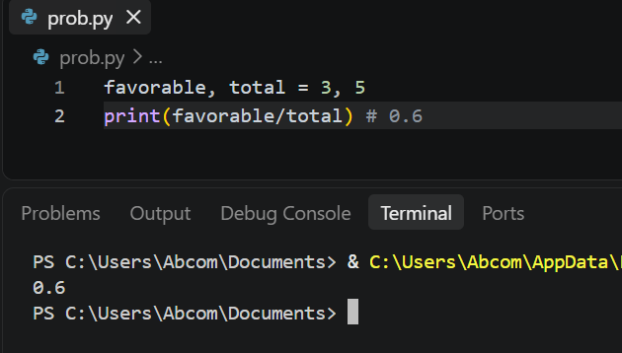
Conditional and independent
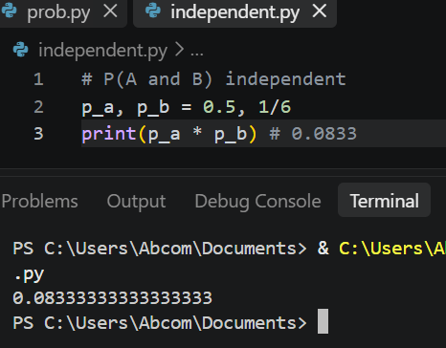
3. Bayes Theorem
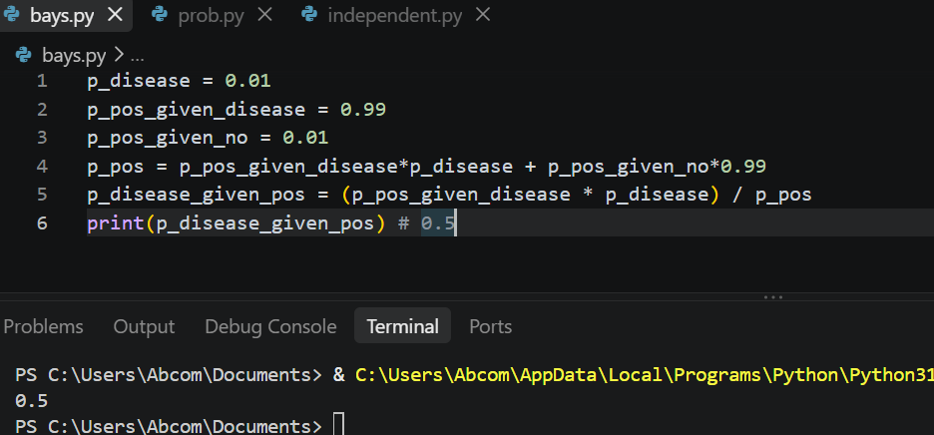

4. Normal Distribution
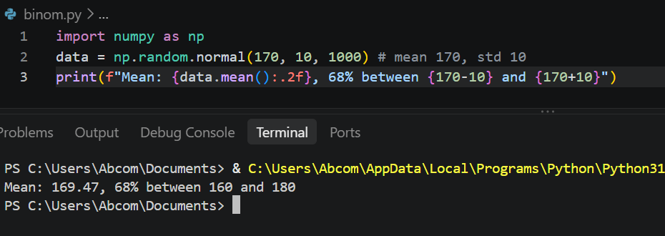
5. Binomial Distribution
