DAY 11: -Matplotlib
Thursday,24-09-26
Matplotlib is a low-level data visualization library that lets you create static, animated, and interactive charts in Python using lines, bars, dots.
Concepts of matplotlib is as follows: -
1. Line Chart
Definition: Shows data points connected by a straight line to show trend over time or continuous sequence.
Use: When you want to see growth, decline, ups and downs over time.
Example: Monthly sales from Jan to Dec. Line going up means sales increasing.
2. Bar Chart
Definition: Uses rectangular bars where length/height represents value. Bars can be vertical or horizontal.
Use: To compare different categories side by side.
Example: Sales of Electronics vs Fashion vs Grocery. Taller bar = more sales.
3. Histogram
Definition: Looks like bar chart but for numeric range. It groups numbers into bins (ranges) and shows how many values fall in each bin.
Use: To see distribution - how data is spread, where most values lie.
Example: Sales values grouped as 10k-15k, 15k-20k etc. Shows most months sales are 20k-25k.

4. Scatter Plot
Definition: Shows two numeric variables as dots. Each dot is one observation with X and Y value.
Use: To see relationship/correlation between two variables.
Example: Ad Spend on X-axis, Sales on Y-axis. If dots go up together, positive correlation.
5. Pie Chart
Definition: Circle divided into slices. Each slice shows percentage/proportion of a whole. Total = 100%.
Use: To show share or composition of categories.
Example: Total sales = 100%. Electronics 40%, Fashion 35%, Grocery 25% as 3 slices.
6. Box Plot
Definition: Shows 5 numbers - Minimum, Q1 (25%), Median (50%), Q3 (75%), Maximum. Box is Q1 to Q3, line inside is median, dots outside are outliers.
Use: To find outliers and understand spread/variance.
Example: Box plot of sales shows median 24k, and any dot far away is an unusual high sale.
7. Area Chart
Definition: Same as line chart but area below the line is filled with colour. Shows volume along with trend.
Use: When you want to highlight magnitude/volume, not just trend.
Example: Same monthly sales as line chart, but filled area shows total volume of sales achieved.

TASK and deliverables :-Day_11 matplotlib
Dataset I used for all charts:
Month, Sales, Profit, Category, Ad_Spend for 12 months.
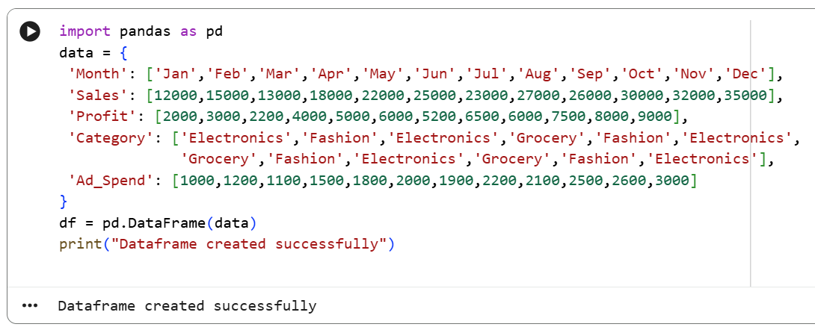

- Line Chart - Shows Trend
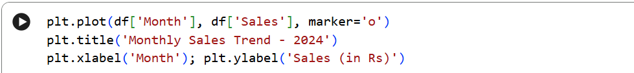

Output:-
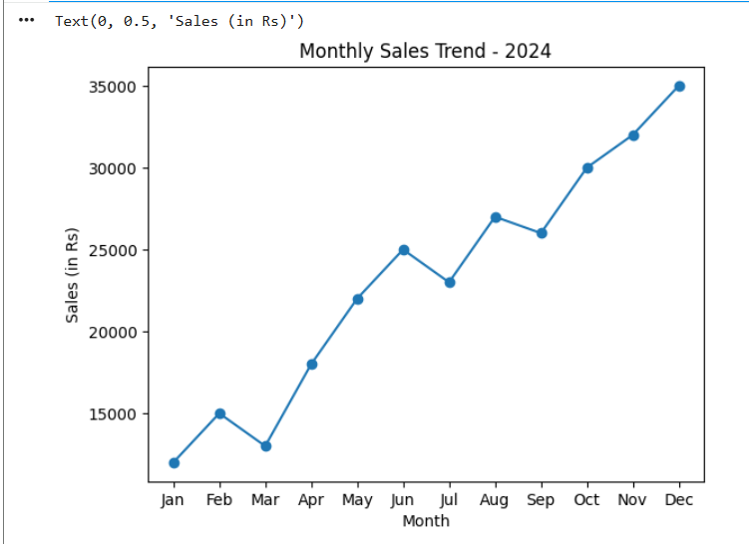
Interpretation: Sales is increasing over time, dips in March and July.
- Bar Chart - Compares Categories
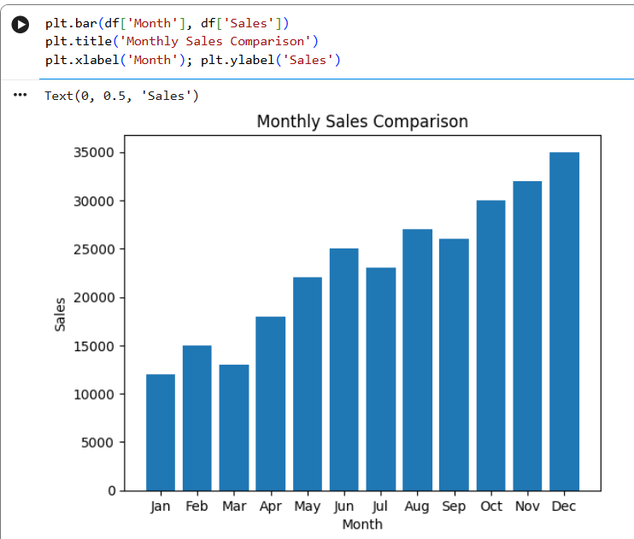

Interpretation: Dec has highest sales (35000), Jan lowest.

- Histogram - Shows Distribution
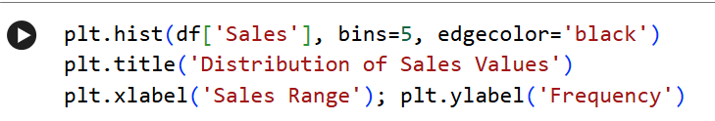

Output:-
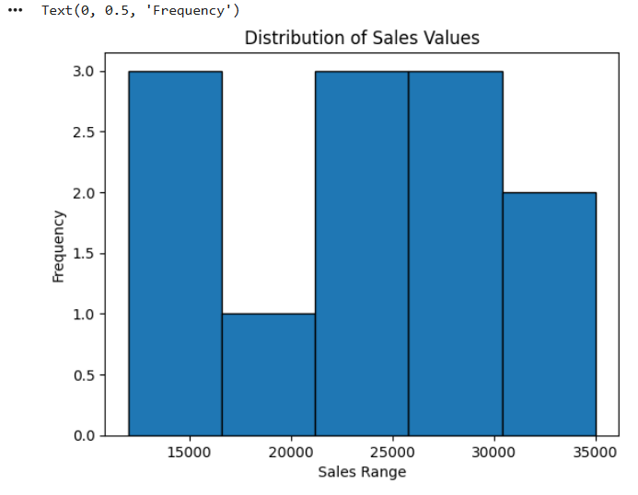
Interpretation: Most months sales are between 20000-30000 range.

- Scatter Plot - Shows Relationship
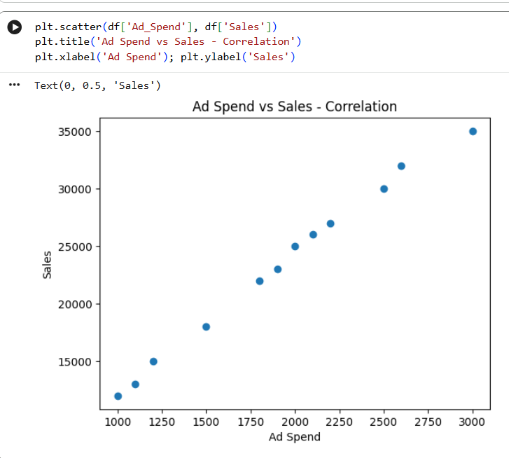Interpretation: Strong positive correlation - as ad spend increases, sales also increase. Important for ML regression.

- Pie Chart - Shows Proportion
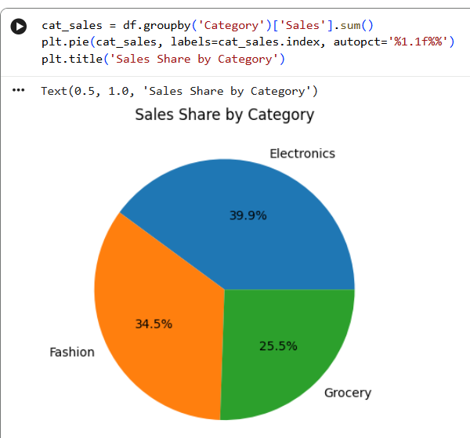
Interpretation: Electronics 39.9% contributes most, then Fashion 34.5%.

- Box Plot - Shows Outliers
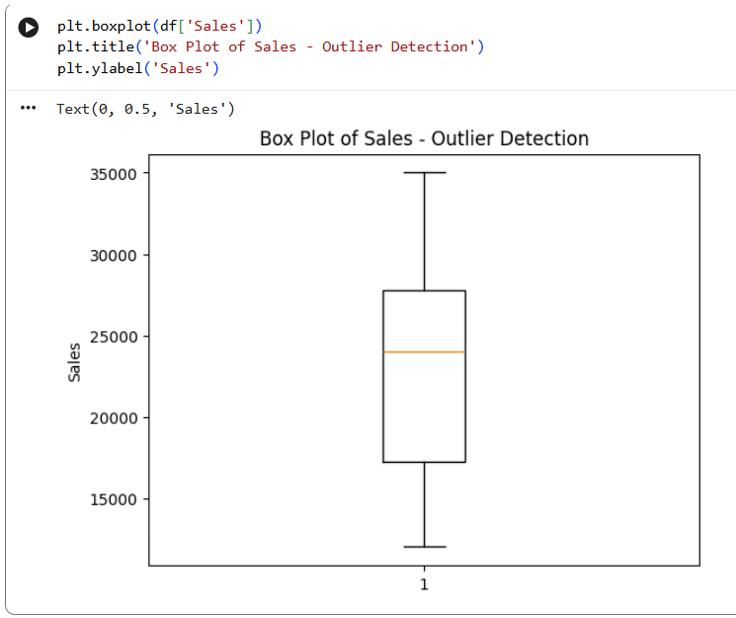
Interpretation: Median sales is 24000, Q1=∼17000, Q3=∼27500. No extreme outliers.

- Area Chart - Shows Volume
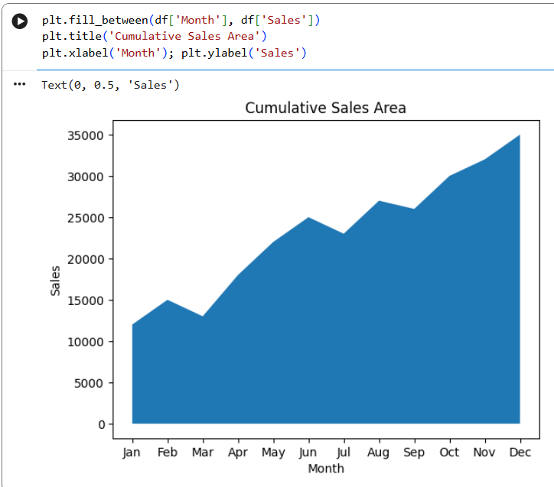
Interpretation: Same as line but highlights volume under curve, good for total sales visual.

- Stacked Bar Chart - 2 variables
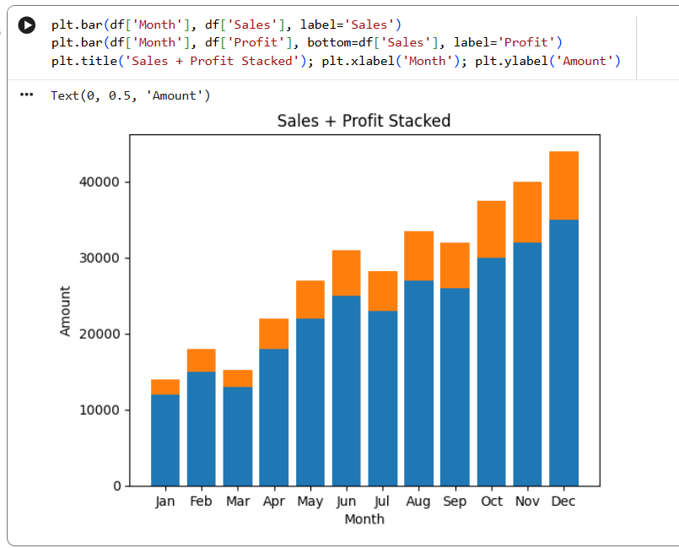
Interpretation: Profit margin is ∼25% of sales consistently.

- Double Line Chart - Sales vs
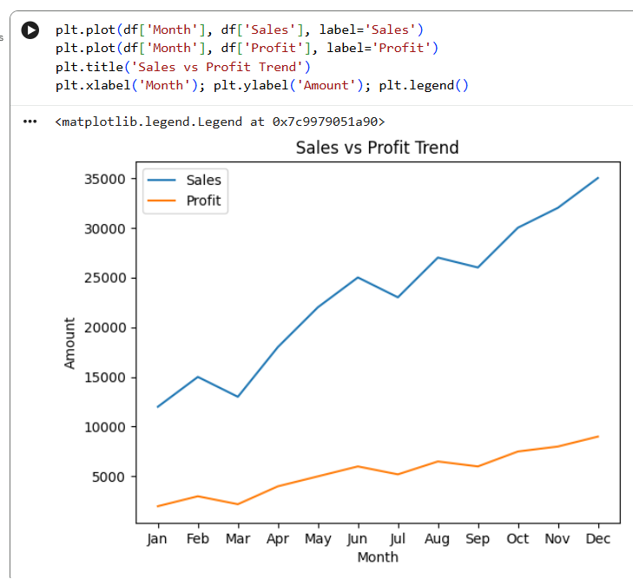
Interpretation: Both lines move together - profit follows sales.

- Horizontal Bar Chart - Category
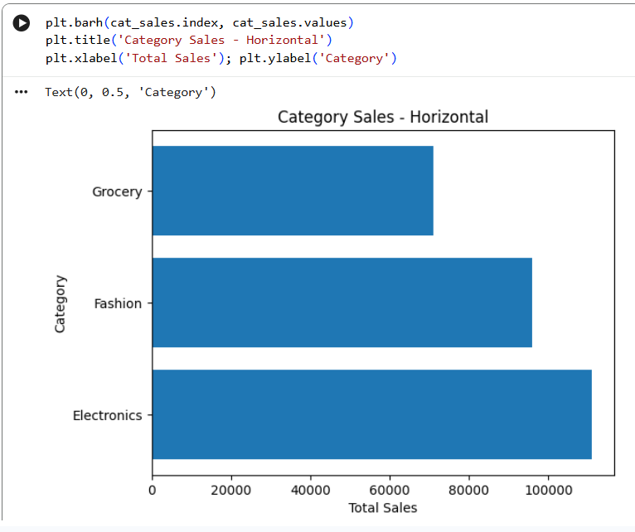Interpretation: Easier to read category names than vertical bar.

- Why, the visualization should communicate information, not just look attractive?
- Because a business pays for decisions, not decoration.
- If a chart looks pretty but doesn't tell what to do next, it's useless.
- Good visualization answers What happened, Why, and So What in 5 seconds.

