DAY13_Power BI
Friday,25-09-26
Power BI is a Business Intelligence tool that helps to import, clean, analyze and visualize data to make business decisions. It takes raw data from Excel and shows it as Charts, Cards, and Tables on one page.
- some topics of Power BI:-
- Import Data
Definition: Getting data from Excel / CSV / Database into Power BI.
How: Home > Get Data > Excel > Select Sales_Data.xlsx > Load
Example: You imported your file with columns Order_ID, Category, Amount.

- Power Query
Definition: Data cleaning engine of Power BI. It's like an Excel cleaner before making charts. Every step is recorded.
Where: Home > Transform Data
Example: Removing null rows, removing duplicates from Customer_ID.

- Transform Data
Definition: Cleaning operations inside Power Query — rename columns, remove columns, change case.
Example:
You did Promoted Headers — first row became header.You removed extra column Salesperson if not needed.Your M-code Table.TransformColumnTypes is part of Transform.
- Data Types
Definition: Telling Power BI what kind of data each column is, so it calculates correctly.
type text = Text (Order_ID, Category) — Icon ABCtype date = Date (Order_Date) — Icon Calendar — Needed for Monthly SalesInt64.Type = Whole Number (Quantity) — Icon 123Decimal = For Price/Amount (99.50)
Example: If Order_Date is Text, Line Chart will NOT work. You must change it to Date in Transform tab > Data Type.
- Filters
Definition: Filters hide unwanted data at Visual level, Page level, or Report level. Users cannot change it.
Where: Filters panel on right.
Example: Filter Panel > Category > Uncheck "Stationery" — Dashboard will show only Electronics + Fashion. You used this to exclude test data.
- Slicers
Definition: Slicers are VISUAL filters that USER CAN CONTROL. Like buttons on dashboard.
Where: Visualizations > Slicer icon (with funnel)
Example: Insert Slicer > Drag Region into it. Now end user can click East / West / North and all 6 visuals change automatically. You must add Region Slicer.
- Charts
Definition: Visual representation of data.
Bar Chart = Compare categories (Sales by Category)Pie Chart = Show % share (Sales by Region)Line Chart = Show trend over time (Monthly Sales)
Example: Bar Chart: X-axis = Total Sales, Y-axis = Category — Electronics bar is longest.8. Cards
Definition: Cards show a single BIG number (KPI).
Where: Visualizations > Card icon
Example:
Card 1: Total Sales = SUM(Amount) = $2.5MCard 2: Total Orders = COUNTROWS = 1500Card 3: Total Customers = DISTINCTCOUNT = 800Place these 3 cards on top row of dashboard.9. Tables
Definition: Shows exact data in rows and columns with totals. Like Excel inside Power BI.
Where: Visualizations > Table icon (grid)

10. Matrix
Definition: Advanced Table + Pivot Table. It has Rows, Columns, AND Values with drill-down.
Where: Visualizations > Matrix icon (next to Table)
Example:
Rows = CategoryColumns = RegionValues = Total Sales

DELIVERABLES_DAY13
What they have to do Create a one-page sales dashboard. Include:
• Total Sales • Total Orders • Total Customers
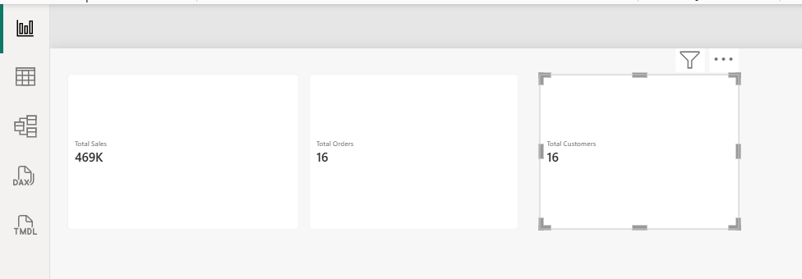

• Sales by Category
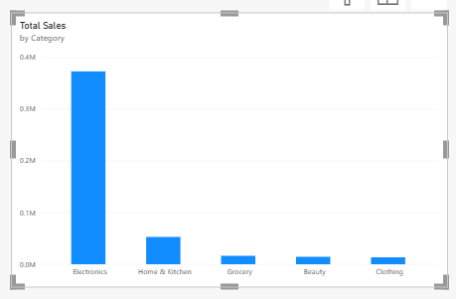
• Sales by Region
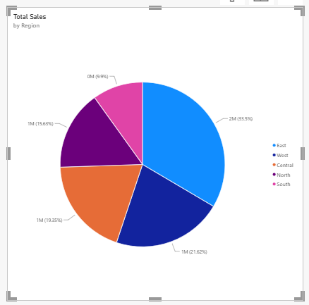
• Monthly Sales
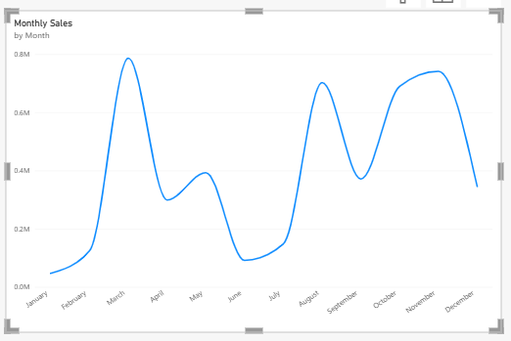
- Why?
Power BI is an important business-intelligence skill.
Power BI is #1 Business Intelligence (BI) skill because:
- Business Decision: CEO can see in 5 seconds — Which Category is failing? Which Region is best? Which Month had highest sales?
- No Coding: You made full dashboard without Python — just drag-drop + DAX.
- Industry Demand: Every company (Amazon, Infosys, Banks) needs Sales Dashboard. This is your interview project.
- "Power BI helps convert raw sales data into actionable insights using Power Query for cleaning, DAX measures for KPIs like Total Sales, and visuals like Cards, Charts, and Matrix to show trends and comparisons on a single page.

