DAY14: DAX
Friday,25-09-26
DAX = Data Analysis Expressions
It's the formula language of Power BI. Like Excel formulas, but for dashboards.
DAX is used to create Measures and Calculated Columns that calculate dynamically when you click filters/slicers.
Create measures:
- Total Revenue: - Total sales amount
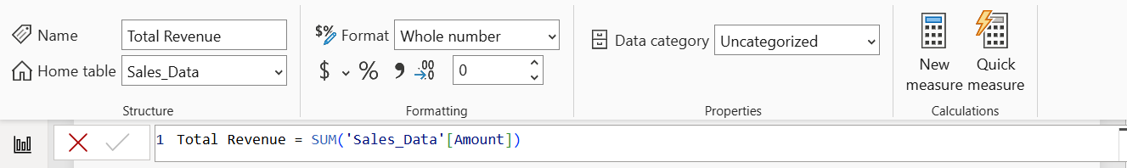
- Total Profit: -
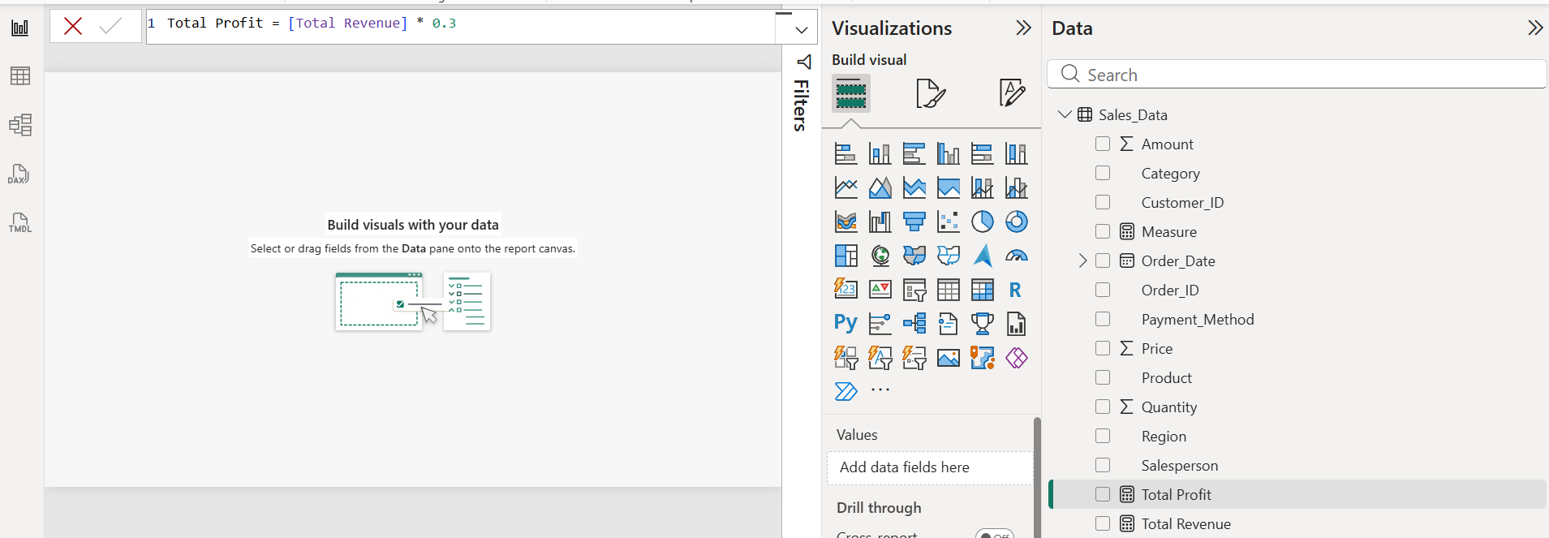

- Total Orders: -
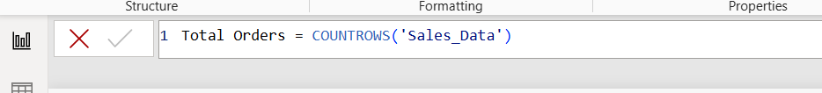
- Total Customers
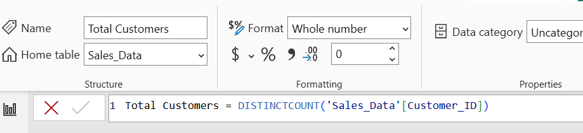
- Average Order Value
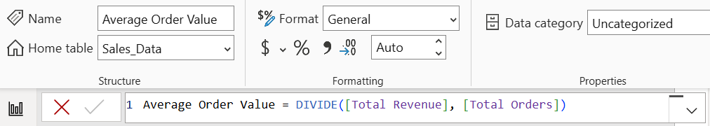
- Profit Margin
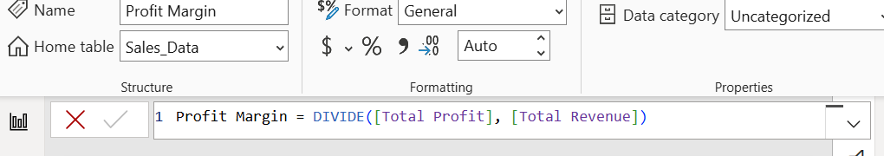

Final output for above topic:-
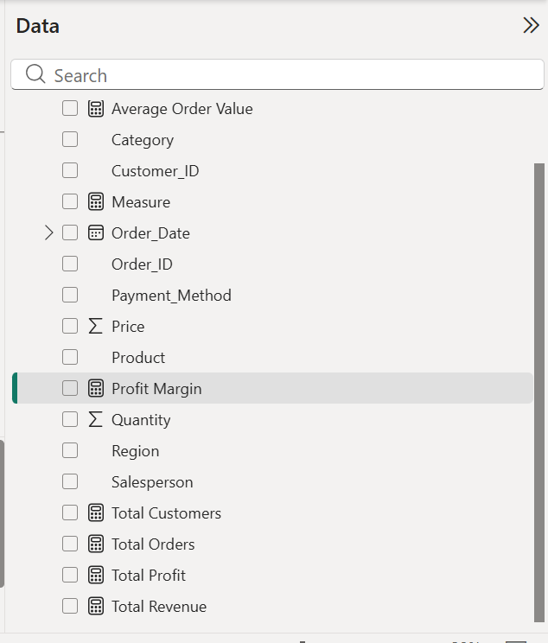
Then learn:
- CALCULATE: Changes context. Like saying "Calculate Revenue BUT ONLY FOR..."
- FILTER: Returns table that meets condition. Here: Only rows where Region=East
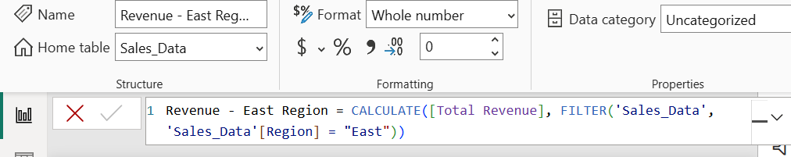

• ALL: removes’ filters. Even if user clicks East slicer, this measure still shows total of ALL regions. Used to calculate % of total.
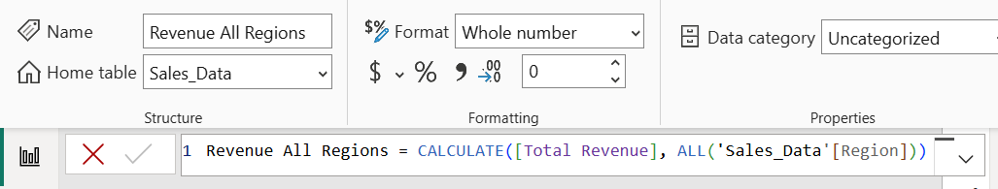

• SUMX: Definition: SUMX goes row by row, multiplies Quantity*Price for each row, then adds. SUM can't do multiplication inside
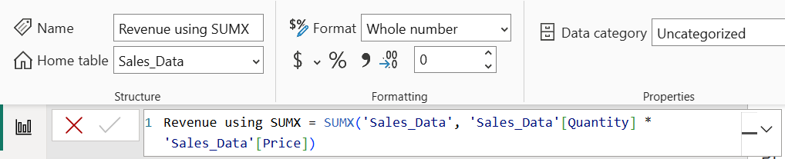
• COUNTROWS: - Counts total rows (including duplicates).
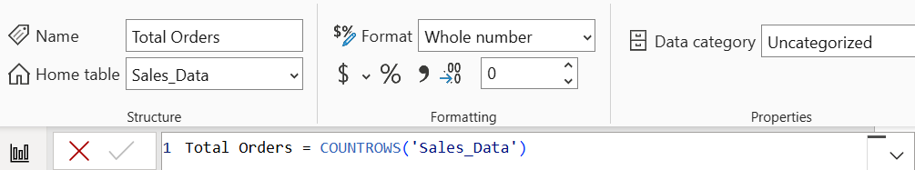
• DISTINCTCOUNT: - Counts unique values only (removes duplicates).

- Why? DAX is required for dynamic calculations inside Power BI.
DAX is required because measures created with DAX respond to user interactions (slicers/filters) and calculate dynamically, whereas raw columns are static.

