DAY 15: -Git/GitHub
Saturday,26-09-26
Git = tool on your laptop to track changes. GitHub = website where you save those tracked changes online to show others.
- Repository: Folder on GitHub to store your whole project.
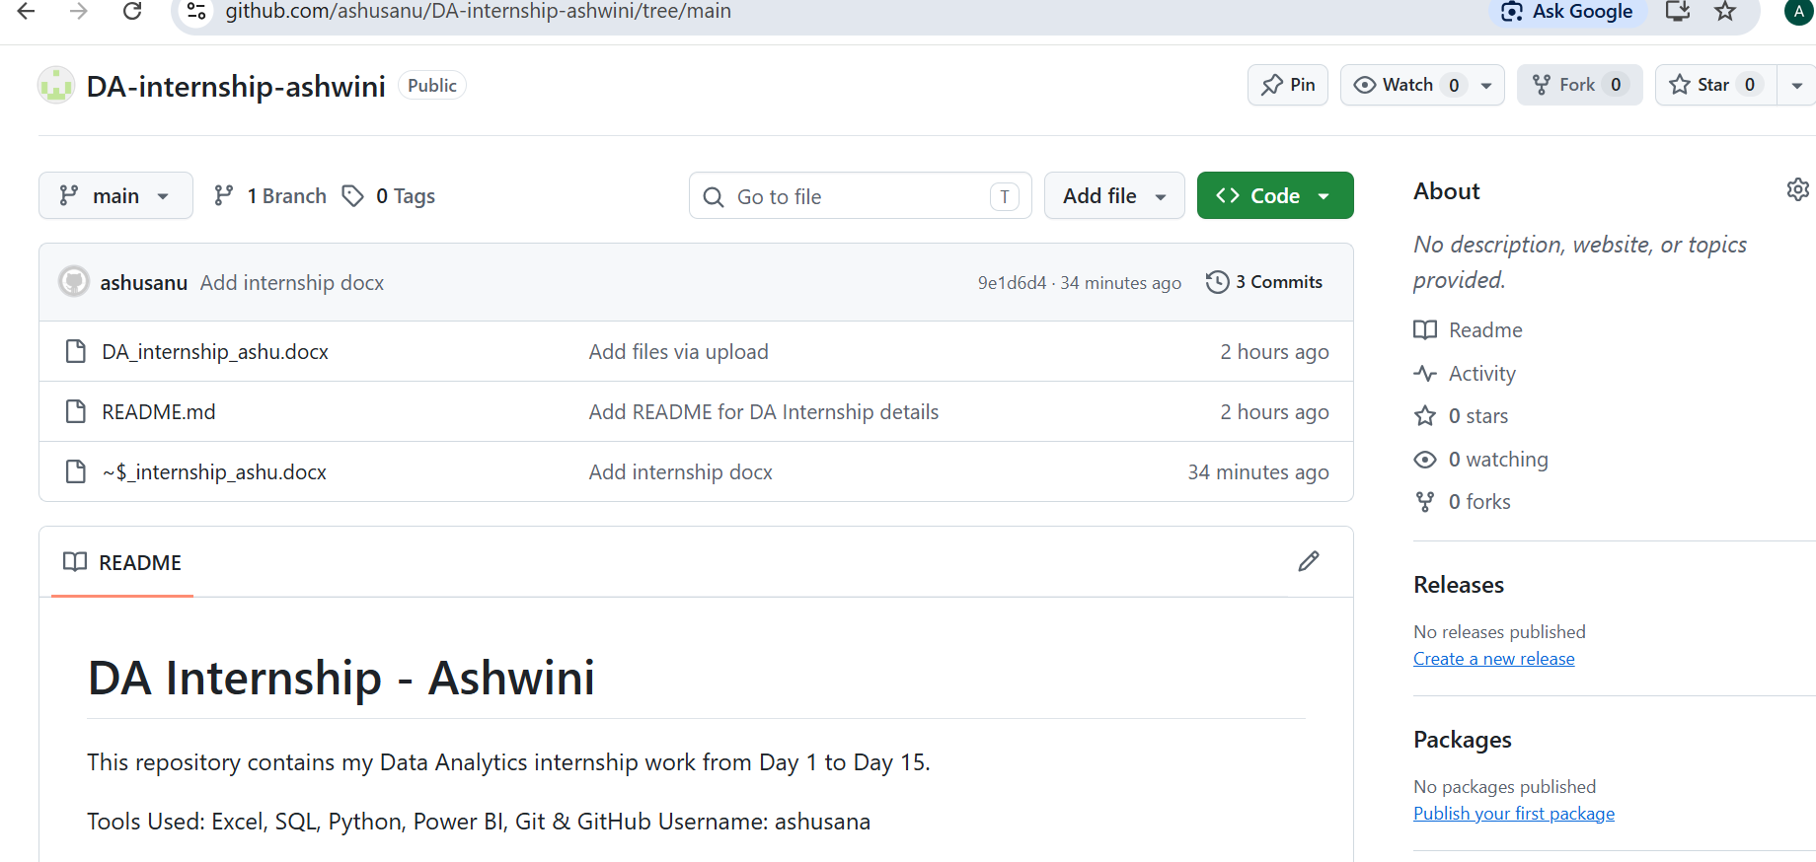

- Clone: Download GitHub repo to your laptop. git clone <link>
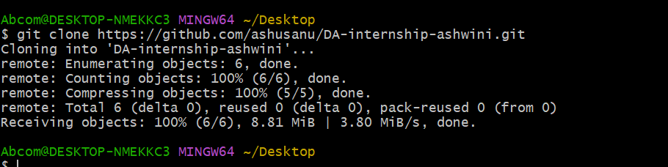

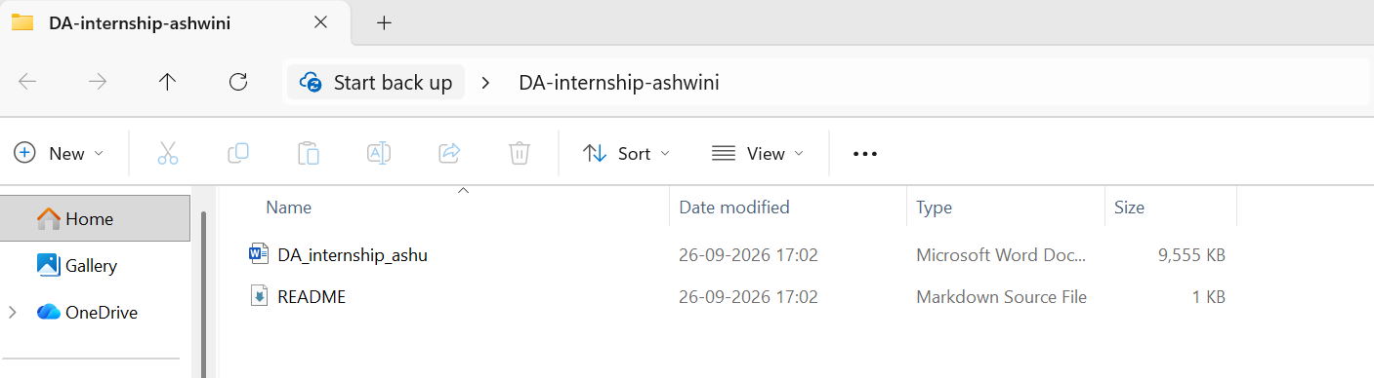
- Commit: Save your changes locally with a message. git commit -m "Day 1 done"
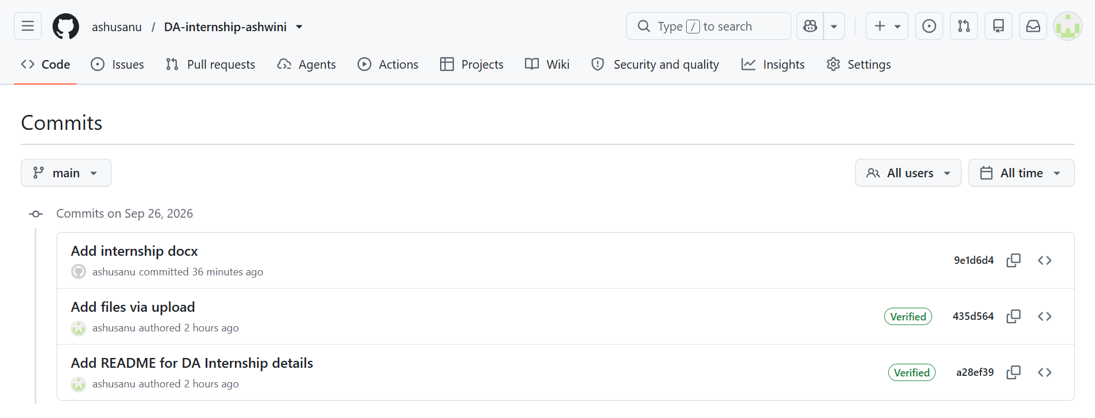

- Push: Upload your local saved changes to GitHub. git push
Push = UPLOAD to GitHub
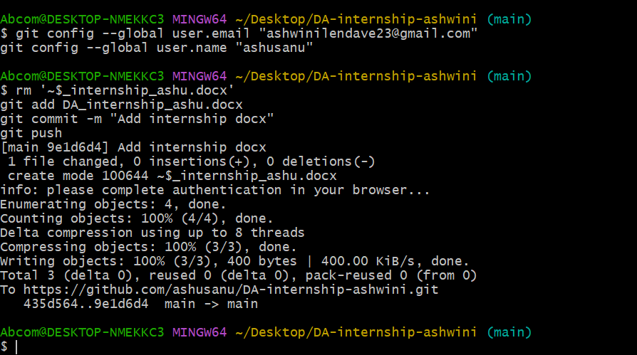
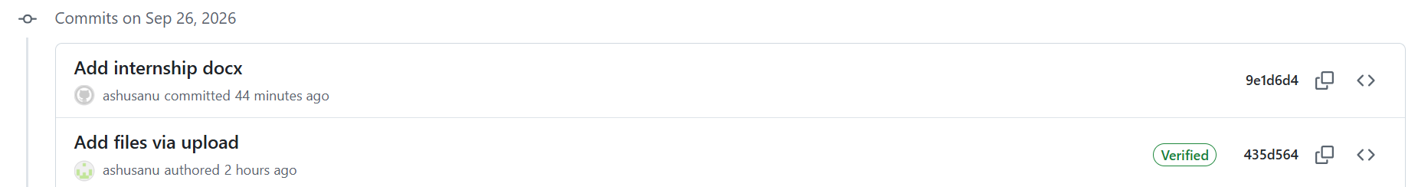

- Pull: Download latest changes from GitHub to your laptop. git pull
Pull = DOWNLOAD from GitHub to Laptop
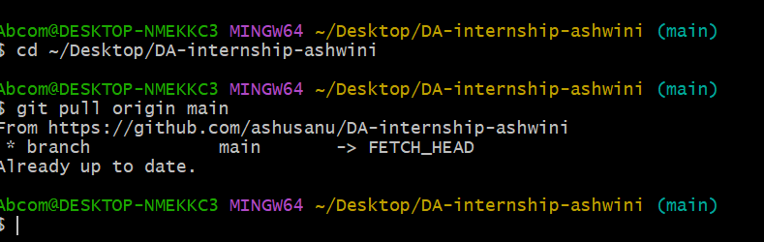

- Branch: Copy of your code to work separately. git branch feature
Branch = A copy/version of your project.
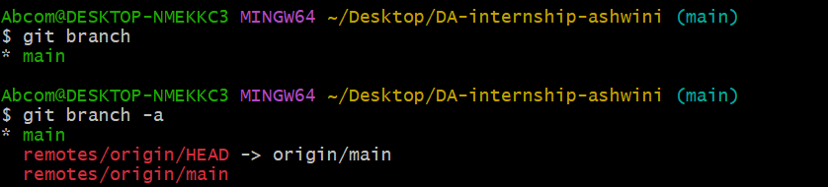
- Merge: Combine branch code into main. git merge feature.
- gitignore: File that tells Git which files/folders NOT to upload.
- README: Front page of your repo — describes your project.

