DAY2: - PYTHON BASICS FOR DATA ANALYTICS
Friday,11/09/26
*Here we learn about the basic concepts of python which is used to write the code
Basic concepts of python as below:-
1. VARIABLES
Variable is a container to store data value.
Example:
name = "Amit"
age = 21
salary = 50000.50
2. DATA TYPES
Types of data stores.
Main Types: int, float, str, bool, list, tuple, set, dict
Check type: type(age)
It returns “str”
3. STRINGS
Text data inside quotes.
name = "Data Science"
print(name.upper()) # DATA SCIENCE
print(name.lower()) # data science
print(len(name)) # 12String concatenation: "Data Science"
4. INTEGERS
Whole numbers without decimal.
a = 10
b = 20
print(a + b) # 30
5. FLOAT
Numbers with decimal point.
price = 99.99
rating = 4.5
6. BOOLEAN
True or False value. Used in conditions.
is_pass = True
is_fail = False
print(10 > 5) # True
7. LISTS
Ordered, changeable collection. Allows duplicates.
fruits = ["apple", "banana", "mango"]
fruits.append("orange")
print(fruits[0]) # apple
print(fruits) # ['apple', 'banana', 'mango', 'orange']List functions: append(), remove(), sort(), len()
8. TUPLES
Ordered, unchangeable collection. Round brackets.pythoncolors = ("red", "green", "blue")
print(colors[1]) # green
# colors[1] = "yellow" -> Error, tuple cannot change
9. SETS
Unordered, no duplicates allowed. Curly brackets.
nums = {1, 2, 2, 3, 4}
print(nums) # {1, 2, 3, 4} duplicate removed
10. DICTIONARIES
Key-value pair storage.
student = {
"name": "Amit",
"age": 21,
"city": "Mumbai"
}
print(student["name"]) # Amit
print(student.keys())
print(student.values())
11. OPERATORS
A) Arithmetic: + - _ / % __ (power)
B) Comparison: ==!= > < >= <=
C) Logical: and, or, not
D) Assignment: = += -= _=
Example:
a = 10
b = 3
print(a % b) # 1 remainder
print(a ** b) # 1000
12. CONDITIONS
(if-elif-else):Used to take decisions.
age = 18
if age >= 18:
print("Adult")
elif age >= 13:
print("Teenager")
else:
print("Child")
13. LOOPS
- FOR LOOP - When you know how many times to repeat
for i in range(5):
print(i)
# 0,1,2,3,4
fruits = ["apple", "banana", "mango"]
for fruit in fruits:
print(fruit)
- WHILE LOOP - When condition is true
i = 1
while i <= 5:
print(i)
i += 1
LOOP CONTROL:
break - stop loop
continue - skip current iteration
for i in range(10):
if i == 5:
break
print(i)
Deliverables:-day02_python_basics.py
Write programs for:
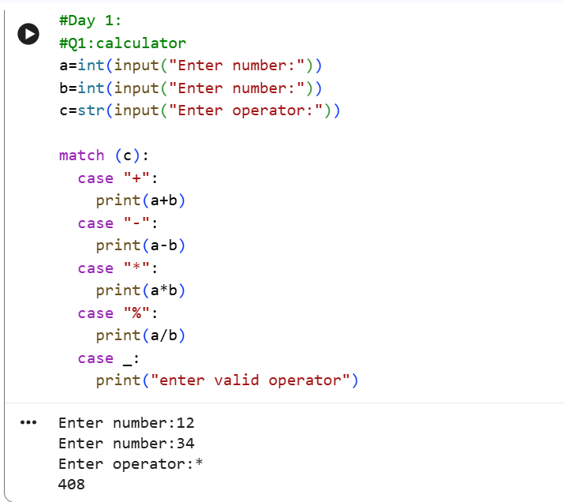
Here we take 2 numbers as input and using match case provide operators as we choose and printed the result by performig operation
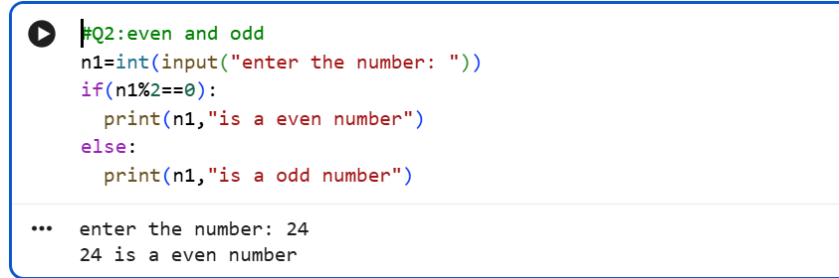
In this question we take a number as input and by applying condition i.e. (number/2==0) by using if-else statement provide the appropriate result according to input.
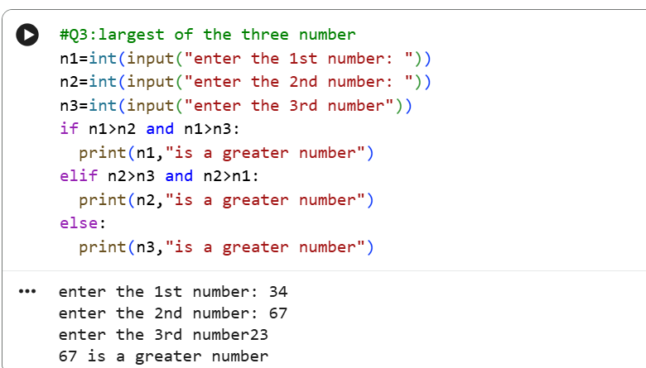
To find the largest of three number we take 3 numbers as input and using “ if-elif-else” as well as “and” giving the coditions for finding greater number
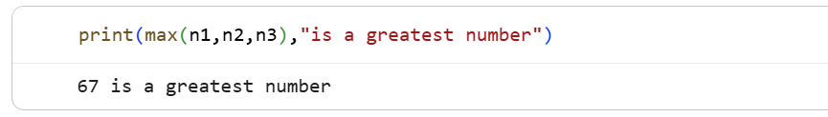
To reduce the line of code here we using simply max() to return the greatest of three
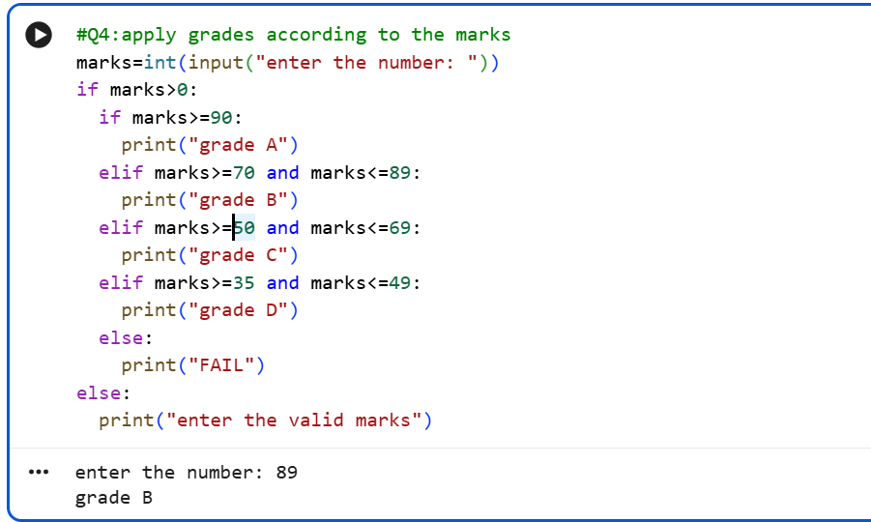
Here simply we take the marks as input and use the nested if for giving the result as grade
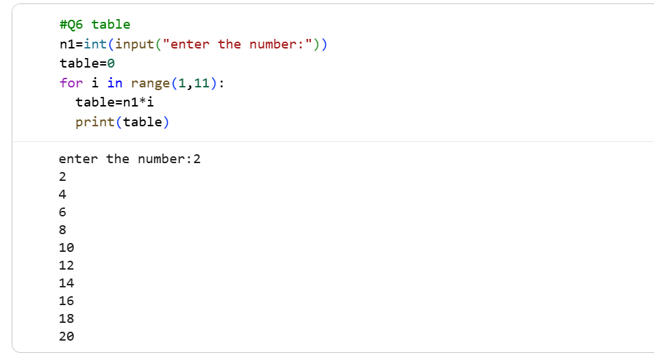
We want to print the table we just use for loop for iteration and inside loop print the product of number and iteration from(1-11) so it will be returns table upto 10 iteration.
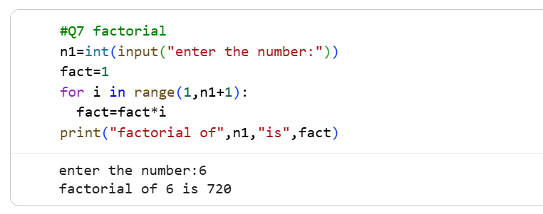
Here we have to print factorial so we iterate the for loop from(1,n+1) and apply logic of fact=fact*I where i=1 and fact=1 and print final result stored in fact out of the for loop
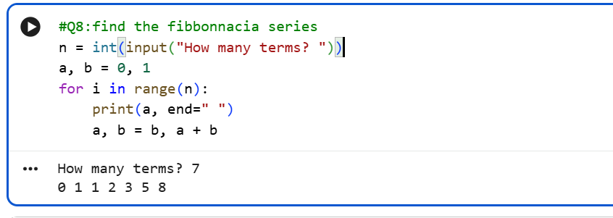
To give the Fibonacci series we consider a,b and give the expression a,b=b,a+b where (a,b=0,1) as initials and then print a which iterate in range of n
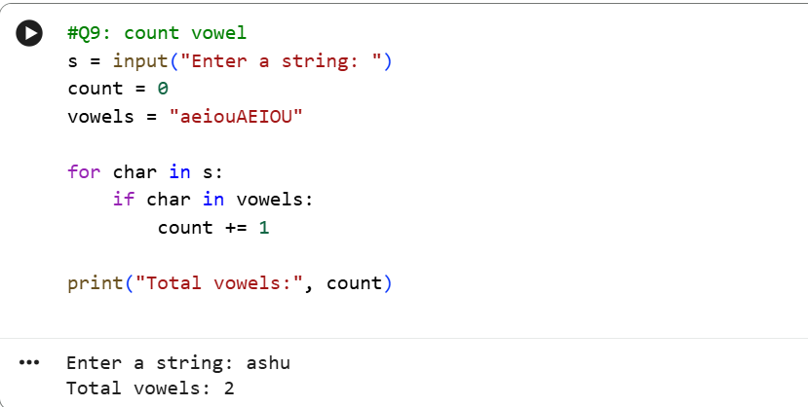
Here we count the vowels in given word so we stored lower and upper case of vowels in variable name as vowel and using for loop iterate the characters in string also using if we increase count if character is vowel and final count print out of the for loop.
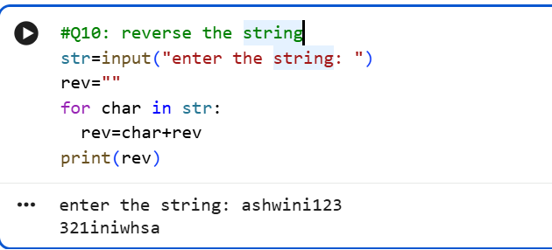
To reverse the string we use empty string as rev and iterate characters in the string using for loop where condition are rev=char +rev which store characters reversly in the string.

